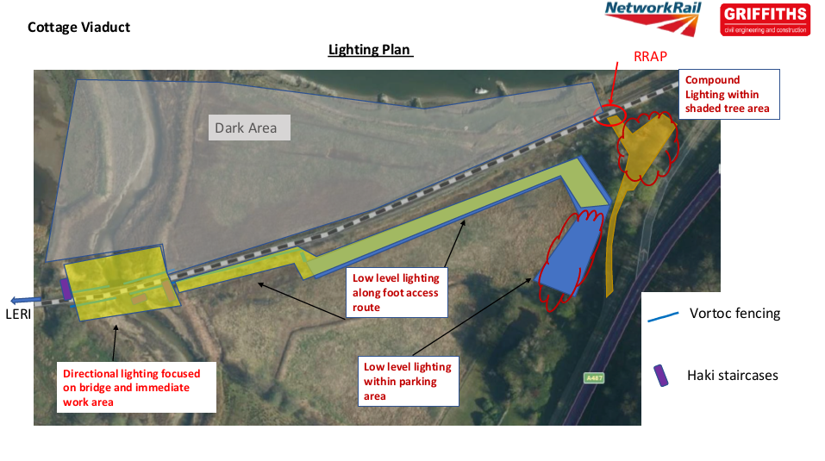

The works will be checked on a weekly basis by the Ecological Clerk of Works (Otter Licenced Ecologist or their duly accredited agent).
Lighting:
Low Level Lighting to Car Park and Foot access routes
- Low Level Lighting to access route and car park will be 110v Festoon Lighting mounted <1m above ground level with shrouding to prevent overspill toward Dark Area. Lighting only to illuminate access footways/ walkways in car park and toward structure
- Festoon Lighting will use Low energy bulbs
- Spacing of Bulb holders for festoon lighting minimum 2m spacing
- Lighting will be powered by Generator/ battery array from site compound which will be switched off when not in use.
- Lighting will be inspected daily by the Site Representative, and damaged bulbs or dislodged shrouds will be replaced.
Compound Lighting
- Compound lighting will be using 3 number VT1 tower lights set at max height 3m. VT1 lighting to have shrouding/ baffling to prevent overspill to dark area behind compound. Lighting will only illuminate the main walking routes and ‘courtyard within compound area.
- Shrouding will also be provided using the Site Welfare cabins as a physical lighting barrier along the perimeter of the Compound areas.
- Additional shrouding will be provided by both the trees and railway bunding behind the welfare units.
- Lighting will only be utilised when AG staff working on site. It will be off at ALL other times.
Directional Lighting to Viaduct
- Festoon Lighting will be erected below the structure to illuminate the work areas and access points only.
- Festoon Lighting will be downward facing with shrouding to prevent light overspill away from work area.
- Lighting will be powered by Generator/ battery array from site compound which will be switched off when not in use.
- Lighting will be inspected daily by the Site Representative, and damaged bulbs or dislodged shrouds will be replaced.
- Festoon Lighting will use Low energy bulbs
- Spacing of Bulb holders for festoon lighting minimum 2m spacing
- The lighting at the viaduct should be on the underside only and not light up the surrounding protected site and wildlife reserve.
- No lighting will be required trackside and therefore illuminate the on to the protected site and surrounding habitat.
- The railway embankment acts as a natural bund to stop light spill from the underside of the viaduct and area of the works.
- Two tripod/ box lights on the underside of the viaduct in the area of the works only.
Alun Griffiths Rail/ YGC will undertake Lighting level surveys pre works to measure Lighting LUX levels up to 20m from the Structure, access routes and site compound and parking areas pre-installation of lighting and a further survey once the Lighting has been installed to ensure that Lux levels are less than 3 lux above natural conditions at that location. If so, works will cease and the lighting will be re-arranged and lighting levels re-surveyed prior to works recommencing.

