CRoW Appendix 4 (140_10_SD02)  CRoW Act 2000: Natural Resources Wales application for permission - Formal Notice |  | 
Natural Resources Wales Formal Notice.
Requirements of Section 28I of the Wildlife & Countryside Act 1981 as amended by the Countryside and Rights of Way Act (CRoW) 2000.
Duty in relation to granting any consent, licence or permit for activities likely to damage Sites of Special Scientific Interest (SSSI).
Guide to filling in this form for Natural Resources Wales staff:
To be completed by Permitting Officers for any applications for a permission which the Natural Resources Wales has considered under S28G duties to protect and enhance SSSIs. This applies to all proposed permissions within a SSSI, and to operations outside the SSSI boundary which are likely to damage its special features.
Refer to OI 140_10 ‘Applying the Countryside and Rights of Way (CRoW) Act 2000 to applications for permits with potential for impact on Sites of Special Scientific Interest (SSSI)’, including the flowchart in Appendix 2.
Pink italic text – drafting notes, to be deleted before completion/consultation.
Blue text – examples, to be replaced with permission-specific information.
Ensure you have completed all sections.
- Natural Resources Wales area/region/NPS hub: | South East
- Name of SSSI: | Nelson Bog SSSI
- Type of permission: | Environmental Permit (Variation)
- Date for Natural Resources Wales permit determination: | 14/05/2021
- Predicted 28 day date for response from NRW conservation/ecology (under S28 I(4)): | N/A
- Natural Resources Wales reference no: | PAN - 010650
- National grid reference: | The Bryn Recycling Limited site at Gelliargwellt Farm, Gelligaer, Hengoed, Mid Glamorgan, CF82 8FY is centred around the NGR ST 12429 96574.  The Nelson Bog SSSI is roughly centred around the NGR 12063 95651.  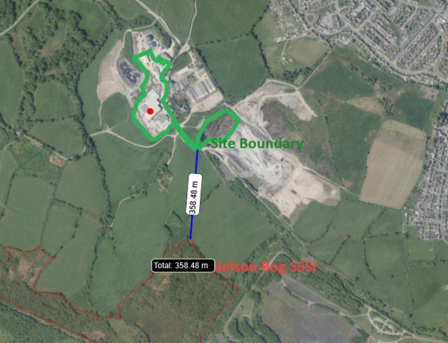
- Description of proposal: | The proposal is for a variation to the Material Recycling Facility and Open Windrow Composting Facility at Bryn Recyling Limited Gelliargellt Farm.  The proposed changes area to increase of the area of the site. The four new areas to be included in the permit are:  Area A – The operator wishes to include this area into their permit boundary. This area includes two dry floors (mainly used for drying animal bedding for the farm) however they wish this to be permit as a back-up drying floor for wood wastes.  Area B - The operator has proposed that to include an open fronted building and an area of concrete impermeable surface that is currently used by the MRF to store dried woodchip.  Area C - The proposal the operator has made for this area is to include an area of previously undeveloped land that is necessary for the infrastructure upgrades required by the Fire Prevention and Mitigation Plan.  Area D – The operators proposal here is to extend the area used for open windrow composting in the south-easterly direction tan to the south west to capture the Surface Water Lagoon.  The proposal also requests that a number of additional waste codes are added to the list of permitted waste codes allowed to be accepted at the MRF facility and the Open Windrow Composting facility.  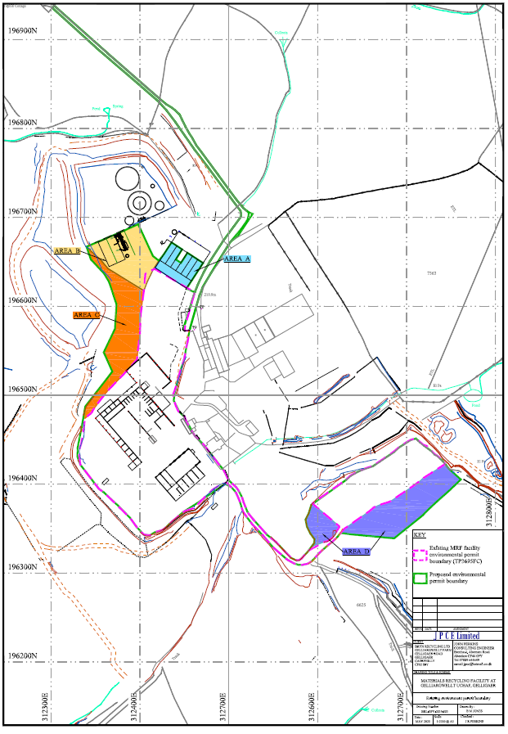
- Is the proposed activity within (wholly or partially) the SSSI boundary? | No, the site is located around 363m NW of the SSSI.
- Has there been any pre-application discussion or correspondence with NRW conservation/ecology | No.
- What aspect(s) of the proposed permission may damage the features which are of special interest for the SSSI?
The following ‘Operations Requiring Consent’ (or other activities associated with the permission) that may cause damage) are relevant to the proposed permission.

7 Dumping, spreading or discharging of any waste materials.

The following SSSI features and mechanisms of impact have been considered to assess the likelihood of damage:

Terrestrial flora (eg. mire communities, oak/sissle woodland, mesotrophic grassland, fen communities), affected by deposit of airborne particulate matter released from the activity and potentially contaminated surface water discharges.
- Decision
The proposed permission is not likely to damage any of the flora, fauna or geological or physiological features which are of special interest.

The proposed permission is not likely to damage the SSSI features via contamination surface waters as there are no discharges from potentially contaminated waste storage, waste treatment, fuel and vehicle storage areas of the site which is directed to underground storage tanks. There are two discharges to surface water but via interceptors and soakaways. The interceptors discharge to individual soakaways. The soakaways are both situated in land that is at a higher ground elevation than the nearest watercourses and are above the groundwater table. The ground surface of all areas where waste is stored on the site is impermeable reinforced concrete. All composting leachate from the proposed boundary extension to the composting area will be directed to the suitably contained leachate lagoon which is then utilised within other processes on the wider Bryn Recycling Limited site.

The proposed variation to the emission is not likely to increase the risk of damage to the SSSI features via deposit of airborne particulate matter as there is no changes proposed to these activities as a result of this variation.

Natural Resources Wales is minded to:
Issue the permission

- Name and job title of Natural Resources Wales officer: | Matthew Fryer  Permitting Officer
- Date form sent to NRW conservation/ecology | NA
For Natural Resources Wales use only, once NRW conservation/ecology response received
- NRW conservation/ecology comment on assessment: | NA
- Name and job title of NRW conservation/ecology officer:
- Date of receipt of NRW conservation/ecology response: | NA

