Permit
The Environmental Permitting (England & Wales) Regulations 2016
Mr Scott Walton

Scott Walton Contracting
New Barn
St Athan
Barry
Llanmaes
CF62 4AJ

Permit number

EPR/CB3190ZE

Permit
The Environmental Permitting (England and Wales) Regulations 2016
Permit number

EPR/CB3190ZE

The Natural Resources Body for Wales (“Natural Resources Wales”) authorises, under regulation 13 of the Environmental Permitting (England and Wales) Regulations 2016

Mr Scott Walton (“the operator”),

of

43 The Woodlands

Brackla

Bridgend

CF31 2JF

to operate waste operations at

Scott Walton Contracting

New Barn

St Athan

Barry

Llanmaes

CF62 4AJ

to the extent authorised by and subject to the conditions of this permit.

Under regulation 27(2) of the Regulations, standard rules SR2009 No6 are conditions of this permit.

Name | Date
Huw Davies | 26/05/2021

Authorised on behalf of Natural Resources Wales

Schedule 1 - Site plan

This is the plan referred to in the standard rules SR2009 No6

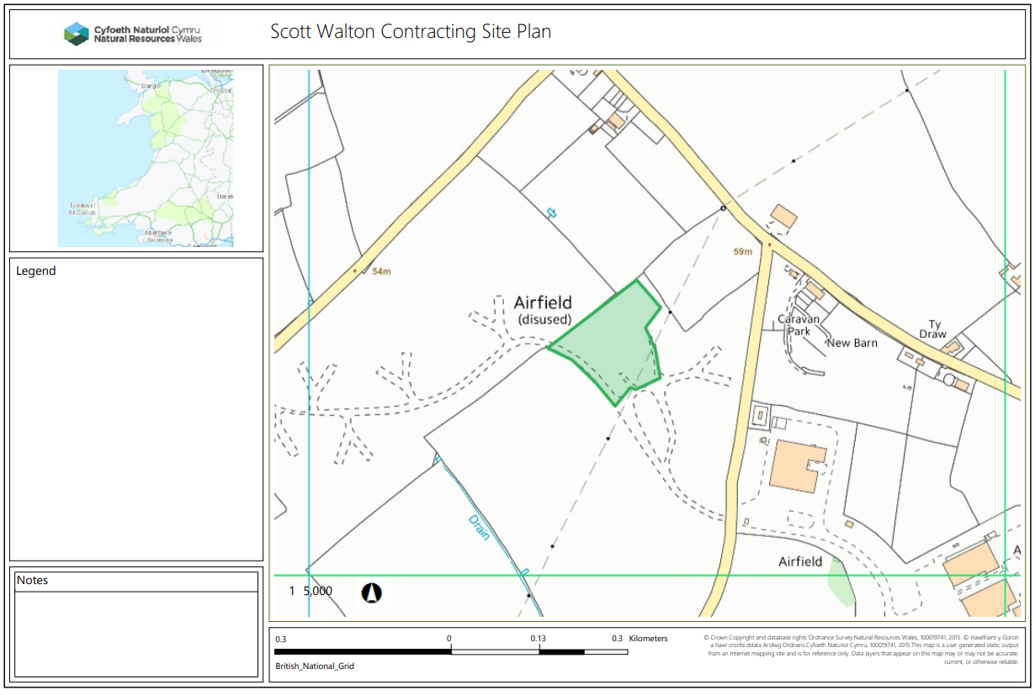

© Crown Copyright and database right 2021. Ordnance Survey licence number 100019741.

END OF PERMIT

