Introduction:
Pontsticill WTW has been identified as requiring a dedicated run to waste system in order to enable the redirection of water flow to prevent non-compliant water with the potential to harm human health progressing through the treatment process, ultimately protecting final water quality. The run to waste incorporates a new diversion post 2nd stage filters, a de-chlorination and sampling facility and discharge via an existing outfall to river. Sodium thiosulphate will be dosed automatically to the de-chlorination chamber to remove chlorine from the discharged water.

The Emergency RTW flow will be 40 Ml/d (462l/s), with an emergency RTW time of 2 hours; however for the purposes of this trial the run to waste duration will be reduced to 15-20 minutes.
Site Layout: 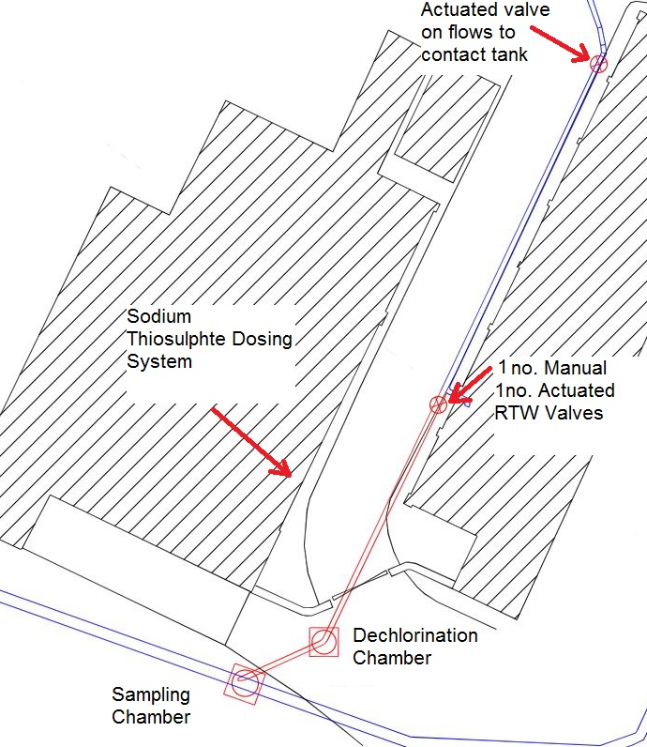

Emergency Run to Waste (ERTW) is only to be used to prevent non-compliant water with the potential to harm human health progressing through the treatment process, ultimately protecting final water quality as defined in POF 008 (Critical parameter board)
Disinfection Turbidity - Treated Water Tank Inlet Turbidity [J] <0.3mg/l
Disinfection Turbidity - Treated Water Tank Inlet Turbidity [J] >0.5ntu

Pre ERTW Checks:
- Inform Duty/Standby manager that plant has ESD for PCV failure.
- Run Sodium Thiosulphate Dosing System. Fill mixing tank with Sodium Thiosulphate before RTW is started.

Steps for Automated RTW:
- Ensure Plant has fully Shutdown.
- Check flow meter operation for proper Run to Waste control.
- Check correct valve operation while returning to normal plant operation.
- Manually open RTW guard valve.
- Open sampling and dosing chambers (barrier off)
- Initiate Emergency Run to Waste and re-start Plant.
- Start-up plant at maximum flow of 40Ml/d.
- Manual Chlorine Sampling of chamber to start immediately and continue through RTW every 15 minutes provided results are satisfactory.
- Continue RTW for as long as is necessary discharging to river to establish compliant water post second stage filters.(up to 2 hours. Escalate to Duty manager if longer is required)
- Check water quality compliance on second stage instrumentation and record reading in the site Log POF 007.
- Initiate reversal of RTW when satisfactory readings are witnessed for 15mins.
- Return the plant to normal/desired flow rates
- Manually close RTW guard valve.
- Reinstate sampling and dosing chambers.
- Confirm with Duty/Standby manager now that the RTW is complete

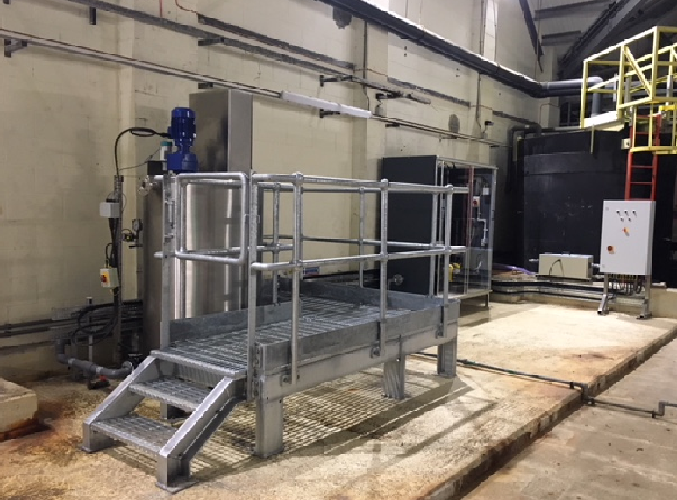
Sodium Thiosulphate Mixing and Dosing System
The trial run to waste will allow for the de-chlorination process to be confirmed and allow for refinement if required. This will be a managed process, via de-chlorination chamber and sample chamber, and Process Science colleagues will be on site to support this activity.
Based on using sodium sulfite De-Chlor tablets for dechlorinating there will be a requirement to add at least 1.775mg of sodium sulfite for every milligram of chlorine. Therefore, based on 40ML/d run to waste flow with a 1.0mg/l chlorine concentration (assuming run to waste will last worst case scenario for 1 hour) 74.55grams of sodium sulfite De-Chlor Tablet will be required.
Based on using sodium thiosulphate for dechlorinating there will be a requirement to add at least 7mg of Thio for every milligram of chlorine. Therefore, based on 40ML/d run to waste flow with a 1.0mg/l chlorine concentration (assuming run to waste will last worst case scenario for 1 hour) 294grams of sodium thiosulphate will be required.
Each De-chlor table is 140grams. 5 tablets will be used in the De-Chlor chamber which should have an excess of sodium sulfite to ensure full dechlorination has been achieved.

Actuated Valve on forward flows to Contact Tank
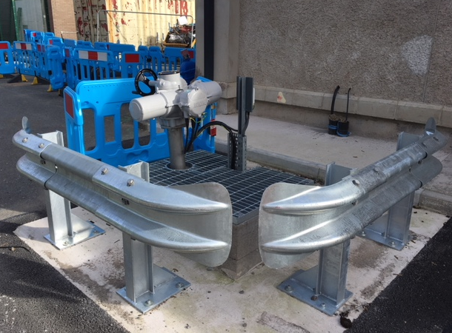

Actuated RTW Valve
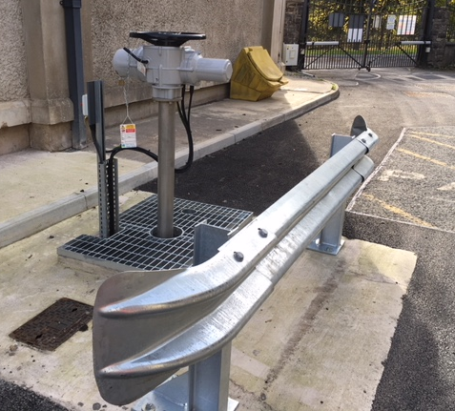

Further Information:

It is the Duty managers’ responsibility to ensure that the OPNOT is sent to NRW via Smarthub to inform of both the start and end of the ERTW activity.
Duration and key quality sample results must be included for:
- Discharge volume and rate of discharge - calculated from the summated flows of the second stage filter outlets
- Discharge start and end times
- Total available chlorine – Samples to be taken from sampling chamber within 15 minutes of start of run to waste and then at least every hour thereafter.
- pH - Use inline monitor readings at point of ERTW
- Turbidity – Use inline monitor readings at point of ERTW and at raw water intake. If turbidity monitor readings of the ERTW discharge is greater than the raw water turbidity monitor readings and are above 8 NTU, then a sample will be taken so that it can be sent for analysis of suspended solids.
- Total aluminium as Al – Use inline monitor readings at point of ERTW
Samples will be analysed at on-site lab / using handheld meters, with the exception of suspended solids where if required a sample will be sent for analysis.

