DRAFT
Pen-y-Gwaith Reservoir Improvements
Design Philosophy Statement

Project no. 123242
Prepared for:
Natural Resources Wales
January 2021


Table of contents

1. Introduction 1
2. Engineering Design 2
2.1 General 2
2.2 Flood design 3
2.3 Geotechnical 7
2.4 Embankment A & B Improvements 7
2.5 Embankment C Culvert 7
2.6 Embankment D Improvements 8
2.7 Embankment D Spillway and Outlet Channel 9
2.8 Embankment D Scour 10
3. Environmental Considerations 10

Details of document preparation and issue:
Version no. | Prepared | Checked | Reviewed | Approved | Issue date | Issue status
P01 | M.Calder | Liam McCarthy | Stephen Cavanagh | Stephen Cavanagh | 27/01/21 | Outline design draft

Project no. 123242 |  | Client’s reference no. N/A
File name: | 123242-BUK-ZZ-00-RP-C-00004

Notice:
This report was prepared by Binnies UK Limited (BUKL) solely for use by Natural Resources Wales. This report is not addressed to and may not be relied upon by any person or entity other than Natural Resources Wales for any purpose without the prior written permission of BUKL. BUKL, its directors, employees and affiliated companies accept no responsibility or liability for reliance upon or use of this report (whether or not permitted) other than by Natural Resources Wales for the purposes for which it was originally commissioned and prepared.
In producing this report, BUKL has relied upon information provided by others. The completeness or accuracy of this information is not guaranteed by BUKL.

Introduction

Binnies UK Ltd (BUKL) has been commissioned to undertake the outline design of a series of improvement works at a reservoir in the Gwydyr Forest known as Pen-y-Gwaith reservoir. The improvement works are required to enable Pen y Gwaith reservoir to pass flows safely and satisfy the remaining Measures in the Interest of Safety (MIOS). Additionally, a permanent drawdown facility is to be added. The capacity for the reservoir, as stated in the Prescribed Form of Record, is 11,366m3 and is located at grid reference SH 774 601.

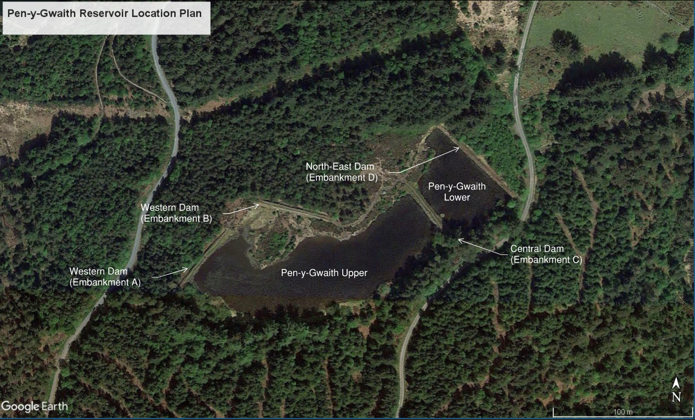
Figure 1 - Location Plan
Pen y Gwaith along with nearby Llyn Bowlen and Pandora formed part of the mining infrastructure at the former Hafna and Pandora lead and zinc mines. Pen y Gwaith comprises two reservoirs, termed Upper and Lower, separated by a Central Dam. The Upper Reservoir is the larger of the two waterbodies and was constructed in the late 19th Century. The North East dam forming the Lower Reservoir was constructed in the 1900s to supply water to High Hafna mine, herein referenced as Embankment D.

In 2016 an inspection under Section 10(2) of the Reservoirs Act 1975 gave eight Measures to be taken in the Interests of Safety (MIOS) at Embankment D including the production of a flood study and flood routing exercise. In 2019, following topographic and bathymetric surveys, the Pen y Gwaith (Upper and Lower) Flood Study concluded that the reservoir does not meet the recommended safety standards for a Category B Dam. Stillwater levels are expected to exceed the crest of Embankment D dam during both the design flood and the safety check flood, and improvements are required in order for the dam to safely pass the floods.

The reservoir is located within the Gwydyr Forest and Snowdonia National Park and is within a Site of Special Scientific Interest (SSSI) and in close proximity to a Special Area of Conservation (SAC), thus the project must deliver a “sympathetic” design, taking account of these designations, to reduce or effectively manage NRW’s liabilities and costs in achieving compliance.

The risks associated with this project include but are not limited to working in environmentally sensitive areas, historic mines and adits, dewatering and temporary works, pollution and contamination, and flood risk.

The reservoir also supplies water to two residential properties downstream. An abstraction point is located on the crest of Embankment D at the northern corner of the site. A filtration system is located within a small timber framed hut located on the western edge of the existing outlet channel, approx. 25m from the existing embankment.

This Design Philosophy Statement describes BUKL’s design approach, assumptions and standards to be used and should be read in conjunction with the following outline design drawings:

Drawing Number | Drawing Title
123242-BUK-ZZ-00-DR-C-00001 | Location Plan
123242-BUK-ZZ-00-DR-C-00010 | Embankment A & B General Arrangement & Long Section
123242-BUK-ZZ-00-DR-C-00020 | Embankment C General Arrangement & Long Section
123242-BUK-ZZ-00-DR-C-00030 | Embankment D General Arrangement & Long Section
123242-BUK-ZZ-00-DR-C-00031 | Embankment D Sections
123242-BUK-ZZ-00-DR-C-00032 | Embankment D Spillway Plan & Sections

Engineering Design

General
Pen-y-Gwaith reservoir is retained by two earthfill embankments along its North-Eastern and Western peripheries. A further embankment separates the upper and lower bodies of water but no longer acts as a retaining structure and its condition is such that the two bodies of water are hydraulically connected. The embankments vary in height between 1-3m above existing ground level and have a total length of approximately 235m.
These embankment lengths, and average heights from the downstream toe to crest level, are summarised as follows:

- Embankment A – approx. 50m long, and approx. 2.46m average height
- Embankment B – approx. 55m long, and approx. 1.34m average height
- Embankment C – approx. 55m long, and approx. 2.40m average height
- Embankment D – approx. 75m long, and approx. 1.10m average height
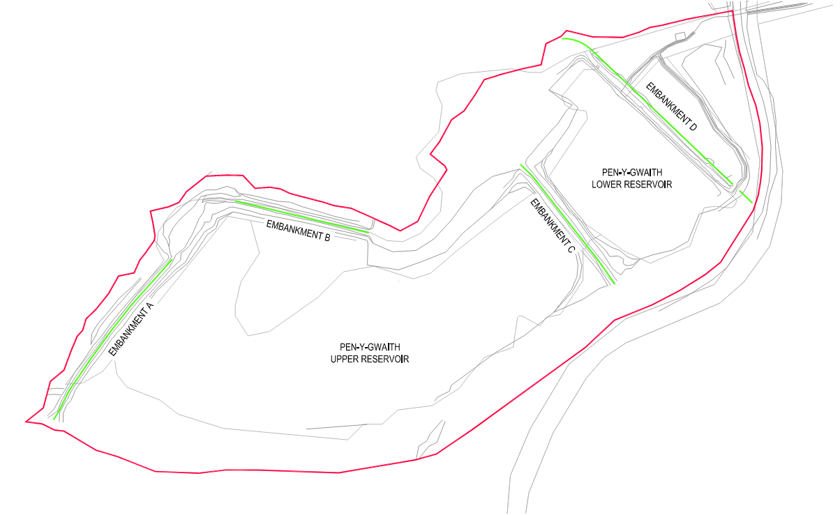
Figure 2 - Pen-y-Gwaith embankments
For Embankment D, it is planned to raise the existing dam by an average of 590mm along its entire length whilst retaining the existing embankment fill where practicable to do so. In order to enable the reservoir to safely pass the design flood, a new 2.5m width spillway will be constructed at the right-hand mitre of the embankment, set back approximately 7.5m from the western edge of the existing forestry road. A new earthen channel is proposed from the base of the spillway, connecting with an existing 450mm diameter culvert beneath the road located some 65m downstream. Currently, there is a crude temporary spillway comprising visqueen sheeting and sand bags located approximately central to the Embankment D. A new permanent scour arrangement is proposed at the site of this breach and temporary spillway.
A new culvert is proposed through Embankment C to provide a permanent hydraulic connection between the Upper and Lower reservoirs. This will ensure that the level of water can be sufficiently lowered in the event of an emergency via the use of the new scour provided at Embankment D
Works are also required to provide a consistent level throughout Embankments A & B to remove undulations in the crest of the embankments. The reservoir is in close proximity to the Hafna Miners’ waymarked walking trail, and the embankment crests are frequently used by members of the general public as an interconnecting footway to link between the Hafna Miners trail, surrounding forestry roads and other waymarked trails throughout the forest.

Flood design
The reservoir is considered Category B, as per guidance in Floods and Reservoir Safety, 4th Ed., ICE 2015, the following standards apply:

- Design Flood – 1:1,000 year
- Safety Check Flood – 1:10,000 year

JBA Consulting undertook a Reservoir Flood Study, and Flood Consequence Analysis (FCA) for Pen-y-Gwaith in May 2020 and August 2020 respectively for Natural Resources Wales (NRW). That work assessed the reservoir inflows, water levels and outflows for a range of design floods. JBA’s study covered both baseline (existing) conditions and potential upgrade options to prevent dam overflowing in extreme floods.

The modelling concluded that current provisions are inadequate and that the dam is not currently protected against overflowing during both the design flood and safety check flood. Pen-y-Gwaith therefore does not meet the standards for a Category B Dam. The FCA identified the peak outflow for the existing spillway, referred to as the baseline condition, for the Design Flood as 0.711m³/s⁻¹.

The Flood Study proposed numerous combinations of dam height and spillway width options ranging from 1.32m to 35m wide, with a corresponding total crest height difference calculated to be 209mm. BUKL reviewed the study, and selected a 2.5m wide spillway as the preferred option as it was felt that this would ensure the delivery of a “sympathetic” design, and would limit adverse effects to the aesthetics of the surrounding forestry.

A summary of the Flood Study results for a 2.5m wide spillway arrangement are shown in Table 1 below.

Table 1 - Flood Study Results
Spillway width (m) | Top of dam (m AOD) | Peak Stillwater level (m AOD)
Spillway width (m) | Top of dam (m AOD) | 1,000-year | 10,000-year
2.5 | 306.353 | 305.753 | 305.832

The results presented in the FCA for lower flood magnitudes did not include a hydrograph for the 2.5m overflow weir width, which was selected as the preferred option. BUKL was commissioned by NRW to undertake a hydrological study of the 2.5m spillway option to derive the results for the 10-year, 30-year, 100-year plus climate change, 1000-year and 1000-year FSR/FEH method floods for comparison against the baseline (existing) condition.
The methodology for the study was:

- Build a simple flood routing model in Flood Modeller (the same software used by JBA).
- Repeat a selection of the option runs previously run by JBA to confirm a consistent approach has been used.
- Run the 2.5m wide weir scenario.
Results are presented below for the 2.5m wide weir option, compared to the baseline case as reported by JBA.
Table 2 - Peak water levels
Scenario | 10-year  (9.3hr storm) | 30-year  (8.5hr storm) | 100-year  plus CC  (6.9hr storm) | 1000-year ReFH2  (5.9hr storm) | 1000-year FSR/FEH  (2.3hr storm)
 | Peak reservoir water level (m AOD)
Baseline | 305.61 | 305.62 | 305.65 | 305.66 | 305.68
2.5m wide weir | 305.63 | 305.66 | 305.73 | 305.76 | 305.75

Table 3 - Peak reservoir outflow
Scenario | 10-year  (9.3hr storm) | 30-year  (8.5hr storm) | 100-year  plus CC  (6.9hr storm) | 1000-year ReFH2  (5.9hr storm) | 1000-year FSR/FEH  (2.3hr storm)
 | Flow m³/s
Baseline | 0.162 | 0.229 | 0.422 | 0.530 | 0.711
2.5m wide weir | 0.132 | 0.182 | 0.328 | 0.402 | 0.377

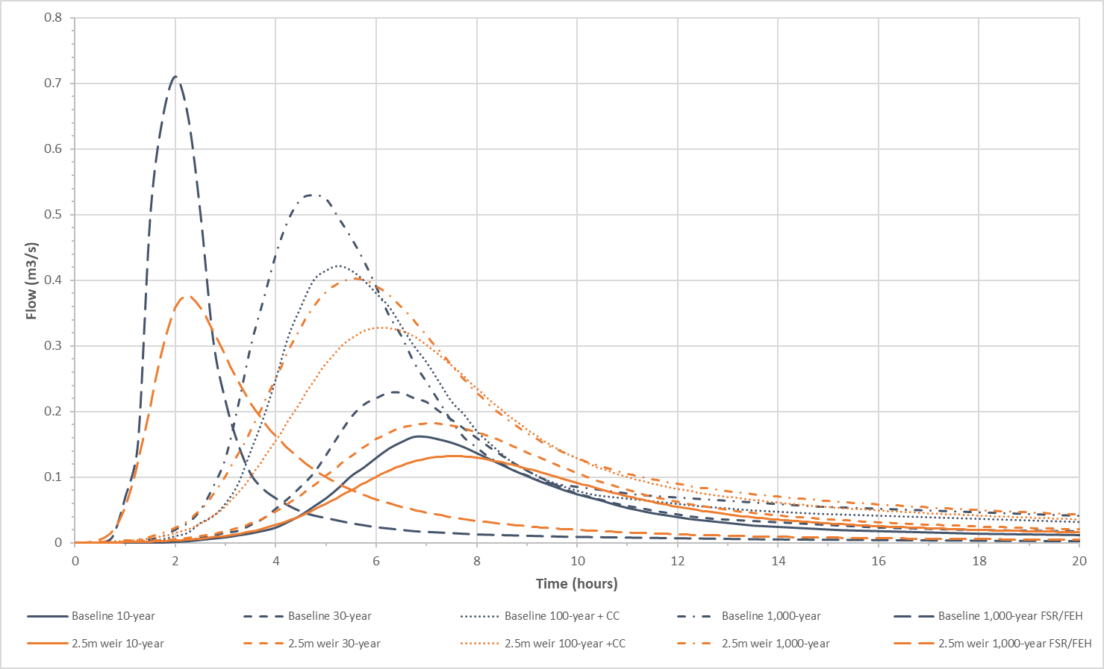
Figure 3 - Outflow hydrographs

Geotechnical
Ground Investigation (GI) works commenced on site in early January 2021. The aim of the GI is to determine the composition of Embankment D, investigate possible sources of embankment fill material, identify underlying ground conditions and determine their engineering properties to assist in progressing the design.

The outline design assumes that the existing embankments and underlying strata are of sufficient capacity to support additional cohesive fill required to raise the embankment. This is subject to further analysis at detailed design stage once Ground Investigation (GI) has been completed.

The ground conditions as observed during the initial site walkover in November 2020 have been summarised within the Geotechnical and Geo-environmental Desk Study (123242-BVL-ZZ-00-RP-GE-00001).

A general summary of this report indicated bedrock geology underlying Pen-y-Gwaith reservoir is defined by the British Geological Survey as Tuff of the Upper Crafnant Volcanic Formation – an Igneous Bedrock formed approximately 452 to 453 million years ago in the Ordovician Period. Approximately 40m north of the site there are siltstones and mudstones of the Cwn Eigiau Formation.

Embankment A & B Improvements
It is proposed to import suitably graded granular material to raise and level the embankment crests. The embankments will be raised by a maximum of 190mm to a level of 306.85mOD. Existing crest levels range between 306.66mOD and 307.12mOD, and thus these embankments are a minimum of 520mm higher than the predicted safety check flood stillwater levels. Therefore, these proposed works bear no detrimental impact to the reservoirs ability to safely pass the design flood. The works are required to reduce slip, trip and fall risks only.
The existing embankment alignment and upstream and downstream slopes are to remain unaffected by the proposed works.
Tree clearance works along this western edge of the reservoir were procured, managed and delivered by NRW in November 2020, and a 5m swathe has been cleared from the toe of the existing dam to enable access along the embankment dam’s length.

Embankment C Culvert

The design includes the provision of a 600mm diameter high density polyethylene twin-wall pipe through Embankment C to make permanent the hydraulic connectivity between the upper and lower bodies of water, and protect against future blockage and surcharge. The culvert is set at an invert level of 304.7mAoD to facilitate drawdown of the upper reservoir via the scour pipe in Embankment D (see section 2.8).

This pipe has been sized sufficiently large to mitigate potential silt blockages. Average recorded levels in the reservoir relative to top water level are mostly in excess of the crown level of the proposed culvert. Therefore, it is anticipated that this culvert connection will remain mostly submerged throughout the year, and the risk of blockages due to debris therefore remains low.

Existing silt levels have largely dictated the location of the culvert connection, and an assessment was made as to the lowest existing silt levels within both the upper and lower bodies of water. The existing silt levels exceed the IL of the culvert by approximately 150mm and some localised disturbance is anticipated during the planned works.

The proposed location of the culvert is approximately 50m west of the existing forestry road. The embankment dam is not suitable for trafficking of large construction plant and machinery due to the narrow crest width, and existing condition which is subject to further analysis upon receipt of the GI factual report. It is anticipated therefore that excavations via a water accessed machine may be the most appropriate solution.

The existing embankment will be reinstated to its original condition upon completion of the culvert installation, and the upstream and downstream slopes are to remain unaffected by the proposed works. The existing masonry walls will require temporary dismantling to enable the installation of this culvert.

Embankment D Improvements

It is proposed to raise the existing embankment by approximately 580mm via the importation of cohesive fill. The material forming the existing embankment will be remain in-situ, subject to an assessment of its suitability following completion of the GI. It is expected that suitable fill material will be imported to site as no locally available sources have been found.

A crest width of 1.5m and downstream slopes of 1(V) to 2(H) are proposed and have been confirmed with NRW. The crest width is sufficient to facilitate access for routine operations and reservoir maintenance. Upstream wave protection to the upstream slope is also proposed from the upstream edge of the crest, to 600mm below TWL. The crest and downstream slope of the embankment are proposed to be covered with a 100mm layer of topsoil.
The suspected original drawdown facility, which is evident by a timber structure at the location of the temporary breach will be investigated and made safe prior to the embankment raising works.

It is noted that the elevation of natural ground at the right abutment is slightly lower than the new proposed crest level. The level of this low spot is approximately 305.9mOD which is 453mm lower than the new crest level, but 68mm higher than the calculated stillwater level for the safety check flood. The upstream ground levels on the approach to the right of the dam are higher than still water level for a length of approximately 5 metres, and therefore waves will break and flow back into the reservoir before reaching the right end of the new dam; for this reason it was decided that it was not necessary to tie the new crest into natural ground of the same level.

At the left abutment, the embankment dam alignment has been extended until existing levels increase to a level greater than the newly proposed crest elevation of 306.353mOD. This has resulted in a approx. 15m extension of the embankment at this western end.

Prior to start of construction, trees will be felled and removed from the area downstream between the dam toe and the forestry road.

Slope stability model

Bedrock is suspected to underly the embankment and therefore instability and the risk of slip surfaces forming is expected to be limited to the embankment itself. Slope stability analysis of the existing the raised embankment will be completed following completion of the GI. A ground model of the embankment will also be prepared following the investigation works. This ground model will then be used in specialist two-dimensional seepage and slope stability analysis packages; Geostudio SEEP/W and SLOPE/W.

The model will be initially built in the SEEP/W environment that assesses groundwater flow in soils, seepage and pore pressures within embankments and their foundations. We will undertake analysis of both steady state and transient conditions to allow stability checks under differing design flood scenarios and rapid drawdown conditions.

This groundwater regime and phreatic surfaces will then passed directly to the corresponding limit equilibrium slope stability model for analysis using Slope/W. Adopting a transient analysis, the models will then be set up to check embankment stability for varying time stages corresponding to changing phreatic surface and pore water pressure within the embankment from initial filling through design flood events and rapid drawdown conditions.

Slope stability calculations will be carried out using minimum factors of safety from ‘An Engineering guide to the safety of embankments dams in the United Kingdom’ BRE 1999. Table 7. Suitable pedestrian and compactions loads will be applied to replicate the anticipated loading during the temporary and permanent states. The results of these calculations will be detailed in the Ground Investigations Interpretative Report.

Embankment D Spillway and Outlet Channel
As described in section 2.2 above, JBA Consulting undertook a Flood Study and FCA for Pen Y Gwaith in May and August 2020 respectively for NRW. That work assessed the reservoir inflows, water levels and outflows for a range of design flood magnitudes. The study covered both baseline (existing) conditions and potential upgrade options to prevent dam overflowing in extreme floods.
JBA tested a large number of different storm durations in their work but their results showed very little sensitivity to storm duration in terms of peak reservoir water level or spillway outflow.
A 2.5m wide weir spillway was selected as the preferred option as this would limit adverse effects to the aesthetics of the surrounding forestry.
A reinforced concrete broad crested weir structure is proposed within the footprint of the existing spillway at the western extent of the existing embankment dam. This will allow for construction to be managed from the existing forestry road.
The weir will be founded on a concrete base slab with vertical side walls, providing an effective weir length of 2.5m. The weir will return the top water level (TWL) of the dam before it was breached. It is anticipated that the blinding for the spillway base will be cast against the existing bedrock subject to confirmation of its depth below existing ground level. This will be analysed and detailed further at detailed design phase following completion of GI.
The slab will provide protection against scour immediately downstream of the weir and will outfall to a new 1m wide trapezoidal earthen channel with 1(V) to 2(H) side slopes to existing ground level. This channel is offset 2.5m from the western edge of the existing forestry road, and follows its general alignment for approx. 65m until it connects to the existing culvert beneath the road.
A small discrete section of the outlet channel is culverted to provide a formal access from the forestry road, and into the general downstream area. This will allow for vehicular access for routine operations and maintenance, and emergency access. A 450mm diameter concrete pipe has been detailed to provide an equal capacity to the existing culvert beneath the forestry road, which is located 25m downstream.

Embankment D Scour
A separate study was completed by Arcadis, on behalf of NRW, to review compliance with the Environment Agency’s Drawdown Guidance SC130001 (2017). The study recommended provision of permanent drawdown facility in compliance with the guidance.
There are two potential arrangements that could be adopted, a sluice gate penstock installed to a level of 304.70mOD, and a bottom outlet through the embankment at a lower level of 304.10mOD.
The sluice gate penstock option was the preferred due to reduced risk of blockage, and reduced risk of disturbance and mobilisation of potentially contaminated silts within the reservoir.
The drawdown facility would be provided through a sluice gate penstock-controlled opening through the embankment. Operation would be from a 1.3m wide level platform that extends from the back face of the upstream headwall unit. Precast headwalls would be provided to the upstream inlet and downstream outlet.
A 300 x 300mm penstock is assumed for outline design. The operating handwheel is to be removable for security against unauthorised operation. A riprap lined channel interfacing with the downstream slab will provide protection against scour and convey flows to the existing naturalised channel that flows south through the downstream area linking with the existing culvert approx. 45m downstream.

Environmental Considerations

As noted in section 1 above, the site is located within an environmentally sensitive area, which is also a popular area and used regularly by members of the visiting public.
The key environmental designations are:
- Snowdonia National Park
- Site of Special Scientific Interest (SSSI)
- Special Areas of Conservation (SAC) – within 80m

Rare and protected species known to be present within 2km of the site include:

- Otter
- Water Vole
- Badgers
- Polecat
- Reptiles
- Schedule 1 birds
- Bats

Habitat identified during ecological surveys also suggests potential to support breeding birds, bats and amphibians within the site and surrounding area.

Planning consent is not required for the main scheme following a Local Planning Authority (LPA) screening of the project undertaken by Snowdonia National Park Authority (SNPA).

Assent for SSSI Mwyngloddiau a Chreigiau Gwydyr and SSSI Pandora Reservoirs will be sought via NRW through the appropriate channels.

The WFD interactive map on the NRW website indicates that the site is within the Conwy tidal limit to Merddwr Water Body in 2016 which had a moderate overall classification, with a moderate ecological classification but a failed chemical classification due to zinc concentrations. A separate WFD assessment of the site is being undertaken by Binnie specialists and their report should be referred to for specific information.
The main environmental impacts will be from the construction phase. During the construction phase, it is anticipated that a separate material laydown areas will be sited within the area located immediately downstream of Embankment D, in addition to a site compound.

