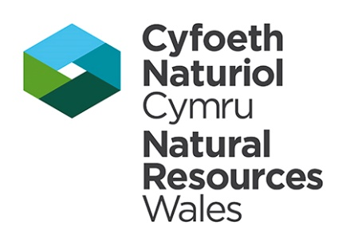

TRANSFER LICENCE TO ABSTRACT WATER

Welsh Ministers are hereby deemed to grant this licence to:-

Natural Resources Wales (‘the Licence Holder”)
Ty Cambria
29 Newport Road
Cardiff
CF24 0TP

This licence authorises the Licence Holder to abstract water from the source of supply described in the Schedule of Conditions to this licence and subject to the provisions of that Schedule. The licence commences from the effective date shown below and shall remain in force until the date of expiry shown below.

Signed:  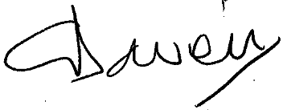  Executive Director of Evidence, Policy and Permitting  Permitting Service  Natural Resources Wales  Cambria House  29 Newport Road  Cardiff  CF24 0TP | Date of issue……TBC
 | Date effective……05.10.2021
 | Date of expiry… 31 March 2028

This licence should be kept safe and its existence disclosed on any sale of the property to which it relates. Please read the ‘important notes’ on the cover to this licence

SCHEDULE OF CONDITIONS

1 SOURCE OF SUPPLY

1.1 | Underground strata comprising of Devil's Bridge Formation at the abandoned Abbey Consols metal mine, near Pontrhydfendigaid, Ceredigion.
2 POINT OF ABSTRACTION

2.1 | At National Grid Reference SN 74366 66180 marked ‘Point A’ on the map.
3 MEANS OF ABSTRACTION

3.1 | A gravity feed pipe of an internal diameter not exceeding 150 millimetres.
4 PURPOSES OF ABSTRACTION

4.1 | Transfer of water to the River Teifi at National Grid Reference 74327 65958 in the course of mine water remediation.
5 PERIOD OF ABSTRACTION
5.1 | All year.

Page 2 of 4
ADDITIONAL INFORMATION
Note: the following information is provided for information only. It does not form part of the licence.
REASONS FOR CONDITIONS
The licence is time-limited to a date to reflect the timing of a future review of the catchment resources availability
IMPORTANT NOTES
Water efficiency note
The Licence Holder should use water abstracted under the terms of this licence in an efficient manner. NRW may refer to its guidance on water efficiency (or equivalent guidance) in determining whether water is being used efficiently and may offer advice on any measures considered necessary to meet particular recommendations.

Page 3 of 4

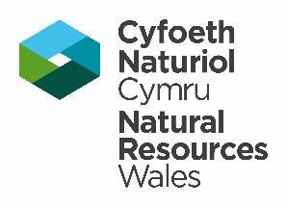
.

MAP ACCOMPANYING LICENCE NUMBER / MAP I GYFEILIO TRWYDDED RHIF
Licence_Number
Scale l Graddfa 1:10,000
© Crown Copyright and database rights Ordnance Survey.Natural Resources Wales, 100019741,2015. © Hawlfraint y Goron a hawl cronfa ddata Arolwg Ordnans.Cyfoeth Naturiol Cymru, 100019741, 2015.

Page 4 of 4


Would you like to find out more about us, or about your environment?

Then call us on
0300 065 3000 (Mon-Fri 9-5)

email
enquiries@naturalresourceswales.gov.uk

or visit our website
www.naturalresourceswales.gov.uk

incident hotline 0300 065 3000 (24hrs)
floodline 0345 988 1188



