Permit Number: | PAN-005818
Applicant name: | Peter Mault
Site Address: | Llwyn Onn, Bryneglwys, Corwen, Denbigshire LL21 9NA
Discharge Point NGR: | SJ 13784 48414
Respond by date: | 25th September 2019 (10 working days)
Permitting Officer: | Katrin Raynor-Evans

Brief Description of proposal:
A new application to dispose of waste diluted sheep dip, three times a year. The applicant wishes to dispose a total of 8.4m3/day of diluted dip to a ratio of 3:1. The dip will be disposed of via a vacuum tanker and spread over a minimum of 1.26 hectares.

Habitats Screening Report – Designations or protected species/habitats:

No designated sites. Lowland heathland borders the disposal site, which is a protected habitat.

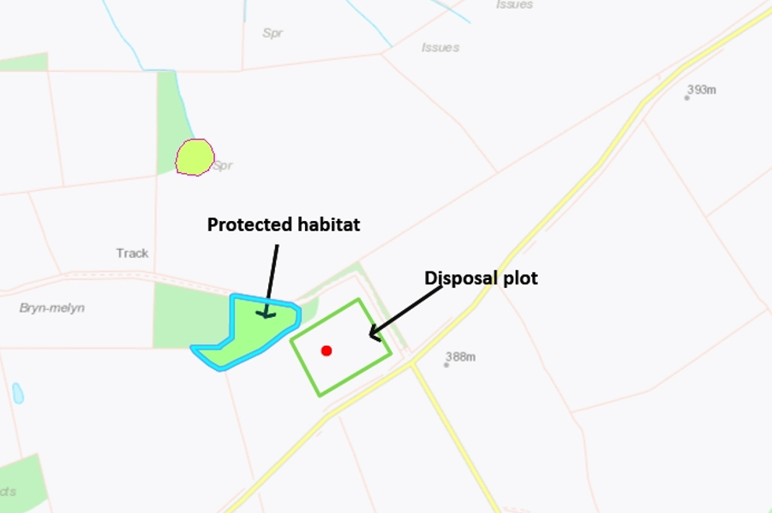

Risk Assessment Results (modelling or L1 Risk Assessment):

The risk assessment has produced a scoring of 59. This may be because a high leaching potential has been identified on site.

Miscellaneous:

N/A

NRM Responses:

Environment Management comments:

Officers name:
Date:

Biodiversity comments:

Officers name:
Date:
Internal Consultation Responses from other NRW Teams:

Geoscience Response:
Assessed level 1 sheet. In general agreement with scoring. Have reduced distance to groundwater receptor to 50m this doesn’t appear to impact score. This was to account for likelihood of the near-by dwellings being on a private water supply from groundwater.

Although soil leachability medium, there is no superficial cover therefore conservative to assume high leachability. The unsaturated zone is likely >5m due to geographical indications.

Overall satisfied that location relatively low risk and L2 assessment not required.
Officers name: Haf Peskett
Date:24.09.19

External Consultations sent to: | Yes/No
National Parks | No
Water Company regarding Drinking Water Protected Zone / SPZ1 | No
Environmental Health | No

Any Permitting Responses:

Date:

