CRoW Appendix 4 (140_10_SD02)  CRoW Act 2000: Natural Resources Wales application for permission - Formal Notice |  | 
Natural Resources Wales Formal Notice.
Requirements of Section 28I of the Wildlife & Countryside Act 1981 as amended by the Countryside and Rights of Way Act (CRoW) 2000.
Duty in relation to granting any consent, licence or permit for activities likely to damage Sites of Special Scientific Interest (SSSI).
Guide to filling in this form for Natural Resources Wales staff:
To be completed by Permitting Officers for any applications for a permission which the Natural Resources Wales has considered under S28G duties to protect and enhance SSSIs. This applies to all proposed permissions within a SSSI, and to operations outside the SSSI boundary which are likely to damage its special features.
Refer to OI 140_10 ‘Applying the Countryside and Rights of Way (CRoW) Act 2000 to applications for permits with potential for impact on Sites of Special Scientific Interest (SSSI)’, including the flowchart in Appendix 2.
Pink italic text – drafting notes, to be deleted before completion/consultation.
Blue text – examples, to be replaced with permission-specific information.
Ensure you have completed all sections.
- Natural Resources Wales area/region/NPS hub: | Wales South Central – Cardiff Environment Team
- Name of SSSI: | Rhymney River Section 33WAF (Geological)  Rumney Quarry 33WVT (Geological)  Severn Estuary 33WGX (Biological/M)  Gwent Levels – Rumney and Peterstone 33WET (Biological)
- Type of permission: | Environmental Permit
- Date for Natural Resources Wales permit determination: | 03/07/2021
- Predicted 28 day date for response from NRW conservation/ecology (under S28 I(4)): | 22/06/2021
- Natural Resources Wales reference no: | PAN-010745
- National grid reference: | NGR: ST 22019 78619  Cardiff Waste Management Resource Centre, Waterside Business Park, Lamby Way, Rumney Cardiff, CF3 2EQ.
- Description of proposal: | This is a new bespoke application for an installation permit – Cardiff Waste Management Resources Centre, hazardous waste transfer station installation and non hazardous waste transfer station waste operation.  The application is for the following Schedule 1 listed activities and waste operations:  - S5.3 Part A(1)(a)(iii) – Disposal or recovery of hazardous waste with a capacity exceeding 10 tonnes per day involving mixing, blending and bulking of hazardous waste (transfer station) up to 7500 tonnes/year.  - S5.3 Part A(1)(a)(iv) – Disposal or recovery of hazardous waste with a capacity exceeding 10 tonnes per day involving re-packaging of hazardous wastes and re-packaging of laboratory smalls (transfer station) up to 7500 tonnes/year.  - S5.6 Part A(1)(a) – Temporary storage of hazardous waste with a total capacity exceeding 50 tonnes, temporary storage of hazardous waste and waste oils  - Waste operation – Non-hazardous waster transfer station, up to 7500 tonnes per year.  Other directly associated activites on site include the treatment (washing, crushing and shredding) and storage of packaged waste, discharge to surface water sewer, fuels and oil storage.  The proposed site will consist of covered storage bays and designated loading/unloading areas, site offices and welfare facilities. Storage operations will be undertaken within designated storage bays whilst transfer operations will be undertaken within the defined loading areas.  There will be process controls in place which are in line with BAT (Waste Treatment) for waste pre-acceptance, waste acceptance, waste storage, waste treatment etc. Standard Operating Procedures (SOP) are in place for the different operations taking place on site.  There are no direct/channelled emissions to air. There is the potential for fugitive dust emissions, noise/vibrations and odour but measures in place to ensure these are minimal.  Foul waters generated at the site welfare facilities will be discharged (under appropriate consent) to foul sewer.
- Is the proposed activity within (wholly or partially) the SSSI boundary? | No  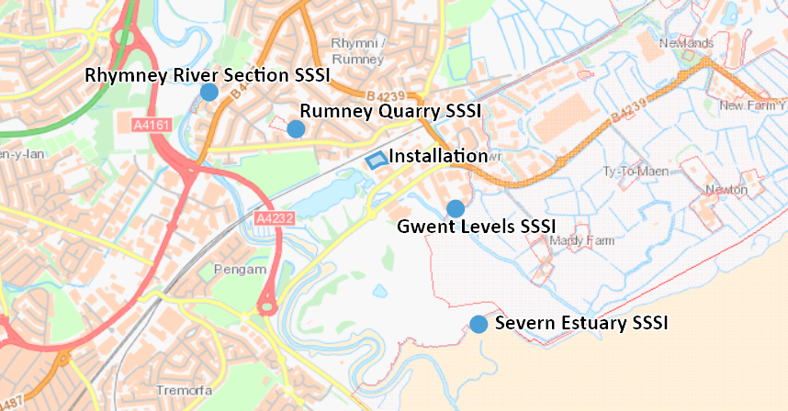  Gwent Levels SSSI – approximately 466m from installation  Rumney Quarry SSSI – approximately 460m from installation  Severn Estuary SSSI – approximately 1km from installation  Rhymney River Section SSSI – over 1km away  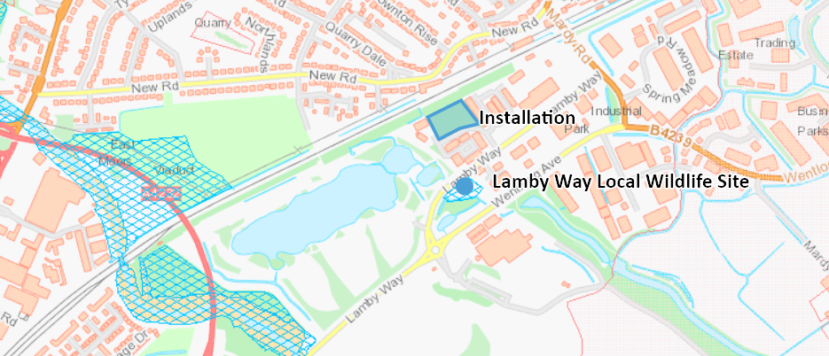  Nearest Local Wildlife Site (LWS) is Lamby Way approximately 100m from the installation. Other non statutory sites (LWS, ancient woodlands, nature reserves) are over 500m away.
- Has there been any pre-application discussion or correspondence with NRW conservation/ecology | No
- What aspect(s) of the proposed permission may damage the features which are of special interest for the SSSI?
The following ‘Operations Requiring Consent’ (or other activities associated with the permission) that may cause damage) are relevant to the proposed permission:

Fugitive dust emissions. Odour and noise/vibrations There are no discharges to surface water or ground as part of this variation. No channelled emission points to air.

The following SSSI features and mechanisms of impact have been considered to assess the likelihood of damage:

SSSI Features
Gwent Levels – Rumney and Peterstone:
- Reen and Ditch Habitat
- Insects and other invertebrates
- Shrill carde bee

Rumney Quarry:
- Geological features

Severn Estuary:
- Intertidal mud and sand
- Rocky shores
- Saltmarsh
- Reeds and swamp
- Eel grass beds
- Assemblages of birds
- Assemblages of fish
- Assemblages of invertebrates
- Flood plain grazing marsh

Rhymney River Section:
- Geological exposures

Mechanisms of Impact: Fugitive dust emissions from vehicle movements on site/particulates from waste storage and treatment processes.
- Decision

Gwent Levels SSSI
The proposed permission is not likely to damage any of the flora, fauna or geological or physiological features which are of special interest.

The application if for a hazardous and non hazardous waste transfer station with no direct emissions to air. The site will consist of internal and external operational areas. External operations will be carried out in two distinct areas. The entirety of the site will be covered by impermeable concrete or tarmac surfacing over which operations will be restricted to the storage of empty gas containers or the unloading/loading of waste. The engineered surfaces within the external operational area will be installed in such a way that they direct collected surface water to a Sustainable Drainage System consisting of Gattic Slot Channels and sealed pipework which directs intercepted water through a series of fuel interceptors from where water is discharged to public surface water sewer at a control rate of flow. In the event of a spill, leak, fire or other incident that could result in contaminants entering the drainage network the risk to the surrounding environment will be limited as prior to discharge collected surface water drainage must pass through a flow control chamber which can be shut-off to prevent unwanted discharges to surface waters. Internal operations undertaken at the proposed site will be contained within three building footprints which will be segregated into individual storage bays. Within these buildings waste will be blended, bulked, re-packaged and stored pending onward transportation. As with the previously discussed external operational areas, the internal operational areas will be located on engineered impermeable surfacing. To prevent leachate, leaks or spills draining outside of these buildings and entering the external drainage network the floors will be constructed with gradients that fall to the rear of the storage bays where leachate, leaks or spills are collected within a linear drainage channel and directed to a designated storage tank. Each storage bay will contain its own linear drainage channel and designated storage tank. Roof waters will be collected by guttering and discharge into the aforementioned surface water drainage system servicing the external operational areas. The proposed Hazardous Waste Transfer Station will operate according to written Standard Operating Procedures and all elements associated with the operation of the Hazardous Waste Transfer Station comply with Best Available Technique requirements specified in UK Sector Guidance Note IPPC S5.06, Guidance for the Recovery and Disposal of Hazardous and Non-Hazardous Waste, December 2004).

Dust emissions from vehicle movements; and Particulates from waste storage and treatment are fugitive emissions. Measures in place to reduce fugitive emissions include the following: 1. All vehicles hauling waste or re-packaged materials will be sheeted/netted or enclosed. 2. Vehicles will be supervised during loading to ensure that they are not overfilled. 3. Regular sweeping of the hard surfaces will ensure that dust release from the site is minimised. 4. Hardstanding installed on trafficked routes to prevent tracking of dusts on vehicles. The main entrance way comprises concrete. 5. Wastes will arrive on site within packaging and/or sealed containers and will leave the site packaged which will severely reduce the potential for dust emissions. 6. Daily routine inspection of the site for aerial emissions will be performed as part of the management procedures. Given the measure in place detailed above there is unlikely to be a significant impact on any of the features of the SSSI’s and any runoff to the reens unlikely.

Severn Estuary SSSI
The proposed permission is not likely to damage any of the flora, fauna or geological or physiological features which are of special interest.

As per the measures in place on site, detailed above there is unlikely to be a significant impact on any of the features of the SSSI’s. The SSSI is also approximately 1km away from the installation with any impact of fugitive emissions unlikely.
Given the 1 km distance and the installation being located in an industrial/commercial area in close proximity to other installations, it is considered that the noise from the installation would not be significant over the current background levels already present in the area. It can be concluded that the noise from the site would not have an impact on the internationally important populations of overwintering birds (which are a designated feature of the Severn Estuary SSSI).

Rhymney River Section SSSI and Rumney Quarry SSSI

The proposed permission is not likely to damage any of the flora, fauna or geological or physiological features which are of special interest.
There will not be any significant impacts on Rumney Quarry SSSI and the Rumney River Section SSSI which are designated for their geological features.

Other non-staturory sites

Other non statutory sites (LWS, ancient woodlands, nature reserves) are within screening distance. Nearest Local Wildlife site is approximately 100m away, Lamby Way SINC. Given the measures in place as detailed above, there is not likely to be a significant impact on these non statutory sites. No direct emissions to air (fugitive emissions only) and drainage from site is via interceptors and controlled before discharge to public sewer. Any pontential contaminated runoff in storage bay/treatment areas and in impermeable surfaced areas with sealed drainage systems with run=off tankered away.

Therefore, the proposed activity is not likely to have a significant impact.
Natural Resources Wales is minded to:
Issue the permission

- Name and job title of Natural Resources Wales officer: | William Wallace  Permitting Officer
- Date form sent to NRW conservation/ecology | 25/05/2021
For Natural Resources Wales use only, once NRW conservation/ecology response received
- NRW conservation/ecology comment on assessment: | Please delete as appropriate:  i) NRW conservation/ecology advise the operation can go ahead  ii) NRW conservation/ecology advise the operation can go ahead with conditions  iii) NRW conservation/ecology advise against permitting the operation  Please ensure that the NRW conservation/ecology response is attached to this Formal Notice.
- Name and job title of NRW conservation/ecology officer:
- Date of receipt of NRW conservation/ecology response:

