Supporting Documents for Walterston Farm
Ground Water Transitional Licence Application

Business Trading Name – WH Dixon & Sons

Business Address – Walterston Farm, Hayscastle, Haverfordwest, Pembrokeshire, SA62 5HT

Category - Technical Supporting Information

Date – 19 November 2019

Content:
Introduction
Groundwater Exempt Area Wales Map

Document 1 Letter of Authorisation

Document 2 Walterston Farm - Entitlement to land owned by WH Dixon & Sons

Document 3 Farm - Location Map

Document 4 Walterston Farm - Groundwater Borehole and Pressure Vessel Location

Document5 - Photographic Evidence Borehole/ Pressure Vessel

Document 6 - Groundwater Distribution Plan

Document 7 - Groundwater Pump Specification

Document 8 - Livestock numbers and water volume used 2011-2017

Information
Brief history of farm eg type livestock only or mixed with arable crops
Walterston Farm is modern dairy unit located on the outskirts of Hayscastle Pembrokeshire. The principal contacts are Mr Henry Dixon, Mrs Margaret Dixon, David and Robert Dixon Sons. The family moved to Walterston farm from Yorkshire in 1986.
Walterston farm is a mixed farm unit and consists of owned land. The farmed land area covers 190hectares (469acres).
The land bank is down to grass leys, silage cropping and fodder beet grown with concentrates fed to the cows to supplement the feed ration. The dairy herd is on a pasture system during the summer months. Under this type of system milk production is predominately from grass with Friesian cows producing an annual average 6000- 9000lts per cow and would be classed as a high performing herd.
Average stocking at the farms amounts to 200 dairy cattle, the cows are kept on cubicles/straw-based systems. The younger
stock between 3-13months 160animals and 13-24moths 150animals are kept at Walterston Farm. Heifers generally calve at 24months when they
joining the milking herd. On average cow numbers are held at 200LSU with barren cows being replaced by 20 first time calvers.

The farm also runs a beef unit with calves from a day old to finished animals at 18 to 24months reared through the farm system.

Water Supply

The farm groundwater source supplies drinking and wash water for the dairy herd via drinking troughs, plate cooler and milking parlour.
The water transfers through the farm mains and is regulated via a pressure vessel cut off switch system and float valves from the drinking troughs and milking parlour wash, animal drinking pattern and milking times are on a need’s basis.
The water that is used for the parlour system wash and bulk tank cleaning is sourced via the public mains supply from DWR Cymru Welsh Water.

The farm lies within a groundwater abstraction exempt area Wales.

A growing number of livestock farmers are seeking to source water from alternative sources such as boreholes, springs, rivers, lakes or rainwater harvesting as costs of mains water increases.
Stock farm water is one of the most important natural resources, whether considering direct water consumption being stock drinking, washing and cleaning. Approximately a third to a half of all potable water abstractions are used for drinking with the remaining being used for cleaning parlours, yards and milk cooling.
From the 1 April 2005, an amendment was made to the Water Act 2003 that deregulated abstractions of less than 20m³/day the law now permits you to abstract up to a maximum of 20m³/day (equal to 20,000 litres per day) without the need for a licence. This is subject to conditions:
(1) You have a legal right to the source of supply if it is on your land.
(2) The abstraction is not part of a series of abstractions from the same source totalling a quantity greater than 20m³/day.
Natural Resources Wales have introduced an application window where a transitional licence application is required to be submitted during this period 1 January 2018 until 31 December 2019. Following this, there is up to a 3-year determination period. The application fee is currently £135. Transitional licence applications are required to be submitted during the application window 1 January 2018 until 31 December 2019 if you abstract more than the exempt limit.

After the 31 December 2019 if more than 20m³/day a full licence application will have to be submitted to continue using the groundwater abstraction.

If a farm has several boreholes which one of them may be a domestic supply which all abstract from the same source of supply, i.e. the same groundwater source that in total abstract more than 20m³/day will require a licence.

Areas within Wales that are outside the Groundwater exempt area should all have an abstraction licence if they abstracted more than the exempt limit.

Map showing Exempt Groundwater Area Wales
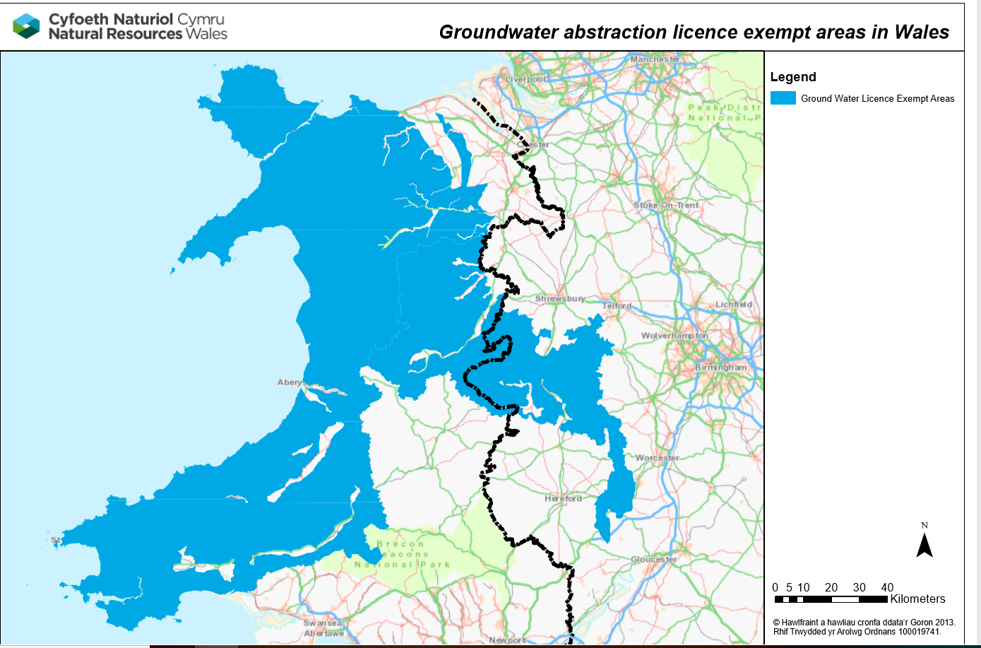

Doc1 Letter of Authorisation

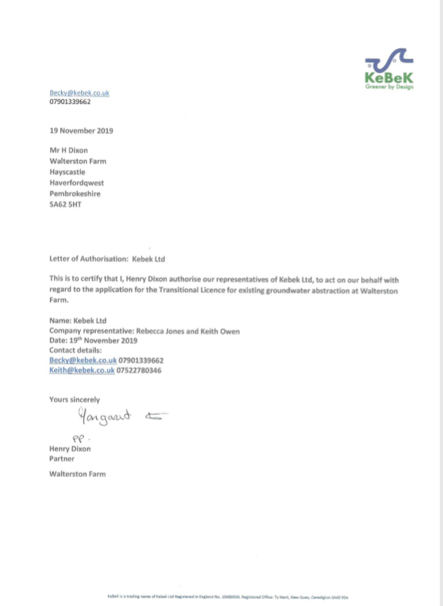

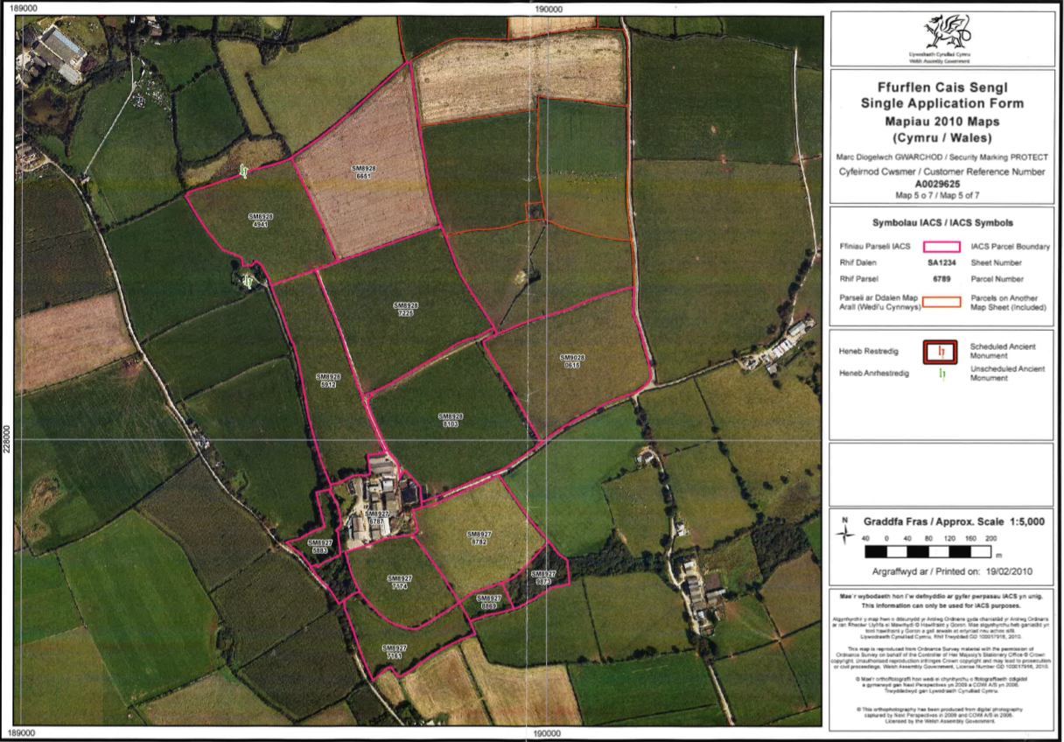
Doc 2 – Entitlement to Land SFP Maps
Land within redline is in the ownership of WH Dixon & Sons
Walterston Farm SA62 5HT

Groundwater abstraction point marked in red circle

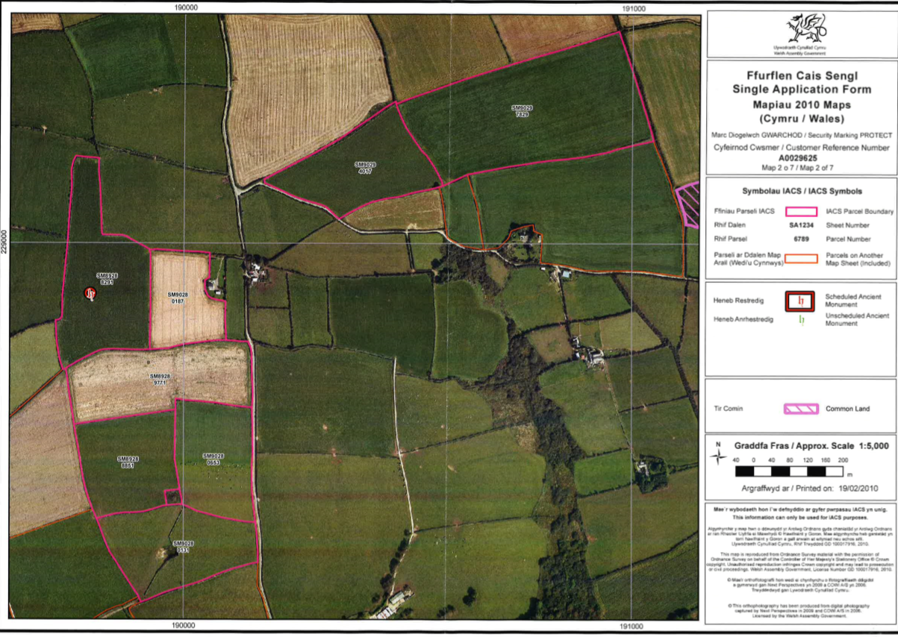
Land within redline is in the ownership of WH Dixon & Sons
Walterston Farm SA62 5HT

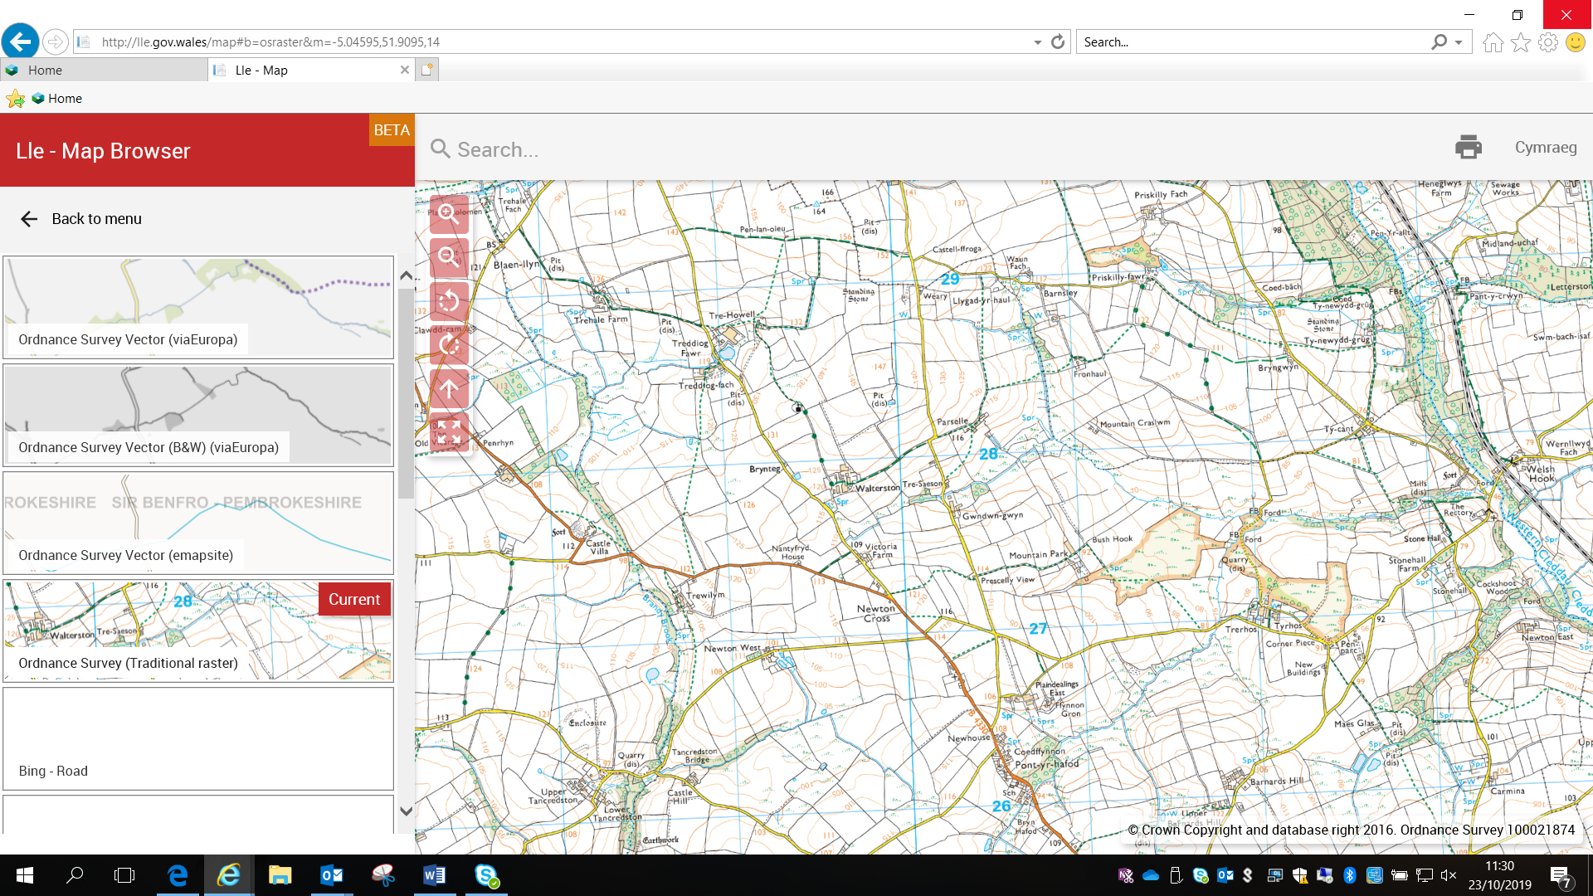
Doc3 Farm Location Map

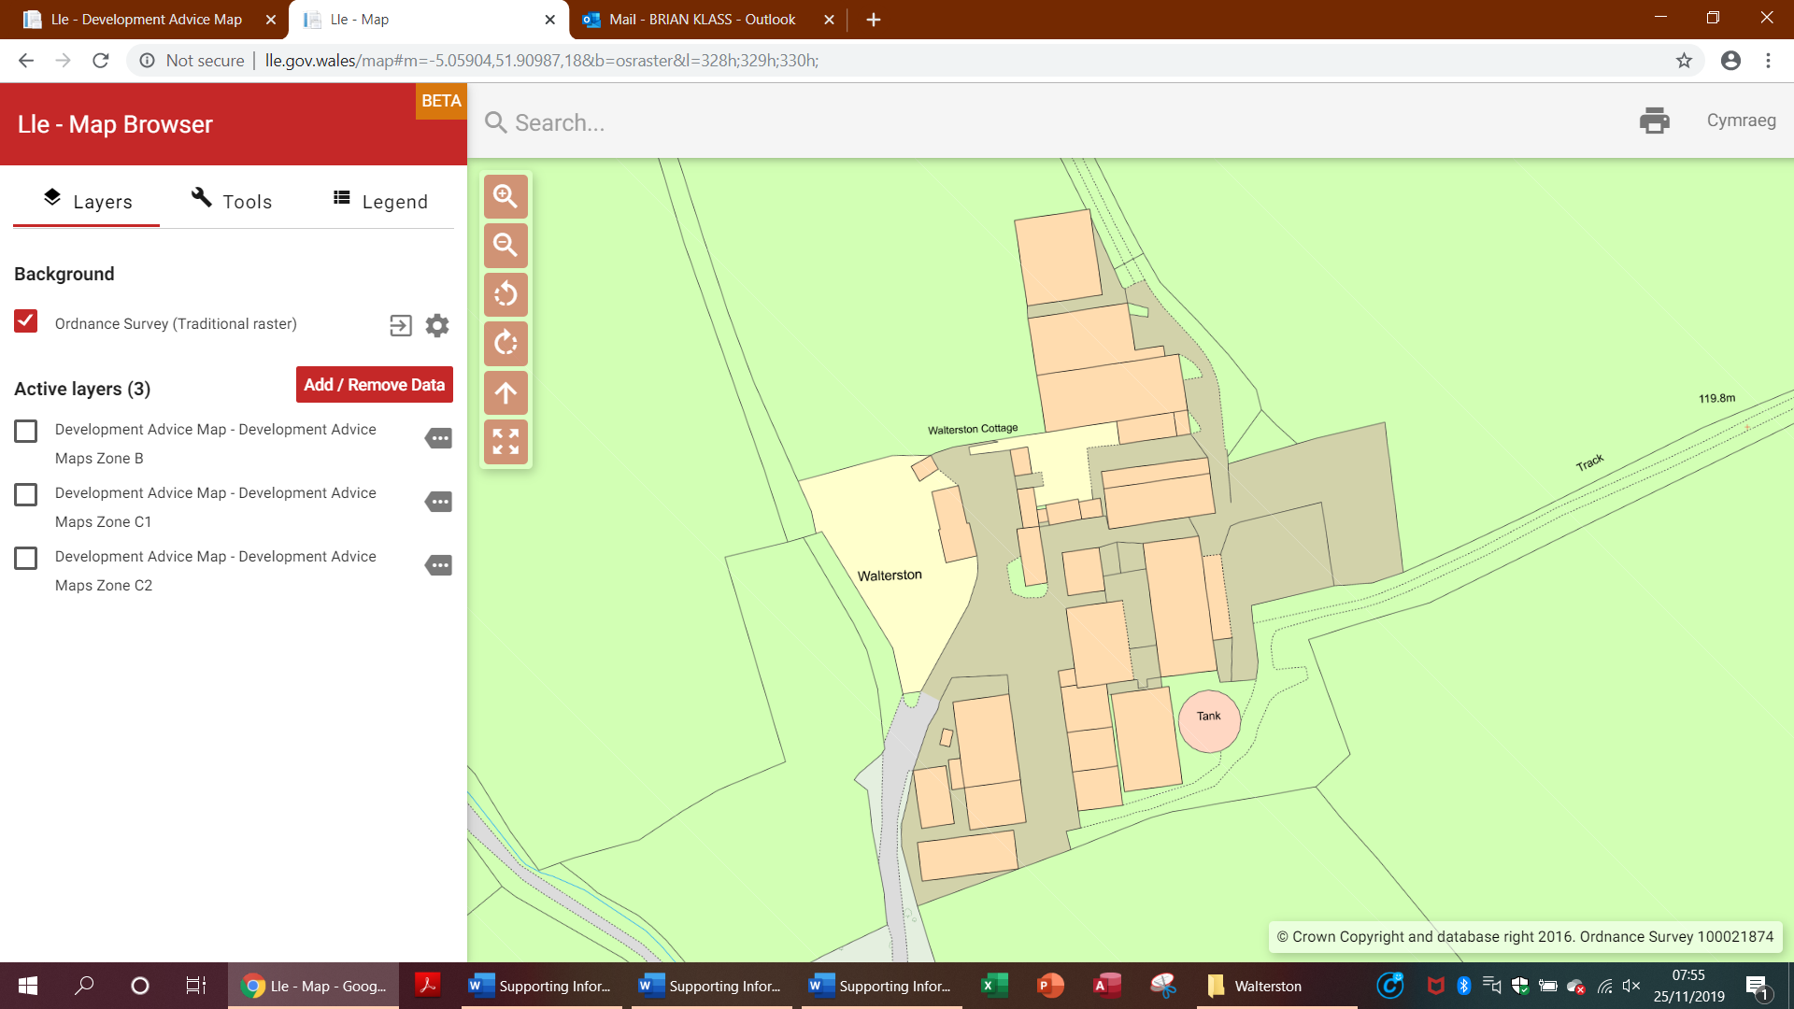
Document 4 Walterston Farm: Groundwater Borehole and Pressure Vessel location
Borehole Location NGR SM 89643- 28012
Pressure Vessel Location NGR SM 89659 - 27966

Doc5 Photographic Evidence Borehole Chamber/ Pressure Vessel
GW Abstraction point Walterston Farm
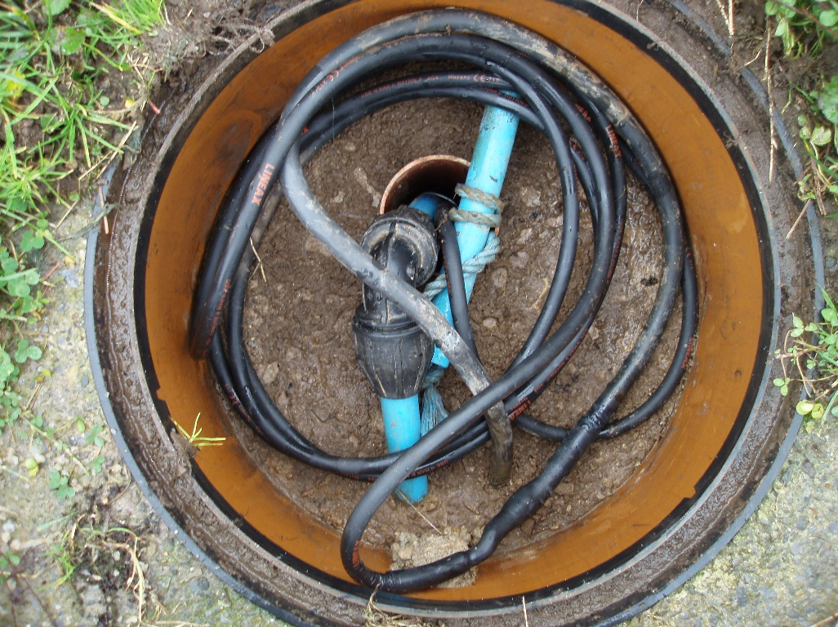
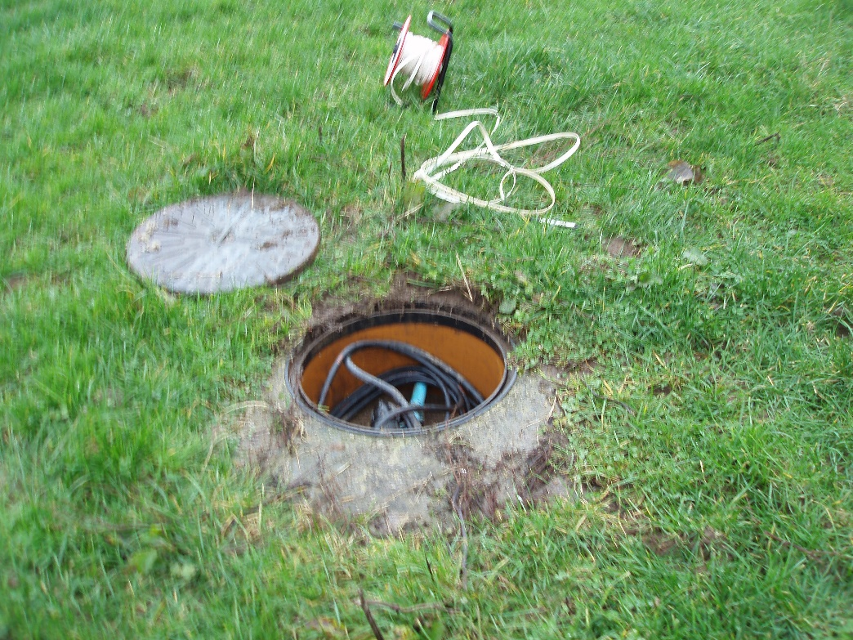

Doc5 Photographic Evidence Borehole Pump
GW Abstraction Pump Details Walterston Farm
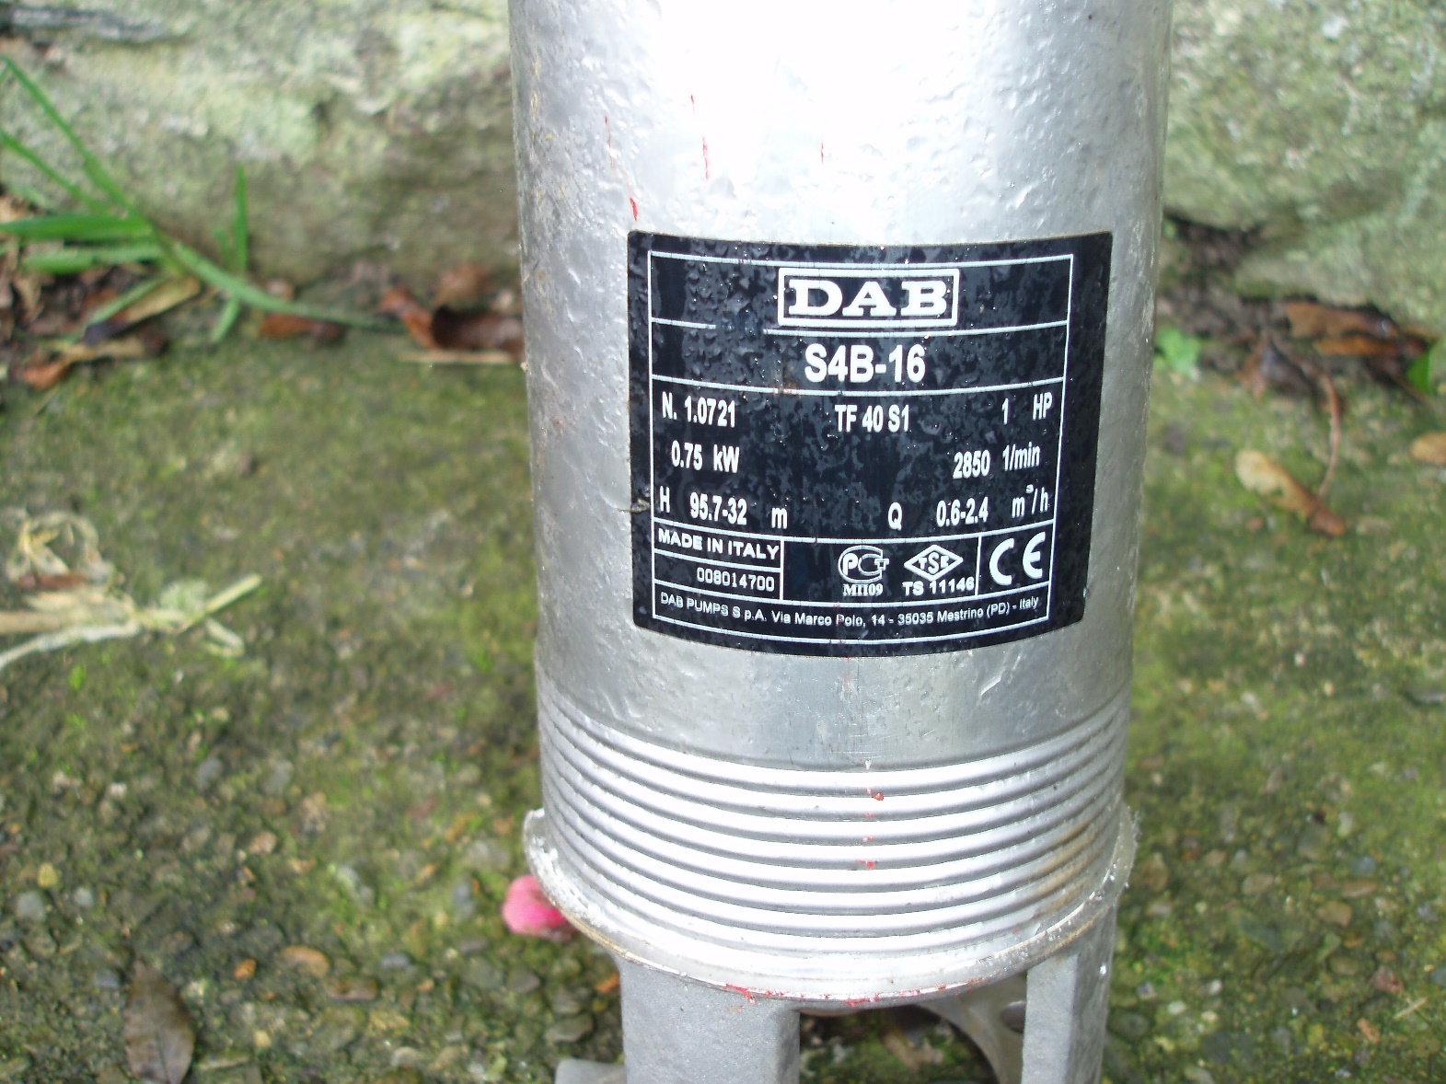

Doc5 Photographic Evidence
GW Pressure Vessel Tank Walterston Farm
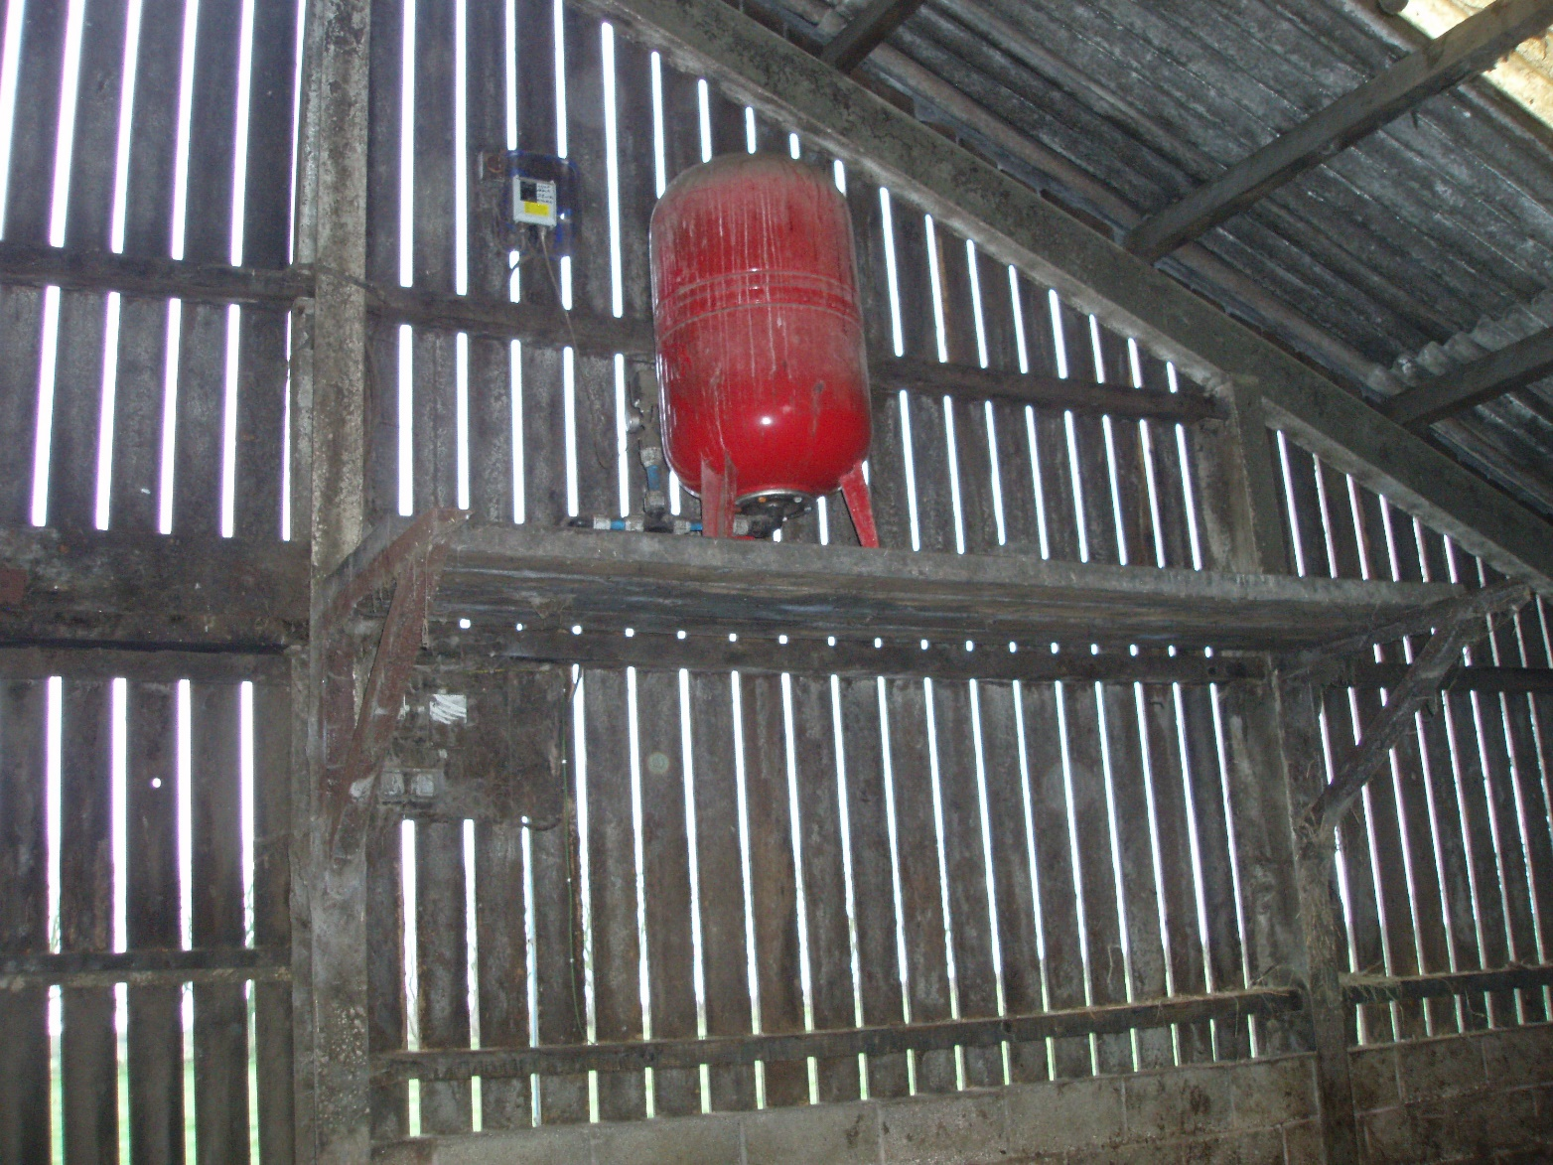

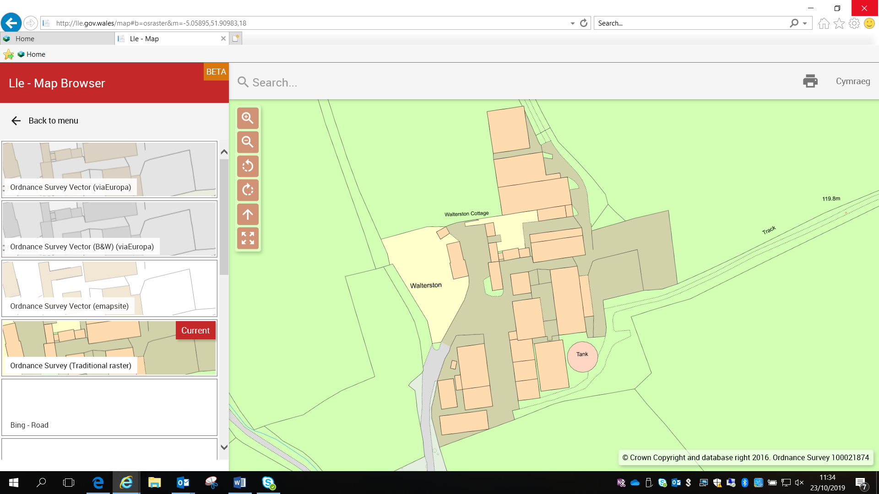
Document6 Walterston Farm: Borehole Distribution Plan
Key:
Groundwater Supply

Welsh Water Supply

Doc7 Groundwater Pump Specifications DAB S4B -16

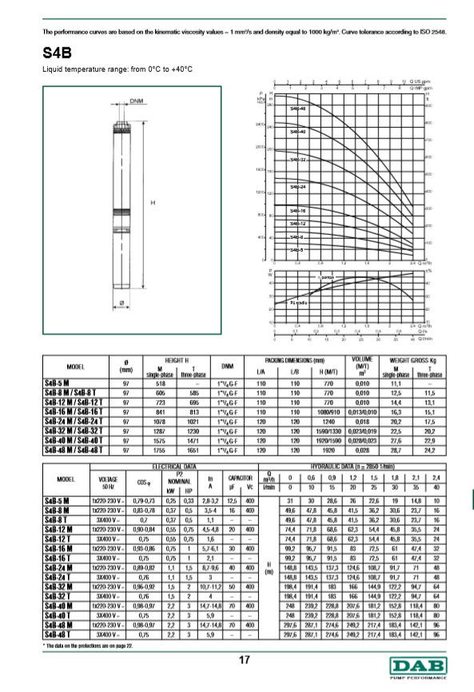

Doc8 Livestock numbers and water volume used 2011-2017

Doc 8 Livestock Numbers from Farm Records extracted from BCMS

Walterston Farm SA62 5HT County Parish Holding Number 55/456/0002

Herd Size by Year

Stock UK Herd No
Livestock | 2011 | 2014 | 2017 | UK745455
Milking Cows
Dairy cows >2 years | 200 | 210 | 212
Dairy Cows 1-2 year | 25 | 20 | 42
Dairy Cows < 1 Year | 25 | 20 | 45
Female Beef
Calved beef
Female beef >2 year | 48 | 56 | 23
Female beef 1-2 year | 75 | 82 | 90
Female beef <1 year | 48 | 57 | 101
Service Bulls
Service bull > 1 year | 3 | 3 | 3
Service bull < 1 year | 0
Other
Calves to sell | 0 | 0 | 0
Other young Stock
Steer
Steer < 1 year | 75 | 58 | 30
Steer > 1 year | 48 | 82 | 20
Total number of animals = 547 |  | = 588 | = 566

Signed



