Duly Made checklist – waste permit SRP Minor Technical variations

Application details
PAN reference | PAN 014745
EPR reference | EPR/BB3793ND/V003 [following this application]
Applicant name | AMG Resources Limited
Facility name | Nevills Dock, Llanelli, Carmarthenshire, SA15 2HD
Area | South West
Operations Team | SW Waste Regulation Team
Site officer/team leader

Relevant dates
Date application arrived in NRW  The duly made date is either  (i) the date the application was originally received at Natural Resources Wales in the event of no additional information being requested during the duly make process.  OR (ii) the date at which the final piece of additional information requested during the duly make process is received. | 19/07/2021
Date application acknowledged | 19/07/2021
Date not duly made (information request sent) | -
Date of any additional not duly made requests | -
Date duly made | -
Date returned to applicant or deemed withdrawn | 06/09/2021
Date applicant sent duly made confirmation | -
Date sent to external consultees (if applicable) | n/a
Date application publicised on Website | n/a
Date advert placed in newspaper (if applicable) | n/a

Documents and information checklist:
Document/ information | Yes | No | N/A | Comments
EMS Summary |  |  | X
Non-technical summary |  |  | X
Site plan
Fee |  |  |  | Amount: £1,311  Date paid: 20/7/2021  Trans#:2091435  Ref: BS/20072021/33 BR - AMG RESOURCES LTD

Application form Part C0.5 – administrative variation of a standard or bespoke permit
Qu # | Action | Yes | No | N/A | Document Ref. if given
1a | Any pre-application discussions document or case reference provided? |  |  |  | No formal preapplication but discussion with site officer.
 | Pre-application record found in DMS?
1b | Permit number given?
1c | Site name and address given?
2a | ‘Details of administrative change’ Box complete? |  |  |  | Change to permit boundary
3 | Does the change involve increasing the area of a SRP?
 | If Yes, has a revised site plan been provided?  (check where the activity is required to happen i.e. inside a building or not vs what is included in the site boundary to see if permit can be complied with/site boundary is suitable) |  |  |  | Boundary shown in plan shows boundary is two close to SAC, SPA, Ramsar, and SSSI.
4 | Contact details completed?
6 | Does the application contain notification of national security issues? |  |  | X
7 | Declaration  NOTE: there is also a declaration question in Part F1. We can accept the application as duly made as long as one of the two declaration sections have been completed correctly
7a | If not a relevant person; is box ticked to confirm authorisation is given?
7b | If the application a standard facility; is box ticked to confirm SRP criteria is met?
7c | Is the declaration complete?
Has the correct person completed the declaration?
Check against relevant people for a company or LLP.
Registered companies only.
Is it registered and active on Companies House
 | Current Appointments Report saved to DMS?
 | Part C0.5 complete?

Application form Part A – applicant/ operator details
Qu # | Action | Yes | No | N/A
1-5 | Applicant details complete?
6 | Address details complete?
6a | Registered companies only.  Is it registered and active on Companies House?
6a | Current Appointments Report saved to DMS?
7 | Contact details complete?
 | Is the applicant a legal person as per definition of ‘operator’?
 | Part A complete?

Location criteria checks
Answer:
- Yes - if the criteria applies and the site is within the relevant distance,
- No – if the criteria applies but the site is not within relevant distance,
- N/A – if the criteria isn’t relevant to the rule set(s) you’re determining.
Only check those designations relevant to the rule set(s) applied for. Check whether the permit area is within relevant distance to all relevant criteria. Use the MyMap report and carry out all required manual checks too, for things the report doesn’t pick up.
If there are any other criteria relevant to the rule set you’re dealing with that aren’t included in the table below, add them in the blank columns.
SAC | SPA |  | Ramsar |  | SSSI | Protected species | Protected Habitats
Yes | Yes |  | Yes |  | Yes | N/A | N/A
MPA | NNR |  | LNR |  | LWS | Ancient Woodland | World Heritage Site
N/A | N/A |  | N/A |  | N/A | N/A | N/A
National Parks | AONB |  | Heritage Coast |  | SAM | Shellfish or bathing water | BAP Species
N/A | N/A |  | N/A |  | N/A | N/A | N/A
Proximity to Newts/ breeding ground
N/A
Human occupation |  | Flood plain |  | Well used for drinking water |  | Spring used for drinking water | Borehole used for drinking water
N/A |  | N/A |  | No |  | No | No
Water course |  | Groundwater SPZ1 & SPZ2 |  | Well used for domestic/ food production |  | Spring used for domestic/ food production | Borehole used for domestic/ food production
N/A |  | N/A |  | N/A |  | N/A | N/A
In an AQMA
N/A

Application form Part F1 - Initial checks, including payment, confidentiality, national security and declaration

Qu # | Action | Yes | No | N/A
 | Has the correct application form been used?
1 | Table 1 Complete?
1 | Has the correct application type/ fee been identified?
2 | Has the OPRA profile been provided? |  |  | X
2 | Has the OPRA profile been provided on Excel? |  |  | X
3 | Is the payment type shown?
3 | Have the payment details been completed?
3 | Is the payment on MyNRW?
5 | Does the application contain notification of national security issues?  If yes: follow Environmental permitting: dealing with claims for national security
5 | Has the applicant asked for any information to be kept confidential?  If yes: follow Environmental permitting: dealing with commercial and industrial confidentiality
6 | Box been tickets to show correct fee is included?
 | Is the application checklist complete?
7 | Declaration  NOTE: there is also a declaration question in Part C0.5. We can accept the application as duly made as long as one of the two declaration sections have been completed correctly
7a | If not a relevant person; is box ticked to confirm authorisation is given?
7b | If the application a standard facility; is box ticked to confirm SRP criteria is met?
7c | If application includes ecological survey information; is box ticked to confirm it can be used as set out in guidance
7d | Is the declaration complete?
Has the correct person completed the declaration?
Check against relevant people for a company or LLP.
 | Part F1 complete?

Additional Checks - confirming the variation ‘type’
Action | Yes | No | Notes
Qu1  Has the operator indicated it’s a Minor Technical variation? |  |  | Yes: go to Qu2  No: check if this is the correct checklist/application type
Qu2  Is the change applied for, one of those we accept as Minor Technical?  Note: refer to definition of Minor Technical in the Charging scheme.  (See examples in the Scheme for guidance on what sort of changes can be administrative.) |  |  | Yes: go to Qu3  No: return application
Qu 3  Does any of the following apply:  - the site is High Public Interest or the type of activity is contentious (it’s incineration, landfill etc.)?  - the emissions/ techniques involved are complex or novel, or complex modeling is required?  - there are sensitive receiving environments around the site (such as designated sites, species etc.) |  |  | Yes: the variation cannot be accepted as Minor Technical – as it involves extra effort at technical determination.  Return the application  No: we can accept the operator’s variation (change) is minor technical in nature  No further consideration needed.

Decision and actions required
Qu # | Action | Yes | No | N/A | Date | Notes
1 | Are all relevant documents present and do they appear to cover the right information? |  |  |  |  | No: Not duly made
2 | Not duly made letter/email sent for additional information?
3 | Has the requested information been received by the deadline date? |  |  |  |  | No: If required Send a further not duly made letter/email.
4 | Application returned?
5 | Application withdrawn?
6 | Application duly made?
7 | Duly made letter/email sent?
8 | Publicise on web?
9 | Advertise in newspaper? |  |  |  |  | Only for HPI sites
10 | DM checklist Saved to the DMS

Decision and actions required
‘Duly Made’ officers notes: Use this box to record conversations with the applicant/ operator, detailed reasons why the application can/cannot be duly made and any subsequent correspondence or actions.
Matthew Fryer - 03/09/2021

Matthew completed the duly making checks for this permit application. The application will be returned as the permit boundary is within 500m of a SAC, SPA, RAMSAR and SSSI as outlined in map below. Return will be processed on 06/09/2021
Matthew Fryer - 03/09/2021

Matthew Fryer Emailed the Operator to explain that the application would be returned and the application fee refunded. MF made it clear that we would start the refund process on Monday 06/09/2021.

Ben Rees - 03/09/2021

Ben Rees replied with a copy of an email exchange regarding the proposed variation. Although it appeared that NRW outlined the SRP may be suitable in regards to the processes on site (and discussed the possibility of having mulitple locations on permit) it does not outline anything in regards to site location and the location criteria for the SRP. SRP location criteria are fixed the permit application cannot be duly made.
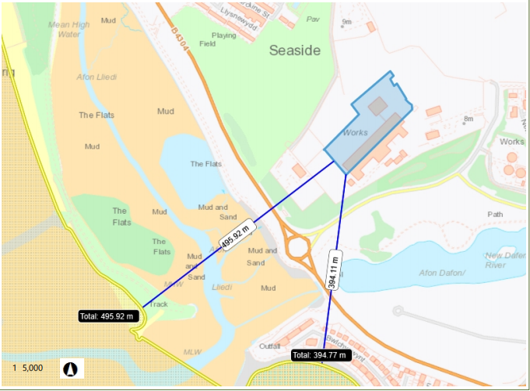

Designated sites:

- Bury Inlet SPA RAMSAR ~496m
- Bury Inlet and Loughor Estuary ~496m
- Carmarthen Bay and Estuaries / Bae Caerfyrddin ac Aberoedd SAC ~395m

Matthew Fryer - 06/09/2021

MF formally returned the application on PALs and began the refund process (Refund request form and Refund log completed). Matthew responded to BR’s email of the 03/09 to confirm that the location criteria are fixed and we could not permit this activity where it is being suggested and therefore the application must be returned.

Matthew Fryer - 07/09/2021

MF received email from Ben Rees requesting we held onto the application fee as they are going to be resubmitting the application with a revised boundary that meets the SRP.

