Permit Number: | PAN-005775
Applicant name: | Mr Robert Hughes
Site Address: | Ty Cerrig, Ty Nant, Corwen, Denbighshire
Discharge Point NGR: | SH 97153 46045 Area 1 and SH 97207 46139
Respond by date: | 9th October 2019 (10 working days)
Permitting Officer: | Katrin Raynor-Evans

Brief Description of proposal:

A new sheep dip application to dispose of 8.4m3/day, three times a year of diluted waste sheep dip spread using a vacuum tanker. The applicant has two disposal sites available which are marked on the map below. There is 1.73 hectares of land available. The applicant needs 1.26 hectares.

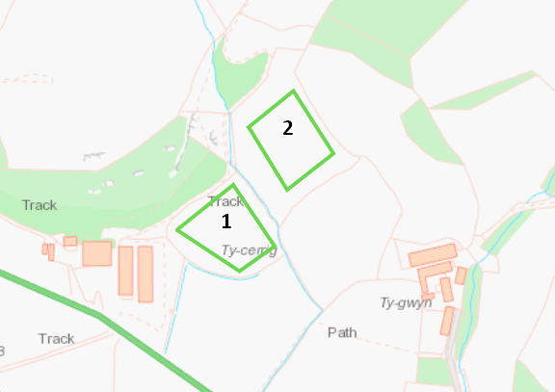

Habitats Screening Report – Designations or protected species/habitats:

No habitat sites picked up in the screening.

Risk Assessment Results (modelling or L1 Risk Assessment):

The Level 1 assessment has given a scoring of 64. This is due to worst case assumed for the unsaturated zone and the proximity to surface water.

Miscellaneous:

NRM Responses:

Environment Management comments:

Officers name:
Date:

Internal Consultation Responses from other NRW Teams:

Geoscience Response:
Response 16/10/2019
It is understood that disposal is proposed on the fields marked A, B and C below
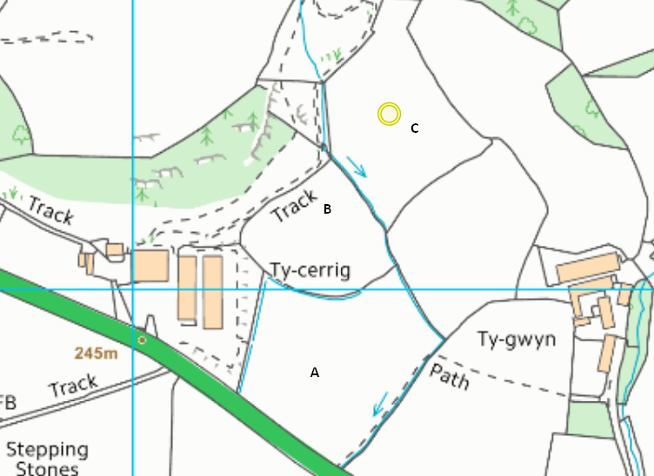

This removes concerns about available area – there is sufficient area for disposal of 8.4 three times a year. Providing disposal meets the standard requirements regarding rotation/standoff distances from streams etc.

Previous comments about not spreading on area which has been under drained remain.

Response 11/10/2019 – would like to re visit once area for each of the 3 disposals is clear as the L1 will need updating.
(a) Spreadsheet:
(b) available area: from correspondence I can see that there has been discussion on available area and rotation. I am not clear where the additional parcel of land is, so I have not checked it against the L1 in terms of risk or if the area is suitable.

What DEFRA say is the disposal should follow basic requirements in that: the land noted on the permit is sufficient so that the spreading of waste sheep dip can be kept to a safe minimum; and the total area is permitted for use not more than once a year; or any individual plots within this wider area are permitted for use no more than once per year. The safe minimum in this context will be determined by the technical assessment of hydraulic and chemical loadings, and compliance with the code of practice limits. Conditions must be used to limit disposals to only once per year on any piece of land. Therefore, I recommend that the permit should specify the individual plots on the Schedule 7 map and in the permit (if they are disposing 3 time a year). This would also aid compliance assessment once the permit is issued.

(c) underdrainage: spreading should not take place on area which is under drained.
(d) borehole: it has been confirmed that borehole is very shallow (1m). Given that it is also up gradient of disposal sites there no further objection on this front.

Response 1/10/2019
Happy to revisit this once the above potential ‘show stoppers’ below are confirmed, particularly as borehole is upgradient and the disposal fields are underlain by Till. I’d be interested to know the Environment Officers opinion.

(a) L1 spreadsheet – needs updating for 3 applications a year, aquifer type is minor (what we used to call secondary) rather than non, also see point D below, I’d suggest the borehole is the nearest groundwater receptor. Making these changes, the score of the L1 is 77.
(b) Permits normally state that the discharge of used/ waste sheep dip to the same individual area of land within the overall disposal site identified in schedule 7 shall not be undertaken more frequently than once per year. A maximum of 5 discharges may be made per year, but the area of land must be rotated within the overall disposal site. Do they have space for the rotation? Particularly if a 10m stand off for the ditch between the fields is applied. Can we check: Is the disposal area being rotated? Is there sufficient area for the rotation?
(c) Permits also state that discharge should not take place where the ground is under drained or has been under drained or mole drained within 12 months prior to any discharge operation, or is cracked down to the drain or any backfill. This I don’t think this sentence is worded very clearly, but to me it reads as if discharge should not take place where there is underdrainage – it looks like there in underdrainage on the top field. Can we confirm whether disposal will take place on the area which is undertrained?
(d) It looks like the well on the map is located 202m from the northern extent of the disposal field. Do we know what the purpose of the well is? Does it need the 50m standoff, or the 500m if intended for potable supply. Do we know how deep the borehole is, or how much is abstracted?

Officers name: Claire Sanderson
Date: 1/10/2019

External Consultations sent to: | Yes/No
National Parks | No
Water Company regarding Drinking Water Protected Zone / SPZ1 | No
Environmental Heath | No

Any Permitting Responses:

Date:

