APPLICATION FOR A MARINE LICENCE FOR MARINE WORKS – Additional Sheets

Cardiff Coastal Defences Scheme

6(b). Please detail the location of the proposed construction project.

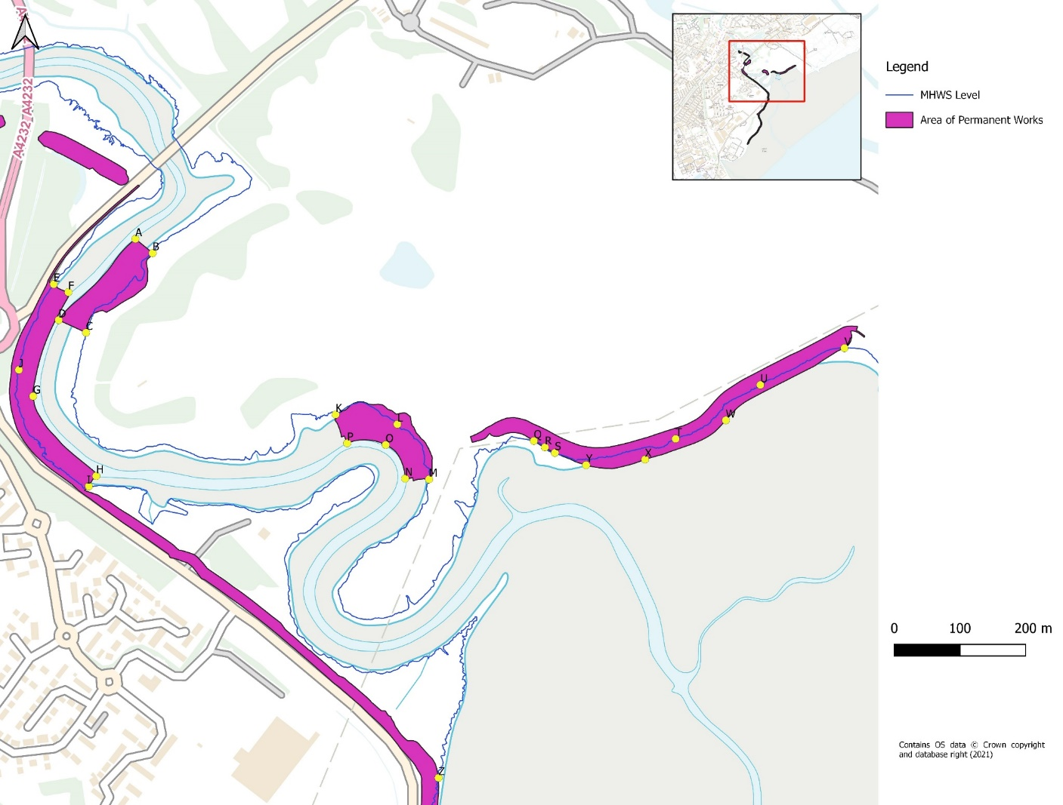
Co-ordinates of permanent works below MHWS

Point | A | B | C | D | E | F | G | H | I
Coordinate | ST2161277910 | ST2163877888 | ST2153777767 | ST2149577786 | ST2148777841 | ST2151077828 | ST2145677670 | ST2155277548 | ST2154177532
J | K | L | M | N | O | P | Q | R
ST2143477710 | ST2191777642 | ST2201177627 | ST2205977543 | ST2202377544 | ST2199377596 | ST2193577598 | ST2221977602 | ST2223677592

S | T | U | V | W | X | Y | Z
ST2225177583 | ST2243577605 | ST2256477687 | ST2269277743 | ST2251177633 | ST2238877573 | ST2229977565 | ST2207477088

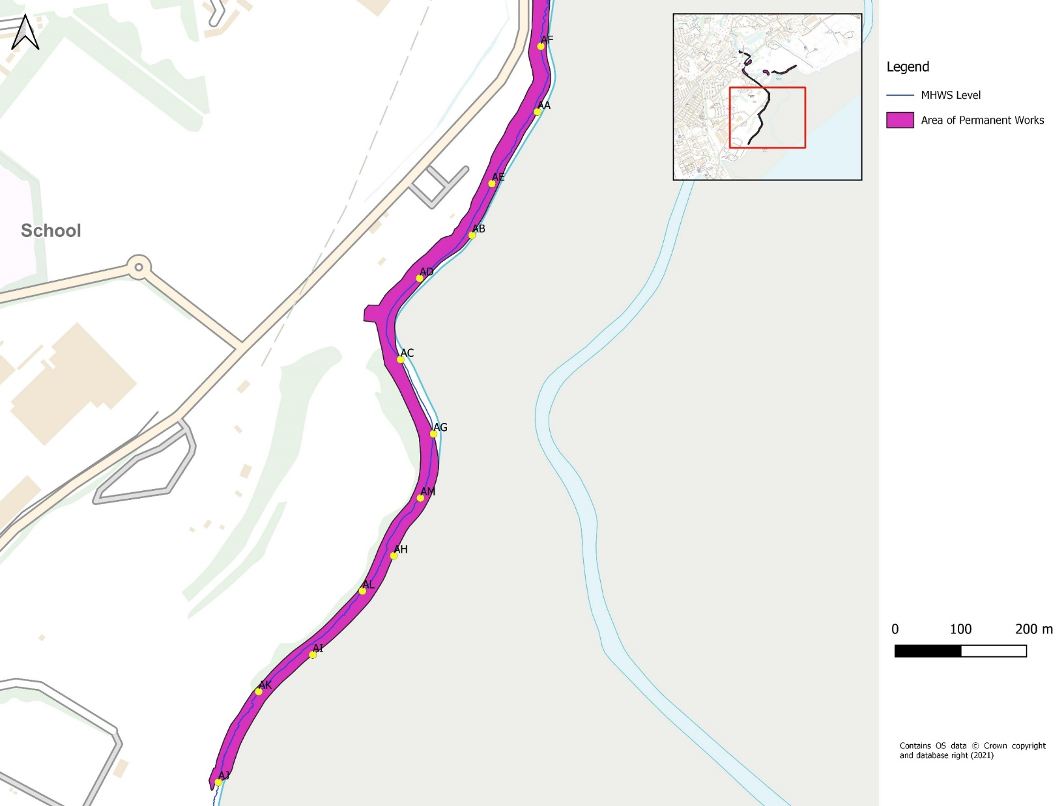

Point | AA | AB | AC | AD | AE | AF | AG | AH
Coordinate | ST2205576904 | ST2195676716 | ST2184776527 | ST2187676651 | ST2198676795 | ST2206077004 | ST2189776414 | ST2183776228
AI | AJ | AK | AL | AM
ST2171376077 | ST2157075883 | ST2163176021 | ST2178976174 | ST2187776316

Co-ordinates of temporary works below MHWS
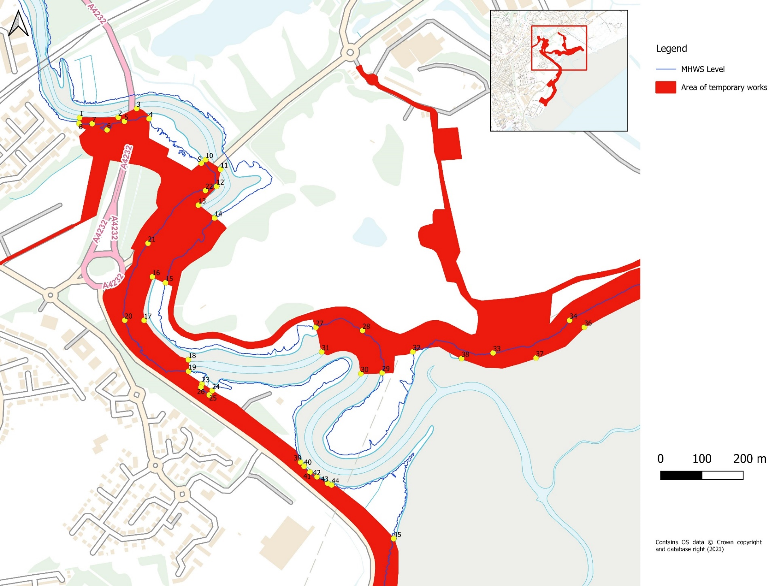

10 | 11 | 12 | 13 | 14 | 15 | 16 | 17 | 18
ST2162878045 | ST2166478022 | ST2165577981 | ST2161177935 | ST2165077904 | ST2153177747 | ST2150077761 | ST2148077656 | ST2158777560

19 | 20 | 21 | 22 | 23 | 24 | 25 | 26 | 27
ST2158777532 | ST2143377656 | ST2148977843 | ST2162877971 | ST2162077502 | ST2164477485 | ST2163777475 | ST2161777493 | ST2189577639

Point | 1 | 2 | 3 | 4 | 5 | 6 | 7 | 8 | 9
Coordinate | ST2132478147 | ST2141778148 | ST2146278169 | ST2149278145 | ST2143278139 | ST2139078118 | ST2135478133 | ST2132278133 | ST2161878037
28 | 29 | 30 | 31 | 32 | 33 | 34 | 35 | 36
ST2200877631 | ST2205577529 | ST2200477526 | ST2190977579 | ST2213077580 | ST2232477577 | ST2250977656 | ST2273077735 | ST2254577639

37 | 38 | 39 | 40 | 41 | 42 | 43 | 44 | 45
ST2242877565 | ST2224877563 | ST2185877312 | ST2186777302 | ST2188177288 | ST2189877276 | ST2192377261 | ST2193377256 | ST2208377126

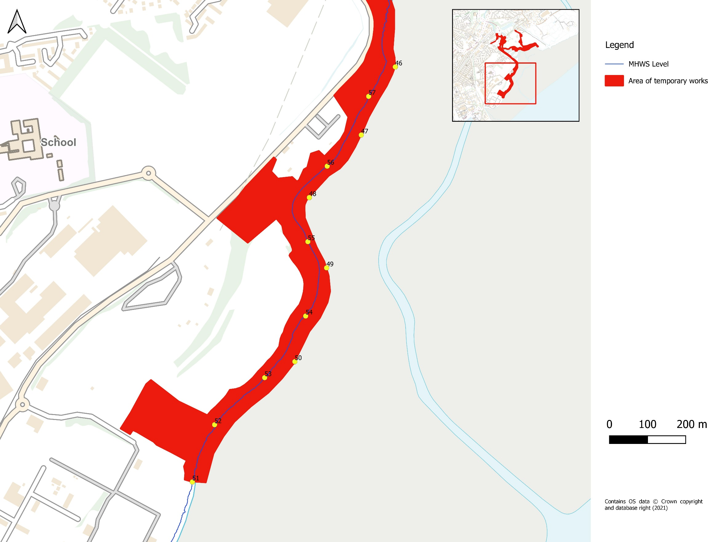

Point | 46 | 47 | 48 | 49 | 50 | 51 | 52 | 53
Coordinate | ST2209676946 | ST2200676768 | ST2187076604 | ST2191576419 | ST2183276173 | ST2156475858 | ST2162276008 | ST2175376131
54 | 55 | 56 | 57
ST2186176293 | ST2186676488 | ST2191776686 | ST2202676869

6(c). The following must be provided with the completed application form:

Cardiff Coastal Defences Area of Permanent Works
Cardiff Coastal Defences Area of Temporary Works

Cardiff Coastal Defences Scheme Footprint Below HAT
Cardiff Coastal Defences Scheme Footprint Below MHWS

Cardiff Coastal Defences Construction Method Statement

CCD-JBAU-00-00-AP-EN-0001-S3-P01-Marine_Licence_Additional_Sheets

Water Framework Directive WFD
Habitats Regulations Assessment HRA
Environmental Statement ES – Split into 2 documents to keep file size below 10MB
- CCD-JBAU-00-00-RP-EN-0002-S3-P04-Environmental_Statement Without Appendices
- CCD-JBAU-00-00-RP-EN-0002-S3-P04-Environmental_Statement Apps E F G H and J
Non-Technical Summary - CCD-JBAU-00-00-RP-EN-0003-S3-P01-Non-Technical Summary
Environmental Statement Appendices – Separate Files
  - Appendix A&B – Scoping Opinions
  - Appendix C – Ecology Phase 1 map – ‘Phase 1 habitats and redline V2’
  - Appendix D – Ecology SINC sites map – ‘Cardiff SINCS’
  - Appendix I&K – GGAT Desk-based Assessment
  - Appendix L – GI Report - CCD-JBAU-ZZ-00-RP-GT-0001-S3-P01-Ground_Investigation_Report
  - Protected sites map – ‘Protected sites red line v2’
  - NVC/Detailed Botanical Survey - CCD-JBAU-XX-XX-TN-EN-0001-S3-P01-Botany_Survey
  - PEA - 2016s5078 Cardiff CRMP OBC - Preliminary Ecological Appraisal v1-2
  - Contaminated Land Report - CCD-JBAU-ZZ-00-RP-GT-0002-S3-P01-Contaminated_Land_Review

Engineering drawings showing details of the proposed scheme
Location 11:
- CCD-JBAU-00-11-DR-C-1100-S3-P01 to CCD-JBAU-00-11-DR-C-1106-S3-P01; Plus
- CCD-JBAU-00-11-DR-C-1150-S3-P01 & CCD-JBAU-00-11-DR-C-1151-S3-P01.

Location 12:
- CCD-JBAU-00-12-DR-C-1200-S3-P02 to CCD-JBAU-00-12-DR-C-1214-S3-P01; Plus
- CCD-JBAU-00-12-DR-C-1250-S3-P01 & CCD-JBAU-00-12-DR-C-1251-S3-P01.

Location 21:
- CCD-JBAU-00-21-DR-C-2100-S3-P01 & CCD-JBAU-00-21-DR-C-2101-S3-P01; Plus
- CCD-JBAU-00-21-DR-C-2150-S3-P01 & CCD-JBAU-00-21-DR-C-2151-S3-P01.

Location 22:
- CCD-JBAU-00-22-SK-Z-0005

Location 31:
- CCD-JBAU-00-31-DR-C-3100-S3-P01 & CCD-JBAU-00-31-DR-C-3101-S3-P01; Plus
- CCD-JBAU-00-31-DR-C-3150-S3-P01 & CCD-JBAU-00-31-DR-C-3151-S3-P01.

Location 32:
- CCD-JBAU-00-32-DR-C-3200-S3-P01 to CCD-JBAU-00-32-DR-C-3206-S3-P01; Plus
- CCD-JBAU-00-32-DR-C-3250-S3-P01 & CCD-JBAU-00-32-DR-C-3251-S3-P01.

Location 42:
- CCD-JBAU-00-32-DR-C-3250-S3-P01; and
- CCD-JBAU-00-42-DR-C-4250-S3-P01.

Location 52:
- CCD-JBAU-00-52-DR-C-5200-S3-P01; and
- CCD-JBAU-00-52-DR-C-5250-S3-P01.

12(c). Please provide a description of all mitigation measures proposed to avoid any impact on designated conservation sites. (continued)

To mitigate against coastal habitat loss as a result of coastal squeeze, compensatory habitat will be provided by the National Habitat Creation Programme. Other details are provided within the Environmental Statement.

