WFD Compliance Assessment of trade discharge at South Caernarfon Creameries
Table 1: project details.
a): Project details where an external party has applied to NRW for any form of authorisation
Application reference number (if applicable) | PAN-008571
Date application received | 31/12/2019
Applicant details | South Caernarfon Creameries
Activity proposed | South Caernarfon Creameries is currently regulated by EPR installation permit BL9941IC. The proposed change which is relevant to the Water Framework Directive is the increase in daily volume discharged from the on site Effluent Treatment Plant (ETP) following its upgrade. It is proposed to increase the discharge from the site from 700m³/day to 1000m³/day.  The following limits are currently on the permit for South Caernarfon Creameries:  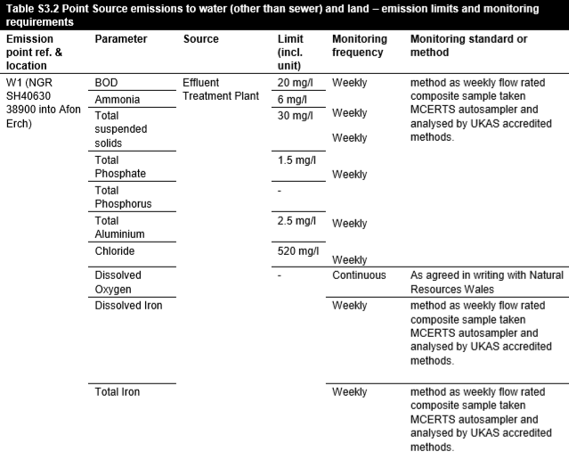  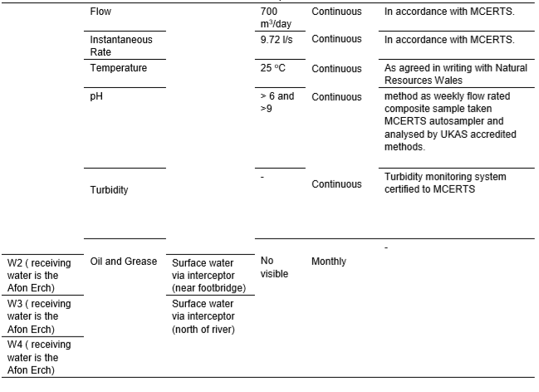  It is not sought to change the maximum concentrations of parameters in the discharges, as detailed in Table S3.2 (EPR/BL9941IC), only the total volume (Flow). The limit for Aluminium will also be reduced from 2.5mg/l to 1.0mg/l in line with TGN 7.01  It should be noted that should the permit variation be issued, within 4 years the ETP will be expected to meet the emission limits as published in the ‘Best Available Techniques (BAT) Reference Document for the Food, Drink and Milk Industries.’
Relevant legislation | Environmental Permitting Regulations 2016
List other permissions that may be required where known | N/A
Location | South Caernarfon Creamery, Rhyd-y-Gwystl, Pwllheli, Gwynedd, LL35 6SB.  Discharge NGR: SH 40630 38900 to the Afon Erch
Application documents | Please find all documents associated with the application on the relevant DMS folder here.
Include: Project purpose and background, site map, scaled plan, site photographs and working method statement.
Timing of works | ASAP, with no end date
List ongoing maintenance requirements. All structures will require maintenance | The EPR permit requires a management system to be in place to control the process and discharge quality. The Management system will also ensure risk is managed and will include ongoing maintenance works.
Environmental Statement | Water Quality Assessment provided by the applicant alongside all other application documentation. All of which can be found on the DMS folder (link above). However, NRW audit of the WQ assessment can be found appended to this document (Appendix 1).
Pre-application correspondence | N/A
NRW team responsible for drafting this WFD Compliance Assessment report, and name of lead officer | Team: Installations and RSR Permitting Team  Officer: Patrick Duffy (Permitting Officer – Installations and RSR Permitting Team)

Stage 1: Complete screening for each water body, add or delete cells as appropriate

Water body name | WB ID | Morphology status* | Overall water body status
Afon Erch (Erch Lower) | GB110065053570 | Good | Moderate

Q1.1 | Is the activity listed in Appendix 2 or Table 5 of OGN 72? | No | Yes – go to Q1.2  No – complete scoping assessment for each water body
Q1.2 | Is the proposal in a water body at high status or high status for morphology?  Water bodies at high status or high-status morphology have little or no human intervention and are more at risk of deterioration | No

Stage 2: Scoping Assessment
Q2.1 Is there a risk that a component of the activity or project may cause deterioration of any element that makes up water body status classification? | Yes: 3.3.4 in OGN72 (Water Quality: Physio-chemical and specific pollutants)  The discharge contains concentrations of sanitary determinands (Ammonia, Orthophosphate and BOD), aluminium is also dosed at the ETP. Given that the proposal is to increase the daily discharge volume by 300 cubic metres per day, this proposal may cause deterioration to the physio-chemical and chemical aspects of the watercourse, a full detailed assessment is required.
For Natura 2000 sites (SAC/SPA/Ramsar) Has a Habitats Regulations Assessment been completed? | A relevant screening report (IR EPR discharges to water) has been completed and saved to the DMS folder here.  The Lleyn Peninsula and the Sarnau SAC is within the relevant screening distance (~8.7km downstream). A HRA will be completed.
Scoping decision of the project cumulatively or ‘in combination’ | No other projects that impact in combination.  This has been concluded by looking at live permitting applications 10km up/downstream of the proposed discharge point. None were found, therefore impacts on WQ will not be compounded by other proposals that can act ‘in combination’.
Overall scoping decision (choose one of the following) | There is a risk the activity/project may cause deterioration or prevent the water body from meeting its objectives and therefore a detailed compliance assessment is required.

Stage 3: Detailed Assessment
A detailed assessment of impact to concentrations of sanitary determinands in the receiving watercourse has been completed (see Appendix 1 below, pages 9-26), in summary:
- Proposed maximum limit for BOD of 40mg/l will ensure the status remains ‘High’ with ample compliance headroom remaining
- Proposed maximum limit of 30mg/l for Ammonia will ensure the status remains ‘High’ with ample compliance headroom remaining
- Proposed mean limit of 15mg/l for Total Phosphate as P will ensure the status remains ‘High’. Whilst there is less compliance headroom remaining, it is also acknowledged that within 4 years the concentration of Total Phosphate as P will be reduced by 86% upon implementation of BAT ELV’s, ensuring improved water quality
- Proposed limits for pH, suspended solids, temperature and flow rate are deemed acceptable as per the respective WFD targets
All conclusions for physio-chemical parameters ensure obligations as per ‘Operational Instruction 50_12: Water Quality Planning: No Deterioration and the Water Framework Directive’ are met.
A detailed assessment regarding aluminium and the dosing salts has also been completed (appendix 2 below, pages 30-33), in summary:
- A limit of 1000ug/l will be set for Total Aluminium as Al as per TGN7.01
- No numeric limit will be set for Anionic/non-ionic polyacrylamide as this will be controlled through the EMS
As per the conclusions above, the status of physio-chemical and chemical parameters will remain ‘High’ following implementation of the proposal. All correct guidance and procedure has been followed.

Authorisation
Conclusion of WFD Compliance Assessment
Name of authorising officer | Patrick Duffy
Job title and date | Permitting Officer – Installations and RSR
Technical specialist comments
Name, job title and date

Consultation with technical advisors/specialists
Relevant section of the WFD compliance assessment | Date(s) of correspondence* and any meeting(s) with technical advisor(s) | Description of how the comments from technical advisors have been considered
*Attach a copy of any written correspondence with the WFD assessment for the audit trail

Appendix 1 – Assessment of Sanitary Determinands:

PAN-008571

Water Quality Assessment Audit

Background
The variation is to increase the daily discharge volume from the effluent treatment plant at Pwllheli Creamery by 300 cubic metres per day, meaning the total discharge volume is a proposed 1000 cubic metres per day. The applicant wishes to maintain the current permit limits, this assessment models the impact of the increased discharge volume containing the proposed limits.

Data Utilised in RQP – Forwards Calculation (proposed limits)
In order to demonstrate the impact of the proposed increased discharge, I have undertaken modelling in the ‘River Quality Planning’ (RQP) software.
In the table below, I present the data utilised within my ‘forwards calculations’. These calculations assess deterioration of several WQ parameters (sanitary determinands) in the receiving watercourse as a result of the increased discharge:

Upstream (U/S) River Quality Data
U/S River Quality | Mean | Std.Dev | Comments on U/S Quality Data
phosphate  Ammonia | 25.69 (ug/l)  14.85 (ug/l) | 23.03 (ug/l)  4.92 (ug/l) | These values are taken from the WISKI WQ sample database.  The data was taken from the WFD stretch that the site discharges into: GB110065053570 – Erch Lower  A total of 13 samples were taken between for orthophosphate and ammonia over the past 5 years to derive the results.  The sample point used to collect this data is ‘R ERCH A497 RD BR’, which is located at SH 39870 36442, approximately 3.5km downstream from the discharge point.  It is appropriate to use a downstream sample point as this sample data will incorporate the existing 700 cubic metre discharge.  Ammonia and phosphate were converted to ug/l from mg/l as RQP can only model to 2 decimal places.
U/S River Flow | Mean (m3/day) | Q95 (m3/day) | Comments
Flow Estimate | 66528 | 16416 | Data used by applicant for their own assessment which was confirmed to be accurate by our internal Hydrology Team.  This flow data is for the river at the point of discharge
Effluent Quality (for historical performance calcs) | Mean | Std.Dev | Comments
Orthophosphate  Ammonia | 368.90 (ug/l)  803  (ug/l) | 604.20 (ug/l)  1223.10  (ug/l) | These values have been calculated from reviewing the effluent quality data for 2020, submitted by the applicant monthly as part of their current permit. This assumes the ETP will maintain treatment efficiency with the increased discharge volumes (check with applicant).  Phosphate and ammonia have been converted to ug/l to ensure consistency in the RQP model as outlined in ‘Comments on U/S Quality Data’.
Effluent Quality (for current permitted limits) | Mean | Std.Dev | Comments
Orthophosphate  Ammonia | 1500 (ug/l)  823.03 (ug/l) | 604.20 (ug/l)  1313.6 (ug/l) | As orthophosphate is currently permitted as a mean the mean is set at the current permitted 1500ug/l (1.5mg/l) and the standard deviation is based on the historical performance.  Ammonia is currently permitted as a max, so the mean and standard deviation are based on ‘the calculation of mean and standard deviation from a percentile’ function in RQP:  Percentile concentration = 6000 (based on limit)  Percentile = 99 (as it’s a max limit)  Coefficient of variation = 1.6 (based on historical CoV)
Effluent Volume | Mean (m3/day) | Std.Dev (m3/day) | Comments
Effluent volume | 149.53 | 49.35 | This is based on the increased 300m³/day discharge volume.  The percentile used in the ‘Calculation of Mean and Standard Deviation from a Percentile’ was 99 (as this is the maximum daily volume). The coefficient of variation was 0.33, which is a fair assumption based on previous reported effluent flow data submitted to NRW by the applicant.

Forwards Calculations – Results

Orthophosphate
MASS BALANCE CALCULATION: MONTE CARLO METHOD
Version 2.5
Calculations done on 18/09/2020 at 11.46
Name of discharge | Pwllheli Creamery (BL9941IC)
Name of river | Erch
Name of determinand | Orthophosphate (ug/l) Forwards Calc on historic performance
INPUT DATA |  |  | RESULTS
UPSTREAM RIVER DATA |  |  | RIVER DOWNSTREAM OF DISCHARGE
Mean flow | 66528.0 |  | Mean quality | 27.12
95% exceedence flow | 16416.0 |  | Standard deviation of quality | 24.25
Mean quality | 25.69 |  | 90-percentile quality | 51.93
Standard deviation of quality | 23.03 |  | 95-percentile quality | 67.56
90-percentile | 51.18 |  | 99-percentile quality | 113.38
DISCHARGE DATA |  |  | DISCHARGE QUALITY
Mean flow | 149.53 |  | Mean quality | 377.78
Standard deviation of flow | 49.35 |  | Standard deviation of quality | 522.86
Mean quality | 368.90 |  | 95-percentile quality | 1287.7
Standard deviation of quality | 604.20 |  | 99-percentile quality | 2627.1
... or 95-percentile | 1257.4 |  | 99.5-percentile quality | 3187.0
% Deterioration Mean | 5.56637

Modelling phosphate utilising the data presented above shows a 6% deterioration when looking at the up/downstream mean.

Ammonia
MASS BALANCE CALCULATION: MONTE CARLO METHOD
Version 2.5
Calculations done on 18/09/2020 at 13.07
Name of discharge | Pwllheli Creamery (BL9941IC)
Name of river | Erch
Name of determinand | Ammonia (ug/l) - Forwards calc on historic performance
INPUT DATA |  |  | RESULTS
UPSTREAM RIVER DATA |  |  | RIVER DOWNSTREAM OF DISCHARGE
Mean flow | 66528.0 |  | Mean quality | 17.55
95% exceedence flow | 16416.0 |  | Standard deviation of quality | 6.46
Mean quality | 14.85 |  | 90-percentile quality | 25.23
Standard deviation of quality | 4.92 |  | 95-percentile quality | 29.08
90-percentile | 21.32 |  | 99-percentile quality | 37.94
DISCHARGE DATA |  |  | DISCHARGE QUALITY
Mean flow | 149.53 |  | Mean quality | 823.55
Standard deviation of flow | 49.35 |  | Standard deviation of quality | 1077.4
Mean quality | 803.00 |  | 95-percentile quality | 2732.8
Standard deviation of quality | 1223.0 |  | 99-percentile quality | 5416.1
... or 95-percentile | 2671.0 |  | 99.5-percentile quality | 6519.1
% Deterioration 90%ile | 18.3396

Modelling ammonia utilising the data presented above shows a 18% deterioration when looking at the up/downstream 90%ile.

Discussion of Results - Forwards Calculation (proposed limits)
As the receiving watercourse is not a riverine SAC, there will be no further assessment in relation to the JNCC targets. However, as there is a % deterioration, I will investigate the proposal to increase discharge volume in relation to the WFD targets.

Further Assessment Orthophosphate

The forwards calculation for orthophosphate presents a 6% deterioration based on the Mean. The Water Framework Directive requires that member states “implement the necessary measures to prevent deterioration of the status of all water bodies….” (Article 4.1). All practicable action must be taken to prevent the deterioration in the status of all water bodies in England and Wales.
Phosphate in relation to the Water Framework Directive – WFD targets and classifications for P are site specific based on altitude and alkalinity. Based on the ‘UKTAG River Phosphorus Calculator 2021’, the class boundaries at the discharge point are as follows (taken from classification point 500m upstream ‘Trib of Afon Erch @ Pont y Felin’ as this is more representative of discharge point conditions):
Altitude = 71m, Mean Observed Alkalinity = 19mgCaCO₃/l. Therefore:
Lower Boundary Value for Class (ug/l) |  |  |  | Lower Boundary Value for Class (mg/l)
High | Good | Moderate | Poor | High | Good | Moderate | Poor
15 | 32 | 97 | 789 | 0.015 | 0.032 | 0.097 | 0.789
These standards are applied as a mean as detailed in ‘The Water Framework Directive (Standards and Classification) Directions (England and Wales) 2015’, this is shown in the table below taken from the directions:
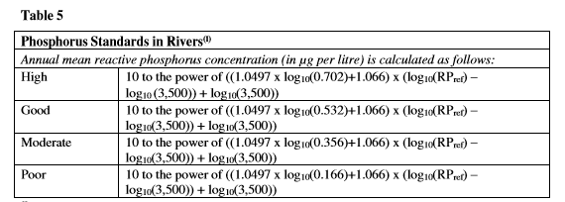
Currently the waterbody GB110065053570 is classified as ‘Good’. The mean concentration of P in the river as per the WISKI WQ samples is 0.02569 mg/l or 25.69 ug/l, which as per the table above, classifies the watercourse as ‘Good’.
The forwards calculation at the historical performance gives a mean quality of 27.12 ug/l. This maintains the ‘Good’ class as per the table. As per our established 50_12 No Deterioration OI, we may allow an in-class 10% deterioration. However, this conclusion is based on the historical ETP efficiency. It is noted that the limit is set at 1.5mg/l. Another forwards calculation has been completed below to demonstrate the impact on the watercourse should the ETP discharge at the full permitted loads of 1.5mg/l:

Orthophosphate – Forwards calculation at full 1.5mg/l
MASS BALANCE CALCULATION: MONTE CARLO METHOD
Version 2.5
Calculations done on 18/09/2020 at 11.53
Name of discharge | Pwllheli Creamery (BL9941IC)
Name of river | Erch
Name of determinand | Orthophosphate (ug/l) Forwards Calc on 1.5mg/l limit
INPUT DATA |  |  | RESULTS
UPSTREAM RIVER DATA |  |  | RIVER DOWNSTREAM OF DISCHARGE
Mean flow | 66528.0 |  | Mean quality | 30.82
95% exceedence flow | 16416.0 |  | Standard deviation of quality | 24.39
Mean quality | 25.69 |  | 90-percentile quality | 55.03
Standard deviation of quality | 23.03 |  | 95-percentile quality | 72.18
90-percentile | 51.18 |  | 99-percentile quality | 116.73
DISCHARGE DATA |  |  | DISCHARGE QUALITY
Mean flow | 149.53 |  | Mean quality | 1526.0
Standard deviation of flow | 49.35 |  | Standard deviation of quality | 595.41
Mean quality | 1500.0 |  | 95-percentile quality | 2645.9
Standard deviation of quality | 600.00 |  | 99-percentile quality | 3365.5
... or 95-percentile | 2624.7 |  | 99.5-percentile quality | 3592.2

The forwards calculation above shows that utilisation of the full permitted load would maintain ‘Good’ class (30.82ug/l).
It is therefore acceptable that the current limit of 1.5mg/l is maintained.

Further Assessment Ammonia

The forwards calculation for ammonia presents a 7% deterioration based on the 90%ile. The Water Framework Directive requires that member states “implement the necessary measures to prevent deterioration of the status of all water bodies….” (Article 4.1). All practicable action must be taken to prevent the deterioration in the status of all water bodies in England and Wales.
Ammonia in relation to the Water Framework Directive – WFD targets and classifications for ammonia are based on the typology of the river. As the altitude at the discharge point is 71m and the Mean Observed Alkalinity is 19mgCaCO₃/l, the Erch at the discharge point is classified as ‘Type 2’ as per the below table from the WFD directions:
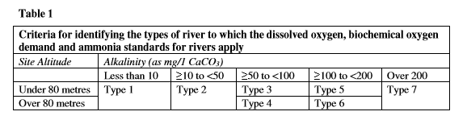
Therefore, the following class boundaries apply:

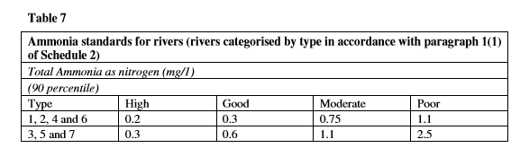
The watercourse is currently classed as ‘High’ with a 90%ile concentration of 0.021mg/l. Despite the forwards calculation showing an 18% deterioration, the downstream 90%ile is still 0.025, comfortably remaining in the ‘High’ class.
However, this conclusion is based on the historical ETP efficiency. It is noted that the limit is set at 6mg/l. Another forwards calculation has been completed below to demonstrate the impact on the watercourse should the ETP discharge at the full permitted loads of 6mg/l:
Version 2.5
Calculations done on 18/09/2020 at 13.29
Name of discharge | Pwllheli Creamery (BL9941IC)
Name of river | Erch
Name of determinand | Ammonia (ug/l) - Forwards calc on 6mg/l current limit
INPUT DATA |  |  | RESULTS
UPSTREAM RIVER DATA |  |  | RIVER DOWNSTREAM OF DISCHARGE
Mean flow | 66528.0 |  | Mean quality | 17.62
95% exceedence flow | 16416.0 |  | Standard deviation of quality | 6.63
Mean quality | 14.85 |  | 90-percentile quality | 25.36
Standard deviation of quality | 4.92 |  | 95-percentile quality | 29.37
90-percentile | 21.32 |  | 99-percentile quality | 38.82
DISCHARGE DATA |  |  | DISCHARGE QUALITY
Mean flow | 149.53 |  | Mean quality | 843.32
Standard deviation of flow | 49.35 |  | Standard deviation of quality | 1144.2
Mean quality | 823.03 |  | 95-percentile quality | 2847.9
Standard deviation of quality | 1313.6 |  | 99-percentile quality | 5750.5
... or 95-percentile | 2781.7 |  | 99.5-percentile quality | 6956.6
The forwards calculation above shows that utilisation of the full permitted load would maintain ‘High’ class (0.025mg/l).
It is therefore acceptable that the current maximum limit of 6mg/l is maintained.

Assessment of BOD

No downstream or upstream data is available for BOD in the Afon Erch. However, there is available data for % saturation of dissolved oxygen within the receiving watercourse:
Sampling Date&Time | Parameter Name | Value (%)
05/02/2014 12:50 | Oxygen, Dissolved, % Saturation | 103.7
27/08/2014 10:55 | Oxygen, Dissolved, % Saturation | 111
23/10/2014 12:05 | Oxygen, Dissolved, % Saturation | 94.6
12/02/2015 11:45 | Oxygen, Dissolved, % Saturation | 99
11/05/2015 12:25 | Oxygen, Dissolved, % Saturation | 102
04/08/2015 13:45 | Oxygen, Dissolved, % Saturation | 99.1
16/11/2015 13:36 | Oxygen, Dissolved, % Saturation | 96
29/03/2019 09:55 | Oxygen, Dissolved, % Saturation | 99.8
25/06/2019 10:52 | Oxygen, Dissolved, % Saturation | 95.7
30/07/2019 11:32 | Oxygen, Dissolved, % Saturation | 91.4
05/12/2019 11:05 | Oxygen, Dissolved, % Saturation | 97.8
07/02/2020 09:41 | Oxygen, Dissolved, % Saturation | 100.5

The average % saturation of dissolved oxygen within the Lower Erch from the 12 samples taken over the past 6 years is 99.22%.

The WFD standards are presented below, as per ammonia, the receiving watercourse is ‘Type 2’:
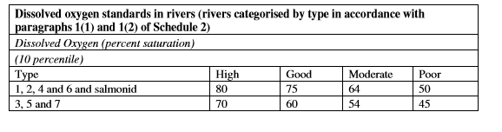
Whilst no direct modelling can be completed, it is clear the 20mg/l BOD limit is fit for purpose. As there is currently 700m³/day of effluent entering the watercourse and the % saturation is comfortably within WFD ‘High’ class with enormous headroom remaining, the limit can remain.

Temperature and pH
The limits on the permit currently are in line with the WFD requirements. Historical sample data demonstrates there are no existing concerns relating to these parameters so the limits can remain unchanged.

Chloride

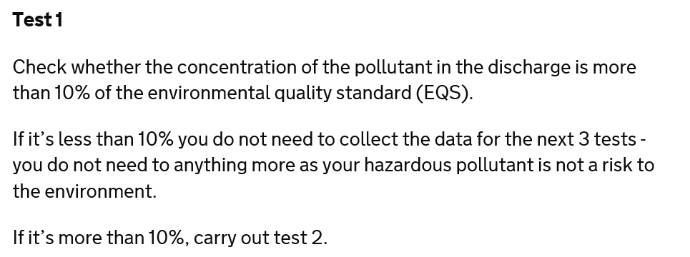
Chloride is a listed specific pollutant with a statutory environmental quality standard of 250,000 ug/l. The applicant is proposing that the limit of 520mg/l (520,000 ug/l) remains on the permit. To ensure this is acceptable, H1 screening tests have been undertaken below. Modelling will be undertaken if required:

Substance (AA or MAC) | Release Concentration (RC) - μg/l | EQS (or PNEC) - μg/l (AA or MAC) | % of EQS (or PNEC)
Chloride | 520000 | 250000 | 208.00%

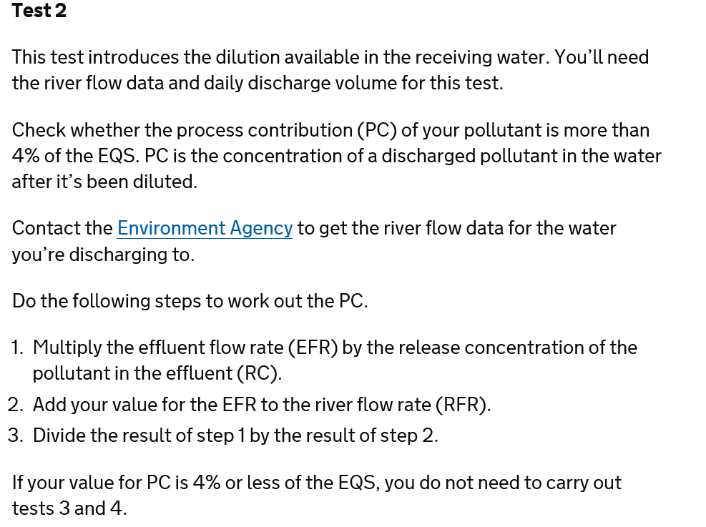
Test 1 is FAILED. Test 2 is below:
Effluent Flow Rate - m³/s | Release Concentration - μg/l | River Flow Rate - m³/s | Process Contribution - μg/l | EQS - μg/l | PC as % of EQS
0.012 | 250000 | 0.19 | 14851.48515 | 250000 | 5.94%

Test 2 is FAILED. Test 3 is below:
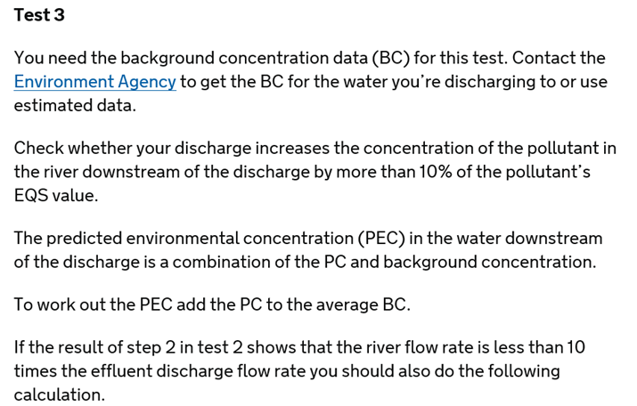

The background concentration for chloride utilised within screening test 3 is 20.64 mg/l, this is from samples taken downstream at ‘R ERCH A497 RD BR’:
Process Contribution | Avg. Background Concentration - μg/l | Predicted Environmental Concentration - μg/l | EQS - μg/l | Difference as % of EQS
14851.49 | 20640.00 | 35491.49 | 250000.00 | 5.94%

Test 3 is PASSED. The proposal to maintain the limit of 520mg/l whilst increasing the discharge volume to 1000 cubic metres per day is ACCEPTABLE.

Total Aluminium

Aluminium is acutely toxic to fish. Technical Guidance Note 7.01 suggests an EQS of 1000 ug/l MAC should be applied for waters complying with the national pH EQS where upper and lower 95 percentile pH values lie between 6.0 and 9.0 (as per the Lower Erch). The current limit of 2.5mg/l total aluminium is not appropriate as the worst permissible effluent quality is 1mg/l total aluminium. As a result, the screening tests have been undertaken on the basis that the concentration in the effluent would be 1mg/l.

Test 1:
Substance (AA or MAC) | Release Concentration (RC) - μg/l | EQS (or PNEC) - μg/l (AA or MAC) | % of EQS (or PNEC)
Aluminium | 1000 | 1000 | 100.00%

Test 1 is FAILED. Test 2 is below:
Effluent Flow Rate - m³/s | Release Concentration - μg/l | River Flow Rate - m³/s | Process Contribution - μg/l | EQS - μg/l | PC as % of EQS
0.012 | 1000 | 0.19 | 59.40594059 | 1000 | 5.94%

Test 2 is FAILED. Test 3 is below:
For the background concentration utilised in test 3, there is no background concentration data available for Aluminium in the Erch. Therefore, as there are no recorded Al issues, no historical use for mining and the pH is >6 and <9, the river is assumed to be ‘clean’, thus 10% of the EQS is assumed to be present within the river (would be 50% if assumed ‘dirty’).
Process Contribution | Avg. Background Concentration - μg/l | Predicted Environmental Concentration - μg/l | EQS - μg/l | Difference as % of EQS
59.4 | 100.00 | 159.40 | 1000.00 | 5.94%

Test 3 is PASSED. A limit of 1mg/l Total Aluminium should be on the permit. This is the maximum permissible concentration we allow.

