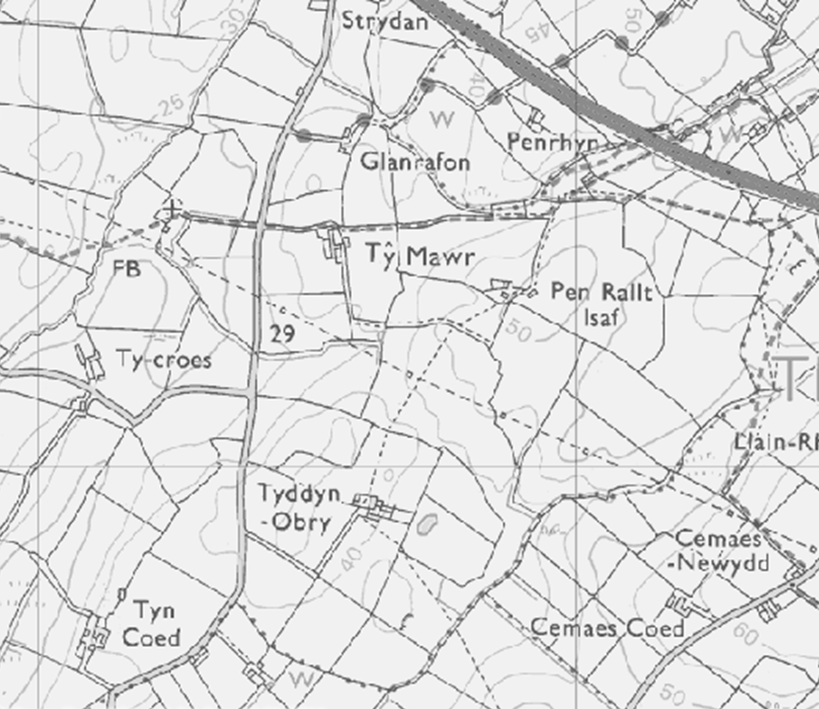
Well 50m buffer
x
50m buffer
T7
T5
T6
T4
T3
T2
T13
T8
T17
T18
T16
T20
T12
T19
T11
T10
T9
 | Site Ref |  |  |  |  |  | TY MAWR
 | Grid Ref
 |  |  |  | Legend
 |  |  | Non-spreading Area (10m on watercourses 50m around spring/well) |  |  |  |  |  |  |  |  |  |  | Spreading Area
 | FARMER |  |  |  |  |  | IG & JG Hughes
 | SITE |  |  |  |  |  | Ty Mawr  Llanbeulan, Ty Croes  Gwyedd LL63 5UR
 |  |  |  | Field  Ref |  |  |  | Spreadable Area |  |  |  |  | Grid Ref
 |  |  |  | T2 |  |  |  | 2.89 |  |  |  |  | SH 37800 75403
 |  |  |  | T3 |  |  |  | 7.62 |  |  |  |  | SH 38145 75265
 |  |  |  | T4 |  |  |  | 2.53 |  |  |  |  | SH 38107 75105
 |  |  |  | T5 |  |  |  | 2.98 |  |  |  |  | SH 38010 75010
 |  |  |  | T6 |  |  |  | 2.8 |  |  |  |  | SH 37899 75112
 |  |  |  | T7 |  |  |  | 1.21 |  |  |  |  | SH 37765 75307
 |  |  |  | T8 |  |  |  | 6.1 |  |  |  |  | SH 37750 75106
 |  |  |  | T9 |  |  |  | 4.34 |  |  |  |  | SH 37506 75097
 |  |  |  | T10 |  |  |  | 2.63 |  |  |  |  | SH 37272 75056
 |  |  |  | T11 |  |  |  | 4.43 |  |  |  |  | SH 37199 75250
 |  |  |  | T12 |  |  |  | 0.83 |  |  |  |  | SH 37193 75458
 |  |  |  | T13 |  |  |  | 1.54 |  |  |  |  | SH 37371 75295
 |  |  |  | T16 |  |  |  | 1.41 |  |  |  |  | SH 37605 75514
 |  |  |  | T17 |  |  |  | 1.52 |  |  |  |  | SH 37480 75272
 |  |  |  | T18 |  |  |  | 1.36 |  |  |  |  | SH 37477 75374
 |  |  |  | T19 |  |  |  | 3.71 |  |  |  |  | SH 37401 75715
 |  |  |  | T20 |  |  |  | 1.65 |  |  |  |  | SH 37337 75534
 |  |  |  | TOTAL |  |  |  | 49.55
 |  |  |  | X = s
 | Site Assessed by: |  |  |  |  |  |  |  |  | R Lewis
 | Date: |  |  |  |  |  |  |  |  | 17/05/2021

