CRoW Appendix 4 (140_10_SD02)  CRoW Act 2000: Natural Resources Wales application for permission - Formal Notice |  | 
Natural Resources Wales Formal Notice.
Requirements of Section 28I of the Wildlife & Countryside Act 1981 as amended by the Countryside and Rights of Way Act (CRoW) 2000.
Duty in relation to granting any consent, licence or permit for activities likely to damage Sites of Special Scientific Interest (SSSI).
Guide to filling in this form for Natural Resources Wales staff:
To be completed by Permitting Officers for any applications for a permission which the Natural Resources Wales has considered under S28G duties to protect and enhance SSSIs. This applies to all proposed permissions within a SSSI, and to operations outside the SSSI boundary which are likely to damage its special features.
Refer to OI 140_10 ‘Applying the Countryside and Rights of Way (CRoW) Act 2000 to applications for permits with potential for impact on Sites of Special Scientific Interest (SSSI)’, including the flowchart in Appendix 2.
Pink italic text – drafting notes, to be deleted before completion/consultation.
Blue text – examples, to be replaced with permission-specific information.
Ensure you have completed all sections.
- Natural Resources Wales area/region/NPS hub: | South East
- Name of SSSI: | Gwent Levels - Nash and Goldcliff
- Type of permission: | Land remediation deployment under bespoke permit EPR/QP3293FY.
- Date for Natural Resources Wales permit determination: | 09/10/2021
- Predicted 28 day date for response from NRW conservation/ecology (under S28 I(4)): | N/A
- Natural Resources Wales reference no: | PAN-015198
- National grid reference: | 336187,187042
- Description of proposal: | A land remediation deployment for material processing, ex-situ bio-treatment of soils and solidification/stabilisation. Perched water and surface water will also be managed and treated before being discharged. The site is at Phase 4a and Phase 5 of Glan Llyn Development in Newport (postcode yet to be agreed). The work will be completed within the next 12 months.  Water  All treatment and waste storage are to take place on impermeable surfaces with sealed drainage. All water emissions will be treated before discharge. See drawing D4583_08 in Appendix A of the Remediation Working Plan for the typical arrangement. Spill kits are also available.  Oils / diesels and COSHH chemicals to be stored with 110% spill capacity storage. Staff to be trained. Spill kits to be available. Refuelling to be undertaken on impermeable surface (any imperfections that risk contact to subsurface to be made good). No refuelling to be undertake within 10m of any excavation. Inspections to be made and corrective action taken when necessary.  Dust  Use dust suppression technique as required e.g. water sprays, bowsers, spray bars.  Use of dust monitoring devices  Consider ceasing operations during prolonged dry or windy periods  Where required cover stockpiles  As required use of the jet wash cleaning vehicle wheels or use of wheel wash  As required use of road sweepers  Consider prevailing weather conditions (wind direction).  Ensure systems are sealed as is reasonably practicable.  Litter/pests  Maintain good levels of site cleanliness.
- Is the proposed activity within (wholly or partially) the SSSI boundary? | No. The site is approximately 490m from the SSSI.  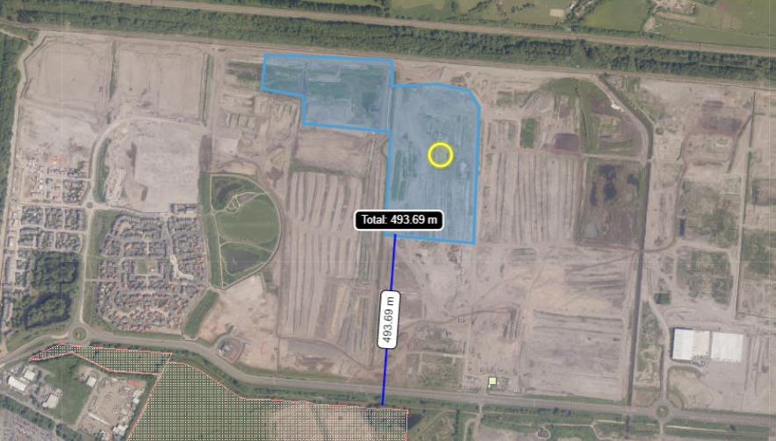
- Has there been any pre-application discussion or correspondence with NRW conservation/ecology | No
- What aspect(s) of the proposed permission may damage the features which are of special interest for the SSSI?
The following ‘Operations Requiring Consent’ (or other activities associated with the permission) that may cause damage) are relevant to the proposed permission.

13a. Modification of field drainage, including the use of mole, tile, tunnel or other artificial drains
14. Changes in the present utilisation of water, including storage, the raising of water levels, irrigation or abstraction from existing water bodies and through boreholes
19. Extraction of minerals including peat, topsoil or subsoil
22. Storage of materials
26. Use of vehicles likely to damage riparian and bank vegetation or craft likely to disturb fauna

The following SSSI features and mechanisms of impact have been considered to assess the likelihood of damage:
- Reen and ditch habitat
- Insects and other invertebrates
- Shrill carder bee
- Decision
i) The proposed permission is not likely to damage any of the flora, fauna or geological or physiological features which are of special interest.

The site is on a relatively flat area of ground, with no downward slope towards the SSSI. Insects, other invertebrates and carder bees should not be affected by the activities due to the distance the site is from the SSSI and as the site is a brownfield site with no significant or protected habitats, no disruption should be caused to them or their habitat. There are no conceivable pathways for harm to the SSSI to be caused.

Natural Resources Wales is minded to issue the permission

- Name and job title of Natural Resources Wales officer: | Louise Bailey  Permitting Officer
- Date form sent to NRW conservation/ecology | N/A saved for information only.

