This template is intended to be used in conjunction with a Band 1 Marine Licence application. Please complete each section below following the guidance provided (max 500 words per section). For any queries relating to this template please contact: marinelicensing@cyfoethnaturiolcymru.gov.uk

Summary
Please provide a brief summary of the application including location of the works (coordinates - lat/long, decimal degrees). For activities that cover a large area please provide coordinates of the approximate extent of works.

The installation of FRP (fibre reinforced polymer) beams to below the soffit of the masonry lintels on each tower on Britannia Bridge, to provide a support mechanism to prevent the lintels from falling onto the carriageway (A55) below; should the cracks in the lintels cause the lintels to fail.

Caernarfon Tower: Latitude, Longitude (decimal) 53.214948 , -4.1841629

Britannia Tower: Latitude , Longitude (decimal) 53.215988 , -4.1856596

Anglesey Tower: Latitude , Longitude (decimal) 53.217032 , -4.1871455

Scope of works
Please provide a full description of all proposed works including:
- Sequence of works (mobilisation, marine works, site remediation (if required))
- Estimated timing of works (duration, working hours, day/night, plus contingency)
- Plant, machinery or vessel required
- Estimated quantities (removals, deposits, construction materials)

Sequence of Works:

- Compound set up
- Pull out testing to test to validate that the main working anchors are suitable for use in the base material.
- Traffic Management on the A55 (to install scaffold crash deck per tower)
- Scaffold installation to each of the towers on the bridge from the service road level.
- Level and dimensional survey - to finalise the lengths required on the FRP beams.
- A trial shift - to ensure the suitability of the lintel supports are as anticipated.
- Installation of Anchors
- Installation of brackets and FRP beams
- Traffic Management on the A55 (to remove scaffold crash deck per tower)
- Scaffold removal from service road level.
- Compound de-mobilisation.

- Site compound set up.
- Site compound set up at rail level on NR owned land.
- Access is via the housing estate (address above).
- Nearby SSSI site to remain unaffected, landmark to be preserved and public footpaths to remain open/unobstructed throughout.
- Pull out tests.
- M20 anchors to be installed at rail level.
- 3rd party independent pull tests to be completed on the 3 towers to ensure sufficient loading for approved design.
- Implementation of TM.
- TM to be used in the form of single lane road closures by night with traffic lights and speed restrictions in place on the open lane.
- 20min blocks of both lanes will be available where required.
- As per the approved TTRO.
- Approved Temporary works design and access arrangements to the location of works.
- Scaffold access to be made from rail deck level to the outer face of the towers on the bridge.
- Working platform will be at the top of each of the 3 towers above the road.
- Site surveys and AFC design validation.
- Upon gaining access to the towers, a simple validation survey will be completed with the use of hand tools/tape measure only to ensure AFC design is as specified.
- Installation of trial FRP beam.
- A trial installation of 1nr of FRP beam lintel supports to the upper tower will be completed to ensure compatibility.
- Installation of M20 anchors and resin cure times.
- Upon approval of the trial shift, the remaining towers will be subject to the anchor installation in the same fashion as the pull out tests completed previously.
- The anchors will be set in a resin that will need to cure prior to the installation of the brackets/beams.

- Installation of the brackets and FRP beams.
- Installation of the remaining brackets and FRP beams and associated detail shown in the approved AFC drawings.
- De-mob site.
- Removal of scaffold and make good the surfaces as per the agreed LBC conditions.
- Removal of the site compound and any arising tools/materials from site/compound area.

Timing of works:

- Enabling Works:– 16-Feb-2021 to 17-Feb-2021 – 8am to 8pm
- Main Works: 27-Sept-2021 to 02-Dec-2021 - 24hrs (shift by night and day)
- Completion Works: 02-Dec-2021 to 06-Dec-2021 24hrs (shift by night and day)

Plant and Equipment in use:

- Rotary hammer drill
- Scaffolding
- Fibre Reinforced Polymer Beams
- Stainless steel brackets and anchors
- Resin

Quantities:

- Anglesey tower – 18 brackets and 9 FRP beams
- Britannia tower – 24 brackets and 12 FRP beams
- Caernarfon Tower – 28 brackets and 14 FRP beams

Access and working areas
Please provide details of access to the site and working areas. This should include:
- Attached map of the access/egress route and working areas (annotated aerial image and/or OS map)
- Predicted plant/vehicle movements
- Storage areas for plant, equipment and materials (if required)
- Risks to navigation

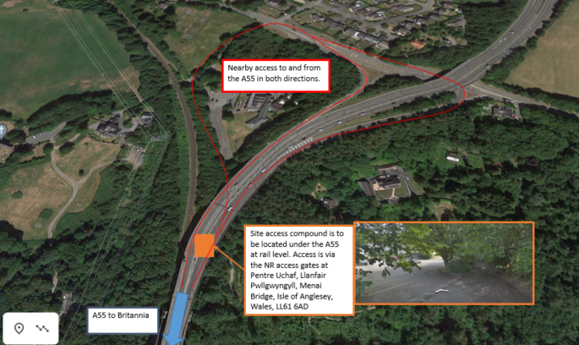
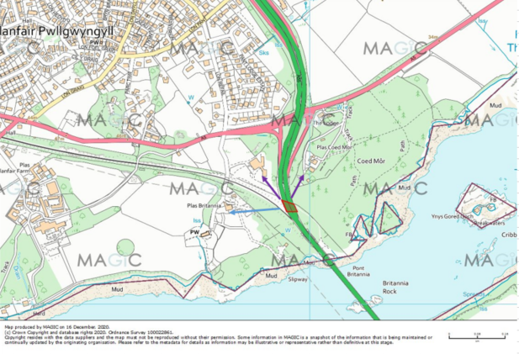

Our main site compound will be formed underneath the A55 at rail level. Access is via the Network Rail access gates at Pentre Uchaf, Llanfairpwllgwyngyll, Anglesey, LL61 6AD.

Working area will be the three towers on Britannia Bridge – Caernarfon, Britannia and Anglesey.

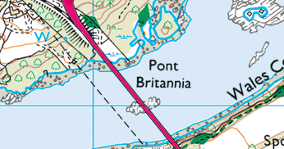

Environmental mitigation
Please list appropriate mitigation measures to minimise impacts on the marine environment these may include:
- Pollution prevention and control procedure (guidance available at: http://www.netregs.org.uk/media/1304/gpp-5-works-and-maintenance-in-or-near-water.pdf)
- Spill response kits
- Minimise plant traffic
- Designated access and egress routes
- Storage of materials (fuel, chemicals, construction waste)
- Biosecurity (guidance available at http://www.snh.gov.uk/docs/A1294630.pdf)

Note: To assist you, the following mitigation statements will be used as conditions within the licence. By signing this method statement you will be agreeing to adhere to these restrictions. If you are unable to do this, the application will not qualify as Band 1.

- All equipment, temporary structures, access tracks, waste and/or debris associated with the works will be removed on completion of the works.

- Bunding, storage facilities and spill kits will be employed to contain and prevent the release of fuel, oils and chemicals associated with the plant, refuelling and construction equipment into the marine environment.

- Plant, vehicles and machinery will not be refuelled on the foreshore.

- Coatings and treatments will be suitable for use in the marine environment and are used in accordance with best environmental practice.

- All equipment, materials, machinery and PPE used will be in a clean condition prior to their arrival on site, and upon removal from site, to minimise risk of introducing non-native species into the marine environment.

- In the event of removal of any sensitive species or habitat designated by NRW under Schedule 7 of the Environment (Wales) Act 2016, no further removals will occur at that location or within 20m of that location.

Please list your bespoke mitigations here:

- There is no direct work or interaction with the water and marine environment.
- No polluting substances including liquids to be used as part of the repair.
- Materials (anchors, brackets and beams) will be securely tied and carefully hoisted up to the towers from within scaffold to minimise risk of materials falling and into water beneath bridge.
- Small quantities of resin will be used to fill any holes and applied by hand to control amount.
- Scaffolding will be installed by competent and qualified persons.
- No refuelling of vehicles on the bridge or within immediate vicinity of bridge and Menai Strait.

- All materials, equipment and waste will be stored securely and covered at the compound location - >150m from the foreshore.
- An ecology survey has been carried out and all recommendations adhered to.

Additional Information
Please list any additional information that may help with the application:
- Consents/permissions required
- List of plans or drawings attached to method statement
- Emergency procedures
- Contact details

IW01234 – Britannia Bridge Lintel Support Project Description – Rev2
IW01234 – Scaffold Design
IW01234 – Britannia Bridge Lintel Support Beams Design Drawing

- Customer details

Signature: 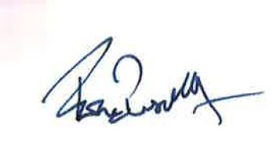

Full name: Fiona Bussell

Organisation name (where appropriate): Amalgamated Construction Ltd.

Contact e mail: Fiona.bussell@amcogiffen.co.uk

Contact phone number: 07557 540036

