CRoW Appendix 4 (140_10_SD02)  CRoW Act 2000: Natural Resources Wales application for permission - Formal Notice |  | 
Information Only

Natural Resources Wales Formal Notice.
Requirements of Section 28I of the Wildlife & Countryside Act 1981 as amended by the Countryside and Rights of Way Act (CRoW) 2000.
Duty in relation to granting any consent, licence or permit for activities likely to damage Sites of Special Scientific Interest (SSSI).
Guide to filling in this form for Natural Resources Wales staff:
To be completed by Permitting Officers for any applications for a permission which the Natural Resources Wales has considered under S28G duties to protect and enhance SSSIs. This applies to all proposed permissions within a SSSI, and to operations outside the SSSI boundary which are likely to damage its special features.
Refer to OI 140_10 ‘Applying the Countryside and Rights of Way (CRoW) Act 2000 to applications for permits with potential for impact on Sites of Special Scientific Interest (SSSI)’, including the flowchart in Appendix 2.
Pink italic text – drafting notes, to be deleted before completion/consultation.
Blue text – examples, to be replaced with permission-specific information.
Ensure you have completed all sections.
- Natural Resources Wales area/region/NPS hub: | South West
- Name of SSSI: | Felin Fach Meadows, Cwmgwili SSSI  Cae Gwynfryn SSSI  Caeau Lotwen SSSI  Caeau Afon Gwili SSSI
- Type of permission: | Environmental Permit
- Date for Natural Resources Wales permit determination: | 03/11/2021
- Predicted 28 day date for response from NRW conservation/ecology (under S28 I(4)): | NA
- Natural Resources Wales reference no: | PAN-012999  EPR/CB3297ZG
- National grid reference: | SN57329 09786

- Description of proposal: | The application is for a Tier 3 Bespoke Application for an physical treatment of non-hazardous waste facility. The site is located at Gavin Griffiths Limited, New Lodge Farm, Pontardulais Road, Cwmgwili, Llanelli, SA14 6PW.  The site will process up to 150,000 tonnes per year. Treatment operations are limited to sorting, screening, separation, blending and crushing of waste to produce soil, soil substitutes and aggregates. Treatment may be by either manual and/or mechanical methods.  The location of the site in relation to the multiple locations of the above listed SSSI is shown by the two figures below:  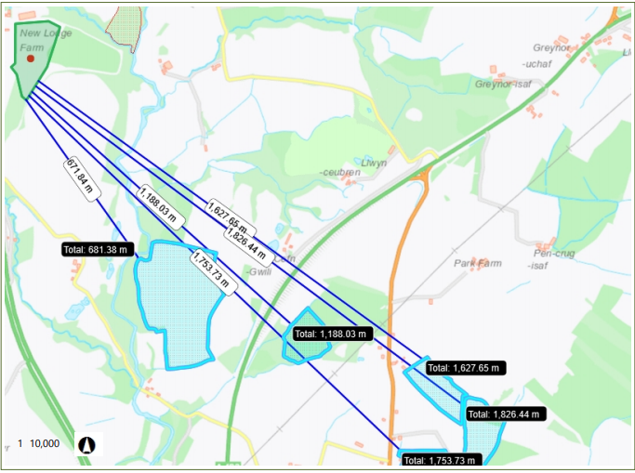  Figure 1. Distance between the site and the multiple locations of the Caeau Afon Gwili SSSI  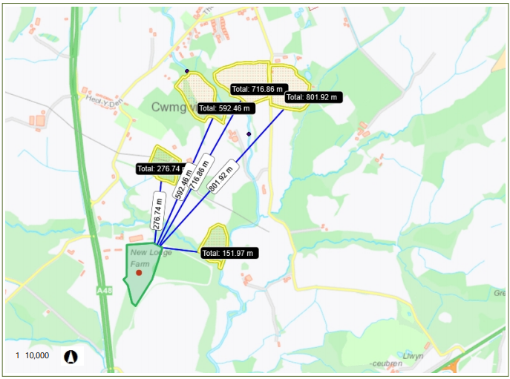  Figure 2. Distance between site and the multiple locations of the Felin Fach Meadows Cwmgwili SSSI
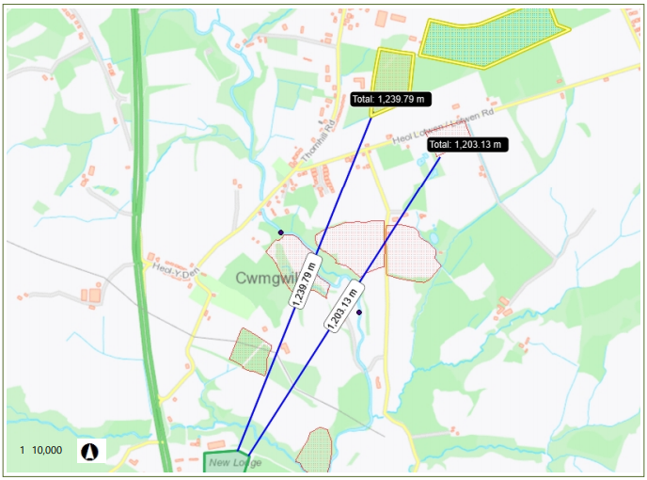
Figure 3 the Distance between the site and the Cae Gwynfryn SSSI (~1203m) and Caeau Lotwen SSSI (~1239m)

- Is the proposed activity within (wholly or partially) the SSSI boundary? | No
- Has there been any pre-application discussion or correspondence with NRW conservation/ecology | No
- What aspect(s) of the proposed permission may damage the features which are of special interest for the SSSI?

Caeau Lotwen SSSI, Cae GwynFryn SSSI, and Felin Fach Meadows, Cwmgwili SSSI, Caeau Afon Gwili SSSI

The following ‘Operations Requiring Consent’ (or other activities associated with the permission) that may cause damage) are relevant to the proposed permission.

- 7. Dumping, spreading or discharging of any materials.
- 22. Storage of Materials

The following SSSI features and mechanisms of impact have been considered to assess the likelihood of damage:

- Protected habitats (eg. Pastures and Meadows) and their supported invertebrate biology affected by suspended solids, and nutrients in run-off water from the proposed site.

- Protected habitats (eg. Pastures and Meadows) and their supported invertebrate biology affected by deposition of fugitive dust emissions from the proposed site.

- Decision
i) The proposed permission is not likely to damage any of the flora, fauna or geological or physiological features which are of special interest.

The proposed permission is not likely to damage any of the flora, fauna or geological or physiological features which are of special interest.

The proposed permission is not likely to damage the SSSI features via contamination surface waters as there are no point source emissions associated with this permission site.

Although the site surface is not impermeable the site is also only permitted to take a specific list of waste codes in line with SR2010 No12 (inert and non-hazardous) and watercourses are greater than 10 metres away from the site boundary and the site is not located on an SPZ.

The proposed permission is not likely to damage the SSSI features via deposit of airborne particulate matter due to the standard control measures and visual monitoring identified within the ‘How to comply with your environmental permit’ guidance and the operators Environmental Risk Assessment and Dust Management Plan:

- Reduced speed limits on site.
- Vehicles will be part of the planned preventative maintenance programme.
- Visual monitoring will throughout the day to identify unacceptable dusty levels.
- Periodic clean downs to remove dust build up.
- Minimised drop heights
- Waste will arrive in sheeted or enclosed vehicles.
- The site is surrounded by an earth bund or trees which will help reduce any airborne dust leaving the site.

Natural Resources Wales is minded to:
Issue the permission

- Name and job title of Natural Resources Wales officer: | Matthew Fryer  Waste Permitting Officer  03/11/2021
- Date form sent to NRW conservation/ecology | N/A
For Natural Resources Wales use only, once NRW conservation/ecology response received
- NRW conservation/ecology comment on assessment: | N/A
- Name and job title of NRW conservation/ecology officer: | N/A
- Date of receipt of NRW conservation/ecology response: | N/A

