PAN-015177 Mymap Report

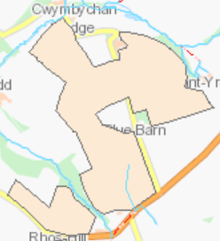
Detailed river network
Noted on the location map document, as a drainage system that will be a 10 meter non spreading area.

Groundwater protection zones
No source protection zones in range of proposed land spreading area.
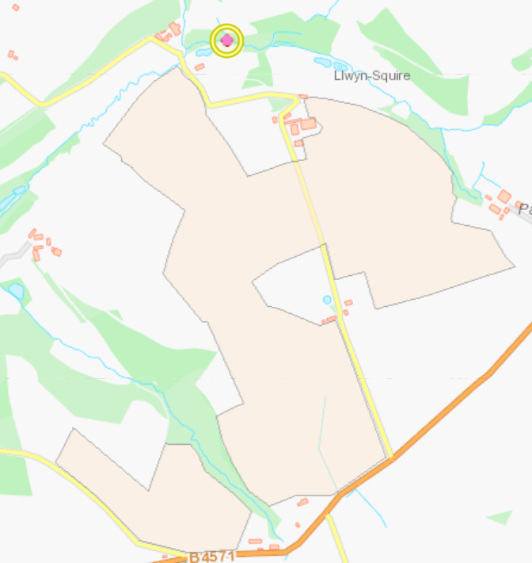
Wells, springs or boreholes used for the supply of water for human consumption including from a private water supply or supplies
My map info: NANT COLL AT CWMBYCHAN TO SUPPLY, Full Abstraction, Effective, Private Non-Industrial, AMENITY POND. Located 117 meters from proposed land spreading site.
No wells in range of proposed land spreading area
any springs wells or boreholes not used to supply water for domestic or food production purposes within 50m

No springs in range of the proposed land spreading area.
European designated sites- Natura 2000 (SPA, pSPA, SAC or cSAC) or Ramsar- or SSSI within 500m

No sites located in range of the proposed land spreading area. Check again

Location of any public rights of way
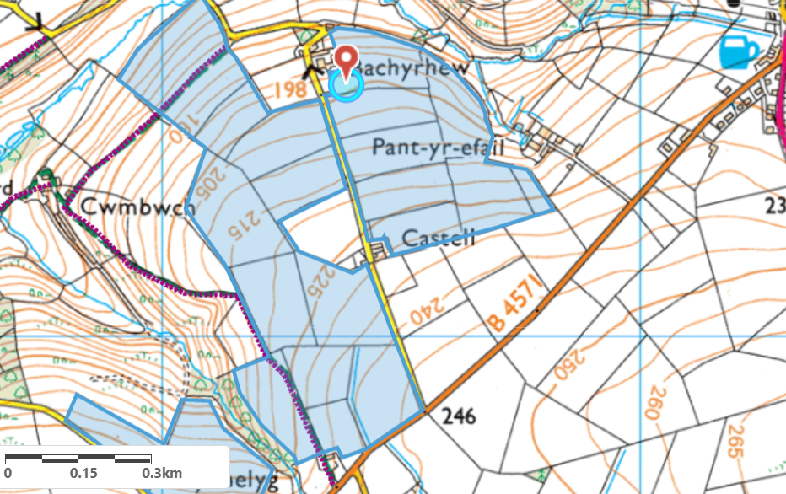
Public right of way path.

Any buildings or houses within 250m of spreading site.
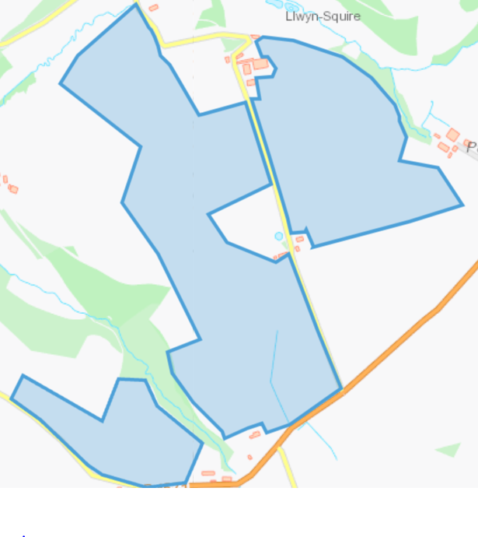
Buildings identified as both residential and farming related.
Other protected sites:
Protected habitats
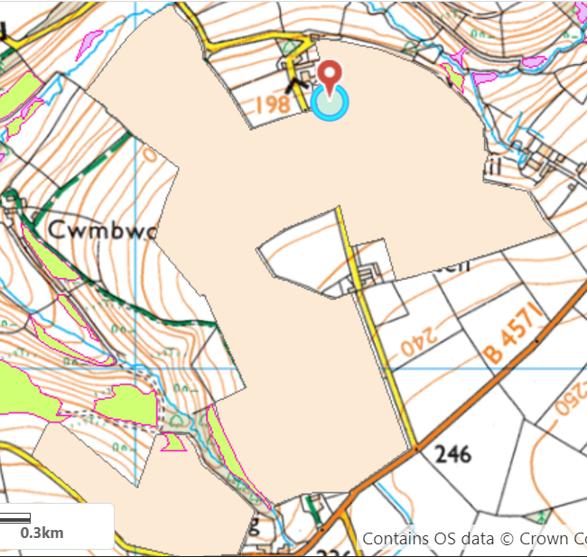
Field S1 contains a protected habitat, also field S3 to the right of field S1 is bordering closely to a protected habitat.
The habitat is described as Lowland dry acid grassland and Lowland calcareous grassland 'semi-improved neutral grassland' but may contain this habitat.
No action is required for this protected habitat as the grassland will benefit from the land spreading activity.
- Protected Species-None
- Protected Habitats- grassland area identified; no action required.
- Scheduled Ancient Monument- None
- Local Nature Reserve- None
- National Nature Reserve- None
- Ancient Woodlands-None
- Local Wildlife Sites (SINC)-None
- National Park-None
- Nitrate Vulnerable Zone (NVZ)- None
- Groundwater Safeguard Zone-None
- Hedges-None
- Ditches-None

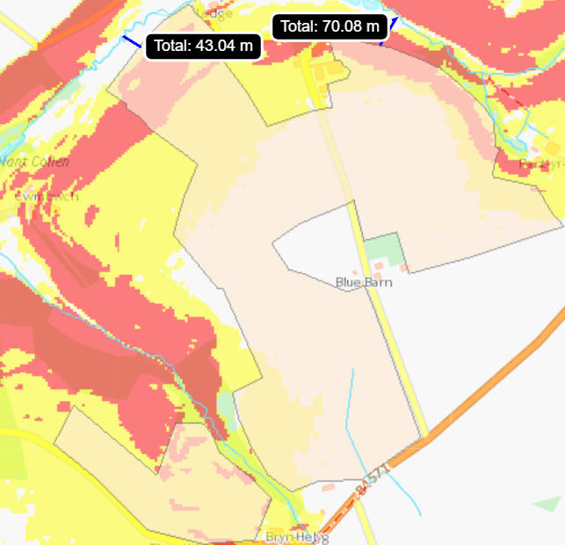
Slope Map
Most of the fields are within acceptable boundaries. Although the edges of fields S7, S10, S11, S1 exceed 12 degrees as seen in red on the map. Although the runoff risk of this waste (cement BPD) is less compared to non-solid wastes.
The blue lines represent the distance the steep fields are from surface water, the risk of runoff of this waste would be higher after periods of rain shortly after land spreading is completed.
Nitrogen associated negative impacts on the environment should be lower with this waste type as it has low levels of nitrogen. Although other PTE runoff could be an issue such as Pb entering surface waters.
Soil type: medium clay
To spread waste the weather conditions must be fair so waste can be incorporated into the soil/crop. (TGN 8.01 box 2.1.7a). The land must not be waterlogged, snow covered or frozen for 12 hours or more in the 24 hours following land spreading. (TGN 8.01 box 2.1.7a).
The water erosion risk for these steeply sloping areas are defined as “high” according to the Code of Good Agricultural Practice for the Protection of Water, Soil and Air for Wales, appendix 2. So, it is important land spreading takes place during fair weather conditions during and following the land spreading activity. This will minimize the risk of surface runoff in the high sloping areas.

