PAN-015812 – MyMap Screening report
1 – surface water courses –
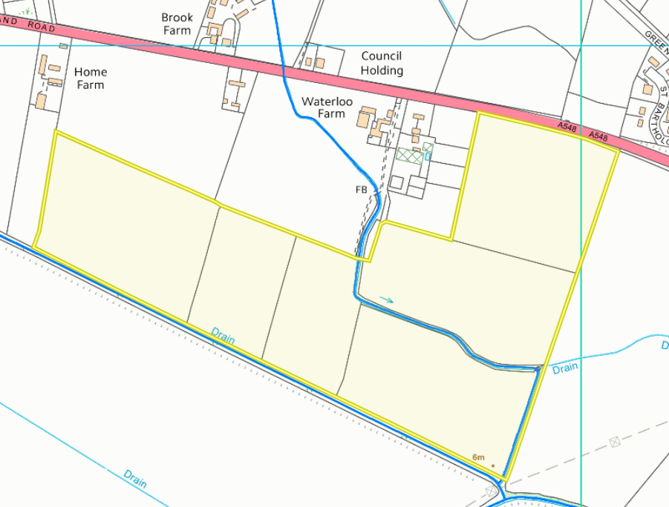
2 - Any SSSI or European designated site - (including SPA, pSPA, SAC, cSAC and Ramsar) – with 500m buffer Zone – Shows none that fall within a 500m buffer.
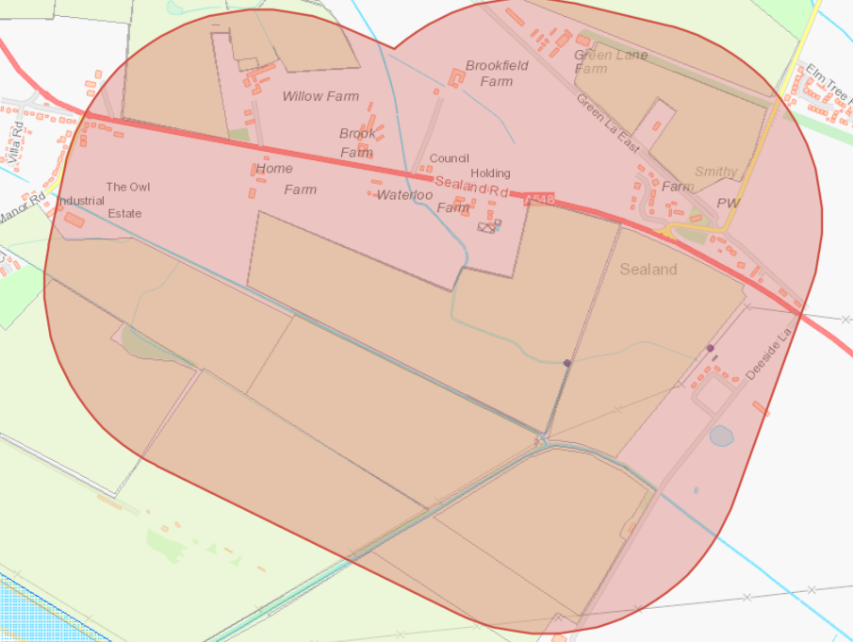

3 – Map showing buildings within 250m
- Church of St Bartholomew
- Churchyard boundary wall Church of St Bartholomew
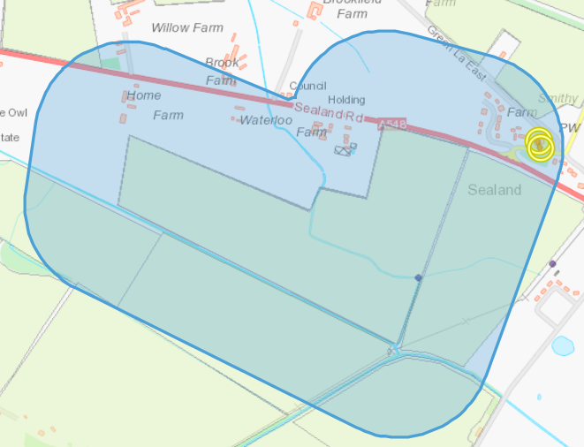
4 The location of any other designated environmentally sensitive sites within 500m.
4a) Protected Habitats – Lowland dry acid grassland and Lowland calcareous grassland
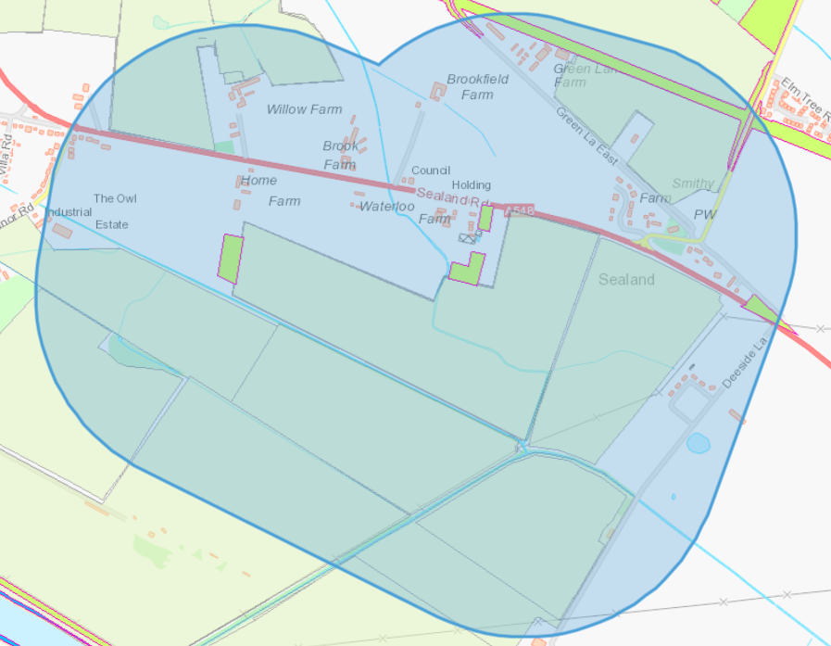

4b) Nitrate vulnerable zones – Image below shows field itself not within NVZ but buffer encompasses a NVZ
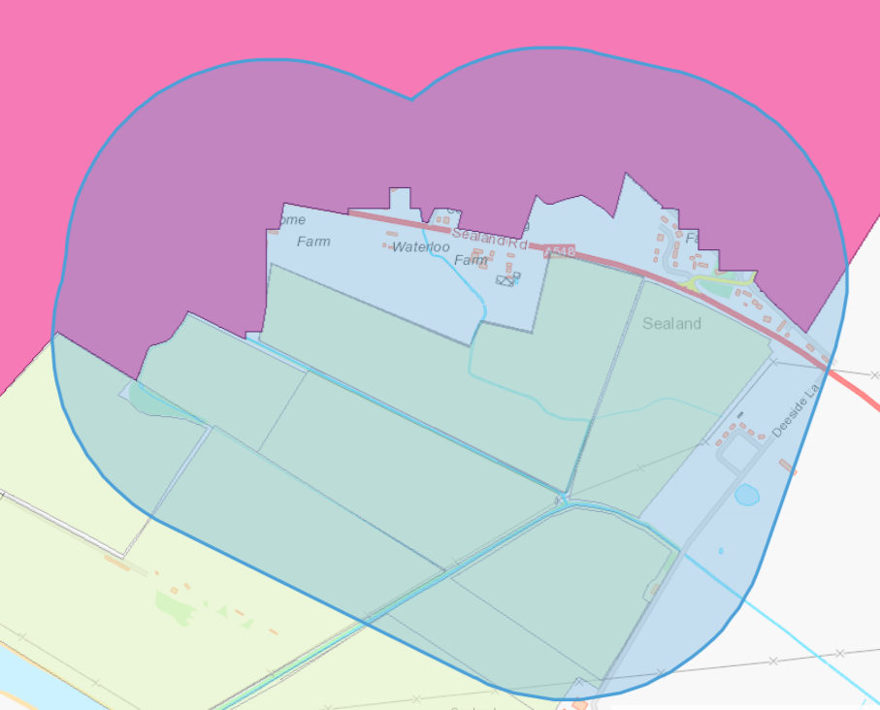
5 - Sloping – Map showing the site slope profile – areas of yellow (7-12) and red (12+) located around watercourses that lie on the borders of field LW2-6. Covered by buffer zones that surround the surface water courses within application.


