Proximity to Human Occupation
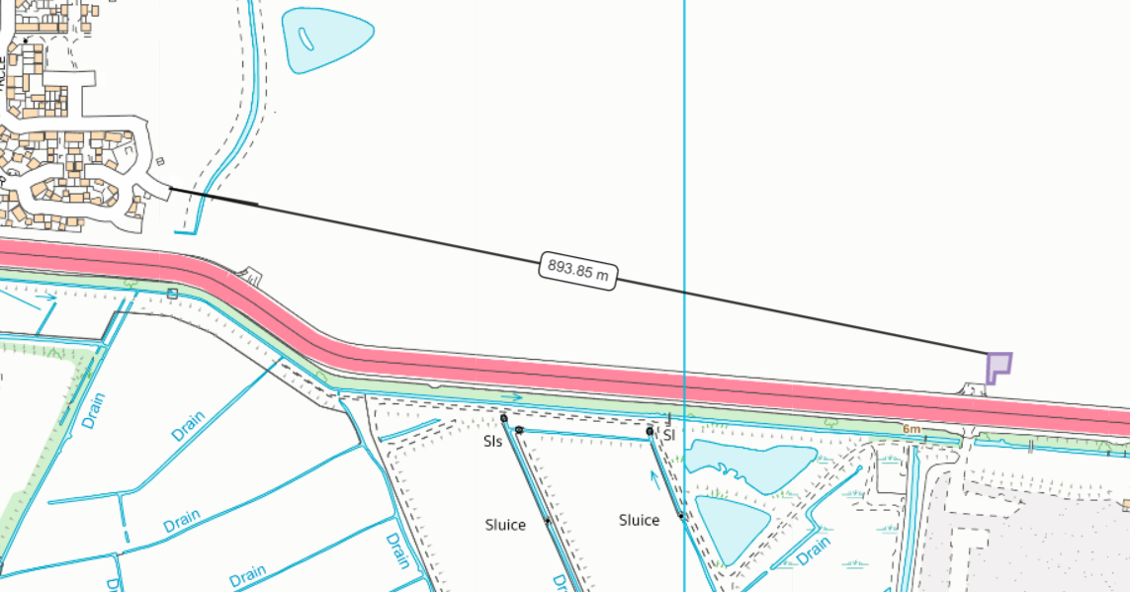

SSSI within 2km
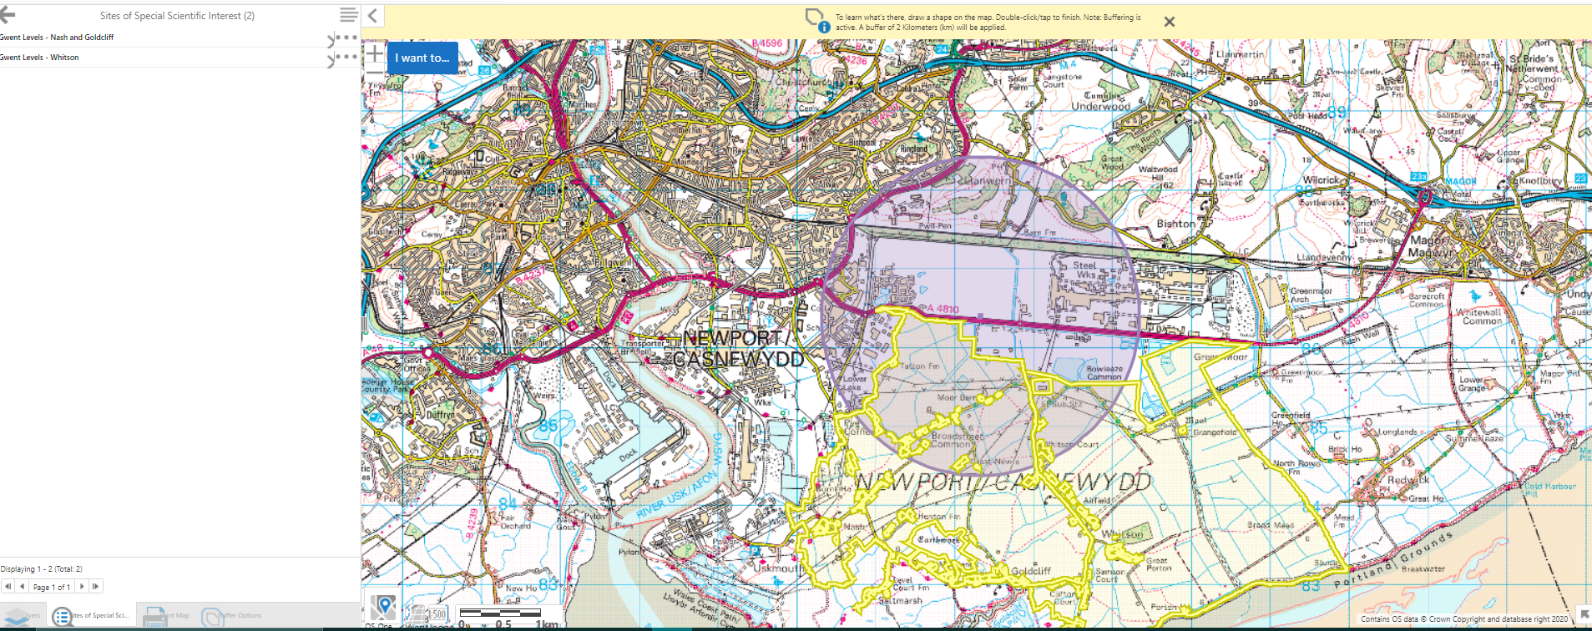

Gwent Levels - Nash and Goldcliff SSSI:
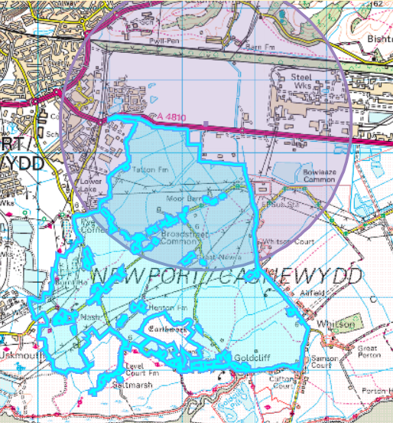

Gwent Levels – Whitson SSSI:
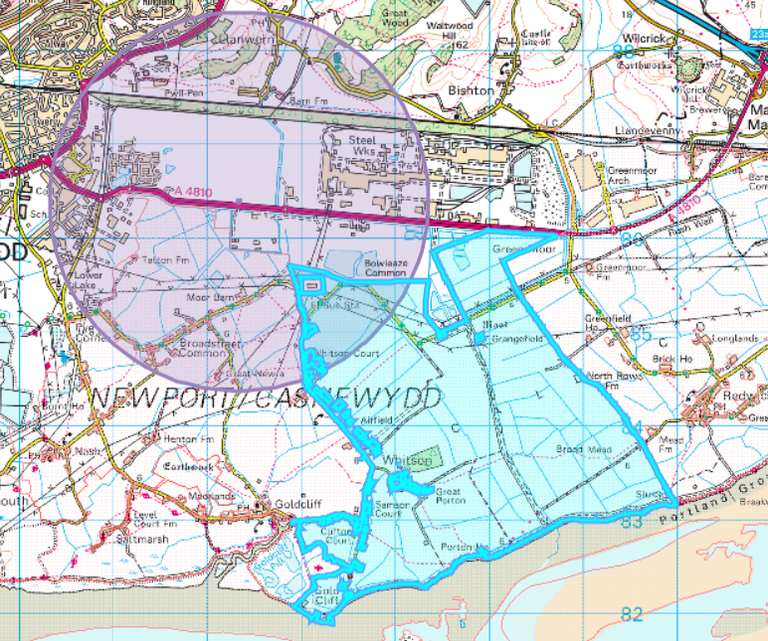
SAC, SPA, Ramsar 1km- None found
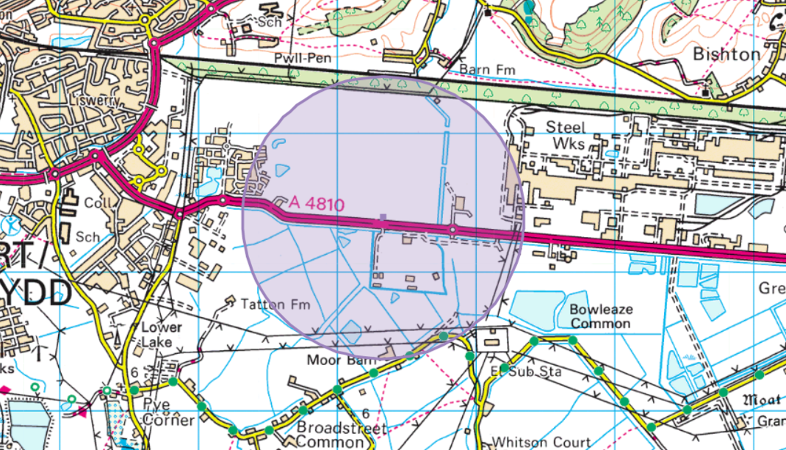

Aquifer Designation (Superficial)- 8010


Aquifer Designation (Bedrock)- 3922
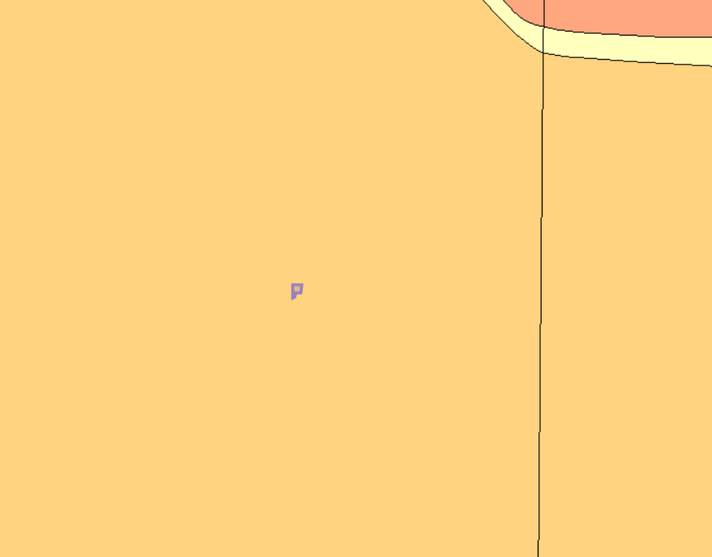

Source protection zone- site not within
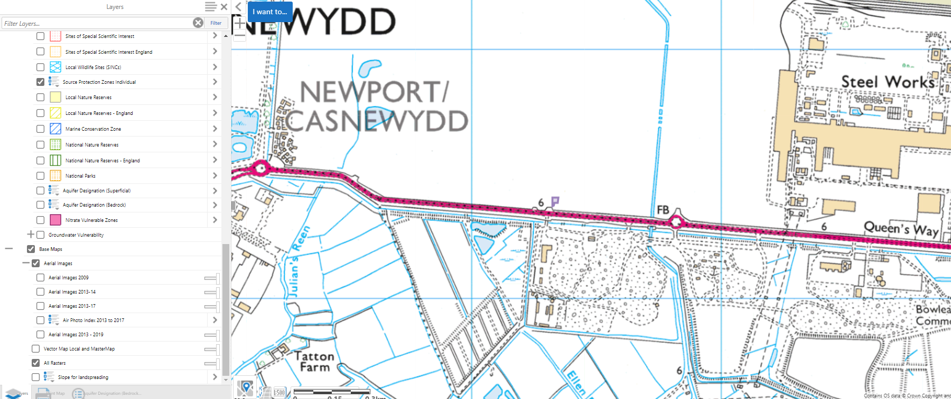

Air Quality Management Areas- site not within
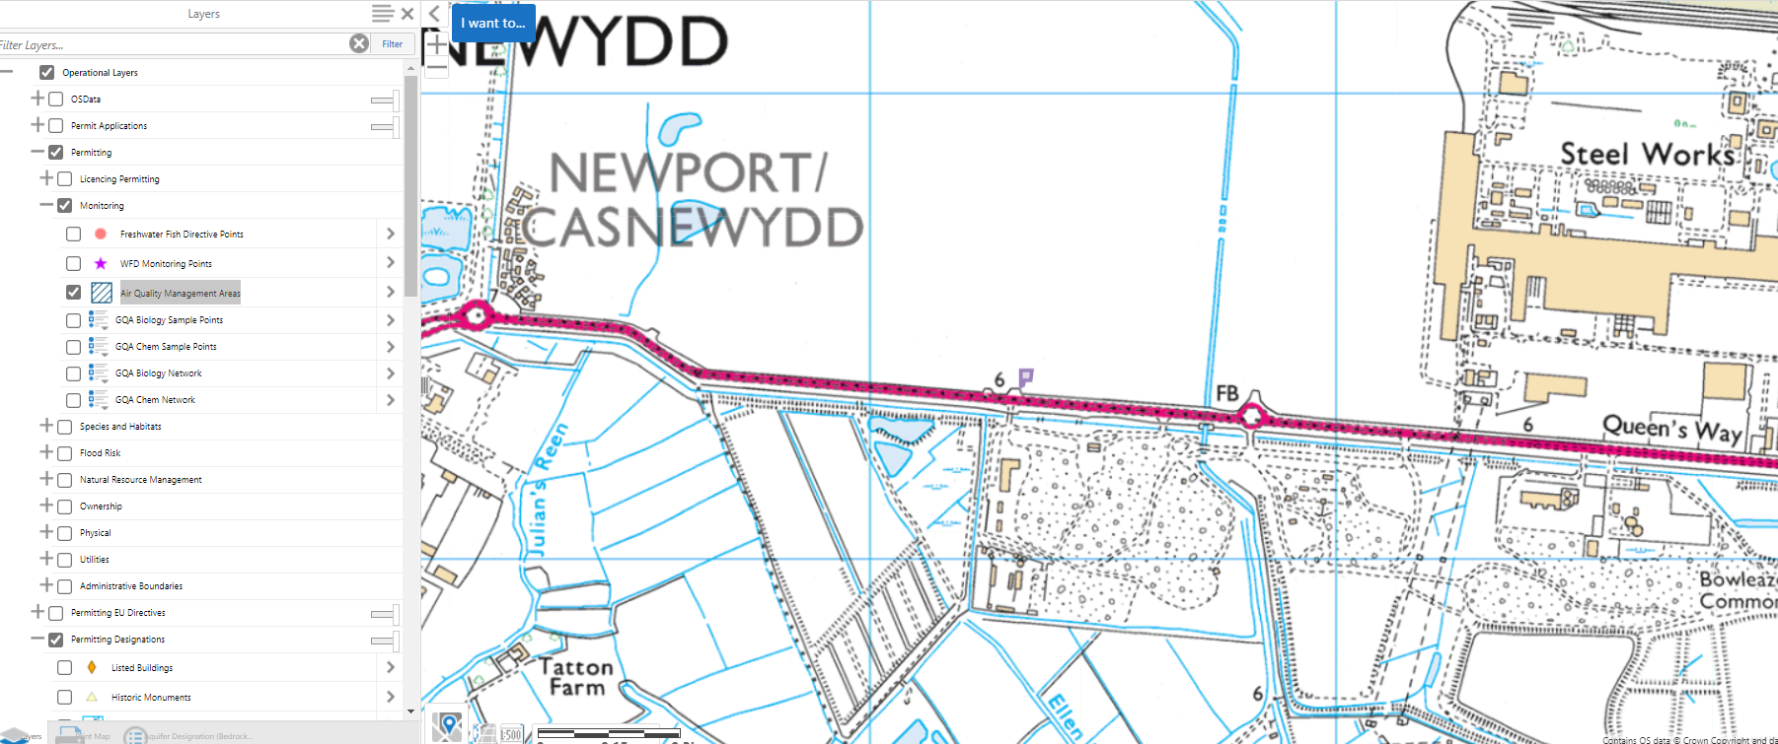

Flood risk from rivers
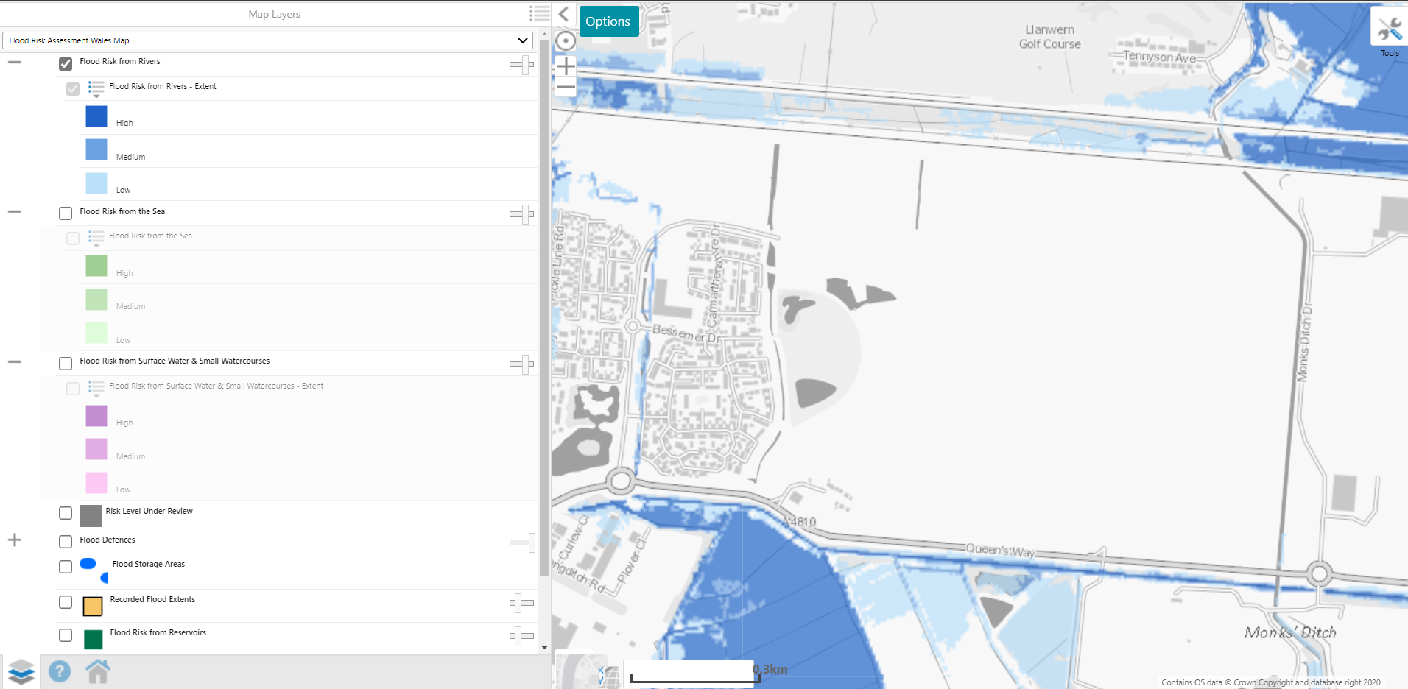

Flood risk from the sea
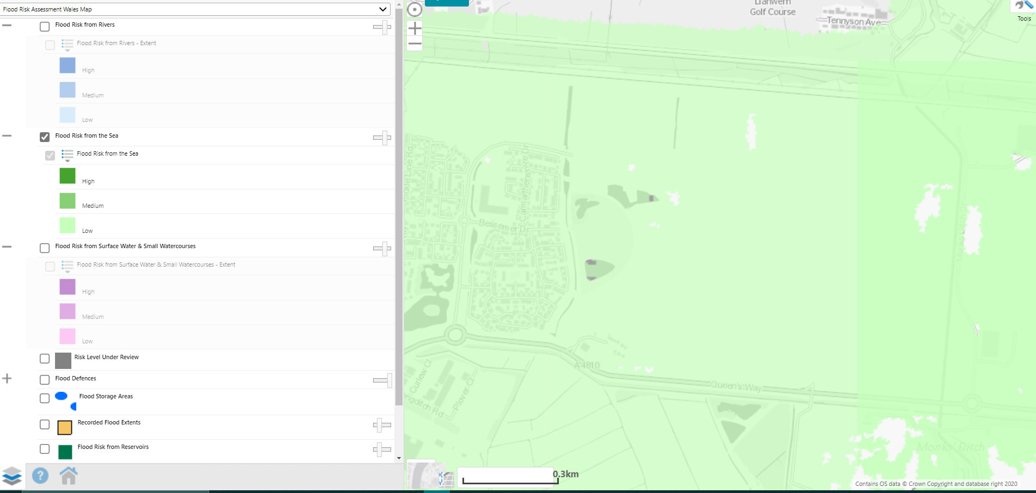

Flood Risk from Surface Water & Small Watercourses
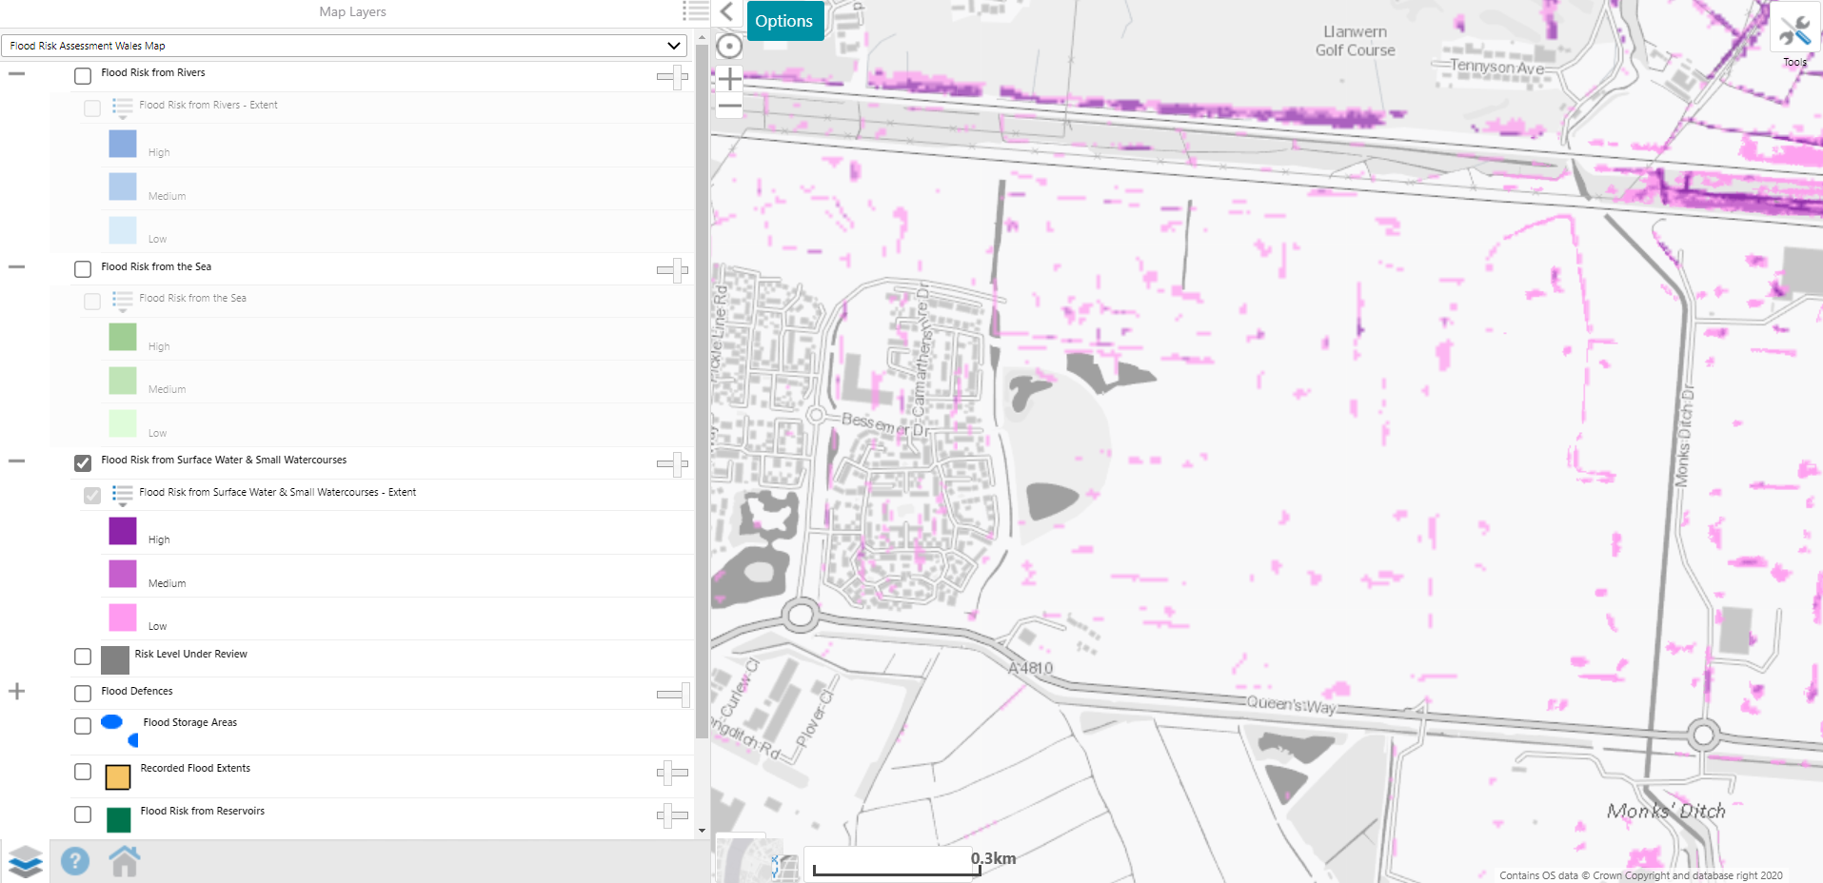

Protected Habitats- reedbeds (blue)
Protected species- Eel, Silver eel, Yellow Eel (pink)
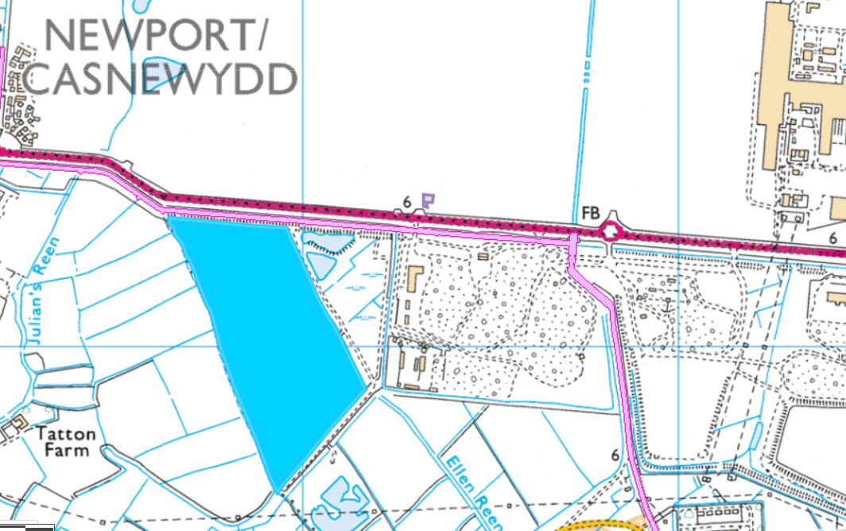

Surface water
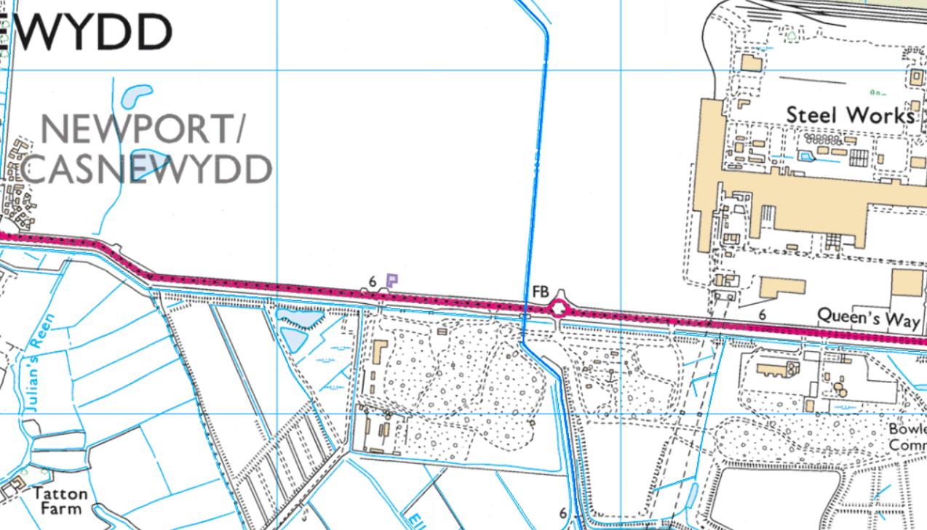

No LWS, NNR, LNR, ancient woodlands or SAM within 1km of the site

