Carew Mill and Causeway Repairs
  - Water Framework Directive Assessment
Pembrokeshire Coast National Park Authority (PCNPA)
November 2021

Doc Ref: 5129589.016-ATK-ZZ-ZZ-RP-CE-0001

Notice
This document and its contents have been prepared and are intended solely as information for Pembrokeshire Coast National Park Authority (PCNPA) and use in relation to the Water Framework Directive (WFD) assessment for Carew Mill and Causeway Repairs
Atkins Limited assumes no responsibility to any other party in respect of or arising out of or in connection with this document and/or its contents.
This document has 21 pages including the cover.

Document history
Revision | Purpose description | Originated | Checked | Reviewed | Authorised | Date
Rev 1.0 | Final issue | AW | KW | RM | RM | 26 Nov 21

Client signoff
Client | Pembrokeshire Coast National Park Authority
Project | Water Framework Directive (WFD) Assessment for Carew Mill and Causeway Repairs
Job number | 5129589.016
Client signature / date

Contents

Chapter Page
1. Introduction 4
1.1. The Site 4
1.2. Previous Consultation 5
2. Methodology 5
2.1. The Water Framework Directive (WFD) – Legislative Background 5
2.2. Methodology of WFD assessment 8
3. Proposed Works and Programme 8
3.1. Overview 8
3.2. Outline construction method 8
3.3. Plant, machinery and vessels 11
3.4. Site Access 11
3.5. Operation 12
3.6. Decommissioning 12
4. WFD Baseline 13
4.1. Surface Waterbodies 13
4.2. Ground Waterbodies 14
4.3. Milford Haven Inner 14
4.4. Statutory Designations 15
4.5. Protected Areas and Sensitive Habitats 18
5. WFD Assessment 20
6. Summary 21
7. References 22

Tables
Table 4-1 - WFD Baseline Information (Natural Resources Wales, 2020) 12
Table 5-1 Assessment of impacts on waterbody quality elements of the Milford Haven Inner waterbody 18

Figures
Figure 1-1 – Carew Mill and Sluice Gates © https://commons.wikimedia.org/w/index.php?curid=30367615 5
Figure 2-1 - Background to WFD Assessments 6
Figure 4-1 - Map of Waterbodies and Site Location (Circled Black) (Natural Resources Wales, 2020) 13

Introduction
Atkins Limited (Atkins) was commissioned by Pembrokeshire Coast National Park Authority (PCNPA) to support the small scale repairs to the historic causeway structure located at Carew Mill, Grid Reference - SN04170385 (Figure 1-1).
This document presents the Water Framework Directive (WFD) assessment for the Works. The aims of the document are to:
- Provide background information on the WFD legislation and the proposed works;
- Provide a high-level baseline understanding of the affected water bodies in the context of the WFD;
- Provide an assessment of the potential for the proposed works to cause deterioration in the WFD status of any waterbody directly or indirectly affected by the Works; and
- Provide an assessment of the potential impacts on waterbody improvement measures and the ability to meet WFD objectives, as well as to suggest mitigation measures where necessary.

The Site
The works are located at Carew Tidal Mill also known as the French Mill (Figure 1-1). Built around 1801, it is one of the oldest corn mills still powered by tidal water in Wales. The works will be focused within the below 4 setting out points (SOP) forming the corner extents of the Site.
- SOP1 – 204139, 203813;
- SOP2 – 204167,203857;
- SOP3 – 204203, 203946; and
- SOP4 – 204221, 203940.
The Works are required to repair the walls of the causeway adjacent to the Millpond and remove/repair the channel sluice gates required under Section 10 and 11 of the Reservoirs Act 1975 to ensure the integrity of the causeway structure. Some of the works will be undertaken from the surface of the causeway around the perimeter of the Mill House and the remainder of the works will be to the vertical walls of the causeway.
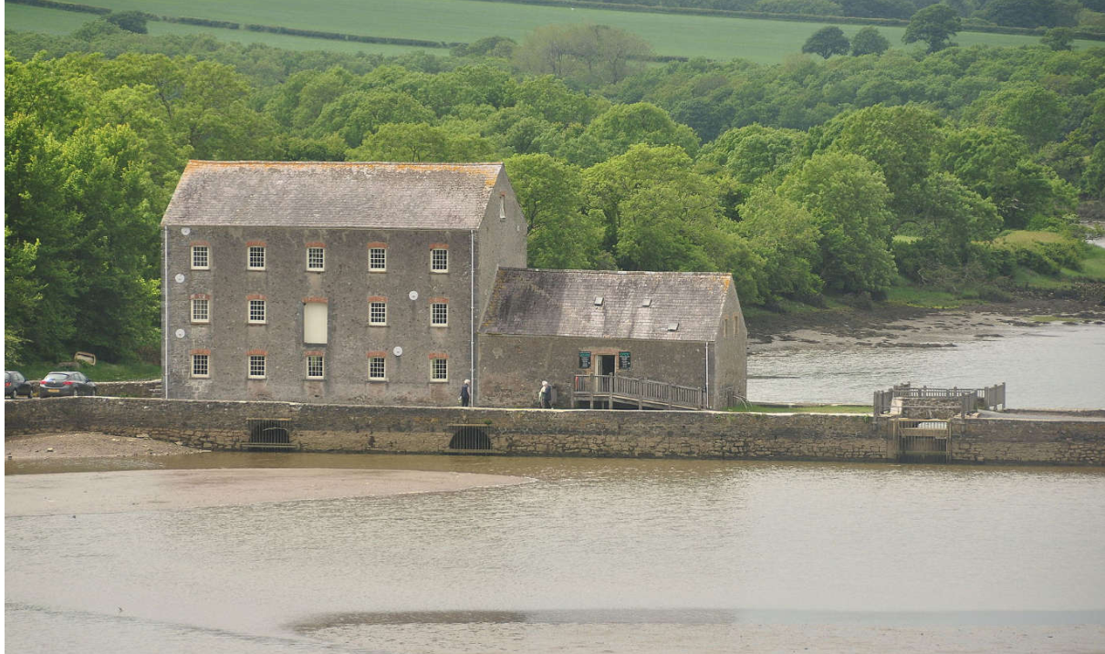
Figure 1-1 – Carew Mill and Sluice Gates © https://commons.wikimedia.org/w/index.php?curid=30367615

Previous Consultation
Past consultation on the method of works has been undertaken with Natural Resources Wales (NRW), at a site meeting on 25/7/17 and approved in a previous marine licence CML1736 and CML 2025. This was undertaken due to the potential impact on marine ecology in the Millpond, specifically the tentacled lagoon worm, Alkmaria Romijni. Responses from this consultation are incorporated into the new method of works that follows.

Methodology

The Water Framework Directive (WFD) – Legislative Background
The Water Framework Directive (WFD) originates from the EU but has been retained in UK law following the UK’s exit, via The Water Environment (Water Framework Directive) (England and Wales) Regulations 2017, as amended. For the purposes of this ES, the legislation will be referred to as the WFD throughout this document, with the assessment of the Scheme in relation to the Water Environment Regulations referred to as a WFD Assessment (some industry practitioners may start referring to it as a Water Environment Regulations Assessment). The Water Environment Regulations (referred to herein as the ‘Regulations’) applies to all coastal and estuarine waters in Wales, to a distance of 1 nautical mile (nm). Under the Regulations, any activity or project with the potential to have an impact directly or indirectly on water body ecology will require a ‘WFD Assessment’. A WFD Assessment will consider whether the activity or project has the potential to cause deterioration in the ecological status or ecological potential of that water body or adjacent water bodies. The WFD Assessment also considers the biological, physico-chemical and hydromorphological qualities of a water body.
The framework for delivering the WFD is through a series of River Basin Management Plans (RBMPs), which requires surface water bodies to achieve both Good Chemical Status (GCS) and Good Ecological Status (GES), and for groundwater bodies to achieve both Good Chemical Status (GCS) and Good Quantitative Status (GQS). The RBMPs outline the actions required to enable natural water bodies to achieve this. Artificial and Heavily Modified Water Bodies (A/HMWB) are surface water bodies that may be prevented from reaching GES due to the modifications necessary to maintain their function for essential human uses, such as flood defence, navigation or drinking water supply. They are, however, required to achieve Good Ecological Potential (GEP), through the implementation of a series of mitigation measures outlined in the RBMP.
New activities and schemes that affect the water environment may adversely impact biological, hydromorphological, physico-chemical and/or chemical quality elements (WFD quality elements), leading to a deterioration in water body status. They may also render proposed improvement measures ineffective, leading to the water body failing to meet its objectives for GES/GEP. Under the WFD, activities and schemes must not cause deterioration in water body status or prevent a water body from meeting GES/GEP by invalidating improvement measures. A summary of key WFD objectives is presented in Figure 2-1.
In addition to protecting and improving water bodies, the WFD also require that a register of ‘Protected Areas’ is developed, which are “all areas lying within each river basin district which have been designated as requiring special protection under specific Community legislation for the protection of their surface water and groundwater or for the conservation of habitats and species directly depending on water”. In the United Kingdom, these Protected Areas are:
- Areas with water-dependent habitats that are protected under the Birds and Habitats Directives, and (by Government policy) under the Ramsar Convention;
- Drinking Water Protected Areas;
- Shellfish Waters;
- Bathing Waters;
- Nutrient Sensitive Areas.
The potential impacts of new activities and schemes on these protected areas must also be considered in order to ensure compliance with the overall requirements of the Regulations.

WFD Objectives
The WFD is a European Directive transposed into UK law which sets out a strategic planning process for the purposes of managing, protecting and improving the water environment. The main objectives of the WFD are to:
- Prevent deterioration in the status of aquatic ecosystems, protect them and improve the ecological condition of waters;
- Aim to achieve at least ‘Good Status’ for all waters by 2015 (2021 or 2027) where fully justified within an extended deadline under Article 4.4;
- Promote sustainable use of water;
- Conserve habitats and species that depend directly on water;
- Progressively reduce or phase out the release of individual pollutants or groups of pollutants that present a significant threat to the aquatic environment;
- Progressively reduce the pollution of groundwater and prevent or limit the entry of pollutants; and
- Help reduce the effects of floods and droughts.
Natural Resources Wales are responsible for implementing the WFD in Wales, with the Environment Agency having joint responsibility for cross-border areas. They monitor, advise and manage many aspects of the water environment through regulating discharges, abstractions and processing environmental permits and licences. Natural Resources Wales and the Environment Agency are committed to implement environmental improvements by reducing the physical impacts of flood risk management activities within artificial or heavily modified water bodies.

WFD Classification
The WFD classification for a defined water body is produced by the assessment of a wide variety of different ‘elements’ which includes:
- ‘biological elements’ such as fish, invertebrates, Phytobenthos (which includes plants, macro-algae, phytoplankton);
- ‘supporting elements’ that include chemical measurements such as ammonia, dissolved oxygen, pH, phosphate, copper, zinc and temperature; and
- ‘supporting conditions’ (sometimes referred to as hydromorphology) that assess the physical attributes of the water body such as ‘quantity and dynamics of flow’ and ‘morphology’.
The assessment given for each element is also accompanied by a measure of certainty in the result. The status classification is published in the RBMP and provides a baseline condition against which compliance and future improvements can be measured.

WFD Compliance
There are three key objectives against which the impacts of proposed works on a water body need to be assessed to determine compliance with the overarching objectives of the WFD:
- Objective 1: The Scheme will not cause a deterioration in any element of water body classification.
- Objective 2: The Scheme will not prevent the WFD status objectives from being reached within the water body or other downstream water bodies.
- Objective 3: The Scheme will contribute to the delivery of the relevant WFD objectives. In this case, it will be what contribution the scheme can make towards the water body reaching its objective GEP through planned RBMP mitigation measures.
Objective 1 and Objective 2 must be met to avoid infraction of the WFD. The delivery of the third objective is central to the implementation of the WFD, where it can be supported through its operational activities. If it is considered that the Scheme is likely to cause deterioration in water body status or prevent a water body from meeting its ecological objectives, then an assessment would be made against the conditions listed in Article 4.7 of the WFD. Article 4.7 can be invoked if; ‘new modifications’ are of overriding public interest and/or the environmental and social benefits of achieving the WFD objectives are outweighed by the benefits of the new modifications to human health, safety and sustainable development; there are no significantly better environmental options that are technically feasible or not disproportionately costly; and all practicable steps for mitigation have been taken.

Figure 2-1 Background to WFD Assessments

Methodology of WFD assessment
NRW is the authority for WFD in Wales and has provided guidance on assessing impacts of new works. Although there is no prescribed template, some recommendations for WFD outline methodology can be found on the gov.uk website. This WFD assessment has been conducted with the following outline methodology:
- Proposed works and programme;
- Baseline WFD data collation;
- Screening of associated surface and ground water bodies;
- Identification of WFD elements which may be affected by the proposed works;
- Assessment of impacts on identified WFD elements against WFD status/objectives; and
- Provision of a WFD summary statement of compliance.

Proposed Works and Programme

Overview
The purpose of the project is to undertake small scale repairs to the historic causeway structure at the Site. Some of the works will be undertaken from the surface of the causeway around the perimeter of the Mill House and the remainder of the works will be to the vertical walls of the causeway.
Further details of the works required, and detailed design can be found in the following drawings, which were submitted as part of the Marine Licence application:
- 5129589.016-ATK-ZZ-ZZ-DR-D-001;
- 5129589.016-ATK-ZZ-ZZ-DR-D-002; and
- 5129589.016-ATK-ZZ-ZZ-DR-D-003.
Work is anticipated to commence in September 2020 and will continue into November 2020, taking approximately 8 weeks. If, for any reason, the works cannot be completed in this time period, they would take place in the following financial year; recommencing in April 2021 and completing in June 2021. There is a need to avoid any works during the peak summer tourist period.

Outline construction method
The following work activities are required:
- Activity 1 – Inspection of causeway masonry walls;
- Activity 2 – Carry out pointing repairs to masonry walls;
- Activity 3 – Carry out grouting repairs to masonry walls;
- Activity 4 – Install stoplog channels and stoplogs to drain the pond and remove sluice gates for repair; and
- Activity 5 – Reinstall the gates and remove stoplogs.
Activities 1, 2 and 3 will take place in a sequence at sections along the wall i.e. cleaning, inspection and repair in one area will be completed before moving on to the next area of wall.
Activities 4 and 5 are linked, as they enable to removal / replacement of the sluice gates.

Activity 1
The walls (3-4m height) will be cleaned by hand so that the joints in the masonry can be inspected and any voids identified for infilling. Any loose material or weeds growing in joints of the wall will be placed in buckets and removed to a skip located at the site compound. Waste materials will be removed to an appropriate licensed waste disposal site.

Activity 2
Voids identified during inspection will be hand repaired with like for like lime-mortar material.
The sequence of works is as follows:
- Mix lime mortar materials on the causeway (above MHWS) by hand in small quantities and place into buckets; and
- Place a 1m strip of plastic sheeting on the river-bed, to catch falling mortar materials used in repointing. Plastic sheeting and waste materials will be removed at the end of each working day and placed in the skip.
- Hand-fill voids with lime mortar.
- All unused lime mortar will be removed from site and disposed of to the skip in the site compound. Hand tools and equipment will be collected and taken to the site compound to be cleaned.

Activity 3
Any identified larger voids will be infilled by pressure grouting. Holes of 35mm will be drilled into the existing masonry to reach the voids in the walls. Tubes will be placed into the drilled holes and concrete grout pumped under moderate pressure to infill the voids and stabilise the walls.
The sequence of works is as follows:
- Drill horizontal holes using a hand drill of 35mm diameter and up to ~400mm depth in mortar joints (avoiding stone) for placing horizontal grout pipes;
- Place tubes into the drilled holes; and
- Pump lime-based grout through grout pipes to fill voids in wall. The grout materials will be discharged from the causeway above through a grouting pipeline (35mm size pipe) under controlled pressure using a compressor.
- The process of using plastic sheeting as discussed in Section 3.2.2 will be applied here whilst larger voids are filled. Leakage of grout is rare in these circumstances, however, if leakage occurs all grout pumping will stop and leaks plugged with hand applied mortar. The mortar will be allowed to set before further attempts at grouting are made. Grout pipes will be removed on completion.

Activity 4
To increase available access to repair the mill sluices, the gates will be propped open to allow the pond to vary naturally with the tide and not impound water at low tide. Works will take placed at low tide in the sluice channels.

On high tides the water reenters the pond and will naturally fill which will allow the pond mud to regain some moisture and protect the worm habitat. Draining of the pond in this way does not result in the mud drying and in addition there is always some residual water inflows from the upstream River Carew.

Similar to the process in Activity 3, concrete grout will be pumped into voids behind the existing masonry in order to stabilise the sluice channels.

- Drill horizontal holes using a hand drill of 35mm diameter and up to ~400mm depth in mortar joints (avoiding stone) for placing horizontal grout pipes;
- Place tubes into the drilled holes; and
- Pump lime-based grout through grout pipes to fill voids in wall. The grout materials will be discharged from the causeway above through a grouting pipeline (35mm size pipe) under controlled pressure using a compressor.
- The process of using plastic sheeting as discussed in Section 3.2.2 will be applied here whilst larger voids are filled. Leakage of grout is rare in these circumstances, however, if leakage occurs all grout pumping will stop and leaks plugged with hand applied mortar. The mortar will be allowed to set before further attempts at grouting are made. Grout pipes will be removed on completion.

Activity 5
Similar to the process in Activities 3 and 4, concrete grout will be pumped into voids behind the existing masonry in order to stabilise the walls.

- Drill horizontal holes by hand of 35mm diameter in mortar joints (avoiding stone) for placing horizontal grout pipes.
- Place tubes into the drilled holes.
- Pump grout through grout pipes to fill voids in wall. The grout materials will be discharged from the causeway above through a grouting pipeline (35mm size pipe) under low pressure.
Timber parts of the stoplogs will be replaced on a like for like basis.

Activity 6
This work will involve like for like repairs. Existing concrete will be broken out by hand machinery and disposed of. The following tasks will be undertaken:

- Break out existing concrete with hand machinery. Remove concrete spoil into buckets/wheelbarrows and place in a small skip ready for off-site removal.
- Set up shutters(moulds) for the new toe beam and spillway crest.
- Bring in concrete by road – transport to required location by wheelbarrow.
- Place and compact concrete. Let concrete set.
- Removal temporary shutters.

Plant, machinery and vessels
No vessels are required for the Works, all work will be undertaken using land-based machinery. The works will be undertaken using medium or small sized construction equipment, in addition to manual labour for handling materials and repointing works. All works are to take place out of the water column and will occur either at low tide.

Site Access
The main access to the Site will be via Castle Lane, which is connected to the A4075.
A site compound will be located in the small PCNPA depot in Castle Lane. This will reduce the number of vehicles required to drive down to the mill itself. Deliveries will be to the site compound.

Operation
Operation of the Works will commence as soon as the Works are completed. No further works are expected once the site is in operation. Once established, the Site will be taken over by PCNPA.

Decommissioning
There are no plans to decommission the Works. They are permanent works required to maintain the Mill and the Millpond.

WFD Baseline
Carew Mill is situated in the Western Wales River Basin District. The management strategies for the district are stated in the Western Wales River Basin Management Plan (NRW, 2020). River basin management is a continuous cycle of planning and delivery. The first RBMP was published in 2009 and set out the management plan for the first six years 2009-2015 (Cycle 1). The plan was updated in 2015 to cover the second period 2015-2021 (Cycle 2) and will be updated again in 2021. The purpose of the management plan is to protect and improve the water environment for the wider benefits to people and wildlife.
Data obtained from NRW Water Watch Wales Map Gallery (Natural Resources Wales, 2020) and DEFRAs Magic Map (DEFRA, 2020) was used to determine this WFD baseline, including any surrounding protected sites. A 2 km buffer around the central search point (Grid Ref: SN04170385) of the Site was used, as per guidance provided by NRW.

Surface Waterbodies
Carew Mill is located in the ‘Cleddau and Pembrokeshire Coastal Rivers’ catchment and the surrounding designated water body is the ‘Milford Haven Inner’ (ID: GB531006114100). This waterbody is classified as a transitional waterbody, approximately 21 km² in size and is currently achieving ‘Moderate’ overall water quality status. As the works lie directly in the boundary of this designated waterbody, it has been screened in for further assessment.
The Cleddau and Pembrokeshire Coastal Rivers catchment also contains the ‘Carew - HW to conf with Carew Tidal Millpond’ (ID: GB110061031210), a river waterbody approximately 1 km upstream of the Site, and the ‘Milford Haven Outer’ (ID: GB641008220000), a coastal waterbody approximately 10 km downstream from the Site. The extents of the ‘Carew - HW to conf with Carew Tidal Millpond’ waterbody do not include the actual Millpond which is to be drained, and is also not tidally influenced. Due to this, the distance from the Site and the localised nature of the Works, it is deemed unlikely that there will be any impacts on either of these waterbodies and therefore, they have been screened-out from further assessment.
The above water bodies classifications for Cycle 1 and Cycle 2 are summarised in Table 4-1 below.
Table 4-1 - WFD Baseline Information (Natural Resources Wales, 2020)
Name | Type | HMWB | Waterbody ID | Area (km²) | Protected Area Designation | Overall Status Cycle 1 | Overall Status Cycle 2
Milford Haven Inner | Transitional | No | GB531006114100 | 21 | SAC | Moderate | Moderate
Carew - HW to conf with Carew Tidal Millpond | River | No | GB110061031210 | 5 km (Length) | N/A | Good | Good
Milford Haven Outer | Coastal | No | GB641008220000 | 35 | SAC, Bathing Water | Moderate | Moderate

Ground Waterbodies
The surrounding ground waterbody is the ‘Pembrokeshire Carboniferous Limestone’ (ID: GB41002G206000), approximately 336 km² in size and is currently achieving ‘Good’ overall quality status (See Table 4-2). Groundwater is present at very shallow depths, at or immediately below the ground surface, and is expected to be tidally influenced. However, as none of the proposed works includes; dredging or depositing of sediment, which may cause disturbance to the river or lagoon bed, it is deemed unlikely that there will be any impact to the ground waterbody and therefore it has been screened-out from further assessment.
Table 4-2 – WFD Ground Waterbodies Baseline Information (Natural Resources Wales, 2020)
Name | Type | Waterbody ID | Area (km²) | Overall Status Cycle 1 | Overall Status Cycle 2
Pembrokeshire Carboniferous Limestone | Groundwater | GB41002G206000 | 336 | Good | Good
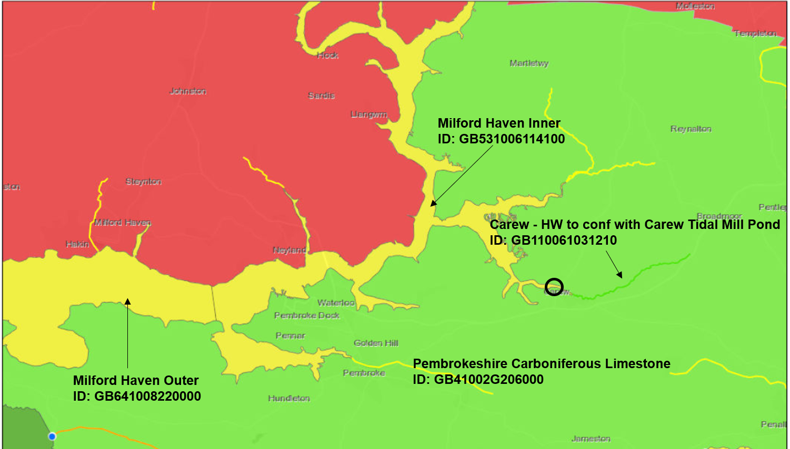
Figure 4-1 - Map of Waterbodies and Site Location (Circled Black) (Natural Resources Wales, 2020)
The following waterbody has been screened-in for further assessment:
- Milford Haven Inner (ID: GB531006114100)

Milford Haven Inner
Milford Haven Inner is not a AHMWB and therefore is not required to be assessed for mitigation measures. The overall status for the waterbody has been assessed as ‘Moderate’, with ecological status as ‘Moderate’ and chemical status as ‘Fail’. Localised evidence from WFD monitoring suggests this is due to hyper-nutrification from dense growth of opportunistic macroalgae species in some areas and Dissolved Inorganic Nitrogen (DIN) achieving ‘Moderate’ classification (NRW, 2020). A summary of the WFD status classification is provided in Table 4-3.
Table 4-3 – WFD Status –Milford Haven Inner (Natural Resources Wales, 2020)
Waterbody: – Milford Haven Inner, transitional waterbody
Overall status: Moderate
Ecological status: Moderate
Chemical status: Fail
Mitigation measures: Not Assessed
Biological quality elements | Physico-Chemical quality elements | Hydro-morphological supporting elements
Fish: Good | Temperature: Not Assessed | Hydrological Regime: Supports Good
Invertebrates: Good | pH: Not Assessed | HMWB: No
Macroalgae: Moderate | Dissolved oxygen: High | Morphology: Supports Good
Phytoplankton: High | Phosphate: Not Assessed
 | Copper: Good
 | Zinc: Good
 | Arsenic: Good
 | Iron: Good

Statutory Designations
To understand the wider impacts on surrounding protected areas and their features, a site check was performed on Defra’s MAGIC map service (DEFRA, 2020), the Welsh governments open-source spatial platform – Lle (Welsh Government, 2020) and NRW Water Watch Wales Map Gallery (Natural Resources Wales, 2020). A 2 km buffer was used, however, a sense-check on designations outside of this boundary was carried out in case mobile and/or migratory species features could be present. The following statutory designations are located in a 2km vicinity of the works.
- Pembrokeshire Marine / Sir Benfro Forol Special Area of Conservation (SAC);
- Pembrokeshire Bat Sites and Bosherston Lakes / Safleoedd Ystlum Sir Benfro a Llynnoedd Bosherston SAC;Milford Haven Water Site of Special Scientific Interest (SSSI); and
- Carew Castle SSSI.
Under the WFD and government guidance, assessment is to be carried out on any designated Natura 2000 conservations sites defined under previous European legislation, which includes the two SACs. Any additional features of the two SSSIs which are not designated as part of the SACs, were also considered. However, neither SSSI has additional features which are likely to be impacted by the works, mainly due to the inhabitable environment, localised nature of the works, and / or the salinity tolerances of those habitats / species.
Carew Tidal Mill is located in one of the most upstream ends of the Pembrokeshire Marine SAC which covers an area of 1,380 km² and has been selected for the presence of 8 marine habitat types and associated Annex II species from the Habitats Directive as summarised in Table 4-3.
Pembrokeshire Bat Site and Bosherston Lakes is located approximately 200m upstream of Carew Mill and covers an area of 1.2 km², which mainly consists of the grounds of Carew Castle (JNCC, 2020). Bat usage of the Castle is well known, with some areas being out of bounds for visitors to avoid disturbing the bats.

Table 4-3 – WFD protected areas sites and their qualifying features
Site Name | Designated Features | Conservation Objectives
Pembrokeshire Marine / Sir Benfro Forol SAC | Habitats:  - Sandbanks which are slightly covered by seawater all the time;  - Estuaries;  - Mudflats and sandflats not covered by seawater at low tide;  - Coastal lagoons;  - Large shallow inlets and bays;  - Reefs;  - Submerged or partially;  - submerged sea caves; and  - Atlantic salt meadows.  Species:  - Grey seal Halichoerus grypus;  - Shore dock Rumex rupestris;  - Otter Lutra lutra;  - Allis shad Alosa alosa;  - Twaite shad Alosa fallax;  - River lamprey Lampetra fluviatilis; and  - Sea lamprey Petromyzon marinus. | Conservation objectives are the maintenance, or where appropriate the restoration of the ‘favourable conservation status’ of habitats and species features for which SACs and SPAs are designated.’ See individual links for further details.  Pembrokeshire Marine
Pembrokeshire Bat Sites and Bosherton Lakes / Safleoedd Ystlum Sir Benfro a Llynnoedd Bosherton SAC | Habitat:  - Hard oligo-mesotrophic waters with benthic vegetation of Chara species.  Species:  - Greater horshoe bat Rhinolophus ferrumequinum;  - Lesser Horshoe bat Rhinolophus hipposideros; and  - Otter Lutra lutra. | Pembrokeshire Bat Sites and Bosherton Lakes
The main source of impact from the works will be from the draining of the Millpond. The majority of the features of the Pembrokeshire Marine SAC are extremely unlikely to inhabit or be found in the Millpond. It is possible for shad species to migrate up to 800 km upstream to spawn (JNCC, 2020). However, they are not known to traverse obstacles and prefer gravelly sites to spawn. The muddy substrate around the Site is not suitable and therefore impacts to shad are unlikely. Past site visits have determined no Otter holts (dens) in the area, and no disturbance to the embankments is expected, as works are confined to the walls and causeway.
The designated features of Pembrokeshire Bat Sites and Bosherston Lakes SAC located upstream of the Site, specifically the Bat species, are unlikely to be impacted by the works as all proposed works are to be carried out during daylight, with minimal noise and / or light disturbance. The walls and causeway are not likely to provide bat roosting habitat.
Therefore, the surrounding statutory designated sites of Carew Tidal Mill have been screened-out from further assessment.

Protected Areas and Sensitive Habitats
WFD protected areas and sensitive habitats within the area need to be considered and are summarised in Table 4-4 (See Figure 4-2).
No bathing and/or drinking water protected areas were found within the 2 km buffer of the Site. The closest Bathing Water Protected Area (BWPA) is ‘Sandy Haven’ approximately 17 km Northwest from the Site. The closest drink water protected area (DWPA) is ‘Penglyn Brook - HW to tidal limit, Cleddau Estuary’ approximately 8 km Northeast from the Site.
Table 4-4 - Summary of WFD Sensitive habitats and Protected Areas
WFD Protected Areas and Habitats | Location in relation to the Site
Special Area of Conservation (SAC) | The Works lie in the Pembrokeshire Marine SAC and approximately 200m East of the Pembrokeshire Bat Sites and Bosherston Lakes SAC.
High Sensitivity | There are small scattered areas of Saltmarsh along the river embankments around the Site, with the largest area being approximately 800m from the Site. Saltmarsh often plays an important role in the structural composition or stability of the seabed and provides semi-sheltered areas for some species (Wildlife Trusts, 2020).
Low Sensitivity | Areas of the following lower sensitive habitats are located in 2 km Site. See Figure .  - Rocky shore  - Subtidal Soft Sediment  - Intertidal Soft Sediment
The main source of impact of the sensitive habitats comes from pollution spills and increased sedimentation. However, as discussed in Table 5-1, the likelihood for these impacts to occur with the suitable mitigation measures employed throughout the Works is minimal. Furthermore, due to the distance of the Site from the protected areas, there is little to no risk of the proposed works impacting them and so they have been screened-out from further assessment.

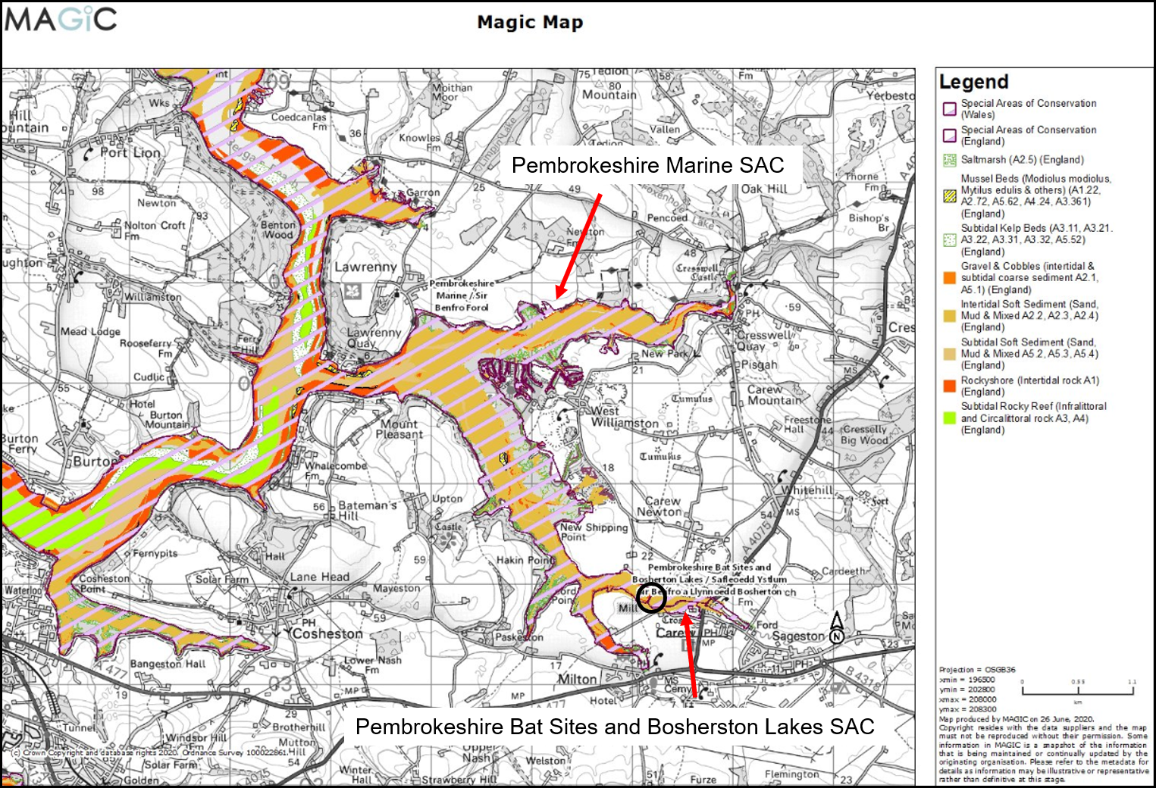
Figure 4-2 – Surrounding sensitive habitats and designations of the Carew Tidal Mill Site (Circled black) (DEFRA, 2020)

WFD Assessment
The following table - Table 5-1, presents the results of the preliminary WFD assessment for the Milford Haven Inner waterbody.

Table 5-1 Assessment of impacts on waterbody quality elements of the Milford Haven Inner waterbody
Biology  Fish fauna: Species composition and abundance; Presence of type-specific disturbance sensitive species; Age structure of fish communities.  Benthic invertebrate fauna: Composition; Abundance.  Macroalgae and phytoplankton: Taxonomic composition; Average macroalgae and phytoplankton abundance. | Physicochemical  Salinity, Nutrient concentrations, pH, Oxygen balance; Acid neutralising capacity, Temperature, Transparency.  Pollution by all priority substances identified as being discharged into the waterbody.  Pollution by other substances identified as being discharged in significant quantities into the waterbody. | Hydro-morphological Supporting Elements  Hydrological regime: Quantity and dynamics of water flow.  Morphological conditions: water column depth variation; Structure and substrate of the river bed. | Mitigation Measures that will be employed throughout the works  - Working during daylight hours, during low tide / areas from which the tide has been excluded and outside busy summer months;  - A toolbox talk will be given to contractors prior to the start date in order to inform contractors of the sensitive habitat and the limitations on access and working areas within the Millpond.  - Use of bio-degradable fuels, well-maintained equipment and spill kits provided for fuel/oil leaks. Plant and machinery will be switched off when not in use;  - No materials to be stored in the intertidal area.  - General measures to avoid or alleviate negative impacts on ecological receptors such as following the Pollution Prevention Guidelines, and the Construction Industry Research and Information Association (CIRIA) guidance on the control of water pollution from construction sites;  - All equipment and materials used will be in a clean condition prior to their arrival on site, and on removal from site, to minimise risk of introducing INNS into the marine environment.  - Raise awareness of the presence of otters (no holt in vicinity).
Assessment of Impact | Assessment of Impact | Assessment of Impact
During previous consultation as discussed in Section 1.2, assessment of impacts were raised regarding the tentacled lagoon worm, Alkmaria romijni, and the potential drying out of the mudflats. NRW reported the Millpond as having patchily dense oligochaete worms, including low population numbers of the tentacled lagoon worm (NRW, 2018). The method of works has been updated to ensure efficient flooding of the mudflats including spill over during Spring tides so that the Millpond will only be left dry for a maximum of, up to 7 days, allowing sufficient hydration for the Tentacled Lagoon Worm communities.  All repair works will be undertaken during neap tides or at the surface, away from tidal reaches and in a limited timeframe. Therefore, as there are limited pathways between the Works and the waterbody when the works are proposed to take place, no impacts on biological elements are expected. | As shown in Table 4-3, the Milford Haven Inner waterbody has had ‘Fail’ chemical status since 2015. WFD monitoring has recorded the reason for this to be Tributyltin levels along with ‘Moderate’ Dissolved Inorganic Nitrogen levels (DIN). Dissolved Oxygen has been assessed as ‘High’. Temperature and pH have not been assessed. All trace metals have been assessed as ‘Good’.  The proposed works are not expected to disturb any dormant contaminants back into the water column as no dredging or depositing of sediment is proposed and the majority of the works will be carried out at the surface or during low tide / areas from which the tide has been excluded. Once the tide starts to rise any disturbance on the mudflats from work carried out on the walls of the dam will be minimal. The works will not affect DIN levels.  There is potential for pollutants such as fuel/oil from machinery and concrete to leak onto the mudflats during the works. However standard good practice measures have been considered in the Mitigation Measures section to reduce these impacts including; the use of bio-degradable fuel, spill kits no fuelling allowed alongside the Mill. All appropriate mitigation measures will be in place and deployed during the Works to minimise any pollution risks. | The Milford Haven Inner waterbody has ‘Supports Good’ status for both morphological conditions and hydrological regime since 2015.  The type of works are expected to have minor temporary changes to the hydro-morphological supporting elements of the waterbody, with the removal of the sluice gates and use of the stoplogs. However, this will be short temporary changes and will revert to the current regime once the works are complete.  The Works will also enhance the stability of the walls and life expectancy of the sluice gates, which provides benefits to the users of the Carew Tidal Mill and will come at a greater cost if not repaired.
The potential for the proposed works to result in deterioration to the biological quality elements is considered NEGLIGIBLE. | The potential for the proposed works to result in deterioration to the physicochemical quality elements is considered NEGLIGIBLE. | The potential for the proposed works to result in deterioration to the hydro-morphological supporting elements is considered NEGLIGIBLE to MINOR.

Summary
This preliminary WFD Assessment has evaluated the proposed works at Milford Haven Inner waterbody (ID: GB531006114100), against the biological, physicochemical and hydro-morphological elements of the WFD and potential impacts on the surrounding protected areas, sensitive habitats and statutory designated sites. Based on the information available and considering the mitigation measures which will be employed throughout the Works, the Works is expected to have a NEGLIGIBLE impact on the biological, physicochemical and hydro-morphological quality and supporting elements of the WFD waterbodies and is therefore WFD compliant.
The implementation of the repair works will prevent further deterioration to the Carew Tidal Mill wall and sluice gates, supporting the ongoing operation and recreational use of a unique historic site.

References
DEFRA, 2020. MAGIC. [Online]
Available at: https://magic.defra.gov.uk/home.htm
[Accessed 06 23 2020].
JNCC, 2020. 1102 Allis shad Alosa alosa. [Online]
Available at: https://sac.jncc.gov.uk/species/S1102/
[Accessed 26 06 2020].
JNCC, 2020. SACs in the United Kingdom. [Online]
Available at: https://sac.jncc.gov.uk/site/
[Accessed 26 06 2020].
Natural Resources Wales, 2020. Water Watch Wales Map Gallery. [Online]
Available at: https://waterwatchwales.naturalresourceswales.gov.uk/en/
[Accessed 23 06 2020].
NRW, 2018. Pembrokeshire Marine / Sir Benfro Forol, Cardiff: Natural Resources Wales.
NRW, 2020. Evidence Review of the trophic status of the Milford Haven, Cardiff: Natural Resources Wales.
NRW, 2020. River Basin Management Plans. [Online]
Available at: https://naturalresources.wales/evidence-and-data/research-and-reports/water-reports/river-basin-management-plans/western-wales-river-basin-management-plan/?lang=en
[Accessed 23 06 2020].
Welsh Government, 2020. Lle - Map Browser. [Online]
Available at: http://lle.gov.wales/map#m=-4.78105,51.71065,13&b=europa&l=6;5;12;1356;
[Accessed 29 06 2020].
Wildlife Trusts, 2020. Saltmarshes and Estuaries. [Online]
Available at: https://www.wildlifetrusts.org/where_see_estuaries_saltmarshes#:~:text=Terry%20Whittaker%2F2020VISION-,Saltmarshes%20and%20estuaries,populations%20of%20well%2Dadapted%20species.
[Accessed 25 06 2020].

Rob Morgan
Atkins Limited
West Glamorgan House
12 Orchard St
Swansea
SA1 5AD
Tel: +44 (0)1792 641172
rob.morgan@atkinsglobal.com

© Atkins Limited except where stated otherwise

The WFD classification scheme for GES includes five categories: high, good, moderate, poor and bad. ‘High status’ means no or very low human pressure. ‘Good status’ means a ‘slight’ deviation from this condition, ‘moderate status’ means ‘moderate’ deviation, and so on.

