

Permit with introductory note
The Environmental Permitting (England & Wales) Regulations 2016

Mills Poultry Ltd

Pentreucha Farm
Llanerfyl
Welshpool
Powys
SY21 0JB

Permit number

EPR/AP3230UK

Pentreucha Farm

Permit number EPR/AP3230UK

Introductory note

This introductory note does not form a part of the permit

The main features of the permit are as follows.

Mills Poultry Limited is a limited company operating a poultry farm with 135,000 places for rearing chickens for meat production. Birds are brought in from a hatchery and transported to a processing plant at the end of the growing period. Both the hatchery and the processing plant are at different locations and run by different operators. The average cycle length is 63 days.

The land around the installation is predominantely an agricultural area with surrounding grazing land, and some residential housing within 400 metres to the south of the installation. The land around the installation has a relatively steep incline, dropping away quickly to the south and rising sharply to the north west. Mature trees screen the southern edge of the installation. There are surface waters within 250 metres of the installation, with the Nant Menial (a tributary of the Afon Banwy) running in a north easterly direction approximately 15 metres to the south of one of House 4. Approximately 3.4km to the north east of the installation is a Site of Special Scientific Interest known as Cors Lawnt.

The site is comprised of four poultry units; all of which have side inlets and roof ridge extraction fans, and all of which are sited on concrete bases, with associated biomass boilers and feed storage in enclosed fibre glass bins. Birds which die during the production cycle are recorded and removed from houses on a daily basis. Carcasses are held in vermin proof bins prior to spreading. Used litter is removed from site and spread on separately owned agricultural land.

Releases from intensive farming installations may include releases of ammonia and dust to air, releases to controlled water, land and groundwater as well as releases of odour and noise.

The status log of the permit sets out the permitting history, including any changes to the permit reference number.

Status log of the permit
Description | Date | Comments
Application AP3230UK received | Duly made 29/01/2007
Additional information requested | 01/05/2007 | Response received on 02/07/2007
Application determined and permit AP3230UK issued | 06/07/2007
Variation application EPR/AP3230UK/V002 received | Duly made 24/01/2011
Variation application determined and variation EPR/AP3230UK/V002 issued | 11/02/2011
Variation application EPR/AP3230UK/V003 received | Duly made 16/12/2016
Variation application determined and variation EPR/AP3230UK/V003 issued | 28/02/2017

End of introductory note

Permit
The Environmental Permitting (England and Wales) Regulations 2016

Permit number

EPR/AP3230UK

This is the consolidated permit referred to in the variation and consolidation notice for application EPR/AP3230UK/V003 authorising,

Mills Poultry Ltd (“the operator”),

whose registered office is

Minffordd

Llangadfan

Welshpool

SY21 0PL

company registration number 4553061

to operate a regulated facility at

Pentreucha Farm

Llanerfyl

Welshpool

Powys

SY21 0JB

to the extent authorised by and subject to the conditions of this permit.

Signed | Date
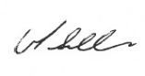 | 28th February 2017

Victoria Seller

Authorised on behalf of Natural Resources Wales

Conditions

Management

General management

The operator shall manage and operate the activities:

in accordance with a written management system that identifies and minimises risks of pollution, including those arising from operations, maintenance, accidents, incidents, non-conformances, closure and those drawn to the attention of the operator as a result of complaints; and

using sufficient competent persons and resources.

Records demonstrating compliance with condition 1.1.1 shall be maintained.

Any person having duties that are or may be affected by the matters set out in this permit shall have convenient access to a copy of it kept at or near the place where those duties are carried out.

1.2 Energy efficiency

1.2.1 The operator shall:

(a) take appropriate measures to ensure that energy is used efficiently in the activities;

(b) review and record at least every four years whether there are suitable opportunities to improve the energy efficiency of the activities; and

(c) take any further appropriate measures identified by a review.

1.3 Efficient use of raw materials

1.3.1 The operator shall:
(a) take appropriate measures to ensure that raw materials and water are used efficiently in the activities;
(b) maintain records of raw materials and water used in the activities;
(c) review and record at least every four years whether there are suitable alternative materials that could reduce environmental impact or opportunities to improve the efficiency of raw material and water use; and
(d) take any further appropriate measures identified by a review.

1.4 Avoidance, recovery and disposal of wastes produced by the activities

The operator shall take appropriate measures to ensure that:

(a) the waste hierarchy referred to in Article 4 of the Waste Framework Directive is applied to the generation of waste by the activities; and

(b) any waste generated by the activities is treated in accordance with the waste hierarchy referred to in Article 4 of the Waste Framework Directive; and

(c) where disposal is necessary, this is undertaken in a manner which minimises its impact on the environment.

The operator shall review and record at least every four years whether changes to those measures should be made and take any further appropriate measures identified by a review.

2 Operations
2.1 Permitted activities

2.1.1 The operator is only authorised to carry out the activities specified in schedule 1 table S1.1 (the “activities”).

2.2 The site

2.2.1 The activities shall not extend beyond the site, being the land shown edged in green on the site layout plan at schedule 7 to this permit.

2.3 Operating techniques

2.3.1 (a) The activities shall, subject to the conditions of this permit, be operated using the

techniques and in the manner described in the documentation specified in schedule 1, table S1.2, unless otherwise agreed in writing by Natural Resources Wales.

(b) If notified by Natural Resources Wales that the activities are giving rise to pollution, the operator shall submit to Natural Resources Wales for approval within the period specified, a revision of any plan or other documentation (“plan”) specified in schedule 1, table S1.2 or otherwise required under this permit which identifies and minimises the risks of pollution relevant to that plan , and shall implement the approved revised plan in place of the original from the date of approval, unless otherwise agreed in writing by Natural Resources Wales.

2.3.2 The operator shall maintain and implement a system to record the number of animal places and animal movements.

2.3.3 The operator shall maintain and implement a system to record the quantities of solid manure or slurry exported from the installation, as defined on the site plan in schedule 7. The record shall include as a minimum:
- the date of export from the site
- the quantity exported
- details of the receiving site

2.3.4 The operator shall ensure that where waste produced by the activities is sent to a relevant waste operation, that operation is provided with the following information, prior to the receipt of the waste:

(a) the nature of the process producing the waste;

(b) the composition of the waste;

(c) the handling requirements of the waste;

(d) the hazardous property associated with the waste, if applicable; and

(e) the waste code of the waste.

2.3.5 The operator shall ensure that where waste produced by the activities is sent to a landfill site, it meets the waste acceptance criteria for that landfill.

2.4 Improvement programme

2.4.1 The operator shall complete the improvements specified in schedule 1 table S1.3 by the date specified in that table unless otherwise agreed in writing by Natural Resources Wales.

2.4.2 Except in the case of an improvement which consists only of a submission to Natural Resources Wales, the operator shall notify Natural Resources Wales within 14 days of completion of each improvement.

3 Emissions and monitoring

3.1 Emissions to water, air or land

3.1.1 There shall be no point source emissions to water, air or land except from the sources and emission points listed in schedule 3 tables S3.1, S3.2 and S3.3.

Emissions of substances not controlled by emission limits

Emissions of substances not controlled by emission limits (excluding odour) shall not cause pollution. The operator shall not be taken to have breached this condition if appropriate measures, including, but not limited to, those specified in any approved emissions management plan, have been taken to prevent or where that is not practicable, to minimise, those emissions.

3.2.2 The operator shall:

(a) if notified by Natural Resources Wales that the activities are giving rise to pollution, submit to Natural Resources Wales for approval within the period specified, an emissions management plan which identifies and minimises the risks of pollution from emissions of substances not controlled by emission limits;

(b) implement the approved emissions management plan, from the date of approval, unless otherwise agreed in writing by Natural Resources Wales.

3.2.3 All liquids in containers, whose emission to water or land could cause pollution, shall be provided with secondary containment, unless the operator has used other appropriate measures to prevent or where that is not practicable, to minimise, leakage and spillage from the primary container.
    - Periodic monitoring shall be carried out at least once every 5 years for groundwater and 10 years for soil, unless such monitoring is based on a systematic appraisal of the risk of contamination

3.3 Monitoring

3.3.1 The operator shall, unless otherwise agreed in writing by Natural Resources Wales, undertake the monitoring specified in the following tables in schedule 3 to this permit:

point source emissions specified in tables S3.1, S3.2 and S3.3;

3.3.2 The operator shall maintain records of all monitoring required by this permit including records of the taking and analysis of samples, instrument measurements (periodic and continual), calibrations, examinations, tests and surveys and any assessment or evaluation made on the basis of such data.

3.4 Odour

3.4.1 Emissions from the activities shall be free from odour at levels likely to cause pollution outside the site, as perceived by an authorised officer of Natural Resources Wales, unless the operator has used appropriate measures, including, but not limited to, those specified in any approved odour management plan, to prevent or where that is not practicable to minimise the odour.

3.5 Noise and vibration

3.5.1 Emissions from the activities shall be free from noise and vibration at levels likely to cause pollution outside the site, as perceived by an authorised officer of Natural Resources Wales, unless the operator has used appropriate measures, including, but not limited to, those specified in any approved noise and vibration management plan to prevent or where that is not practicable to minimise the noise and vibration.

3.5.2 The operator shall:

(a) if notified by Natural Resources Wales that the activities are giving rise to pollution outside the site due to noise and vibration, submit to Natural Resources Wales for approval within the period specified, a noise and vibration management plan which identifies and minimises the risks of pollution from noise and vibration;

(b) implement the approved noise and vibration management plan, from the date of approval, unless otherwise agreed in writing by Natural Resources Wales.

3.6 Pests
3.6.1 The activities shall not give rise to the presence of pests which are likely to cause pollution, hazard or annoyance outside the boundary of the site. The operator shall not be taken to have breached this condition if appropriate measures, including, but not limited to, those specified in any approved pests management plan, have been taken to prevent or where that is not practicable, to minimise the presence of pests on the site.

3.6.2 The operator shall:
(a) if notified by Natural Resources Wales, submit to Natural Resources Wales for approval within the period specified, a pests management plan which identifies and minimises risks of pollution, hazard or annoyance from pests;
(b) implement the pests management plan, from the date of approval, unless otherwise agreed in writing by Natural resources Wales

4 Information

4.1 Records

All records required to be made by this permit shall:

be legible;

be made as soon as reasonably practicable;

if amended, be amended in such a way that the original and any subsequent amendments remain legible, or are capable of retrieval; and

be retained, unless otherwise agreed in writing by Natural Resources Wales, for at least 6 years from the date when the records were made, or in the case of the following records until permit surrender:
- off-site environmental effects; and
- matters which affect the condition of the land and groundwater.
4.1.2 The operator shall keep on site all records, plans and the management system required to be maintained by this permit, unless otherwise agreed in writing by Natural Resources Wales.

4.2 Reporting

4.2.1 The operator shall send all reports and notifications required by the permit to Natural Resources Wales using the contact details supplied in writing by Natural Resources Wales.

4.2.2 The operator shall, unless notice under this condition has been served within the preceding four years, submit to Natural Resources Wales, within six months of receipt of a written notice, a report assessing whether there are other appropriate measures that could be taken to prevent, or where that is not practicable, to minimise pollution.

4.3 Notifications
4.3.1 (a) In the event that the operation of the activities gives rise to an incident or accident which significantly affects or may significantly affect the environment, the operator must immediately—
(i) inform Natural Resources Wales,
(ii) take the measures necessary to limit the environmental consequences of such an incident or accident, and
(iii) take the measures necessary to prevent further possible incidents or accidents;
(b) in the event of a breach of any permit condition the operator must immediately—
(i) inform Natural Resources Wales, and
(ii) take the measures necessary to ensure that compliance is restored within the shortest possible time;
(c) in the event of a breach of permit condition which poses an immediate danger to human health or threatens to cause an immediate significant adverse effect on the environment, the operator must immediately suspend the operation of the activities or the relevant part of it until compliance with the permit conditions has been restored.

4.3.2 Any information provided under condition 4.3.1 shall be confirmed by sending the information listed in schedule 5 to this permit within the time period specified in that schedule.

4.3.3 Where Natural Resources Wales has requested in writing that it shall be notified when the operator is to undertake monitoring and/or spot sampling, the operator shall inform Natural Resources Wales when the relevant monitoring and/or spot sampling is to take place. The operator shall provide this information to Natural Resources Wales at least 14 days before the date the monitoring is to be undertaken.

4.3.4 Natural Resources Wales shall be notified within 14 days of the occurrence of the following matters, except where such disclosure is prohibited by Stock Exchange rules:

Where the operator is a registered company:

any change in the operator’s trading name, registered name or registered office address; and

(b) any steps taken with a view to the operator going into administration, entering into a company voluntary arrangement or being wound up.

Where the operator is a corporate body other than a registered company:

any change in the operator’s name or address; and

any steps taken with a view to the dissolution of the operator.

In any other case:

the death of any of the named operators (where the operator consists of more than one named individual);

any change in the operator’s name(s) or address(es); and

any steps taken with a view to the operator, or any one of them, going into bankruptcy, entering into a composition or arrangement with creditors, or, in the case of them being in a partnership, dissolving the partnership.

4.3.5 Where the operator proposes to make a change in the nature or functioning, or an extension of the activities, which may have consequences for the environment and the change is not otherwise the subject of an application for approval under the Regulations or this permit:

Natural Resources Wales shall be notified at least 14 days before making the change; and

the notification shall contain a description of the proposed change in operation.

4.3.6 Natural Resources Wales shall be given at least 14 days notice before implementation of any part of the site closure plan.

4.4 Interpretation

4.4.1 In this permit the expressions listed in schedule 6 shall have the meaning given in that schedule.

4.4.2 In this permit references to reports and notifications mean written reports and notifications, except where reference is made to notification being made “without delay”, in which case it may be provided by telephone.

Schedule 1 - operations

Table S1.1 activities
Activity listed in Schedule 1 of the EP Regulations | Description of specified activity |  | Limits of specified activity
Section 6.9 A(1)(a)(i) Rearing of poultry or pigs intensively in an installation with more than: (i) 40,000 places of poultry | The rearing of poultry in a facility with a capacity for 135,000 broiler places |  | From receipt of birds, raw materials and fuels onto the site, to removal of birds and associated wastes from site

Directly Associated Activity
Biomass boilers | Operation of six biomass boilers where the aggregate boiler net rated thermal imput is less than 1MWth | From receipt of raw materials and fuels, to release of combustion products to air and associated wastes removed from site. Biomass fuel comprising only virgin timber, straw, miscanthus
Dirty water tank | Storage of dirty water from washing of poultry houses | Temporary storage of wash down water, pending removal of dirty water from site

Table S1.2 Operating techniques
Description | Parts | Date Received
Application EPR/AP3230UK for a permit | The responses to sections B2.3.1, B2.3.2, B2.3.3, B2.6.1, B2.6.2, B2.6.3, B2.7.1, B2.7.2 and plan B1.3/009 in the application | 29/01/2007
Request for Information dated 01/05/2007 | Response to Request for Information confirming installation reference in odour and noise management plans | 02/07/2007
Variation application EPR/AP3230UK/V003 | Information provided in Appendix 7 of the application: Technical Standards, including information relating to the Renewable Heat Incentive | 28/11/2016

Table S1.3 Improvement programme requirements
Reference | Requirement | Date
IC1 | The operator shall maintain and implement the odour management plan submitted with the application in accordance with SGN How to Comply with your environmental permit for intensive farming, Version 2. The operator shall review the plan and record at least every 4 years or as soon as practicable after a complaint (whichever is the earlier), whether changes to the plan should be made and make any appropriate changes to the plan identified by a review. | 06/07/2007
IC2 | The operator shall maintain and implement the noise management plan submitted as part of the application in accordance with SGN How to comply with your environmental permit for intensive farming, Version 2. The operator shall review and record at least every 4 years or as soon as practicable after a complaint (whichever is the earlier), whether changes to the plan should be made and make any appropriate changes to the plan identified by a review. | 06/07/2007

Schedule 2 - waste types, raw materials and fuels

Table S2.1 Raw materials and fuels
Raw materials and fuel description | Specification
- | -

Schedule 3 – emissions and monitoring

Table S3.1 Point source emissions to air – emission limits and monitoring requirements
Emission point ref. & location | Source | Parameter | Limit (including unit) | Reference period | Monitoring frequency | Monitoring standard or method
High velocity roof fan outlets, as shown in the Site Plan in Schedule 7 | Houses 2-5 | - | - | - | - | -
Vent from LPG tank | LPG tanks | - | - | - | - | -
Air breather on fuel oil tank (integral) | Generator - |  | - | - | - | -
Exhaust on generator | Generator | - | - | - | - | -
Exhaust from biomass boiler, as shown in the Site Plan in Schedule 7 | BB2 Grid Ref: 302662, 309303  BB2 Grid Ref: 302662, 309305 | - | - | - | - | -
Exhaust from biomass boiler, as shown in the Site Plan in Schedule 7 | BB3 Grid Ref: 302624, 309286 | - | - | - | - | -
Exhaust from biomass boiler, as shown in the Site Plan in Schedule 7 | BB4 Grid Ref: 302600, 309204  BB4 Grid Ref 302598, 309205 | - | - | - | - | -
Exhaust from biomass boiler, as shown in the Site Plan in Schedule 7 | BB5 Grid Ref: 302595, 309249 | - | - | - | - | -

Table S3.2 Point Source emissions to water (other than sewer) – emission limits and monitoring requirements
Emission point ref. & location | Source | Parameter | Limit (incl. unit) | Reference Period | Monitoring frequency | Monitoring standard or method
All roof water channelled to Afon Banwy vis small open ditches | All roof water | - | - | - | - | -

Table S3.3 Point source emissions to land– emission limits and monitoring requirements
Emission point ref. & location | Source | Parameter | Limit  (incl. Unit) | Reference period | Monitoring frequency | Monitoring standard or method
Soak away | Clean water from roof and yard area | - | - | - | - | -

Schedule 4 - reporting

There is no reporting under this schedule.

Schedule 5 - notification

These pages outline the information that the operator must provide.

Units of measurement used in information supplied under Part A and B requirements shall be appropriate to the circumstances of the emission. Where appropriate, a comparison should be made of actual emissions and authorised emission limits.

If any information is considered commercially confidential, it should be separated from non-confidential information, supplied on a separate sheet and accompanied by an application for commercial confidentiality under the provisions of the EP Regulations.

Part A

Permit Number

Name of operator

Location of Facility

Time and date of the detection

(a) Notification requirements for any activity that gives rise to an incident or accident which significantly affects or may significantly affect the environment

To be notified Immediately

Date and time of the event

Reference or description of the location of the event

Description of where any release into the environment took place

Substances(s) potentially released

Best estimate of the quantity or rate of release of substances

Measures taken, or intended to be taken, to stop any emission

Description of the failure or accident.

(b) Notification requirements for the breach of a permit condition

To be notified immediately

Emission point reference/ source

Parameter(s)

Limit

Measured value and uncertainty

Date and time of monitoring

Measures taken, or intended to be taken, to stop the emission

Time periods for notification following detection of a breach of a limit
Parameter | Notification period

(c) In the event of a breach of permit condition which poses an immediate danger to human health or threatens to cause an immediate significant adverse effect on the environment:

To be notified immediately

Description of where the effect on the environment was detected

Substances(s) detected

Concentrations of substances detected

Date of monitoring/sampling

Part B - to be submitted as soon as practicable

Any more accurate information on the matters for notification under Part A.

Measures taken, or intended to be taken, to prevent a recurrence of the incident

Measures taken, or intended to be taken, to rectify, limit or prevent any pollution of the environment which has been or may be caused by the emission

The dates of any unauthorised emissions from the facility in the preceding 24 months.

Name*

Post

Signature

Date

* authorised to sign on behalf of the operator

Schedule 6 - interpretation

“accident” means an accident that may result in pollution.
“application” means the application for this permit, together with any additional information supplied by the operator as part of the application and any response to a notice served under Schedule 5 to the EP Regulations.

“authorised officer” means any person authorised by Natural Resources Wales under section 108(1) of The Environment Act 1995 to exercise, in accordance with the terms of any such authorisation, any power specified in section 108(4) of that Act.

“emissions of substances not controlled by emission limits” means emissions of substances to air, water or land from the activities, either from the emission points specified in schedule 3 or from other localised or diffuse sources, which are not controlled by an emission limit..
“emissions to land” includes emissions to groundwater.
“EP Regulations” means The Environmental Permitting (England and Wales) Regulations SI 2016 No.1154 and words and expressions used in this permit which are also used in the Regulations have the same meanings as in those Regulations.
“groundwater” means all water, which is below the surface of the ground in the saturation zone and in direct contact with the ground or subsoil.

“Industrial Emissions Directive” means DIRECTIVE 2010/75/EU OF THE EUROPEAN PARLIAMENT AND OF THE COUNCIL of 24 November 2010 on industrial emissions

“Manure and slurry” have the following meaning:
- Manures may be either slurries or solid manures.
- Slurries consist of excreta produced by livestock whilst in a yard or building mixed with rainwater and wash water and, in some cases, waste bedding and feed. Slurries can be pumped or discharged by gravity.
- Slurry includes duck effluent, seepage from manure and wash water.
- Solid manures include farmyard manure (FYM) and comprise material from straw-based housing systems, excreta with lots of straw/sawdust/woodchips in it, or solids from mechanical separators.
- Most poultry systems produce solid manure (litter).
- Solid manure can generally be stacked.

“Manure management plan” means the requirements described in Section 2.3 of SGN 6.09 How to Comply – Intensive Farming.
“Pests” means Birds, Vermin and Insects.

“SGN How to comply – Intensive Farming” The EPR Sector Guidance Note 6.09 for intensive pig and poultry farmers, Version 2 published January 2010.
“year” means calendar year ending 31 December.

Schedule 7 - site plan
Site Location Plan
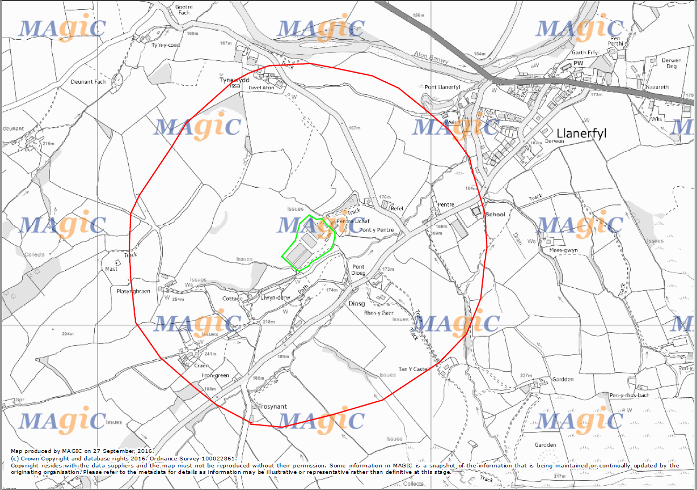

Site Layout Plan Legend

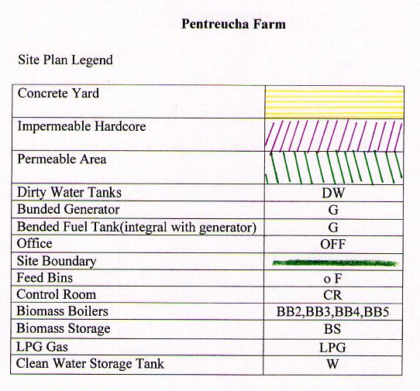

Site Layout Plan
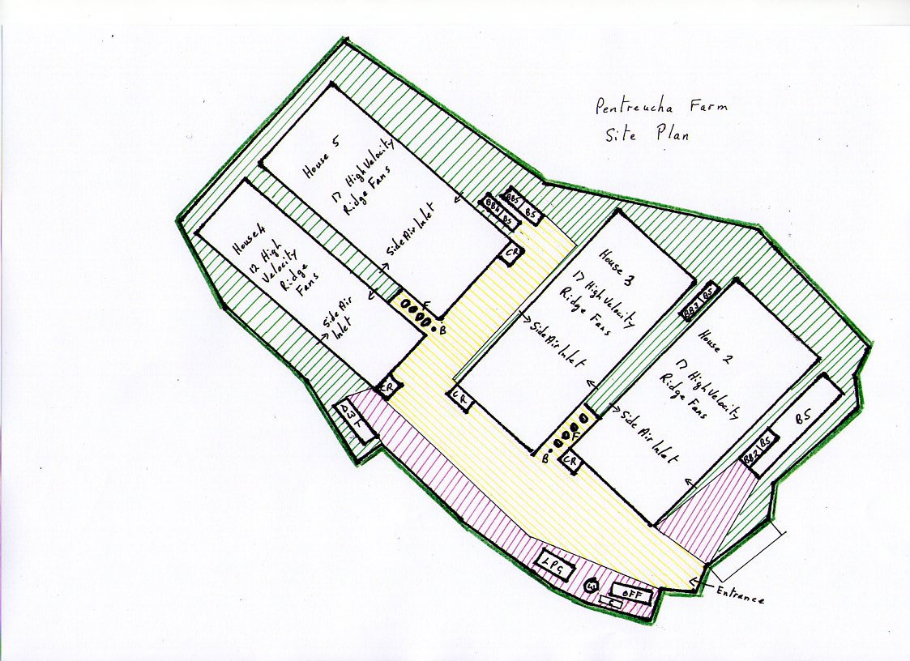
END OF PERMIT

