Permit with introductory note

The Environmental Permitting (England & Wales) Regulations 2010

Mr William Bedell

Neuadd Isaf Poultry Farm
Penybont
Llandrindod Wells
Powys
LD1 5SW

Variation application number
EPR/HP3836MG

Permit number

EPR/HP3836MG

Neuadd Isaf Poultry Farm

Permit number EPR/HP3836MG

Introductory note

This introductory note does not form a part of the notice.

The main features of the site are as follows.

Neuadd Isaf Poultry Unit is situated approximately two and a half kilometres East from Llandrindod Wells in Powys. It is approximately centred on National Grid Reference SO 09510 62130.

The installation is operated by Mr William Bedell and will house a maximum of 170,900 broiler chickens. The birds will be brought to the site at approximately one day old and removed at maturity. The birds will be delivered and removed on an “All In, All Out” basis.

The Birds will be housed in four buildings each of which will be constructed to the latest BAT standards. The buildings will be be equipped with high velocity roof vents and will be heated by biomass boilers.

After the birds are removed the litter will be removed and spread on off site land. The buildings will then be cleaned, disinfected and dried prior to the next re-stocking of birds. All wash waters will be collected and disposed of appropriately.

The status log of a permit sets out the permitting history, including any changes to the permit reference number. .

Status log of the permit
Description | Date | Comments
Application HP3836MG | Duly made 01/12/06
Permit issued | 30/01/08
IC3, requirement for Condition Deleted | Not required
Variation EPR/HP3836MG/V002 (PAS Number FP3134TA) | Duly Made 30/04/2010
Variation Determined | 17/05/2010
Variation Application EPR/HP3836MG/V003 | Duly made 30/10/14 | Application for biomass boilers.
Variation determined | 27/02/15 | Variation issued
Variation Application EPR/HP3836MG/V004 | Duly made 11/11/15 | Application for use of grade A “clean” recycled wood in the biomass boilers.
Variation determined | 29/01/16 | Variation and consolidated permit issued

End of introductory note

Permit
The Environmental Permitting (England and Wales) Regulations 2010

Permit number

EPR/HP3836MG

This is the consolidated permit referred to in the variation and consolidation notice for application EPR/HP3836MG/V004 authorising,

Mr William Bedell (“the operator”),

of

Neuadd Isaf

Penybont

Llandridnod Wells

Powys

LD1 5SW

to operate an installation at

Neuadd Isaf Poultry Farm

Penybont

Llandrindod Wells

Powys

LD1 5SW

to the extent authorised by and subject to the conditions of this permit.

Name | Date
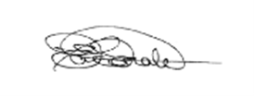 | 29 January 2016

Eirian Macdonald

Authorised on behalf of Natural Resources Wales

Conditions

Management

General management

The operator shall manage and operate the activities:

in accordance with a written management system that identifies and minimises risks of pollution, including those arising from operations, maintenance, accidents, incidents, non-conformances, closure and those drawn to the attention of the operator as a result of complaints; and

using sufficient competent persons and resources.

Records demonstrating compliance with condition 1.1.1 shall be maintained.

Any person having duties that are or may be affected by the matters set out in this permit shall have convenient access to a copy of it kept at or near the place where those duties are carried out.

1.2 Energy efficiency

1.2.1 The operator shall:

(a) take appropriate measures to ensure that energy is used efficiently in the activities;

(b) review and record at least every four years whether there are suitable opportunities to improve the energy efficiency of the activities; and

(c) take any further appropriate measures identified by a review.

1.3 Efficient use of raw materials
1.3.1 The operator shall:

(a) take appropriate measures to ensure that raw materials and water are used efficiently in the activities;
(b) maintain records of raw materials and water used in the activities;
(c) review and record at least every four years whether there are suitable alternative materials that could reduce environmental impact or opportunities to improve the efficiency of raw material and water use; and
(d) take any further appropriate measures identified by a review.

1.4 Avoidance, recovery and disposal of wastes produced by the activities
    - The operator shall take appropriate measures to ensure that:

(a) the waste hierarchy referred to in Article 4 of the Waste Framework Directive is applied to the generation of waste by the activities; and

(b) any waste generated by the activities is treated in accordance with the waste hierarchy referred to in Article 4 of the Waste Framework Directive; and

(c) where disposal is necessary, this is undertaken in a manner which minimises its impact on the environment.
    - The operator shall review and record at least every four years whether changes to those measures should be made and take any further appropriate measures identified by a review.

2 Operations
2.1 Permitted activities

2.1.1 The operator is only authorised to carry out the activities specified in schedule 1 table S1.1 (the “activities”).

2.2 The site

2.2.1 The activities shall not extend beyond the site, being the land shown edged in green on the site plan at schedule 7 to this permit.

2.3 Operating techniques

2.3.1 (a) The activities shall, subject to the conditions of this permit, be operated using the techniques and in the manner described in the documentation specified in schedule 1, table S1.2, unless otherwise agreed in writing by Natural Resources Wales.

(b) If notified by Natural Resources Wales that the activities are giving rise to pollution, the operator shall submit to Natural Resources Wales for approval within the period specified, a revision of any plan specified in schedule 1, table S1.2 or otherwise required under this permit which identifies and minimises the risks of pollution relevant to that plan , and shall implement the approved revised plan in place of the original from the date of approval, unless otherwise agreed in writing by Natural Resources Wales.

2.3.2 The operator shall maintain and implement a system to record the number of animal places and animal movements.

2.3.3 Waste shall only be accepted if:

(a) it is of a type and quantity listed in schedule 2 table S2.2; and

(b) it conforms to the description in the documentation supplied by the producer and holder.
2.3.4 Any raw materials or fuels listed in schedule 2 table S2.1 shall conform to the specifications set out in that table.

2.3.5 The operator shall maintain and implement a system to record the quantities of solid manure or slurry exported from the installation, as defined on the site plan in schedule 7. The record shall include as a minimum:
- the date of export from the site
- the quantity exported
- details of the receiving site

2.3.6 The operator shall ensure that where waste produced by the activities is sent to a relevant waste operation, that operation is provided with the following information, prior to the receipt of the waste:

(a) the nature of the process producing the waste;

(b) the composition of the waste;

(c) the handling requirements of the waste;

(d) the hazardous property associated with the waste, if applicable; and

(e) the waste code of the waste.

2.3.7 The operator shall ensure that where waste produced by the activities is sent to a landfill site, it meets the waste acceptance criteria for that landfill.

2.4 Improvement programme

2.4.1 The operator shall complete the improvements specified in schedule 1 table S1.3 by the date specified in that table unless otherwise agreed in writing by Natural Resources Wales.

2.4.2 Except in the case of an improvement which consists only of a submission to Natural Resources Wales, the operator shall notify Natural Resources Wales within 14 days of completion of each improvement.

3 Emissions and monitoring

3.1 Emissions to water, air or land

3.1.1 There shall be no point source emissions to water, air or land except from the sources and emission points listed in schedule 3 tables S3.1 and S3.2.
  - Emissions of substances not controlled by emission limits
    - Emissions of substances not controlled by emission limits (excluding odour) shall not cause pollution. The operator shall not be taken to have breached this condition if appropriate measures, including, but not limited to, those specified in any approved emissions management plan, have been taken to prevent or where that is not practicable, to minimise, those emissions.

3.2.2 The operator shall:

(a) if notified by Natural Resources Wales that the activities are giving rise to pollution, submit to Natural Resources Wales for approval within the period specified, an emissions management plan which identifies and minimises the risks of pollution from emissions of substances not controlled by emission limits;

(b) implement the approved emissions management plan, from the date of approval, unless otherwise agreed in writing by Natural Resources Wales.

3.2.3 All liquids in containers, whose emission to water or land could cause pollution, shall be provided with secondary containment, unless the operator has used other appropriate measures to prevent or where that is not practicable, to minimise, leakage and spillage from the primary container.
    - Periodic monitoring shall be carried out at least once every 5 years for groundwater and 10 years for soil, unless such monitoring is based on a systematic appraisal of the risk of contamination

3.3 Odour

3.3.1 Emissions from the activities shall be free from odour at levels likely to cause pollution outside the site, as perceived by an authorised officer of Natural Resources Wales, unless the operator has used appropriate measures, including, but not limited to, those specified in any approved odour management plan, to prevent or where that is not practicable to minimise the odour.

3.4 Noise and vibration

3.4.1 Emissions from the activities shall be free from noise and vibration at levels likely to cause pollution outside the site, as perceived by an authorised officer of Natural Resources Wales, unless the operator has used appropriate measures, including, but not limited to, those specified in any approved noise and vibration management plan to prevent or where that is not practicable to minimise the noise and vibration.

3.4.2 The operator shall:

(a) if notified by Natural Resources Wales that the activities are giving rise to pollution outside the site due to noise and vibration, submit to Natural Resources Wales for approval within the period specified, a noise and vibration management plan which identifies and minimises the risks of pollution from noise and vibration;

(b) implement the approved noise and vibration management plan, from the date of approval, unless otherwise agreed in writing by Natural Resources Wales.

3.5 Monitoring

3.5.1 The operator shall, unless otherwise agreed in writing by Natural Resources Wales, undertake the monitoring specified in the following tables in schedule 3 to this permit:
- point source emissions specified in tables S3.1 and S3.2.

3.5.2 The operator shall maintain records of all monitoring required by this permit including records of the taking and analysis of samples, instrument measurements (periodic and continual), calibrations, examinations, tests and surveys and any assessment or evaluation made on the basis of such data.

3.6 Pests
3.6.1 The activities shall not give rise to the presence of pests which are likely to cause pollution, hazard or annoyance outside the boundary of the site. The operator shall not be taken to have breached this condition if appropriate measures, including, but not limited to, those specified in any approved pests management plan, have been taken to prevent or where that is not practicable, to minimise the presence of pests on the site.
3.6.2 The operator shall:
(a) if notified by Natural Resources Wales, submit to Natural Resources Wales for approval within the period specified, a pests management plan which identifies and minimises risks of pollution, hazard and annoyance from pests;
(b) implement the pests management plan, from the date of approval, unless otherwise agreed in writing by Natural Resources Wales.

4 Information

4.1 Records
    - All records required to be made by this permit shall:
- be legible;
- be made as soon as reasonably practicable;
- if amended, be amended in such a way that the original and any subsequent amendments remain legible, or are capable of retrieval; and
- be retained, unless otherwise agreed in writing by Natural Resources Wales, for at least 6 years from the date when the records were made, or in the case of the following records until permit surrender:
- off-site environmental effects; and
- matters which affect the condition of the land and groundwater.
    - The operator shall keep on site all records, plans and the management system required to be maintained by this permit, unless otherwise agreed in writing by Natural Resources Wales.

4.2 Reporting
4.2.1 The operator shall send all reports and notifications required by the permit to Natural Resources Wales using the contact details supplied in writing by Natural Resources Wales.

4.2.2 The operator shall, unless notice under this condition has been served within the preceding four years, submit to Natural Resources Wales, within six months of receipt of a written notice, a report assessing whether there are other appropriate measures that could be taken to prevent, or where that is not practicable, to minimise pollution.

4.3 Notifications
4.3.1 (a) In the event that the operation of the activities gives rise to an incident or accident which significantly affects or may significantly affect the environment, the operator must immediately:
(i) inform Natural Resources Wales;
(ii) take the measures necessary to limit the environmental consequences of such an incident or accident; and
(iii) take the measures necessary to prevent further possible incidents or accidents.
(b) In the event of a breach of any permit condition the operator must immediately:
(i) inform Natural Resources Wales; and
(ii) take the measures necessary to ensure that compliance is restored within the shortest possible time.
(c) In the event of a breach of permit condition which poses an immediate danger to human health or threatens to cause an immediate significant adverse effect on the environment, the operator must immediately suspend the operation of the activities or the relevant part of it until compliance with the permit conditions has been restored.

4.3.2 Any information provided under condition 4.3.1, shall be confirmed by sending the information listed in schedule 5 to this permit within the time period specified in that schedule.

4.3.3 Where Natural Resources Wales has requested in writing that it shall be notified when the operator is to undertake monitoring and/or spot sampling, the operator shall inform Natural Resources Wales when the relevant monitoring and/or spot sampling is to take place. The operator shall provide this information to Natural Resources Wales at least 14 days before the date the monitoring is to be undertaken.

4.3.4 Natural Resources Wales shall be notified within 14 days of the occurrence of the following matters, except where such disclosure is prohibited by Stock Exchange rules:

Where the operator is a registered company:
- any change in the operator’s trading name, registered name or registered office address; and

(b) any steps taken with a view to the operator going into administration, entering into a company voluntary arrangement or being wound up.

Where the operator is a corporate body other than a registered company:

(a) any change in the operator’s name or address; and
- any steps taken with a view to the dissolution of the operator.

In any other case:
- the death of any of the named operators (where the operator consists of more than one named individual);
- any change in the operator’s name(s) or address(es); and
- any steps taken with a view to the operator, or any one of them, going into bankruptcy, entering into a composition or arrangement with creditors, or, in the case of them being in a partnership, dissolving the partnership.

4.3.5 Where the operator proposes to make a change in the nature or functioning, or an extension of the activities, which may have consequences for the environment and the change is not otherwise the subject of an application for approval under the Regulations or this permit:
- Natural Resources Wales shall be notified at least 14 days before making the change; and
- the notification shall contain a description of the proposed change in operation.

4.3.6 Natural Resources Wales shall be given at least 14 days notice before implementation of any part of the site closure plan.

4.4 Interpretation

4.4.1 In this permit the expressions listed in schedule 6 shall have the meaning given in that schedule.

4.4.2 In this permit references to reports and notifications mean written reports and notifications, except where reference is made to notification being made “without delay”, in which case it may be provided by telephone.

Schedule 1 - Operations

Table S1.1 activities
Activity listed in Schedule 1 of the EP Regulations | Description of specified activity | Limits of specified activity
Section 6.9 A(1)(a) Rearing of poultry or pigs intensively in an installation with more than 40,000 places for poultry | The rearing of poultry in a facility with a capacity for 170,900 places. | From receipt of birds, raw materials and fuels onto the site, to removal of birds and associated wastes from site

Directly Associated Activity
Carcass incineration | Operation of an Incinerator for carcass disposal Animal Health approved < 50 kg/hr | From receipt of raw materials, fuels and carcasses, to release of  combustion products to air and the removal of associated wastes from  site.
Biomass Boilers | Operation of Biomass Boilers with an aggregated thermal rated input not exceeding 0.856MWth for site heating requirements, burning biomass fuel. | From receipt of raw materials and fuels, to release of combustion products to air and associated wastes removed from site.  Biomass fuel comprising only virgin timber, straw, miscanthus or grade A “clean” recycled wood. See table S2.2.  Not to include any waste material other than that specified above. Not to include animal carcasses.

Table S1.2 Operating techniques
Description | Parts | Date Received
Application | The responses to sections B2.3.1, B2.3.2, B2.3.3, B2.6.1, B2.6.2, B2.6.3, B2.7.1, B2.7.2 in the application. | 01/12/06
Variation Application  EPR/HP3836MG/V003 | Responses to Part B3 section 3 of the application form and referenced supporting documentation.  Best available techniques as described in BAT conclusions under Directive 2010/75/EU of the European Parliament and of the Council on industrial emissions for Intensive Farming installations. | 16/09/2014
Variation Application  EPR/HP3836MG/V004 | Supporting documentation entitled proposed changes | 11/11/2015

Table S1.3 Improvement programme requirements
Reference | Requirement | Date
IC1 | A written plan shall be submitted to the Agency for approval, following a review of all site drainage at the installation. The plan shall take into account the appropriate measures for the management of drainage systems and run-off in S3.3 of TGN How to Comply, Version 1, and include a timetable for any improvements to the drainage system.  The notification requirements of condition 2.5.2 shall be deemed to have been complied with on submission of the plan.  The plan shall be implemented by the operator from the date of approval in writing by the Agency subject to such amendments or additions as notified by the Agency. | Completed
IC2 | A written plan shall be submitted to the Agency for approval following a review of existing poultry housing and management practices at the installation. The plan shall take into account the appropriate measures in S6.2.1 & S6.2.2 of TGN How to Comply, Version 1. The plan shall identify measures to reduce emissions to all media, the likely cost of such measures and a proposed timetable for their implementation.  The notification requirements of condition 2.5.2 shall be deemed to have been complied with on submission of the plan.  The plan shall be implemented by the operator from the date of approval in writing by the Agency subject to such amendments or additions as notified by the Agency. | Completed
IC3 | The operator shall provide written proposals to reduce the emission from Neuadd Isaf Poultry Farm by 44% or such other measures so that the contribution to the ammonia concentratio9n in air at the River Ithon (Site of Special Scientific Interest) is no more than 0.5 µg/m³ as an annual average.  The proposals shall be implemented by the operator by 30 October 2011 subject to such amendments, timescales or additions as notified by the Environment Agency. | Completed

Schedule 2 - Waste types, raw materials and fuels

Table S2.1 Raw materials and fuels
Raw materials and fuel description | Specification
Fuel for biomass boiler units | Biomass fuel comprising only virgin timber, straw, miscanthus or grade A “clean” recycled wood as specified in PAS 111:2012 Specification for the requirements and test methods for processing waste wood.

Table S2.2 Permitted waste types and quantities for use as biomass boiler fuel
Waste code | Description
03 01 05 | sawdust, shavings, cuttings, wood, particle board and veneer other than those mentioned in 03 01 04
15 01 03 | wooden packaging
19 12 07 | Wood other than that mentioned in 19 12 06

Schedule 3 – Emissions and monitoring

Table S3.1 Point source emissions to air – emission limits and monitoring requirements
Emission point ref. & location | Parameter | Source | Limit (incl. unit) | Reference period | Monitoring frequency | Monitoring standard or method
Side fan outlets on buildings 1-4 as shown on the plan reference “Neuadd Isaf Farm Plan” in the application. | -- | Poultry sheds 1 - 4 | --- | --- | --- | ---
Vent from LPG tanks as shown on the plan reference “Neuadd Isaf Farm Plan” in the application. | --- | LPG Tanks | ---- | --- | --- | ---
Chimney from carcass incinerator as shown on the plan reference “Neuadd Isaf Farm Plan” in the application. | --- | Carcass incinerator | ---- | --- | --- | ---

Exhaust from stand-by generator as shown on the plan reference “Neuadd Isaf Farm Plan” in the application.
Vents from fuel tanks as shown on the plan reference “Neuadd Isaf Farm Plan” in the application. | --- | Diesel Tanks | --- | --- | --- | ---
Exhaust chimney on Biomass Boiler located at 309598, 262130 | --- | 0.214 MW Biomass Boiler | --- | --- | --- | ---
Exhaust chimney on Biomass Boiler located at 309595, 262135 | --- | 0.214 MW Biomass Boiler | --- | --- | --- | ---
Exhaust chimney on Biomass Boiler located at 309593, 262139 | --- | 0.214 MW Biomass Boiler | --- | --- | --- | ---
Exhaust chimney on Biomass Boiler located at 309590, 262145 | --- | 0.214 MW Biomass Boiler | --- | --- | --- | ---

Table S3.2 Point Source emissions to land – emission limits and monitoring requirements
Emission point ref. & location | Parameter | Source | Limit (incl. unit) | Reference Period | Monitoring frequency | Monitoring standard or method
Emissions to ditches as shown on the plan reference “Neuadd Isaf Farm Plan” in the application. | --- | Roof and yard drainage serving buildings 1 – 4 | ---- | ---- | --- | ---

Schedule 4 - Reporting

There is no reporting under this schedule.

Schedule 5 - Notification

These pages outline the information that the operator must provide.

Units of measurement used in information supplied under Part A and B requirements shall be appropriate to the circumstances of the emission. Where appropriate, a comparison should be made of actual emissions and authorised emission limits.

If any information is considered commercially confidential, it should be separated from non-confidential information, supplied on a separate sheet and accompanied by an application for commercial confidentiality under the provisions of the EP Regulations.

Part A

Permit Number

Name of operator

Location of Facility

Time and date of the detection

((a) Notification requirements for any activity that gives rise to an incident or accident which significantly affects or may significantly affect the environment

To be notified Immediately

Date and time of the event

Reference or description of the location of the event

Description of where any release into the environment took place

Substances(s) potentially released

Best estimate of the quantity or rate of release of substances

Measures taken, or intended to be taken, to stop any emission

Description of the failure or accident.

(b) Notification requirements for the breach of a permit condition

To be notified immediately

Emission point reference/ source

Parameter(s)

Limit

Measured value and uncertainty

Date and time of monitoring

Measures taken, or intended to be taken, to stop the emission

Time periods for notification following detection of a breach of a limit
Parameter | Notification period

(c) In the event of a breach of permit condition which poses an immediate danger to human health or threatens to cause an immediate significant adverse effect on the environment:

To be notified immediately

Description of where the effect on the environment was detected

Substances(s) detected

Concentrations of substances detected

Date of monitoring/sampling

Part B - to be submitted as soon as practicable

Any more accurate information on the matters for notification under Part A.

Measures taken, or intended to be taken, to prevent a recurrence of the incident

Measures taken, or intended to be taken, to rectify, limit or prevent any pollution of the environment which has been or may be caused by the emission

The dates of any unauthorised emissions from the facility in the preceding 24 months.

Name*

Post

Signature

Date

* authorised to sign on behalf of the operator

Schedule 6 - Interpretation
“accident” means an accident that may result in pollution.
“application” means the application for this permit, together with any additional information supplied by the operator as part of the application and any response to a notice served under Schedule 5 to the EP Regulations.
“authorised officer” means any person authorised by Natural Resources Wales under section 108(1) of The Environment Act 1995 to exercise, in accordance with the terms of any such authorisation, any power specified in section 108(4) of that Act.
“Biomass” means:

a) vegetable matter from agriculture and forestry (waste material);
b) vegetable waste from the food processing industry, if the heat generated is recovered (waste material);
c) fibrous vegetable waste from virgin pulp production and from production of paper from pulp, if it is co-incinerated at the place of production and the heat generated is recovered (waste material);
d) cork waste (waste material);
e) wood waste with the exception of wood waste which may contain halogenated organic compounds or heavy metals as a result of treatment with wood preservatives or coating, and which includes in particular such wood waste originating from construction and demolition waste (waste material); and
f) virgin wood, wood chips and pellets (not waste material).

“building” means a construction that has the objective of providing sheltering cover and minimising emissions of noise, particulate matter, odour and litter.
“emissions to land” includes emissions to groundwater.
“emissions of substances not controlled by emission limits” means emissions of substances to air, water or land from the activities, either from the emission points specified in schedule 3 or from other localised or diffuse sources, which are not controlled by an emission limit..
“EP Regulations” means The Environmental Permitting (England and Wales) Regulations SI 2010 No.675 and words and expressions used in this permit which are also used in the Regulations have the same meanings as in those Regulations.

“grade A “clean” recycled wood” means wood meeting grade A as specified in PAS 111:2012 Specification for the requirements and test methods for processing waste wood.
“groundwater” means all water, which is below the surface of the ground in the saturation zone and in direct contact with the ground or subsoil.

“Industrial Emissions Directive” means DIRECTIVE 2010/75/EU OF THE EUROPEAN PARLIAMENT AND OF THE COUNCIL of 24 November 2010 on industrial emissions

“Manure and slurry” have the following meaning:
- Manures may be either slurries or solid manures.
- Slurries consist of excreta produced by livestock whilst in a yard or building mixed with rainwater and wash water and, in some cases, waste bedding and feed. Slurries can be pumped or discharged by gravity.
- Slurry includes duck effluent, seepage from manure and wash water.
- Solid manures include farmyard manure (FYM) and comprise material from straw-based housing systems, excreta with lots of straw/sawdust/woodchips in it, or solids from mechanical separators.
- Most poultry systems produce solid manure (litter).
- Solid manure can generally be stacked.

“Manure management plan” means the requirements described in Section 2.3 of SGN 6.09 How to Comply – Intensive Farming.

“Pests” means Birds, Vermin and Insects.

“virgin timber” means timber from whole trees and the woody parts of trees including branches and bark derived from forestry works, woodland management, tree surgery and other similar operations (it does not include clippings or trimmings that consist primarily of foliage);

virgin wood processing (e.g. wood offcuts, shavings or sawdust from sawmills) or timber product manufacture dealing in virgin timber.

If virgin timber is mixed with waste timber or any other waste, the mixed load is classed as waste.

“SGN How to comply – Intensive Farming” The EPR Sector Guidance Note 6.09 for intensive pig and poultry farmers, version 2 published January 2010.
“year” means calendar year ending 31 December.

Schedule 7 - Site plan

Site plan

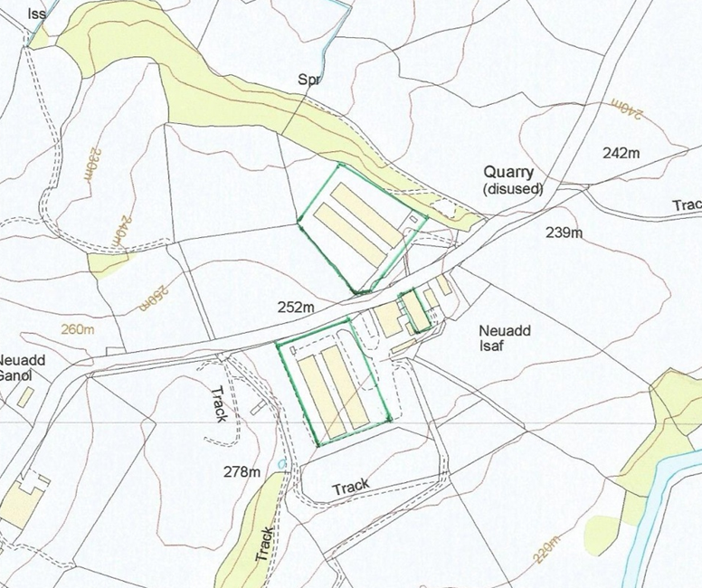
© Crown Copyright and database right 2015. Ordnance Survey licence number 100019741.

Site Layout plan (not to scale and for information only)

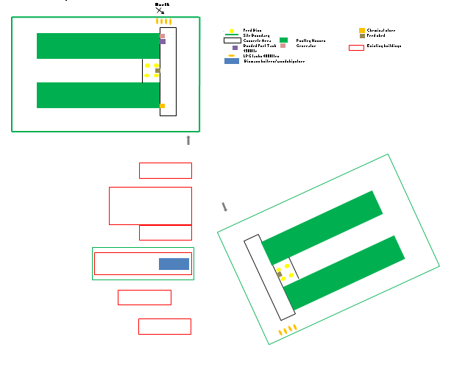

END OF PERMIT

