AS Modelling & Data Ltd. Response to - Notice requiring further information

Brynrorin Farm
Abermule
Montgomery
Powys
SY15 6JJ

Application number: EPR/NP3038WF/A001

Natural resources Wales comments are in blue, AS Modelling & Data Ltd. responses are in red.

Total number of bird places applied for

There is inconsistency between the submitted documents regarding the total number of bird places applied for. Application form B3 states that 80,000 bird places are being applied for, a figure which is repeated in the non-technical summary. However the ammonia and odour modelling studies state that there is one existing poultry house at the farm which provides 16,000 bird places, and the applicant wishes to construct a new house which will provide a further 32,000 bird places. Both reports state that the studies have considered the impacts of an optional additional house with a 32,000 bird place capacity. Please confirm the total number of bird places being applied for: 48,000 or 80,000.

The bird numbers in the ammonia and odour modelling reports are as information supplied to AS Modelling and Data Ltd.

Existing poultry house: explanation as to how the building design meets BAT

There is some inconsistency in the application with regard to descriptions of the design of the existing 16,000 bird places poultry house. The non-technical summary suggests that this house has high-velocity, roof-mounted extraction fans which are controlled by the ambient temperature inside the house. This document and others also suggest the house operates an aviary system that is fitted with manure belts which will allow manure removal on a twice-weekly basis. These descriptions could be referring to the design of the proposed new poultry houses; however it is not clear in the documents that this is the case.

The odour and ammonia modelling studies provide descriptions of the existing poultry house design, stating that it is naturally ventilated and that manure collects within the house and is removed at the end of each crop cycle (approximately once per year).

The building design/ventilation in the ammonia and odour modelling reports are as information supplied to AS Modelling and Data Ltd.

Odour Modelling Study

‘An Odour Dispersion Modelling Study of the Impact of the Existing and Proposed Free Range Egg Laying Units at Brynrorin near Abermule in Montgomeryshire’ S. Howse, 2014

The odour modelling study references two papers, Nimmermark¹ 2005 and Fournel² 2012, to justify the derivation of the odour emission rates used. The study uses the findings of these papers to make assumptions with regard to the predicted ventilation rates and internal odour concentrations for both the existing and two proposed houses, which have then been used to calculate the odour emission rates. However, when other available literature – i.e. Hayes et al. (2006)³ and the SCAIL Agriculture tool⁴ - is considered, the ventilation rates and internal odour concentration figures used in the Brynrorin study do not allow the ‘worst-case scenario’ odour emission rate to be calculated.

The odour emission rates calculated by AS Modelling & Data Ltd. emission model, which take into account likely internal concentration rates and ventilation rates, are in the higher end of the range reported by Hayes et al; peak emission rates are considerably greater than any reported emission rates. The modelling study designed to provide an indication of 98th percentile odour exposures; this is because guidance on acceptability of odour is framed in terms of the 98th percentile odour concentration. High emission rates on hot summer days are adequately covered. Emissions during the clearing out process are not covered and are likely to be higher than ant emission that occurs while birds are housed; however, they only occur for a few hours approximately once each year and therefore can have no effect on 98th percentile exposures. The SCAIL Agriculture tool is at best a screening model, modelling a continuous emissions at the highest emission rate found in literature and does not provide any useful indication of likely 98th percentile exposures. SCAIL also has a limited set of meteorological data, the driving meteorology may be many kilometres away and is unlikely to be at all representative where there is complex terrain.

The odour modelling study uses the Global Forecast System (0.5 degree) meteorological (met) dataset. Currently, there is no sufficient evidence to suggest that the GFS met data is adequate in a detailed impact assessment. For modelling odour exposure, Environment Agency H4 guidance suggests the use of met data from:
- A representative meteorological station;
- If such a station is not available or the site has specific local features that are likely to influence dispersion significantly, consideration should be given to the use of site specific predictive meteorological datasets derived from analysis of synoptic data. Data of sufficient quality for use in steady state and non steady state models is available commercially from a number of sources (e.g. TAPM data from the Air Pollution Model; MM5 data derived from the fifth generation Mesoscale Model).
- Your own weather station if you have one on the site. You should demonstrate that the siting of this will give a true representation of the conditions of the site.

Please repeat the odour modelling assessment using the emission factors set out in Hayes et al. (2006)³ and / or the SCAIL Agriculture tool⁴, and using a met dataset that has been selected in line with the points above from the H4 guidance – such as Met Office Numerical Weather Prediction meteorological data extracted at the site location - and resubmit the study.

If other emission factors are used, please provide justification for the deviation from the use of Hayes et al. (2006)³ and / or the SCAIL Agriculture tool⁴. If other met datasets are used, please provide justification for deviation from the H4 guidance given above.

There are no representative meteorological stations. The nearest include stations are in mountainous areas of Wales or lowland sites in the west Midlands. Stations in mountainous areas include local effects not representative of the application site and can only be considered as representative of the site of the meteorological station itself. Such data cannot be used as representative of anywhere else, even relatively close to the station. The used of a lowland site for a mountainous area might be appropriate if it is free of the influence of local topography and large buildings etc. and a program such as FLOWSTAR is used to modify the wind speeds and direction for a mountainous site. However, it should be noted that ideally exposed meteorological stations are few and far between.

NWP data can provide useful tool where a representative station is not available, but if NRW believe these data necessarily provide good “site specific data” in complex terrain, they are mistaken. Even with the highest resolution data the nearest grid point may be 2km distant from the application site and because of the resolution, may include local effects not representative of the application site.

What is required is a broad scale representation of the wind regime free of local effects which can then be modified by a program such as FLOWSTAR. Data from The GFS which has an effective resolution of ~27 km (latterly ~13 km) and is archived at 0.5 degree; AS Modelling & Data Ltd. will admit that a higher archive resolution would be desirable (~15 km would be best, but the 0.5 degree resolution certainly does not preclude is usefulness for dispersion modelling.

It should be noted that the data used in this case is a distance weighted average of the nearest 4 GFS archive grid point and that it is not from the nearest grid point, which may be 25 km distant. Also note that the GFS archive resolution is considerable greater than the observational data available over Wales.

Other points about the AS Modelling & Data Ltd. method that should be noted are that in complex terrain the FLOWSTAR module is always used. FLOWSTAR can, at an acceptable accuracy, calculate a flow fold over the entire modelling domain. In this case the resolution is 32 x 32 over a 10 km x 10 km and therefore the resolution of the wind field is ~300 m. That is, there is a wind flow calculated at each 300 m resolution grid point. This means that the plume may flow over and around hills and along valleys for instance. Note that if a single “representative” met data set is used this is not the case, the wind regime is then fixed across the entire modelling domain, and if, for example the flow is correct for an E-W aligned valley, it is not then correct for a N-W aligned valley of over tops of hills and mountains.

NRW have previously been provided with a short report showing the methods performance at Sennybridge and Lake Vrynwy, compared to the actual recorded data at these stations. Other similar tests have also been performed by AS Modelling for various stations around the UK, in all case the results indicate the method is valid and provides comparable dispersion modelling results to the observational site data. It would be interesting to know if other using “representative” data for their, modelling have to provide a similar level of verification? It should also be noted that the use of “represrntative” staions these days rarely seems to adhere to Royal Met Society of Defra guidelines, which put in place guards against using unsuitable data

It should be noted that similar methods to the AS Modelling & Data Ltd. method are used successful in other sectors to predict wind speed and direction in complex terrain, the forestry sector and wind generation sectors for example.

AS modelling & Data Ltd are disappointed by the failure of NRW to properly assess or seemingly understand the merits of the methodology and its continuing mantra that “the resolution is too low”, with no qualification of why this might be a bad thing.

The GFS wind rose (the driving data) and the wind rose obtained from FLOWSTAR for the position of the existing poultry house (what is actually used to drive the dispersion model at that point) are provided in Figure 1a and Figure 1b below. Note that elsewhere in the modelling domain wind rose obtained from FLOWSTAR would not be the same. As an example the FLOWSTAR output for 10 m winds (16th Jan 2010 at 2200) is provided in Figure 2, this date and time was chosen rather arbitrarily, but was the first W’ly wind (blowing towards the SSSI) encountered in the met file.

Figure 1a. GFS wind rose

Figure 1b. FLOWSTAR wind rose

Figure 2. Vector 10 m wind field 16th Jan 2010 at 2200
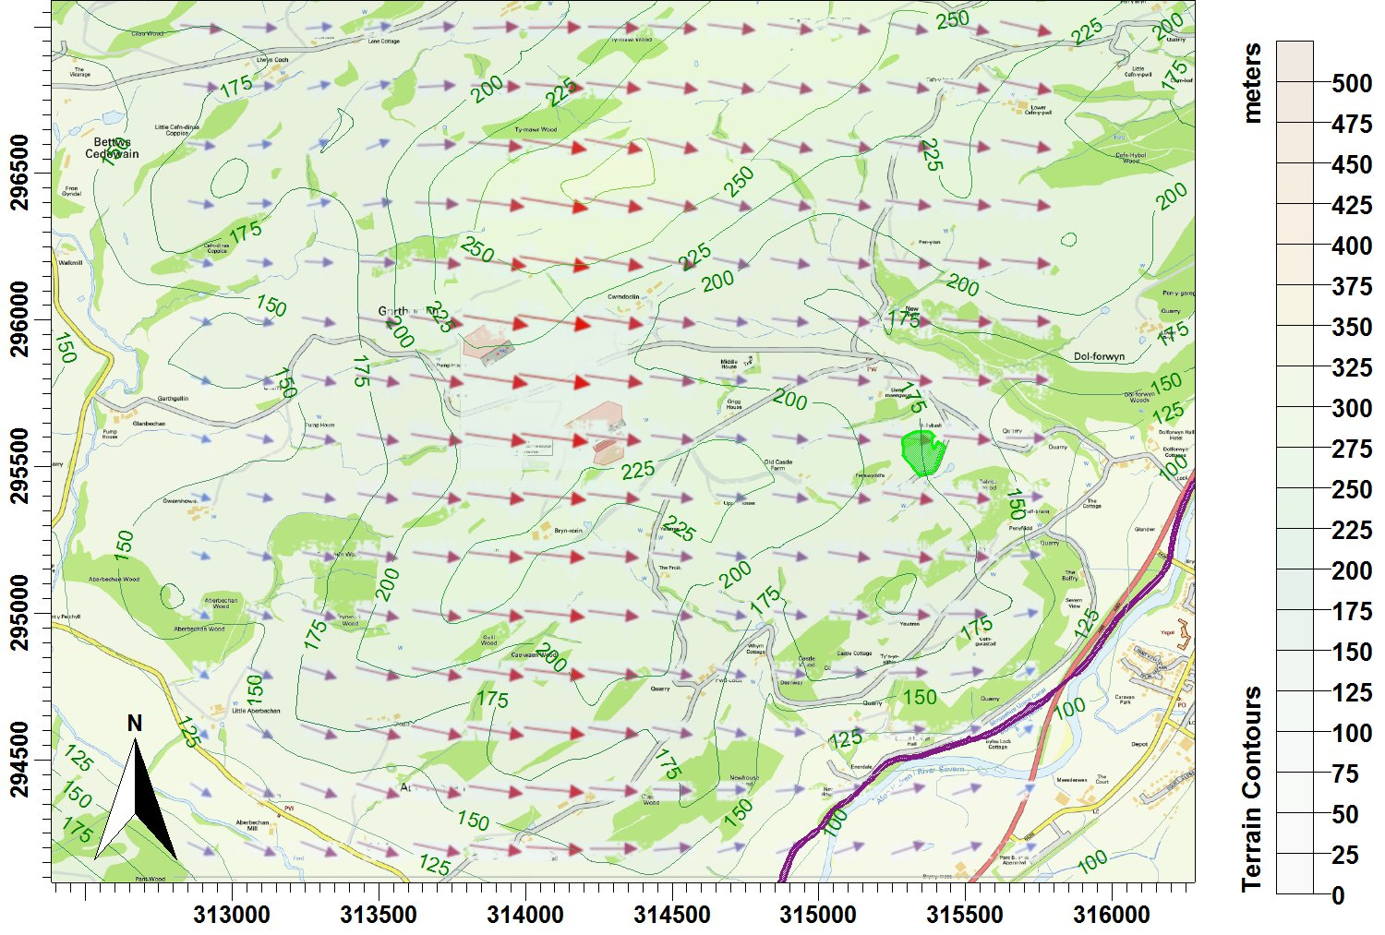
© Crown copyright and database rights. 2015.

Ammonia Modelling Study

‘A Report on the Modelling of the Dispersion and Deposition of Ammonia from the Existing and Proposed Free Range Egg Laying Units at Brynrorin near Abermule in Montgomeryshire’, S. Smith, 2014.

The screening radius used in the above study is 2km, which is not appropriate for all habitat designations. Please re-assess the impact of ammonia emissions on habitats found within the appropriate radii of the site as outlined in the Environment Agency’s guidance document ‘H1 Annex B Intensive Farming’.

NRW should be aware that there are no other SSSIs than those already include within 5 km, nor any internationally designated sites other than those already included with 10 km of Brynrorin.

