

Permit
The Environmental Permitting (England & Wales) Regulations 2010

Raymond Brown Minerals and Recycling Ltd

IBA Recycling Facility
Wimborne Road
Barry Docks
CF63 3DH

Permit number

EPR/LP3239AW

Permit
The Environmental Permitting (England and Wales) Regulations 2010

Permit number

EPR/LP3239AW

The Natural Resources Body for Wales (“Natural Resources Wales”) authorises, under regulation 13 of the Environmental Permitting (England and Wales) Regulations 2010

Raymond Brown Minerals and Recycling Ltd (“the operator”),

whose registered office is

160 Christchurch Road

Ringwood

Hampshire

BH24 3AR

company registration number 3601649

to operate an installation at

IBA Recycling Facility

Wimborne Road

Barry Docks

CF63 3DH

to the extent authorised by and subject to the conditions of this permit.

Under regulation 27(2) of the Regulations, standard rules SR2012 No13 are conditions of this permit.

Name | Date
[name of authorised person] | [DD/MM/YYYY]

Authorised on behalf of Natural Resources Wales

Schedule 1 - Site plan

This is the plan referred to in the standard rules SR2012 No13

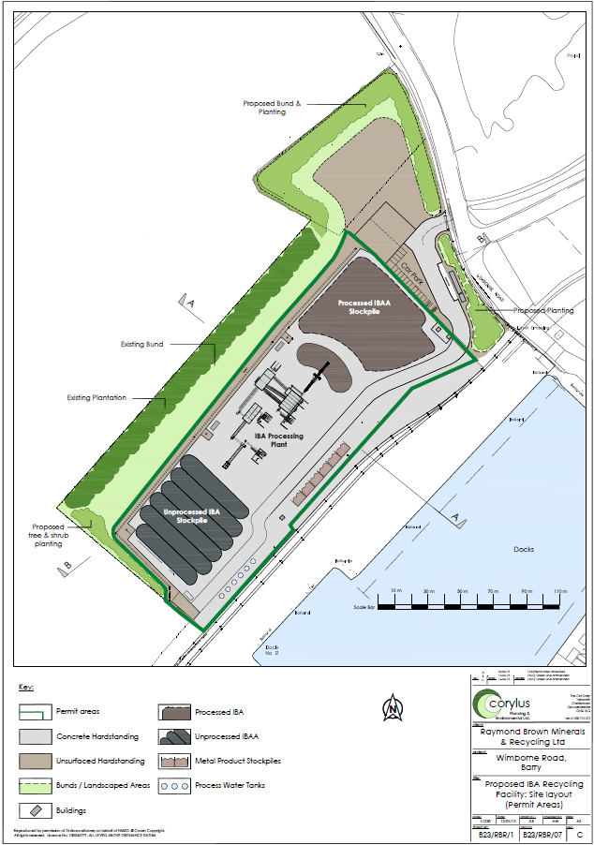

© Crown Copyright and database right 2015. Ordnance Survey licence number 100030994.

END OF PERMIT

