Ein cyf/Our ref: VP3832MZ CAR- NRW 0017492

Eich cyf/Your ref:

Dyddiad/Date: 27 April 2016

For the attention of Mr G Evans

Noble Foods Limited
Whitney Road
Standlake
Witney
Oxfordshire OX29 7RB

Dear Mr G Evans

Pig and Poultry Assurance Scheme: Compliant Inspection
Farm Name: St Pierre Farm Poultry Unit
Permit Number: VP3832MZ

Thank you for taking part in the inspection by your Farm Certification Body on 21 March 2016.
Natural Resources Wales has been informed by your Certification body that during the inspection the following breaches of your permit were identified as listed below.

Permit Condition Numbers:
1.3 Energy 4 year review last complete September 2011

1.4 Raw materials and Water 4 year review last completed September 2011

1.5 Avoidance, recovery and disposal of wastes 4 year review last completed Sept 2011

Please forward to me the updated reviews as listed above by the 10 May 2016 email or hard copy is acceptable.

Please find enclosed the completed Compliance Assessment Record for your records

If I can help with any queries regarding this letter please do not hesitate to get in touch.

Yours faithfully
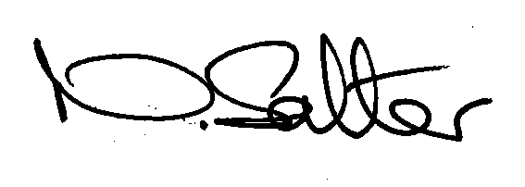
Nichola Salter
Uwch Swyddod Amgylchedd Amaeth / Senior Environment Officer Agriculture
Ffon/Tel 0300 065 3499
E bost/ email nichola.salter@cyfoethnaturiolcymru.gov.uk

