Ein cyf/Our ref: YP3138TY

Eich cyf/Your ref:

Dyddiad/Date: 8 May 2018

Mr J Williams
Lower Ty Newydd
Clytha
Raglan
Monmouthshire
NP15 2BQ

Dear Mr Williams

Pig and Poultry Assurance Scheme: Compliant Inspection
Farm Name: Portfield Farm
Permit Number: YP3138TY

Thank you for taking part in the inspection by your Farm Certification Body on 4 May 2018.

We are pleased to confirm that at the time of inspection you were compliant with your permit. Your farm will continue to remain in the scheme for the current year.
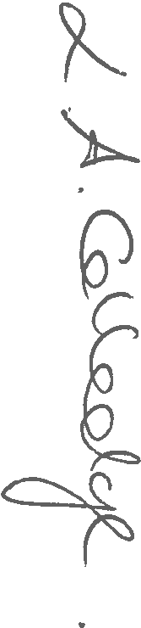
Please contact us should you have any questions about this letter.

Yours sincerely

LESLEY COLLEDGE
Swyddog Cymorth Technegol / Technical Support Officer
Cyfoeth Naturiol Cymru / Natural Resources Wales
Ffôn/Tel: 0300 065 3492
E-bost uniongyrchol/Direct e-mail: lesley.colledge@cyfoethnaturiolcymru.gov.uk
Croesewir gohebiaeth yn y Gymraeg a'r Saesneg
Correspondence welcomed in Welsh and English

