

Permit with introductory note
The Environmental Permitting (England & Wales) Regulations 2016

Mr Edward Morgan and Mr James Morgan

Dolidre Poultry Unit
Dolidre Farm
Llanddewi
Llandrindod Wells
Powys
LD1 6SE

Permit number

EPR/MP3130TW

Dolidre Poultry Unit
Permit number EPR/MP3130TW

Introductory note

This introductory note does not form a part of the permit

The main features of the permit are as follows.

Dolidre Poultry Unit is operated by Edward and James Morgan and is situated in a predominantly agricultural area to the south of Llanddewi Ystradenni (NGR SO 1092 6795). The site consists of three poultry houses built to BAT standard with a total capacity of 140,000 broiler chicken places. Birds are housed at a day old and depopulated at around thirty-five to forty-nine days of age. There are between 6-8.5 cycles a year. Houses are warmed with heaters and floors are covered with a minimum depth of 2cm of bulk wood shavings. Temperature and humidity are monitored on a daily basis. Houses are fitted with high velocity roof mounted extraction fans and gable end vents, with side wall inlets. Water is provided via a nipple drinking system fitted with cups to reduce leakage and spills. Feed is delivered to the bulk feed bins and augered into the houses, with birds fed a minimum of three diets during their growth with a gradual reduction in levels of protein and phosphorus. At depletion the litter is removed from the site with approximately 50% spread on operator controlled land and the remainder being sold. Small amounts of chemicals are stored on site in a locked bunded chemical store. A standby generator is housed within the northernmost poultry house.
Roof and yard water is directed to a soakaway located at the west side of the site. All wash waters are collected and contained in an underground sealed tank before being spread onto operator controlled land. Fallen stock are stored in secure containers for collection by a licensed renderer.

Previous land use at the site was agricultural grazing land. The installation is not within 400 metres of sensitive receptors. The closest designated habitat sites to the installation are the Special Area of Conservation, River Wye at 416m and there are two Ancient Woodland Sites adjacent to the site. An assessment of the impact of ammonia emissions has predicted no adverse effect on these.

The status log of the permit sets out the permitting history, including any changes to the permit reference number.

Status log of the permit
Description | Date | Comments
Application EPR/MP3130TW/A001 | Duly made 14/05/10
Permit determined | 30/07/10
Variation Application EPR/MP3130TW/V002 | Duly made 19/03/15 | Application for biomass boilers.
Supplementary Information | Received 19/06/15 | Revised site condition report, site plan and biomass boiler information
Supplementary Information | Received 13/07/15 | Revised site perimeter plan
Variation determined | 23/07/15 | Variation issued
Variation issued EPR/MP3130TW/V003 | 13/04/2018 | Natural Resources Wales Variation and consolidation following the implementation of the Intensive Farming BAT conclusions.

End of introductory note

Permit
The Environmental Permitting (England and Wales) Regulations 2016

Permit number

EPR/MP3130TW

This is the consolidated permit referred to in the variation and consolidation notice for application EPR/MP3130TW/V003 authorising,

Mr Edward Morgan and Mr James Morgan (“the operator”),

of

Dolidre Farm

Llanddewi

Llandrindod Wells

Powys

LD1 6SE

to operate an installation at

Dolidre Poultry Unit

Dolidre Farm

Llanddewi

Llandrindod Wells

Powys

LD1 6SE

to the extent authorised by and subject to the conditions of this permit as set out in Appendix 1 and in Appendix 2.

Signed | Date
Holly Noble | 13/04/2018

Authorised on behalf of Natural Resources Wales

APPENDIX 1

Sector Specific Conditions

Introductory note

This introductory note does not form a part of the Condition set

The conditions set out below are incorporated into this permit.

End of introductory note.

Management

General management

The operator shall manage and operate the activities:

in accordance with a written management system that identifies and minimises risks of pollution, including those arising from operations, maintenance, accidents, incidents, non-conformances, closure and those drawn to the attention of the operator as a result of complaints; and

using sufficient competent persons and resources.

Records demonstrating compliance with condition 1.1.1 shall be maintained.

Any person having duties that are or may be affected by the matters set out in this permit shall have convenient access to a copy of it kept at or near the place where those duties are carried out.

1.2 Energy efficiency

1.2.1 The operator shall:

(a) take appropriate measures to ensure that energy is used efficiently in the activities;

(b) review and record at least every four years whether there are suitable opportunities to improve the energy efficiency of the activities; and

(c) take any further appropriate measures identified by a review.

1.3 Efficient use of raw materials

1.3.1 The operator shall:

(a) take appropriate measures to ensure that raw materials and water are used efficiently in the activities;
(b) maintain records of raw materials, water, fuel and electrical energy used in the activities;
(c) review and record at least every four years whether there are suitable alternative materials that could reduce environmental impact or opportunities to improve the efficiency of raw material and water use; and
(d) take any further appropriate measures identified by a review.

1.4 Avoidance, recovery and disposal of wastes produced by the activities
    - The operator shall take appropriate measures to ensure that:

(a) the waste hierarchy referred to in Article 4 of the Waste Framework Directive is applied to the generation of waste by the activities; and

(b) any waste generated by the activities is treated in accordance with the waste hierarchy referred to in Article 4 of the Waste Framework Directive; and

(c) where disposal is necessary, this is undertaken in a manner which minimises its impact on the environment.
    - The operator shall review and record at least every four years whether changes to those measures should be made and take any further appropriate measures identified by a review.

2 Operations
2.1 Permitted activities

2.1.1 The operator is only authorised to carry out the activities specified in schedule 1 table S1.1 (the “activities”).

2.2 The site

See Appendix 2.

2.3 Operating techniques

2.3.1 (a) The activities shall, subject to the conditions of this permit, be operated using the techniques and in the manner described in the documentation specified in schedule 1, table S1.2, unless otherwise agreed in writing by Natural Resources Wales.

(b) If notified by Natural Resources Wales that the activities are giving rise to pollution, the operator shall submit to Natural Resources Wales for approval within the period specified, a revision of any plan specified in schedule 1, table S1.2 or otherwise required under this permit which identifies and minimises the risks of pollution relevant to that plan , and shall implement the approved revised plan in place of the original from the date of approval, unless otherwise agreed in writing by Natural Resources Wales.

2.3.2 The operator shall maintain and implement a system to record the number of animal places and animal movements.

2.3.3 The operator shall maintain and implement a system to record the quantities of solid manure or slurry exported from the installation, as defined on the site plan in schedule 7. The record shall include as a minimum:
- the date of export from the site
- the quantity exported
- details of the receiving site

2.3.4 The operator shall ensure that where waste produced by the activities is sent to a relevant waste operation, that operation is provided with the following information, prior to the receipt of the waste:

(a) the nature of the process producing the waste;

(b) the composition of the waste;

(c) the handling requirements of the waste;

(d) the hazardous property associated with the waste, if applicable; and

(e) the waste code of the waste.

2.3.5 The operator shall ensure that where waste produced by the activities is sent to a landfill site, it meets the waste acceptance criteria for that landfill.

2.3.6 The operator shall ensure that a diet formulation and a nutritional strategy is used that minimises as far as is practicable the amount of Phosphorus and Nitrogen excreted.

2.3.7 Any raw materials or fuels listed in appendix 2 table S2.1 shall conform to the specifications set out in that table.
2.3.8 Waste shall only be accepted if:

(a) it is of a type and quantity listed in appendix 2 table S2.2; and

(b) it conforms to the description in the documentation supplied by the producer and holder.

2.3.9 Waste authorised by this permit shall be clearly distinguished from any other waste on the site.

3 Emissions and monitoring

3.1 Emissions to water, air or land
3.1.1 There shall be no point source emissions to water, air or land except from the sources and emission points listed in tables S3.2, S3.3 and S3.4.
  - Emissions of substances not controlled by emission limits
    - Emissions of substances not controlled by emission limits (excluding odour) shall not cause pollution. The operator shall not be taken to have breached this condition if appropriate measures, including, but not limited to, those specified in any approved emissions management plan, have been taken to prevent or where that is not practicable, to minimise, those emissions.

3.2.2 The operator shall:

(a) if notified by Natural Resources Wales that the activities are giving rise to pollution, submit to Natural Resources Wales for approval within the period specified, an emissions management plan which identifies and minimises the risks of pollution from emissions of substances not controlled by emission limits;

(b) implement the approved emissions management plan, from the date of approval, unless otherwise agreed in writing by Natural Resources Wales.

3.2.3 All liquids in containers, whose emission to water or land could cause pollution, shall be provided with secondary containment, unless the operator has used other appropriate measures to prevent or where that is not practicable, to minimise, leakage and spillage from the primary container.
    - Periodic monitoring shall be carried out at least once every 5 years for groundwater and 10 years for soil, unless such monitoring is based on a systematic appraisal of the risk of contamination.

3.3 Odour

3.3.1 Emissions from the activities shall be free from odour at levels likely to cause pollution outside the site, as perceived by an authorised officer of Natural Resources Wales, unless the operator has used appropriate measures, including, but not limited to, those specified in any approved odour management plan, to prevent or where that is not practicable to minimise the odour.

3.3.2 The operator shall:

(a) if notified by Natural Resources Wales that the activities are giving rise to pollution outside the site due to odour, submit to Natural Resources Wales for approval within the period specified, an odour management plan which identifies and minimises the risks of pollution from odour;

(b) implement the approved odour management plan, from the date of approval, unless otherwise agreed in writing by Natural Resources Wales.

3.4 Noise and vibration

3.4.1 Emissions from the activities shall be free from noise and vibration at levels likely to cause pollution outside the site, as perceived by an authorised officer of Natural Resources Wales, unless the operator has used appropriate measures, including, but not limited to, those specified in any approved noise and vibration management plan to prevent or where that is not practicable to minimise the noise and vibration.

3.4.2 The operator shall:

(a) if notified by Natural Resources Wales that the activities are giving rise to pollution outside the site due to noise and vibration, submit to Natural Resources Wales for approval within the period specified, a noise and vibration management plan which identifies and minimises the risks of pollution from noise and vibration;

(b) implement the approved noise and vibration management plan, from the date of approval, unless otherwise agreed in writing by Natural Resources Wales.

3.5 Monitoring

3.5.1 The operator shall, unless otherwise agreed in writing by Natural Resources Wales, undertake the monitoring specified in the following tables:
- emissions specified in tables S3.1, S3.2, S3.3 and S3.4.

3.5.2 The operator shall maintain records of all monitoring required by this permit including records of the taking and analysis of samples, instrument measurements (periodic and continual), calibrations, examinations, tests and surveys and any assessment or evaluation made on the basis of such data.

3.6 Pests
3.6.1 The activities shall not give rise to the presence of pests which are likely to cause pollution, hazard or annoyance outside the boundary of the site. The operator shall not be taken to have breached this condition if appropriate measures, including, but not limited to, those specified in any approved pests management plan, have been taken to prevent or where that is not practicable, to minimise the presence of pests on the site.
3.6.2 The operator shall:
(a) if notified by Natural Resources Wales, submit to Natural Resources Wales for approval within the period specified, a pests management plan which identifies and minimises risks of pollution, hazard and annoyance from pests;
(b) implement the pests management plan, from the date of approval, unless otherwise agreed in writing by Natural Resources Wales.

4 Information

4.1 Records
    - All records required to be made by this permit shall:
- be legible;
- be made as soon as reasonably practicable;
- if amended, be amended in such a way that the original and any subsequent amendments remain legible, or are capable of retrieval; and
- be retained, unless otherwise agreed in writing by Natural Resources Wales, for at least 6 years from the date when the records were made, or in the case of the following records until permit surrender:
- off-site environmental effects; and
- matters which affect the condition of the land and groundwater.
    - The operator shall keep on site all records, plans and the management system required to be maintained by this permit, unless otherwise agreed in writing by Natural Resources Wales.

4.2 Reporting
4.2.1 The operator shall send all reports and notifications required by the permit to Natural Resources Wales using the contact details supplied in writing by Natural Resources Wales.

4.2.2 A report or reports on the performance of the activities over the previous year shall be submitted to Natural Resources Wales by 31 January (or other date agreed in writing by Natural Resources Wales) each year. The report(s) shall include as a minimum:

(a) a review of the results of the monitoring and assessment carried out in accordance with the permit including an interpretive review of that data;

(b) the annual production /treatment data set out in schedule 4 table S4.2; and

(c) the performance parameters set out in schedule 4 table S4.3 using the forms specified in table S4.4 of that schedule.

4.2.3 The operator shall, unless notice under this condition has been served within the preceding four years, submit to Natural Resources Wales, within six months of receipt of a written notice, a report assessing whether there are other appropriate measures that could be taken to prevent, or where that is not practicable, to minimise pollution.

4.3 Notifications
4.3.1 (a) In the event that the operation of the activities gives rise to an incident or accident which significantly affects or may significantly affect the environment, the operator must immediately:
(i) inform Natural Resources Wales;
(ii) take the measures necessary to limit the environmental consequences of such an incident or accident; and
(iii) take the measures necessary to prevent further possible incidents or accidents.
(b) In the event of a breach of any permit condition the operator must immediately:
(i) inform Natural Resources Wales; and,
(ii) take the measures necessary to ensure that compliance is restored within the shortest possible time.
(c) In the event of a breach of permit condition which poses an immediate danger to human health or threatens to cause an immediate significant adverse effect on the environment, the operator must immediately suspend the operation of the activities or the relevant part of it until compliance with the permit conditions has been restored.

4.3.2 Any information provided under condition 4.3.1, shall be confirmed by sending the information listed in schedule 5 to this permit within the time period specified in that schedule.

4.3.3 Where Natural Resources Wales has requested in writing that it shall be notified when the operator is to undertake monitoring and/or spot sampling, the operator shall inform Natural Resources Wales when the relevant monitoring and/or spot sampling is to take place. The operator shall provide this information to Natural Resources Wales at least 14 days before the date the monitoring is to be undertaken.

4.3.4 Natural Resources Wales shall be notified within 14 days of the occurrence of the following matters, except where such disclosure is prohibited by Stock Exchange rules:

Where the operator is a registered company:
- any change in the operator’s trading name, registered name or registered office address; and

(b) any steps taken with a view to the operator going into administration, entering into a company voluntary arrangement or being wound up.

Where the operator is a corporate body other than a registered company:

(a) any change in the operator’s name or address; and
- any steps taken with a view to the dissolution of the operator.

In any other case:
- the death of any of the named operators (where the operator consists of more than one named individual);
- any change in the operator’s name(s) or address(es); and
- any steps taken with a view to the operator, or any one of them, going into bankruptcy, entering into a composition or arrangement with creditors, or, in the case of them being in a partnership, dissolving the partnership.

4.3.5 Where the operator proposes to make a change in the nature or functioning, or an extension of the activities, which may have consequences for the environment and the change is not otherwise the subject of an application for approval under the Regulations or this permit:
- Natural Resources Wales shall be notified at least 14 days before making the change; and
- the notification shall contain a description of the proposed change in operation.

4.3.6 Natural Resources Wales shall be given at least 14 days notice before implementation of any part of the site closure plan.

4.4 Interpretation

4.4.1 In this permit the expressions listed in schedule 6 shall have the meaning given in that schedule.

4.4.2 In this permit references to reports and notifications mean written reports and notifications, except where reference is made to notification being made “without delay”, in which case it may be provided by telephone.

Schedule 1

Operations

See Appendix 2

Schedule 2

Waste types, raw materials and fuels

See Appendix 2

Schedule 3

Emissions and Monitoring

Table S3.1 BAT associated emission levels and monitoring requirements ^{Note 1 and note 2}
Emission point ref. & location | Parameter | Source | Limit (incl. unit) | Reference period | Monitoring frequency | Monitoring standard or method
Weaners | Nitrogen (N) | Excreted | 4.0 kg N  /animal place | Per year | Annually | Calculation by using a mass balance of nitrogen and phosphorus based on the feed intake, dietary content of crude protein, total phosphorus and animal performance or  Estimation by using manure analysis for total nitrogen and total phosphorus content
Weaners | Phosphorus (as P₂O₅) | Excreted | 2.2 kg P₂O₅ /animal place | Per year | Annually | As above
Weaners | Ammonia as NH₃ | Animal house | 0.53 kg NH₃  /animal place | Per year | Annually | Estimation using emission factors
Fattening Pigs | Nitrogen (N) | Excreted | 13.0 kg N  /animal place | Per year- | Annually | Calculation by using a mass balance of nitrogen and phosphorus based on the feed intake, dietary content of crude protein, total phosphorus and animal performance or  Estimation by using manure analysis for total nitrogen and total phosphorus content
Fattening Pigs | Phosphorus (as P₂O₅) | Excreted | 5.4 kg P₂O₅ /animal place | Per year | Annually | As above
Fattening Pigs | Ammonia as NH₃ | Animal house | 2.6 kg NH₃  /animal place | Per year | Annually | Estimation using emission factors
Sows (including suckling piglets) | Nitrogen (N) | Excreted | 30.0 kg N  /animal place | Per year | Annually | Calculation by using a mass balance of nitrogen and phosphorus based on the feed intake, dietary content of crude protein, total phosphorus and animal performance or  Estimation by using manure analysis for total nitrogen and total phosphorus content
Sows (including suckling piglets) | Phosphorus (as P₂O₅) | Excreted | 15 kg P₂O₅  /animal place | Per year | Annually | As above
Mating and gestating sows | Ammonia as NH₃ | Animal house | 2.7 kg NH₃  /animal place | Per year | Annually | Estimated using excretion factors
Farrowing sows (including suckling piglets) with crates. | Ammonia as NH₃ | Animal house | 5.6 kg NH₃  /animal place | Per year | Annually | Estimated using excretion factors
Laying hens | Nitrogen (N) | Excreted | 0.8 kg N  /animal place | Per year | Annually | Calculation by using a mass balance of nitrogen and phosphorus based on the feed intake, dietary content of crude protein, total phosphorus and animal performance or  Estimation by using manure analysis for total nitrogen and total phosphorus content
Laying hens | Phosphorus (as P₂O₅) | Excreted | 0.45 kg P₂O₅  /animal place | Per year | Annually | As above
Laying hens in Caged housing | Ammonia as NH₃ | Animal house | 0.08 kg NH₃  /animal place | Per year | Annually | Estimation by using emission factors
Laying hens in Non caged housing | Ammonia as NH₃ | Animal house | 0.13 kg NH₃  /animal place  ^{Note 3} | Per year | Annually | Estimation by using emission factors
Broilers | Nitrogen (N) | Excreted | 0.6 kg N  /animal place | Per year | Annually | Calculation by using a mass balance of nitrogen and phosphorus based on the feed intake, dietary content of crude protein, total phosphorus and animal performance or  Estimation by using manure analysis for total nitrogen and total phosphorus content
Broilers | Phosphorus (as P₂O₅) | Excreted | 0.25 kg P₂O₅  /animal place | Per year | Annually | As above
Broilers | Ammonia as NH₃ | Animal house | 0.08 kg NH₃  /animal place | Per year | Annually | Estimation by using emission factors
Ducks | Nitrogen (N) | Excreted | 0.8 kg N  /animal place | Per year | Annually | Calculation by using a mass balance of nitrogen and phosphorus based on the feed intake, dietary content of crude protein, total phosphorus and animal performance or  Estimation by using manure analysis for total nitrogen and total phosphorus content
Turkeys | Nitrogen (N) | Excreted | 2.3 kg N  /animal place | Per year | Annually | Calculation by using a mass balance of nitrogen and phosphorus based on the feed intake, dietary content of crude protein, total phosphorus and animal performance or  Estimation by using manure analysis for total nitrogen and total phosphorus content
Turkeys | Phosphorus (as P₂O₅) | Excreted | 1.0 kg P₂O₅  /animal place | Per Year | Annually | As above

Note 1. There are no BAT emission factors specified for pullets.
Note 2. The limits specified in this permit only apply after 20 February 2021
Note 3. For poultry houses operational on 21 February 2017 using a forced ventilation system and an infrequent manure removal (in case of deep litter with a manure pit), in combination with a measure achieving a high dry matter content of the manure, the upper end of the BAT-AEL is 0.25Kg NH₃/ animal place / year.

Table S3.2 – Point source emissions to air emissions limits and monitoring requirements - see Appendix 2.

Table S3.3 – Point source emissions to water (other than sewer) – emission limits and monitoring – see Appendix 2

Table S3.4 – Point source emissions to land – emission limits and monitoring – see Appendix 2

Schedule 4

Reporting

See Appendix 2

Schedule 5 - Notification

These pages outline the information that the operator must provide.

Units of measurement used in information supplied under Part A and B requirements shall be appropriate to the circumstances of the emission. Where appropriate, a comparison should be made of actual emissions and authorised emission limits.

If any information is considered commercially confidential, it should be separated from non-confidential information, supplied on a separate sheet and accompanied by an application for commercial confidentiality under the provisions of the EP Regulations.

Part A

Permit Number

Name of operator

Location of Facility

Time and date of the detection

(a) Notification requirements for any activity that gives rise to an incident or accident which significantly affects or may significantly affect the environment

To be notified within 24 hours

Date and time of the event

Reference or description of the location of the event

Description of where any release into the environment took place

Substances(s) potentially released

Best estimate of the quantity or rate of release of substances

Measures taken, or intended to be taken, to stop any emission

Description of the failure or accident.

(b) Notification requirements for the breach of a permit condition

To be notified within 24 hours

Emission point reference/ source

Parameter(s)

Limit

Measured value and uncertainty

Date and time of monitoring

Measures taken, or intended to be taken, to stop the emission

Time periods for notification following detection of a breach of a limit
Parameter | Notification period

(c) In the event of a breach of permit condition which poses an immediate danger to human health or threatens to cause an immediate significant adverse effect on the environment:

To be notified within 24 hours

Description of where the effect on the environment was detected

Substances(s) detected

Concentrations of substances detected

Date of monitoring/sampling

Part B - to be submitted as soon as practicable

Any more accurate information on the matters for notification under Part A.

Measures taken, or intended to be taken, to prevent a recurrence of the incident

Measures taken, or intended to be taken, to rectify, limit or prevent any pollution of the environment which has been or may be caused by the emission

The dates of any unauthorised emissions from the facility in the preceding 24 months.

Name*

Post

Signature

Date

* authorised to sign on behalf of the operator

Schedule 6 - Interpretation
“accident” means an accident that may result in pollution.
“application” means the application for this permit, together with any additional information supplied by the operator as part of the application and any response to a notice served under Schedule 5 to the EP Regulations.
“authorised officer” means any person authorised by Natural Resources Wales under section 108(1) of The Environment Act 1995 to exercise, in accordance with the terms of any such authorisation, any power specified in section 108(4) of that Act.
“BAT” means “best available techniques” as detailed in the Commission Implementing Decision (EU) 2017/302 published on 21 February 2017.

“building” means a construction that has the objective of providing sheltering cover and minimising emissions of noise, particulate matter, odour and litter.
“emissions to land” includes emissions to groundwater.
“emission factors” are figures which have been agreed in writing with Natural Resources Wales and can be used in specific calculations.
“emissions of substances not controlled by emission limits” means emissions of substances to air, water or land from the activities, either from the emission points specified in schedule 3 or from other localised or diffuse sources, which are not controlled by an emission limit..
“excretion factors” are figures which have been agreed in writing with Natural Resources Wales and can be used in specific calculations.
“EP Regulations” means The Environmental Permitting (England and Wales) Regulations SI 2016 No.675 and words and expressions used in this permit which are also used in the Regulations have the same meanings as in those Regulations.
“groundwater” means all water, which is below the surface of the ground in the saturation zone and in direct contact with the ground or subsoil.

“Industrial Emissions Directive” means DIRECTIVE 2010/75/EU OF THE EUROPEAN PARLIAMENT AND OF THE COUNCIL of 24 November 2010 on industrial emissions

“Manure and slurry” have the following meaning:
- Manures may be either slurries or solid manures.
- Slurries consist of excreta produced by livestock whilst in a yard or building mixed with rainwater and wash water and, in some cases, waste bedding and feed. Slurries can be pumped or discharged by gravity.
- Slurry includes muck effluent, seepage from manure and wash water.
- Solid manures include farmyard manure (FYM) and comprise material from straw-based housing systems, excreta with lots of straw/sawdust/woodchips in it, or solids from mechanical separators.
- Most poultry systems produce solid manure (litter).
- Solid manure can generally be stacked.

“Manure management plan” means the requirements described in Section 2.3 of SGN 6.09 How to Comply – Intensive Farming.

“Pests” means Birds, Vermin and Insects.

“SGN How to comply – Intensive Farming” The EPR Sector Guidance Note 6.09 for intensive pig and poultry farmers, version 2 published January 2010.
“year” means calendar year ending 31 December.

Schedule 7 – Site plan – see Appendix 2

APPENDIX 2

Site Specific Conditions

Introductory note

This introductory note does not form a part of the Condition set

The conditions set out below are incorporated into this permit.

End of introductory note.

2 Operations

2.2 The site

2.2.1 The activities shall not extend beyond the site, being the land shown edged in green on the site plan at schedule 7 to this permit.

2.4 Improvement programme

2.4.1 The operator shall complete the improvements specified in schedule 1 table S1.3 by the date specified in that table unless otherwise agreed in writing by Natural Resources Wales.

2.4.2 Except in the case of an improvement which consists only of a submission to Natural Resources Wales, the operator shall notify Natural Resources Wales within 14 days of completion of each improvement.

Schedule 1 - Operations

Table S1.1 activities
Activity listed in Schedule 1 of the EP Regulations | Description of specified activity | Limits of specified activity
Section 6.9 A(1)(a) Rearing of poultry or pigs intensively in an installation with more than 40,000 places for poultry. | The rearing of poultry in a broiler facility. | To house a maximum capacity of 140,000 birds. From receipt of birds, raw materials and fuels onto the site, to removal of birds and associated wastes from site.

Directly Associated Activity
Biomass Boiler | Operation of 3 Biomass Boiler(s) for site heating. | From receipt of raw materials and  fuels, to release of combustion  products to air and associated  wastes removed from site. With a maximum thermal rated input of 629 kW

Table S1.2 Operating techniques
Description | Parts | Date Received
Application | Sections 1.2, 1.4, 1.6 and 1.8 of the application document in response to section 5a – technical standards , Part B of the application form | 18/02/2010
Variation application MP3130TW/V002 | Part C3 Table 3 Technical Standards | 19/03/2015

Table S1.3 Improvement programme requirements
Reference | Requirement | Date
IC1 | The operator shall comply with the requirements of the BAT Conclusions listed below, as far as they are applicable to the installation, on or before 20 February 2021.  These BAT Conclusions for the intensive rearing of poultry or pigs were published as a Commission Implementing Decision (EU 2017/302) in the Official Journal of the EU on the 21 February 2017.  BAT Conclusions: 1, 2, 3, 4, 5, 6, 7, 8, 9, 10, 11, 12, 13, 14, 15, 19, 23, 24, 25, 26, 27, 29, 31,32, | 20 February 2021
IC2 | The operator shall submit a written report to Natural Resources Wales for approval, detailing compliance with the applicable parts of the BAT conclusions listed in IC1 | 20 March 2021

Schedule 2 - Waste types, raw materials and fuels

Table S2.1 Raw materials and fuels
Raw materials and fuel description | Specification
Fuel for biomass boiler units | Biomass fuel comprising only virgin timber, straw, miscanthus or a combination of these. Not to include any waste material.

Table S2.2 Permitted waste types and quantities

Maximum Quantity
Waste Code | Description
None set | None set

Schedule 3 – Emissions and Monitoring

Table S3.2 Point source emissions to air – emission limits and monitoring requirements
Emission point ref. & location | Parameter | Source | Limit (incl. unit) | Reference period | Monitoring frequency | Monitoring standard or method
Roof fan outlets on poultry houses as shown on the site layout plan in the application. | None set | Poultry sheds 1, 2 and 3 | None set | None set | None set | None set
Side/gable end vents on poultry houses as shown on the site layout plan in the application. | None set | Poultry shed 1, 2 and 3 | None set | None set | None set | None set
Vents from LPG tank as shown on the site layout plan in the application. | None set | LPG Tanks | None set | None set | None set | None set
Vent from generator diesel tank as shown on the site layout plan in the application. | None set | Generator diesel Tank | None set | None set | None set | None set
Exhaust from generator as shown on the site layout plan in the application. | None set | Generator | None set | None set | None set | None set
Emissions from biomass boiler 1 in biomass boiler building as shown on the site plan in schedule 7 | None set | Biomass Boiler 1 | None set | None set | None set | None set
Emissions from biomass boiler 2 in biomass boiler building as shown on the site plan in schedule 7 | None set | Biomass Boiler 2 | None set | None set | None set | None set
Emissions from biomass boiler 3 in biomass boiler building as shown on the site plan in schedule 7 | None set | Biomass Boiler 3 | None set | None set | None set | None set

Table S3.3 Point Source emissions to water (other than sewer) – emission limits and monitoring requirements
Emission point ref. & location | Parameter | Source | Limit (incl. unit) | Reference Period | Monitoring frequency | Monitoring standard or method
None | None set | None set | None set | None set | None set | None set

Table S3.4 Point Source emissions to land – emission limits and monitoring requirements
Emission point ref. & location | Parameter | Source | Limit (incl. unit) | Reference Period | Monitoring frequency | Monitoring standard or method
Soakaway shown on the site layout plan in the application EPR/MP3130TW/A001. | None set | Roof and yard water from Poultry shed 1,2 and 3. | None set | None set | None set | None set

Schedule 4 - Reporting
Parameters, for which reports shall be made, in accordance with conditions of this permit, are listed below.

Table S4.1 Reporting of monitoring data
Parameter | Emission or monitoring point/reference | Reporting period | Period begins
As detailed in table S3.1 and as applicable to your operation | As detailed in table S3.1 and as applicable to your operation | Annually | 1 January

Table S4.2: Annual production/treatment
Parameter | Units
Live birds removed from site | Birds

Table S4.3 Performance parameters
Parameter | Frequency of assessment | Units
Ammonia | Annually | kg NH₃/animal place/year
Total Nitrogen excreted | Annually | kg N excreted/animal place/year
Total Phosphorus excreted | Annually | kg P₂O₅ excreted/animal place/year

Table S4.4 Reporting forms
Media/parameter | Reporting format | Date of form
kg N excreted/animal place/year  and  kg P₂O₅ excreted/animal place/year | Form N&P Excretion 1 or other form as agreed in writing by Natural Resources Wales | 13/04/2018
kg NH₃/animal place/year | Form Air 1 or other form as agreed in writing by Natural Resources Wales | 13/04/2018

Schedule 7 - Site plan

Site plan

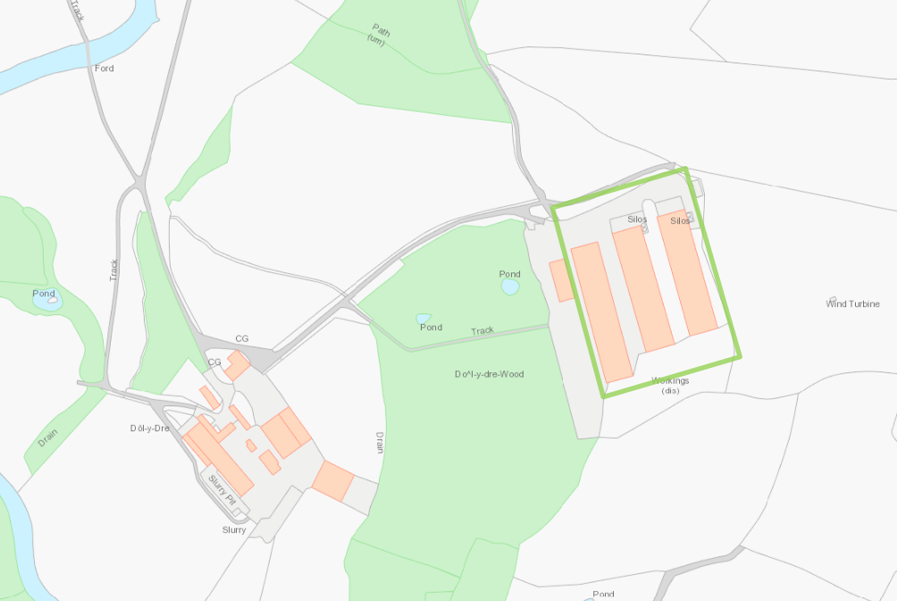

© Crown Copyright and database right 2017. Ordnance Survey licence number 100019741.

Site layout (not to scale):

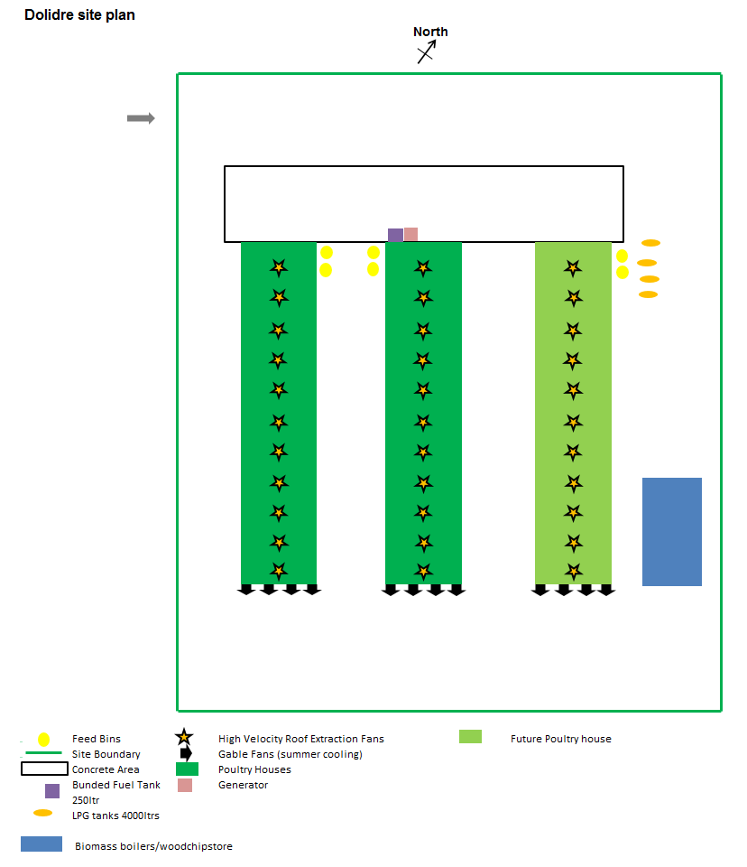

Site Drainage Plan (Not to scale);
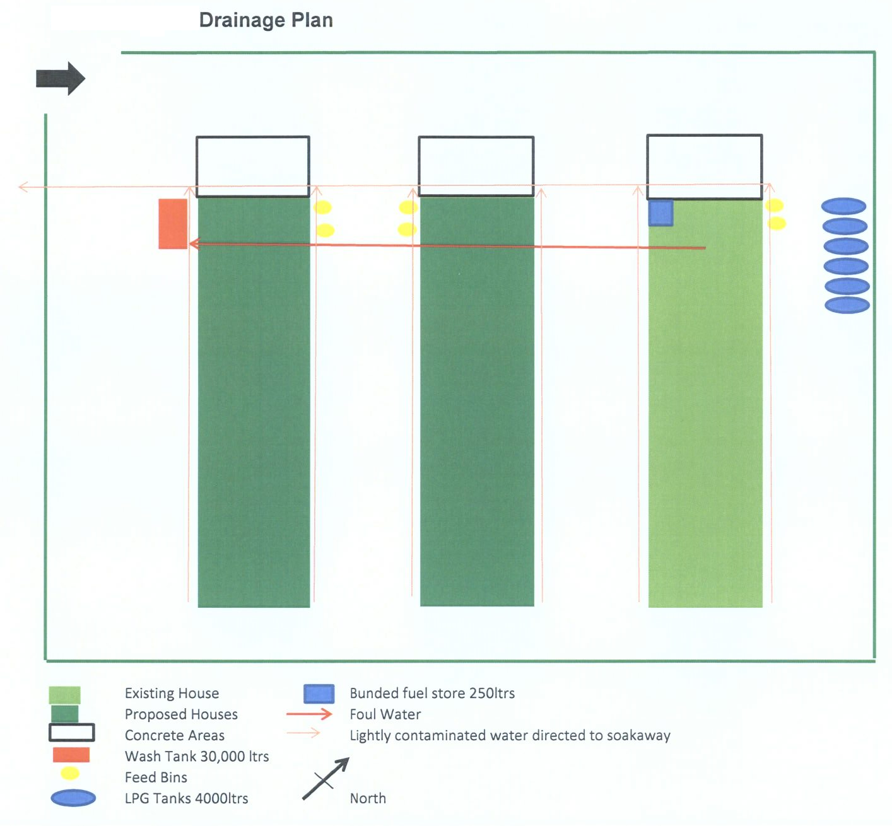

END OF PERMIT

