

Permit
The Environmental Permitting (England & Wales) Regulations 2016

Ystum Colwyn Farms Limited

Ystum Colwyn Anaerobic Digestion Plant
Ystum Colwyn
Meifod
Powys
SY22 6XT

Permit number

EPR/CB3395CX

Permit
The Environmental Permitting (England and Wales) Regulations 2016

Permit number

EPR/CB3395CX

The Natural Resources Body for Wales (“Natural Resources Wales”) authorises, under regulation 13 of the Environmental Permitting (England and Wales) Regulations 2016

Ystum Colwyn Farms Limited (“the operator”),

whose registered office is

Glanrafon Farm

Meifod

Powys

SY22 6XT

company registration number 05662695

to operate an installation

Ystum Colwyn Anaerobic Digestion Plant

Ystum Colwyn

Meifod

Powys

SY22 6XT

to the extent authorised by and subject to the conditions of this permit.

Under regulation 27(2) of the Regulations, standard rules SR2018 No10 are conditions of this permit.

Signed | Date
Holly Noble | 11/01/2022

Authorised on behalf of Natural Resources Wales

Schedule 1 - Site plan

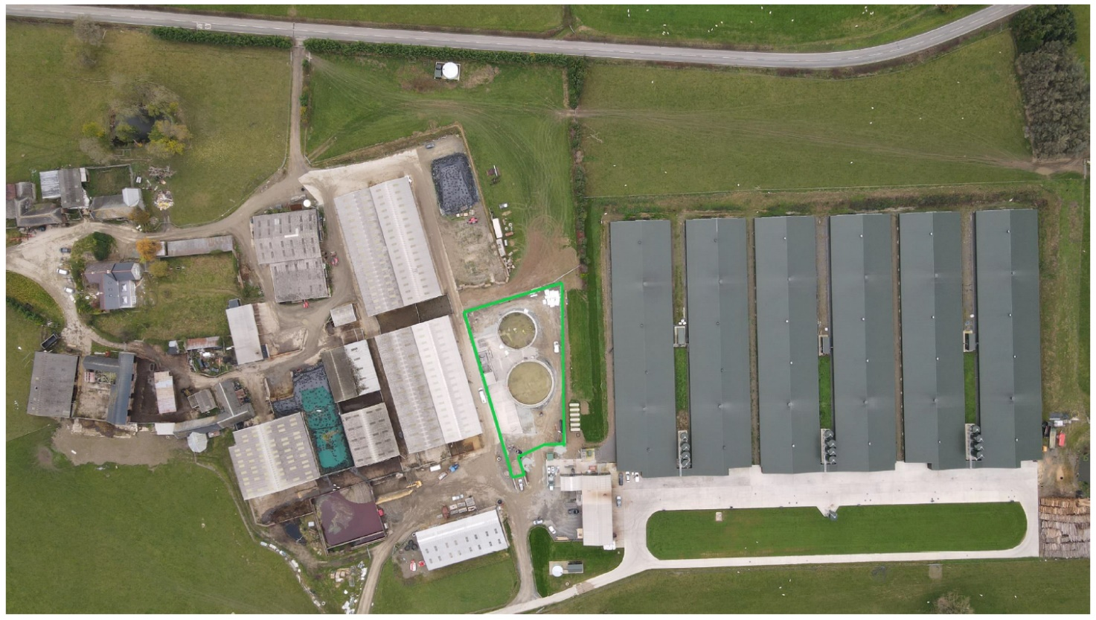
This is the plan referred to in the standard rules SR2018 No10

END OF PERMIT

