CRoW Appendix 4 (140_10_SD02)  CRoW Act 2000: Natural Resources Wales application for permission - Formal Notice |  | 
Natural Resources Wales Formal Notice.
Requirements of Section 28I of the Wildlife & Countryside Act 1981 as amended by the Countryside and Rights of Way Act (CRoW) 2000.
Duty in relation to granting any consent, licence or permit for activities likely to damage Sites of Special Scientific Interest (SSSI).
Guide to filling in this form for Natural Resources Wales staff:
To be completed by Permitting Officers for any applications for a permission which the Natural Resources Wales has considered under S28G duties to protect and enhance SSSIs. This applies to all proposed permissions within a SSSI, and to operations outside the SSSI boundary which are likely to damage its special features.
Refer to OI 140_10 ‘Applying the Countryside and Rights of Way (CRoW) Act 2000 to applications for permits with potential for impact on Sites of Special Scientific Interest (SSSI)’, including the flowchart in Appendix 2.
Pink italic text – drafting notes, to be deleted before completion/consultation.
Blue text – examples, to be replaced with permission-specific information.
Ensure you have completed all sections.
- Natural Resources Wales area/region/NPS hub: | Denbighshire/North East
- Name of SSSI: | Halklyn Common and Hollywell Grassland SSSI  Parc Linden Lixwm SSSI
- Type of permission: | Landspreading deployment under SR2010 No4
- Date for Natural Resources Wales permit determination: | 04/01/2022
- Predicted 28 day date for response from NRW conservation/ecology (under S28 I(4)): | N/A
- Natural Resources Wales reference no: | PAN-015919 under EPR-KP3594VE
- National grid reference: | Farm location: Bryn Y Cosyn Farm - SJ 17909 72494  Fields:  BRYN Y COSYN 1 - SJ 18105 72753  BRYN Y COSYN 2 - SJ 17989 72664  BRYN Y COSYN 3 - SJ 17940 72593  BRYN Y COSYN 4 - SJ 18047 72538  BRYN Y COSYN 5 - SJ 18134 72497  BRYN Y COSYN 6 - SJ 17953 72429  BRYN Y COSYN 7 - SJ 17889 72434  Storage:  BRYN Y COSYN - SJ 17918 72521
- Description of proposal: | Applicant is proposing to spread over an area of land (Bryn-Y-Cosyn) and with waste streams predominantly from the food industry. Waste codes are 020204, 020305, 020103, 020501, 020305, 020705, 070712 as listed in SR2010 No4. All the wastes to be spread are all sludge wastes.  Waste will be applied before seedbed preparation – in August-September for arable fields and February-September for grass fields. The waste will be spread by sub-soil injection to reduce the risk of environmental incidents. Typically wastes will be applied by deep leg injector however a shallow injector may be used dependant on soil/weather conditions at the time of application  The wastes will be applied on an individual basis and carefully managed and monitored to ensure nutrients are applied at or below crop requirement/offtake. If it’s necessary to mix wastes prior to application, wastes will be applied at the lowest individual application rate. When wastes are applied as a mix, the waste with the highest nutrient, PTE or other limiting factor is used as the maximum application rate (i.e., waste will be spread at the lowest application rate).  Application to spread a maximum of 5975 tonnes. The waste will be spread over 20.4 hectares of land within the listed fields at Bryn Y Cosyn and Trem Y Foel. The waste will be stored in mobile storage tanks (capacity of 120 tonnes) and then spread onto the fields.
- Is the proposed activity within (wholly or partially) the SSSI boundary? | NO – Bryn Y Cosyn fields are located 300m and 345m away from Halkyn Common and Holywell Grasslands SSSI and Parc Linden Lixwm SSSI respectively (shown below along with applicant map beneath).  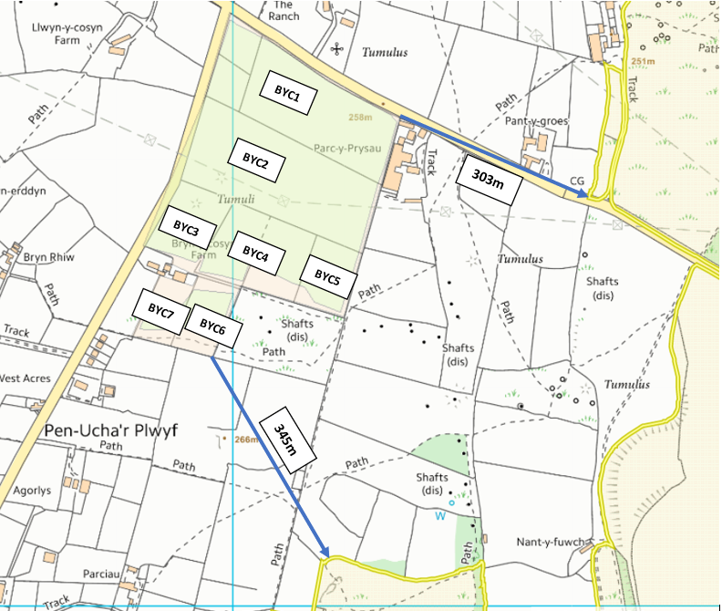  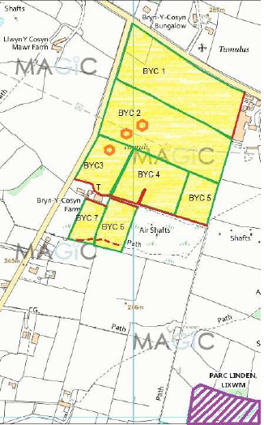 Applicant Map
- Has there been any pre-application discussion or correspondence with NRW conservation/ecology | NO
- What aspect(s) of the proposed permission may damage the features which are of special interest for the SSSI?
The following ‘Operations Requiring Consent’ (or other activities associated with the permission) that may cause damage) are relevant to the proposed permission.

Parc Linden Lixwm SSSI -
- Dumping, spreading, discharging or storage of any materials.

Halklyn Common and Hollywell Grassland SSSI –
- Dumping, spreading, discharging or storage of any materials.

The following SSSI features and mechanisms of impact have been considered to assess the likelihood of damage:

Parc Linden Lixwm SSSI – Calcareous Grassland species
- Sheep’s fescue (Festuca Ovina)
- Crested hair-grass (Koeleria macrantha)
- Glaucous sedge (Carex flacca)
- Common rock-rose (Helianthemum nummularium)
- Salad burnet (Sanguisorba minor)
- Wild thyme (Tymus polytrichus)
- Devil’s bit scabious (Succisa pratensis)
- Common Knapweed (Centaurea nigra)
- Betony (Stachys officinalis)

Parc Linden Lixwm SSSI – Acid Grassland species
- Common bent (Agrostis capillaris)
- Hawthorn bushes (Crataegus monogyna)
- Blackthorn shrubs (Prunus spinosa)
- Bracken (Pteridium aquilinum)

Parc Linden Lixwm SSSI – Geological features –
- Limestone pavement

Halklyn Common and Hollywell Grassland SSSI – Plants Species
- Sheep’s fescue (Festuca Ovina)
- Spring sandwort (Minuartia verna)
- Common bird’s foot trefoil (Lotus corniculatus)
- Yarrow (Achillea millefolium)
- Fairy flax (Linum catharticum)
- Eyebright (Euphrasia officinalis)
- Ribwort plantain (Plantago lanceolata)
- spike rush (Eleocharis quinqueflora)
- common butterwort (Pinguicula vulgaris)
- marsh valerian (Valeriana dioica)
- broad-leaved cottongrass (Eriophorum latifolium)
- purple moor-grass (Molinia caerulea)
- fragrant orchid (Gymnadenia conopsea)
- long-stalked sedge (Carex viridula ssp. Brachyrrhyncha)
- common sedge (Carex nigra)
- marsh arrow grass (Triglochin palustris)
- marsh-marigold (Caltha palustre)

Halklyn Common and Hollywell Grassland SSSI – Animal Species
- great crested newt (Triturus cristatus)
- smooth newt (Triturus vulgaris)
- palmate newt (T. helveticus)
- common frog (Rana temporaria)
- common toad (Bufo bufo)

Halklyn Common and Hollywell Grassland SSSI– Geological features –
- Exposed mineral veins and mine spoil containing mineral specimens

Potential mechanisms for damage
- Nutrient enrichment and the encouragement of grass species at the expense of the broadleaved herbs from the use of slurry waste, that can occur via surface runoff and leaching through the soil.
- Damage to geological features – mineral veins and limestone pavement.
- A change/deterioration in water quality could change species composition within the wetland habitats. An increase in phosphate levels could damage habitat in the SSSI, particularly Calcareous Grass.
- Runoff from roads could be saline and runoff from farms could be nutrient-enriched, both of which need to be controlled.
- Dumping, spreading, discharging or storage of any materials – a key management issue within Halkyn Common and Holywell Grassland arising from fly tipping and the storage of materials which can affect all habitats.
- Decision
ii) The permission is not likely to damage any of the flora, fauna or geological or physiological features which are of special interest because of the reasons below.

- Parc Linden Lixwm SSSI is 345m to the southeast of field BYC6
- Halklyn Common and Hollywell Grassland SSSI is 303m to the East of field BYC1
- Waste streams have low potential to produce airborne dust and particulate matter
- Delivery to storage area is >1km away from designated area (within BYC3)

Potential nutrient enrichment of grassland and other habitats is very unlikely. There are no conceivable impact pathways that could lead to the nutrient enrichment of Halklyn Common and Hollywell Grassland SSSI and Parc Linden Lixwm SSSI due to the distance from the spreading area and the low potential for the sludge waste streams to produce dust matter that could alter the nutrient composition within both sites. This, coupled with the fact that the risk of nutrient enrichment through soil leaching and surface runoff risk is very low (owing to shallow sloping gradient of 0-7 degrees) means that the spreading activities are highly unlikely to damage the flora, fauna and geological features (listed in section 11, above)

Mitigation measures in place –
- Low trajectory spreading operation – the proposed land to be spread on is topographically lower than the SSSI location for both Parc Linden and Halkyn Common and Holywell Grasslands
- Waste spread in accordance with CoGAP
- Operations carried out using the best available techniques
- Spreading to be carried out during appropriate weather conditions
- No travelling on either SSSI
- No activities to occur inside the SSSI boundary of both Parc Linden and Halklyn Common and Hollywell Grassland SSSI

Natural Resources Wales is minded to: Issue the permission

- Name and job title of Natural Resources Wales officer: | Gianluca Broadley  Permitting Officer
- Date form sent to NRW conservation/ecology | n/a saved for information only

