PAN-015919 – MyMap Screening Report
Following RFI response, Racecourse fields 3 and 6 have been removed from the application. Disregard images 1a, 1b, 2b and 6a-d.
Surface Watercourses –
1a) - Map showing surface watercourse 220m East of Racecourse 3 and 6.
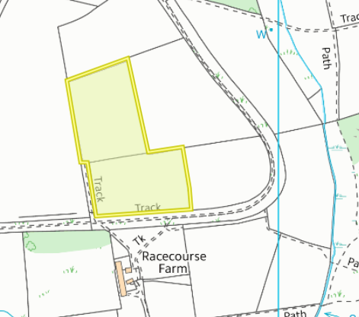
1b) - Racecourse Farm storage – not within Agricultural Benefit Statement – issue located within 50m of Grid Reference provided for storage tank
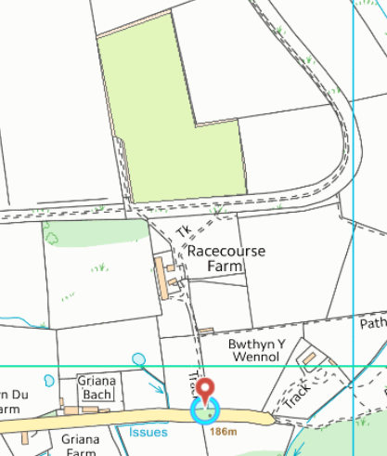

European designated sites- Natura 2000 (SPA, pSPA, SAC or cSAC) or Ramsar- or SSSI within 500m
2a) – Bryn-Y-Cosn –
Special area of conservation - Halkyn Mountain
Sites of Special Interest (SSSI) – Halkyn common and Holywell Grasslands, Parc Linden Lixwm
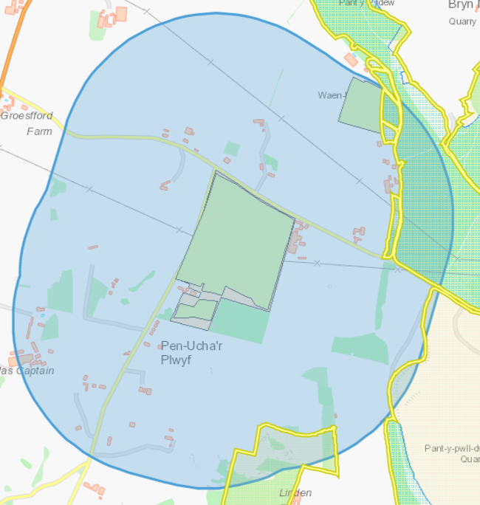
2b. Racecourse Farm –
Special area of conservation - Halkyn Mountain
Sites of Special Interest (SSSI) – Halkyn common and Holywell Grasslands
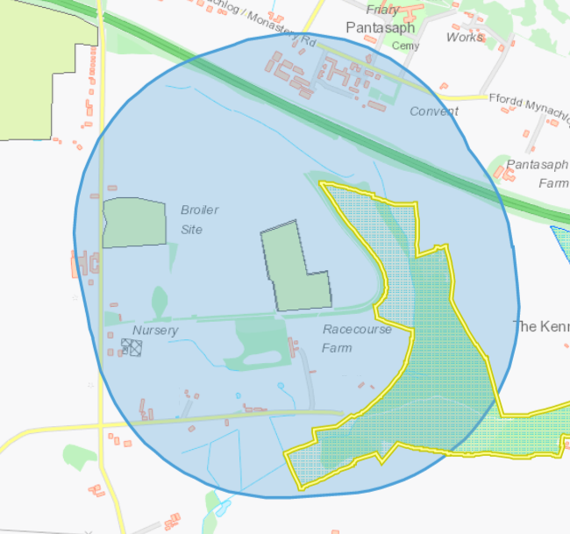

Location of any public rights of way –
3 Bryn-Y-Cosn -
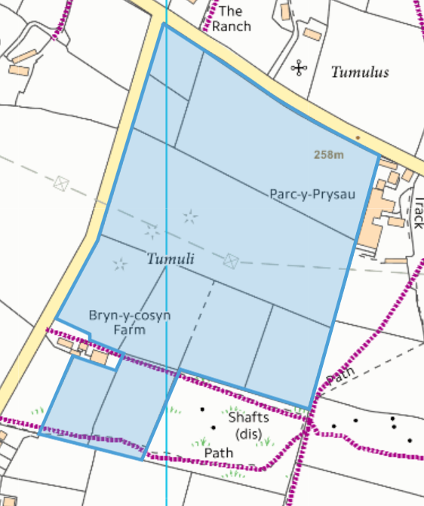
4. Listed buildings –
Trem Y Foel Farm – Gledlom (circled)
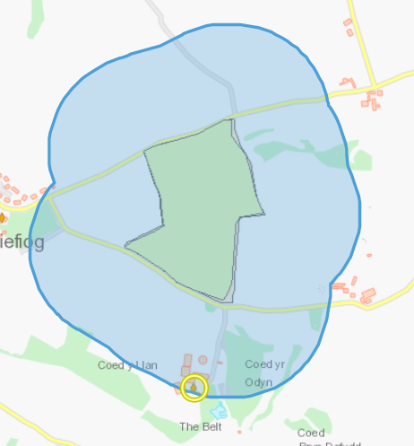

5 - Location of any other designated environmentally sensitive sites within 500m – Bryn-Y-Cosn
5a. Protected Habitats – Lowland calcareous grassland, Lowland dry acid grassland
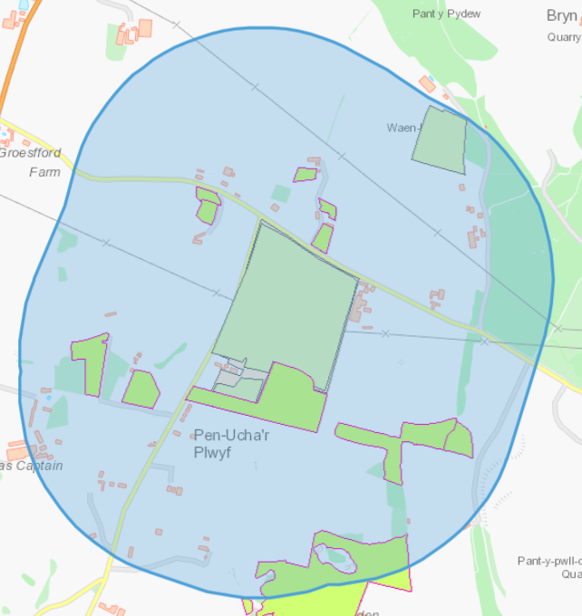
5b. Protected Species – Amphibians, Reptiles
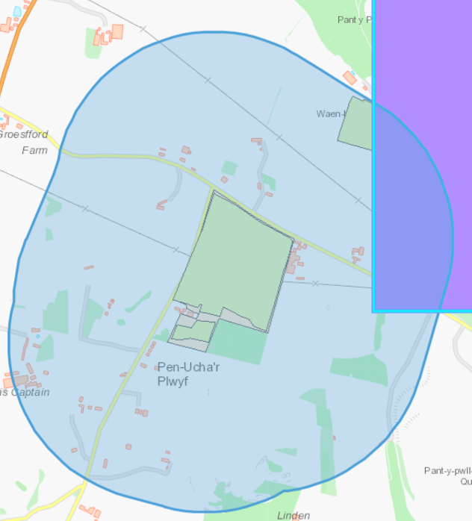

5c. Scheduled ancient monuments - Round Barrow 495m SE of Parc y Prysau (Religious, Ritual and Funerary), Round Barrow 225m SE of Parc y Prysau (Religious, Ritual and Funerary)
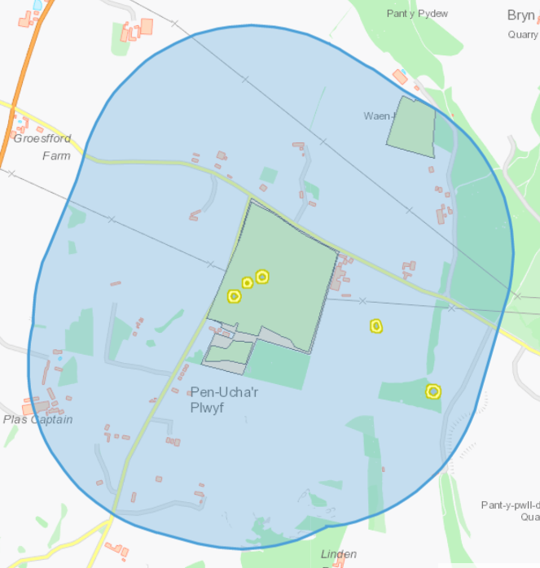
5d. Local Wildlife Sites (SINC) – Bryn-Y-Cosyn pasture, Bryn-Y-berthen pasture, Plas Coch meadow and verge and Pant y Pwll dwr
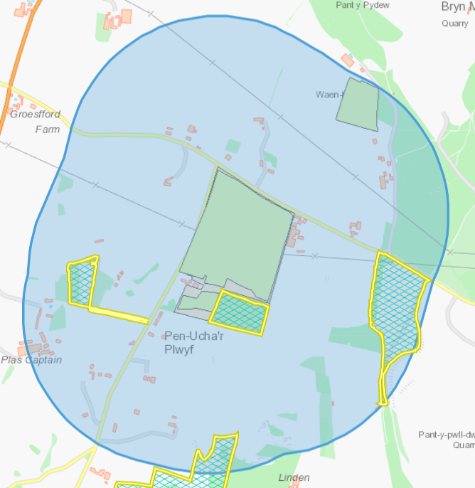

6 - Location of any other designated environmentally sensitive sites within 500m – Racecourse Farm
6a – Protected Habitats - Lowland dry acid grassland and Lowland calcareous grassland, Purple moor grass and rush pastures.
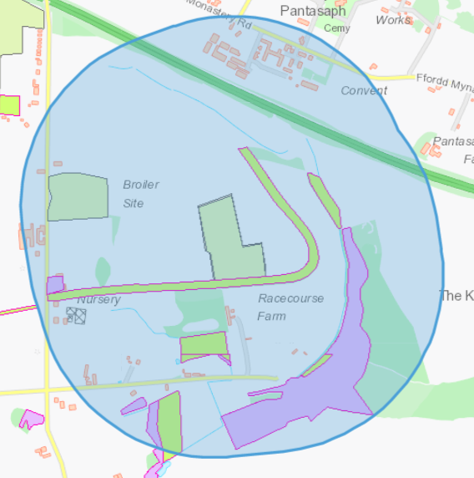
6b - Protected species – Amphibians, Reptiles
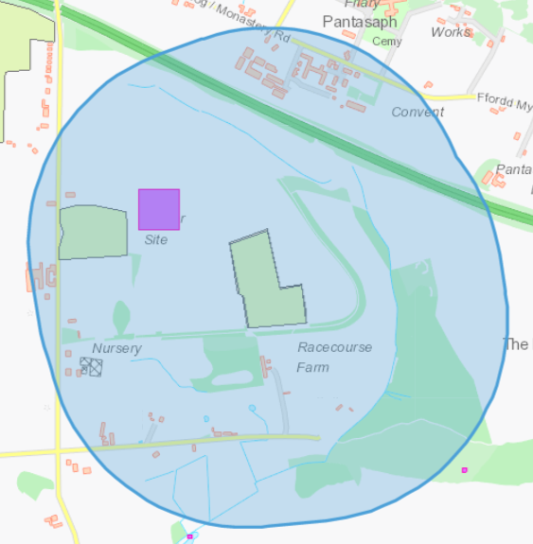

6c – Scheduled Ancient Monuments – Offa’s Dyke
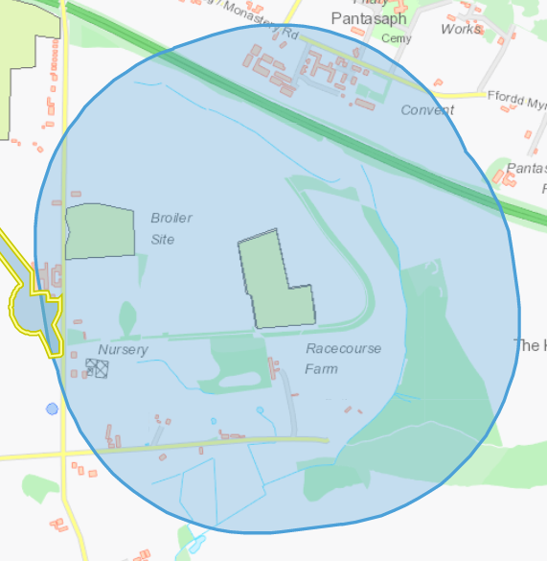
6d – Nitrate vulnerable zones
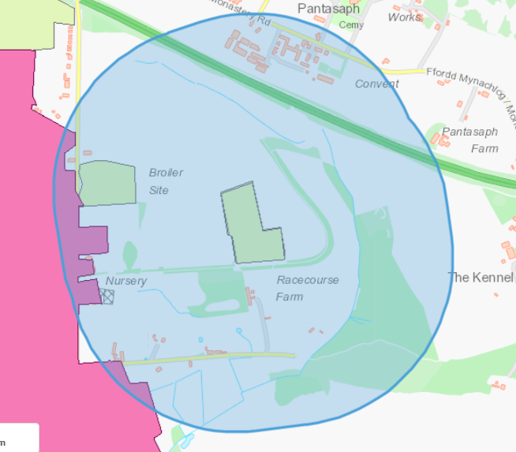

7 - Location of any other designated environmentally sensitive sites within 500m – Trem Y Foel Farm
7a - Protected Habitats – Lowland calcareous grassland, Lowland dry acid grassland
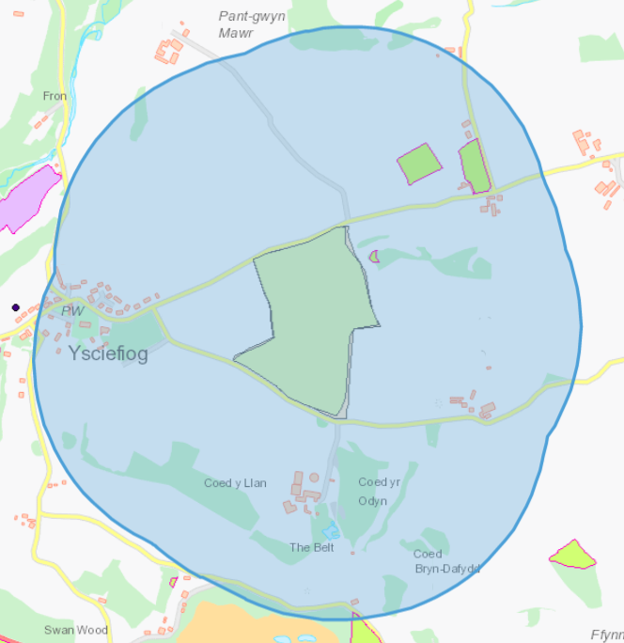
7b - Ancient woodland sites - Restored Ancient Woodland Site and Ancient Semi Natural Woodland
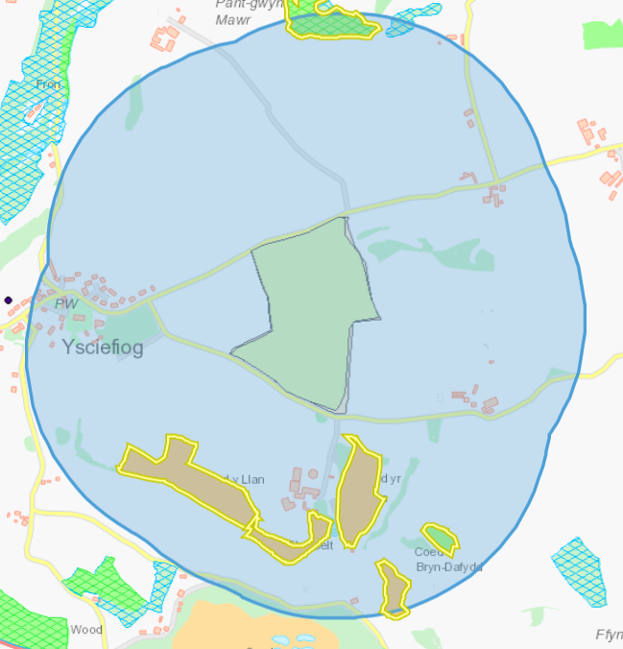

7c - Local Wildlife Sites - Coed Pant-gwyn-Mawr
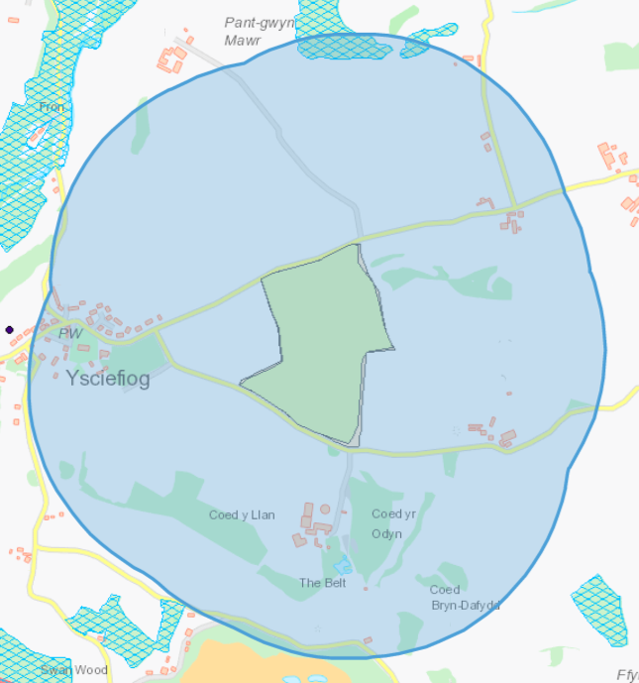
8. Slope Maps – Neither Bryn-Y-Cosn nor Trem Y Foel Farm fields are sloping
8a. Bryn-Y-Cosn
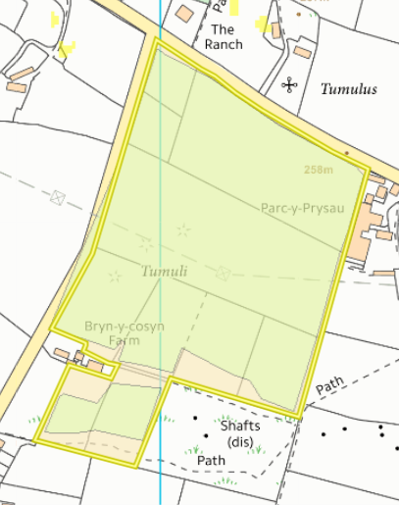
8b. Trem Y Foel


