Permit
The Environmental Permitting (England & Wales) Regulations 2016

Seth Hill & Son Limited

Seth Hill & Son Ltd
The Quarries
Bonvilston
Cardiff
CF5 6TQ

Permit number

EPR/CB3395FT

Permit
The Environmental Permitting (England and Wales) Regulations 2016
Permit number

EPR/CB3395FT

The Natural Resources Body for Wales (“Natural Resources Wales”) authorises, under regulation 13 of the Environmental Permitting (England and Wales) Regulations 2016

Seth Hill & Son Limited (“the operator”),

whose registered office is

Earthmover's House

Unit 16 Llantrisant Business Park

Llantrisant

Pontyclun

Wales

CF72 8LF

company registration number 00512757

to operate waste operations at

Seth Hill & Son Ltd

The Quarries

Bonvilston

Cardiff

CF5 6TQ

to the extent authorised by and subject to the conditions of this permit.

Under regulation 27(2) of the Regulations, standard rules SR2009 No6 are conditions of this permit.

Name | Date
Huw Davies | 18/01/2022

Authorised on behalf of Natural Resources Wales

Schedule 1 - Site plan

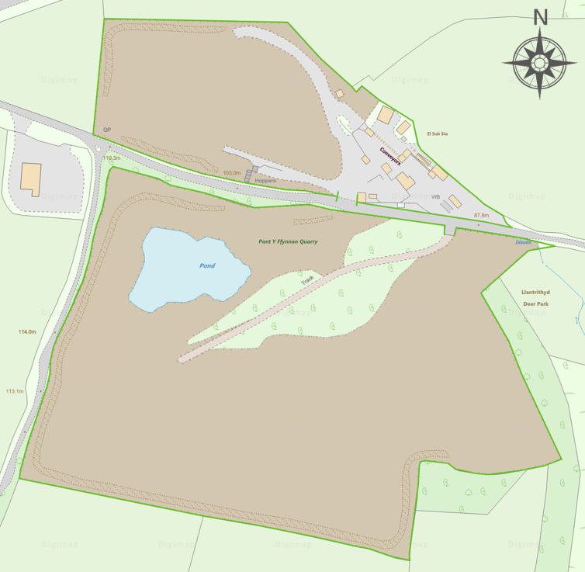
This is the plan referred to in the standard rules SR2009 No6

END OF PERMIT

