CRoW Appendix 4 (140_10_SD02)  CRoW Act 2000: Natural Resources Wales application for permission - Formal Notice |  | 
Natural Resources Wales Formal Notice.
Requirements of Section 28I of the Wildlife & Countryside Act 1981 as amended by the Countryside and Rights of Way Act (CRoW) 2000.
Duty in relation to granting any consent, licence or permit for activities likely to damage Sites of Special Scientific Interest (SSSI).
Guide to filling in this form for Natural Resources Wales staff:
To be completed by Permitting Officers for any applications for a permission which the Natural Resources Wales has considered under S28G duties to protect and enhance SSSIs. This applies to all proposed permissions within a SSSI, and to operations outside the SSSI boundary which are likely to damage its special features.
Refer to OI 140_10 ‘Applying the Countryside and Rights of Way (CRoW) Act 2000 to applications for permits with potential for impact on Sites of Special Scientific Interest (SSSI)’, including the flowchart in Appendix 2.
- Natural Resources Wales area/region/NPS hub: | South Central
- Name of SSSI: | Rhos Tonyrefail
- Type of permission: | Environmental Permit – waste operation: Waste Electrical and Electronic Equipment (WEEE) authorised treatment facility
- Date for Natural Resources Wales permit determination: | 08/02/2022
- Predicted 28 day date for response from NRW conservation/ecology (under S28 I(4)): | N/A
- Natural Resources Wales reference no: | PAN-014030
- National grid reference: | ST 00817 90005
- Description of proposal: | The application is for a Waste Electrical and Electronic Equipment (WEEE) authorised treatment facility at Unit 4, Dinas Isaf Industrial Estate, Tonypandy, CF40 1NY.  - Maximum annual tonnage of 2,499 tonnes  - Accepting waste electronic and electrica equipment only, no wastes containing ozone-depleting substances can be accepted  - Treatment is limited to manual methods only, including sorting and separation, dismantling, repair and/or refurbishment, compaction, baling, and bulking up  - No point source emissions  - Storage and treatment is carried out inside a building, other than ferrous metal which may be stored in a sealed container outside  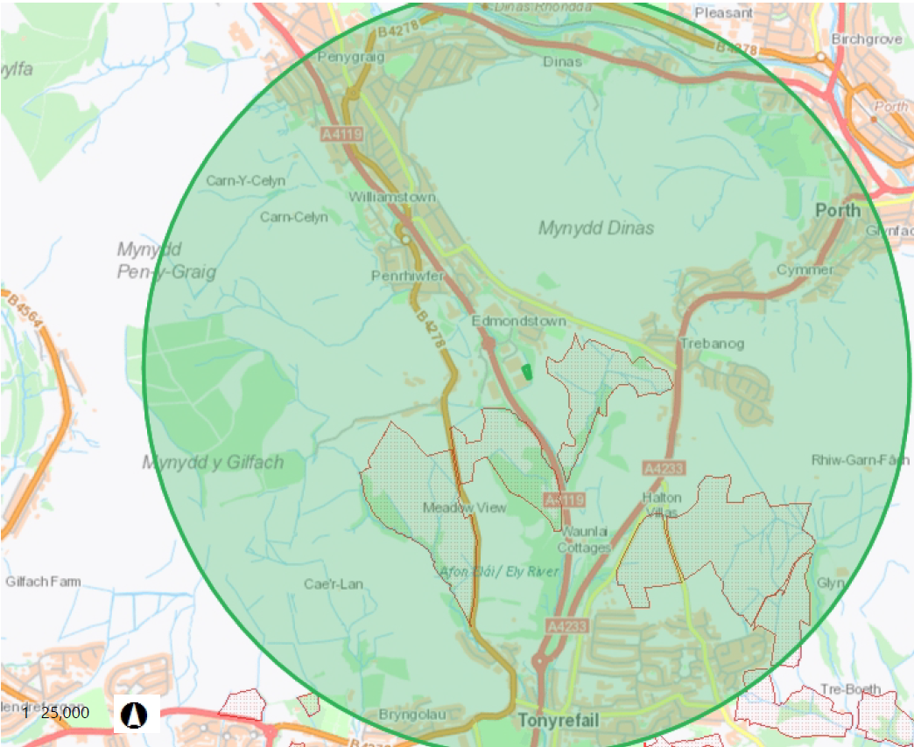  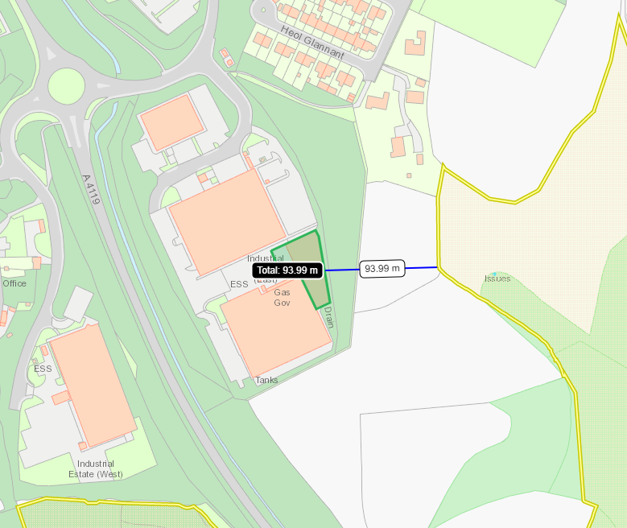
- Is the proposed activity within (wholly or partially) the SSSI boundary? | NO – the activity is approx.94m away from the SSSI at it’s nearest point
- Has there been any pre-application discussion or correspondence with NRW conservation/ecology | NO
- What aspect(s) of the proposed permission may damage the features which are of special interest for the SSSI?
The following ‘Operations Requiring Consent’ (or other activities associated with the permission) that may cause damage) are relevant to the proposed permission:

None of the activities proposed are listed as ‘Operations Requiring Consent’.

The following SSSI features and mechanisms of impact have been considered to assess the likelihood of damage:
Features include marshy grassland, acid flush, species-rich neutral grassland, acid grassland, wet heath and blanket mire. The site is also of special interest for its population of marsh fritillary butterfly.
There is no mechanism for impact from noise or dust as all activities are undertaken inside a building and treatment is manual only. All wastes are stored on an impermeable surface with sealed drainage and the site sits on lower ground below the SSSI, therefore there is no potential impact pathway through contamination of surfacewater or groundwater affecting the habitat.

- Decision
i) The proposed permission is not likely to damage any of the flora, fauna or geological or physiological features which are of special interest.
There is no mechanism (hazard) and no pathway for features to be affected.

Natural Resources Wales is minded to:
Issue the permission

- Name and job title of Natural Resources Wales officer: | Anna Palmer  Senior Permitting Officer
- Date form sent to NRW conservation/ecology | N/A

