PAN-016059 MyMap Screening Report
1 – Surface water courses - River located within close proximity to spreading area (13m - closest) – Spread zone labelled on site map.
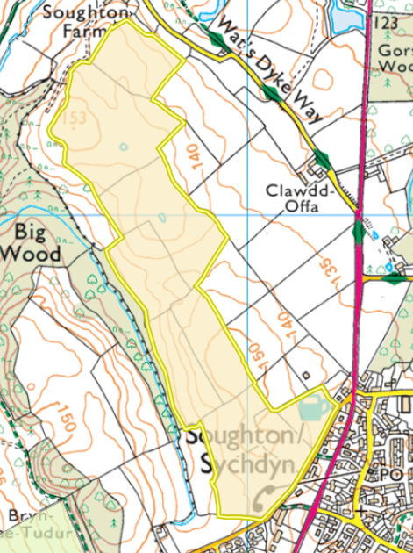
2 – Location of buildings – Local residential area of Soughton
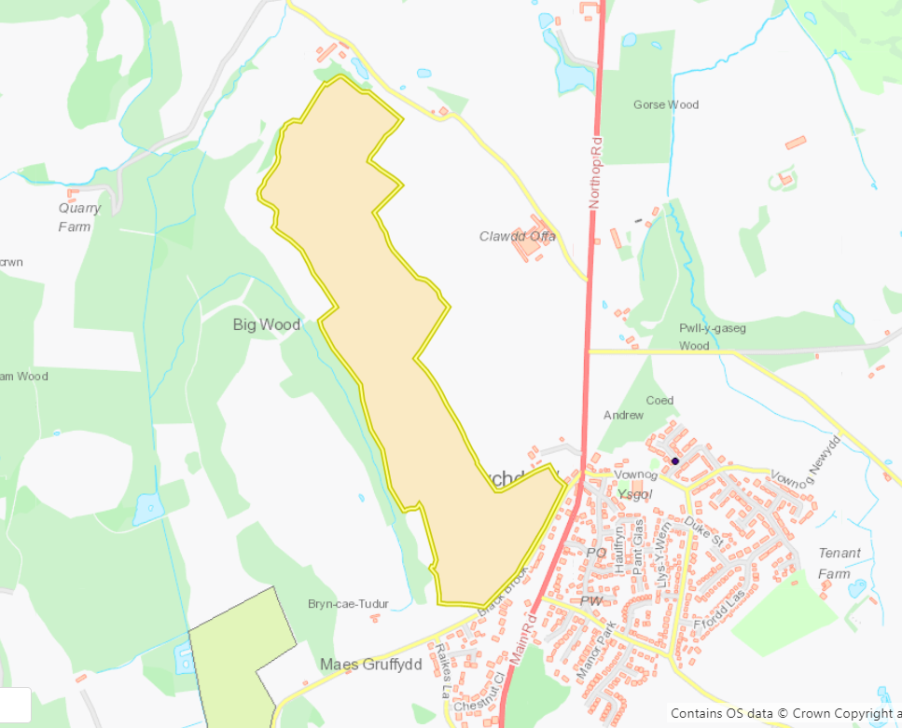

3 - The location of any other designated environmentally sensitive sites within 500m
3a – Protected species – Amphibians, Reptiles (NE – yellow)
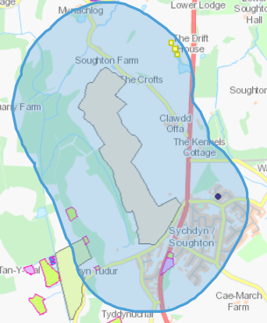
3b – Protected Habitats – Lowland dry acid grassland and Lowland calcareous grassland, Purple moor grass and rush pastures.
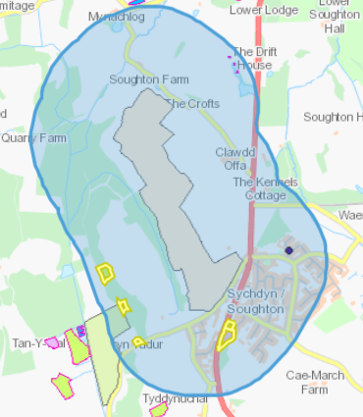

3c – Scheduled Ancient Monuments - Wat's Dyke: Section from Chester-Holywell Road to Soughton Farm, Wat's Dyke: Section SE of Clawdd Offa.
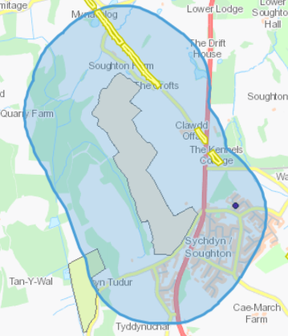
3d – Ancient Woodland – Ancient semi natural woodland, Restored ancient woodland site, Plantation on ancient woodland site.
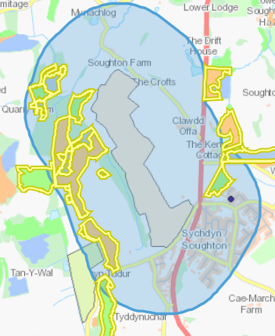
3e – Local wildlife sites (SINC’s) - Coed Andrew, Maes Gruffydd Wetland, Coed Ffoulkes, Gwysaney Alder Carr, Marsh and Pools, Soughton Hall & Gorse Wood Ponds, Tyn y Caeau.
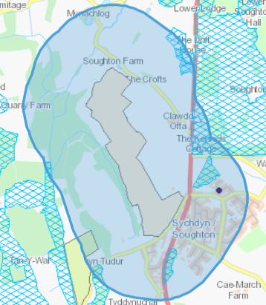
3f – Nitrate vulnerable zones (NVZ)
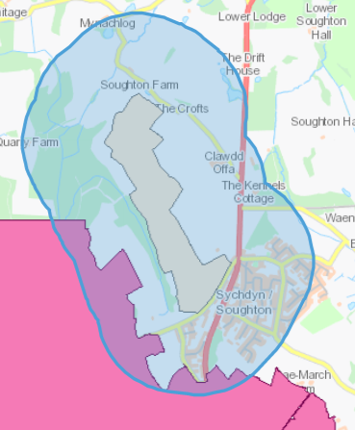
4 – Slope Profile – Majority of the spreading area falls between 0-7 degrees. Areas within fields 3, 4, 5, 6 are between 7-12 degrees near watercourse. Applicant has applied 10m buffer zone.


