

Permit with introductory note
The Environmental Permitting (England & Wales) Regulations 2016

Lloyd’s Animal Feeds (Western) Limited

Wrexham Mill
Bridge Road North
Wrexham Industrial Estate
Wrexham
LL13 9PS

Permit number

EPR/AB3492ZQ

Wrexham Mill

Permit number EPR/AB3492ZQ

Introductory note

This introductory note does not form a part of the permit

The main features of the permit are as follows.

Wrexham Mill is an animal feed manufacturing facility operated by Lloyd’s Animal Feeds (Western) Limited. The mill, which has been operational since the mid 1980s, manufactures compound animal feeds. The facility can manufacture approximately 225,000 tonnes of feed per year, depending on demand.

The site is located in Wrexham Industrial Estate, approximately 4.5 km to the east of Wrexham.

The products manufactured in the mill are based upon core formulations of cereals (e.g. wheat, maize, barley), and other natural ingredients (e.g. soya bean meal, rapeseed meal, sunflower kernel), plus specific additives such as mineral and vitamin supplements.

The key processes undertaken at the site are the receipt and storage of raw materials, weighing, grinding, mixing, conditioning, pressing, cooling, coating, bulk storage of the final products and dispatch from site.

There are four emissions to air, three via cyclone abatement from press line 1, press line 2 and the heat-treated meal line cooler exhausts, and one from the 3.6 MW thermal input gas powered boiler, used for steam generation.

All effluent from factory cleaning, boiler blowdown, vehicle washing and on site amenities goes to foul sewer. Run-off from the site buildings and yards is routed to the main surface water drain to the south of the site, that connects into the network of drains on Wrexham Industrial Site.

There are three European Protected Sites within 10 km of the site. Midland Meres & Mosses Phase 2 RAMSAR 4.6 km away, River Dee and Bala Lake SAC 3.6 km away and Johnstown Newt Sites SAC 7.5 km away. There are no designated SSSIs within 2 km of the site. There are three designated Wildlife sites within 2 km of the site. Wrexham Industrial Estate 0.2 km away, Cefn Park 1.4 km away and Peter’s Dingle 1.6 km away.

The status log of the permit sets out the permitting history, including any changes to the permit reference number.

Status log of the permit
Description | Date | Comments
Application EPR/AB3492ZQ/A001 | Duly made 15/04/2016 | Application for an animal feed manufacturing facility
Schedule 5 notice sent | 27/06/2016 | Further information requested from applicant
Additional information received | 22/07/2016 | Information received in response to schedule 5
Additional information received | 28/07/2016 | Updated site plan received in response to schedule 5
Additional information received | 03/08/2016 | Further information received in response to schedule 5
Schedule 5 notice sent | 26/08/2016 | Further information requested from applicant
Deadline for information extended | 06/10/2016 | Request for further time made by applicant
Deadline for information extended | 24/11/2016 | Request for further time made by applicant
Additional information received | 21/12/2016 | Information received in response to schedule 5
Permit determined  EPR/AB3492ZQ | 17/05/2017 | Permit granted to Lloyd’s Animal Feeds (Western) Limited
Application received  EPR/AB3492ZQ/V002 | Duly made 15/02/2019 | Minor technical variation for an increase in throughput from 185,000t to 225,000t
Variation issued  EPR/AB3492ZQ/V002 | 09/05/2019 | Varied and consolidated permit issued
Regulation 61 Notice sent to operator | 27/04/2020 | Issue of a Notice under Regulation 61(1) of the EPR. Natural Resources Wales initiated review and variation to vary the permit following the publication of the revised Best Available Techniques (BAT) Reference Document (BRef) for Food, Drink and Milk.
Regulation 61 Notice Response Received | 30/10/2020 | Response to Regulation 61 Notice Received
Additional Information Received | 27/04/2021 | Additional information to the Regulation 61 Notice
NRW initiated Variation Issued  EPR/AB3492ZQ/V003 | 26/01/2022 | NRW initiated variation issued to Lloyd’s Animal Feeds (Western) Limited

End of introductory note

Permit
The Environmental Permitting (England and Wales) Regulations 2016

Permit number

EPR/AB3492ZQ

This is the consolidated permit referred to in the variation and consolidation notice for application EPR/AB3492ZQ/V003 authorising,

Lloyd’s Animal Feeds (Western) Limited (“the operator”),

whose registered office is

The Mill

Morton

Oswestry

Salop

SY10 8BH

company registration number 03819415

to operate an installation at

Wrexham Mill

Bridge Road North

Wrexham Industrial Estate

Wrexham

LL13 9PS

to the extent authorised by and subject to the conditions of this permit.

Signed | Date
Holly Noble | 26/01/2022

Authorised on behalf of Natural Resources Wales
/
/

1 Management

General management

The operator shall manage and operate the activities:

in accordance with a written management system that identifies and minimises risks of pollution, including those arising from operations, maintenance, accidents, incidents, non-conformances, closure and those drawn to the attention of the operator as a result of complaints; and

using sufficient competent persons and resources.

Records demonstrating compliance with condition 1.1.1 shall be maintained.

Any person having duties that are or may be affected by the matters set out in this permit shall have convenient access to a copy of it kept at or near the place where those duties are carried out.

1.2 Energy efficiency

1.2.1 The operator shall:

(a) take appropriate measures to ensure that energy is used efficiently in the activities;

(b) review and record at least every four years whether there are suitable opportunities to improve the energy efficiency of the activities; and

(c) take any further appropriate measures identified by a review.

1.3 Efficient use of raw materials

1.3.1 The operator shall:
(a) take appropriate measures to ensure that raw materials and water are used efficiently in the activities;
(b) maintain records of raw materials and water used in the activities;
(c) review and record at least every four years whether there are suitable alternative materials that could reduce environmental impact or opportunities to improve the efficiency of raw material and water use; and
(d) take any further appropriate measures identified by a review.

1.4 Avoidance, recovery and disposal of wastes produced by the activities

The operator shall take appropriate measures to ensure that:

(a) the waste hierarchy referred to in Article 4 of the Waste Framework Directive is applied to the generation of waste by the activities; and

(b) any waste generated by the activities is treated in accordance with the waste hierarchy referred to in Article 4 of the Waste Framework Directive; and

(c) where disposal is necessary, this is undertaken in a manner which minimises its impact on the environment.

The operator shall review and record at least every four years whether changes to those measures should be made and take any further appropriate measures identified by a review.

2 Operations
2.1 Permitted activities

2.1.1 The operator is only authorised to carry out the activities specified in schedule 1 table S1.1 (the “activities”).

2.2 The site

2.2.1 The activities shall not extend beyond the site, being the land shown edged in green on the site plan at schedule 7 to this permit.

2.3 Operating techniques

2.3.1 (a) The activities shall, subject to the conditions of this permit, be operated using the

techniques and in the manner described in the documentation specified in schedule 1, table S1.2, unless otherwise agreed in writing by Natural Resources Wales.

(b) If notified by Natural Resources Wales that the activities are giving rise to pollution, the operator shall submit to Natural Resources Wales for approval within the period specified, a revision of any plan or other documentation (“plan”) specified in schedule 1, table S1.2 or otherwise required under this permit which identifies and minimises the risks of pollution relevant to that plan , and shall implement the approved revised plan in place of the original from the date of approval, unless otherwise agreed in writing by Natural Resources Wales.
2.3.2 Any raw materials or fuels listed in schedule 2 table S2.1 shall conform to the specifications set out in that table.

2.3.3 The operator shall ensure that where waste produced by the activities is sent to a relevant waste operation, that operation is provided with the following information, prior to the receipt of the waste:

(a) the nature of the process producing the waste;

(b) the composition of the waste;

(c) the handling requirements of the waste;

(d) the hazardous property associated with the waste, if applicable; and

(e) the waste code of the waste.

2.3.4 The operator shall ensure that where waste produced by the activities is sent to a landfill site, it meets the waste acceptance criteria for that landfill.

2.4 Improvement programme

2.4.1 The operator shall complete the improvements specified in schedule 1 table S1.3 by the date specified in that table unless otherwise agreed in writing by Natural Resources Wales.

2.4.2 Except in the case of an improvement which consists only of a submission to Natural Resources Wales, the operator shall notify Natural Resources Wales within 14 days of completion of each improvement.

3 Emissions and monitoring

3.1 Emissions to water, air or land

3.1.1 There shall be no point source emissions to water, air or land except from the sources and emission points listed in schedule 3 tables S3.1, S3.2 and S3.3.

3.1.2 The limits given in schedule 3 shall not be exceeded.
    - Periodic monitoring shall be carried out at least once every 5 years for groundwater and 10 years for soil, unless such monitoring is based on a systematic appraisal of the risk of contamination.

Emissions of substances not controlled by emission limits

Emissions of substances not controlled by emission limits (excluding odour) shall not cause pollution. The operator shall not be taken to have breached this condition if appropriate measures, including, but not limited to, those specified in any approved emissions management plan, have been taken to prevent or where that is not practicable, to minimise, those emissions.

3.2.2 The operator shall:

(a) if notified by Natural Resources Wales that the activities are giving rise to pollution, submit to Natural Resources Wales for approval within the period specified, an emissions management plan which identifies and minimises the risks of pollution from emissions of substances not controlled by emission limits;

(b) implement the approved emissions management plan, from the date of approval, unless otherwise agreed in writing by Natural Resources Wales.

3.2.3 All liquids in containers, whose emission to water or land could cause pollution, shall be provided with secondary containment, unless the operator has used other appropriate measures to prevent or where that is not practicable, to minimise, leakage and spillage from the primary container.

3.3 Monitoring

3.3.1 The operator shall, unless otherwise agreed in writing by Natural Resources Wales, undertake the monitoring specified in the following tables in schedule 3 to this permit:

point source emissions specified in table S3.1, S3.2 and S3.3

3.3.2 The operator shall maintain records of all monitoring required by this permit including records of the taking and analysis of samples, instrument measurements (periodic and continual), calibrations, examinations, tests and surveys and any assessment or evaluation made on the basis of such data.

3.3.3 Monitoring equipment, techniques, personnel and organisations employed for the emissions monitoring programme specified in condition 3.3.1 shall have either MCERTS certification or MCERTS accreditation (as appropriate), where available, unless otherwise agreed in writing by Natural Resources Wales.

3.3.4 Permanent means of access shall be provided to enable sampling/monitoring to be carried out in relation to the emission points specified in schedule 3 tables S3.1 unless otherwise agreed in writing by Natural Resources Wales.

3.4 Odour

3.4.1 Emissions from the activities shall be free from odour at levels likely to cause pollution outside the site, as perceived by an authorised officer of Natural Resources Wales, unless the operator has used appropriate measures, including, but not limited to, those specified in any approved odour management plan, to prevent or where that is not practicable to minimise the odour.

3.4.2 The operator shall:

(a) if notified by Natural Resources Wales that the activities are giving rise to pollution outside the site due to odour, submit to Natural Resources Wales for approval within the period specified, an odour management plan which identifies and minimises the risks of pollution from odour;

(b) implement the approved odour management plan, from the date of approval, unless otherwise agreed in writing by Natural Resources Wales.

3.5 Noise and vibration

3.5.1 Emissions from the activities shall be free from noise and vibration at levels likely to cause pollution outside the site, as perceived by an authorised officer of Natural Resources Wales, unless the operator has used appropriate measures, including, but not limited to, those specified in any approved noise and vibration management plan to prevent or where that is not practicable to minimise the noise and vibration.

3.5.2 The operator shall:

(a) if notified by Natural Resources Wales that the activities are giving rise to pollution outside the site due to noise and vibration, submit to Natural Resources Wales for approval within the period specified, a noise and vibration management plan which identifies and minimises the risks of pollution from noise and vibration;

(b) implement the approved noise and vibration management plan, from the date of approval, unless otherwise agreed in writing by Natural Resources Wales.

3.6 Pests
3.6.1 The activities shall not give rise to the presence of pests which are likely to cause pollution, hazard or annoyance outside the boundary of the site. The operator shall not be taken to have breached this condition if appropriate measures, including, but not limited to, those specified in any approved pests management plan, have been taken to prevent or where that is not practicable, to minimise the presence of pests on the site.

3.6.2 The operator shall:
(a) if notified by Natural Resources Wales, submit to Natural Resources Wales for approval within the period specified, a pests management plan which identifies and minimises risks of pollution, hazard or annoyance from pests;
(b) implement the pests management plan, from the date of approval, unless otherwise agreed in writing by Natural resources Wales

4 Information

4.1 Records

All records required to be made by this permit shall:

be legible;

be made as soon as reasonably practicable;

if amended, be amended in such a way that the original and any subsequent amendments remain legible, or are capable of retrieval; and

be retained, unless otherwise agreed in writing by Natural Resources Wales, for at least 6 years from the date when the records were made, or in the case of the following records until permit surrender:
- off-site environmental effects; and
- matters which affect the condition of the land and groundwater.
4.1.2 The operator shall keep on site all records, plans and the management system required to be maintained by this permit, unless otherwise agreed in writing by Natural Resources Wales.

4.2 Reporting

4.2.1 The operator shall send all reports and notifications required by the permit to Natural Resources Wales using the contact details supplied in writing by Natural Resources Wales.

4.2.2 A report or reports on the performance of the activities over the previous year shall be submitted to Natural Resources Wales by 31 January (or other date agreed in writing by Natural Resources Wales) each year. The report(s) shall include as a minimum:

(a) a review of the results of the monitoring and assessment carried out in accordance with the permit including an interpretive review of that data;

(b) the annual production /treatment data set out in schedule 4 table S4.2; and

(c) the performance parameters set out in schedule 4 table S4.3 using the forms specified in table S4.4 of that schedule.

4.2.3 Within 28 days of the end of the reporting period the operator shall, unless otherwise agreed in writing by Natural Resources Wales, submit reports of the monitoring and assessment carried out in accordance with the conditions of this permit, as follows:

(a) in respect of the parameters and emission points specified in schedule 4 table S4.1;

(b) for the reporting periods specified in schedule 4 table S4.1 and using the forms specified in schedule 4 table S4.4 ; and

(c) giving the information from such results and assessments as may be required by the forms specified in those tables.

4.2.4 The operator shall, unless notice under this condition has been served within the preceding four years, submit to Natural Resources Wales, within six months of receipt of a written notice, a report assessing whether there are other appropriate measures that could be taken to prevent, or where that is not practicable, to minimise pollution.

4.3 Notifications
4.3.1 (a) In the event that the operation of the activities gives rise to an incident or accident which significantly affects or may significantly affect the environment, the operator must immediately—
(i) inform Natural Resources Wales,
(ii) take the measures necessary to limit the environmental consequences of such an incident or accident, and
(iii) take the measures necessary to prevent further possible incidents or accidents;
(b) in the event of a breach of any permit condition the operator must immediately—
(i) inform Natural Resources Wales, and
(ii) take the measures necessary to ensure that compliance is restored within the shortest possible time;
(c) in the event of a breach of permit condition which poses an immediate danger to human health or threatens to cause an immediate significant adverse effect on the environment, the operator must immediately suspend the operation of the activities or the relevant part of it until compliance with the permit conditions has been restored.

4.3.2 Any information provided under condition 4.3.1(a)(i), or 4.3.1 (b)(i) where the information relates to the breach of a limit specified in the permit, shall be confirmed by sending the information listed in schedule 5 to this permit within the time period specified in that schedule.

4.3.3 Where Natural Resources Wales has requested in writing that it shall be notified when the operator is to undertake monitoring and/or spot sampling, the operator shall inform Natural Resources Wales when the relevant monitoring and/or spot sampling is to take place. The operator shall provide this information to Natural Resources Wales at least 14 days before the date the monitoring is to be undertaken.

4.3.4 Natural Resources Wales shall be notified within 14 days of the occurrence of the following matters, except where such disclosure is prohibited by Stock Exchange rules:

Where the operator is a registered company:

any change in the operator’s trading name, registered name or registered office address; and

(b) any steps taken with a view to the operator going into administration, entering into a company voluntary arrangement or being wound up.

Where the operator is a corporate body other than a registered company:

any change in the operator’s name or address; and

any steps taken with a view to the dissolution of the operator.

4.3.5 Where the operator proposes to make a change in the nature or functioning, or an extension of the activities, which may have consequences for the environment and the change is not otherwise the subject of an application for approval under the Regulations or this permit:

Natural Resources Wales shall be notified at least 14 days before making the change; and

the notification shall contain a description of the proposed change in operation.

4.3.6 Natural Resources Wales shall be given at least 14 days notice before implementation of any part of the site closure plan.

4.3.7 Where the operator has entered into a climate change agreement with the Government, Natural Resources Wales shall be notified within one month of:
(a) a decision by the Secretary of State not to re-certify the agreement;
(b) a decision by either the operator or the Secretary of State to terminate the agreement; and
(c) any subsequent decision by the Secretary of State to re-certify such an agreement.

4.4 Interpretation

4.4.1 In this permit the expressions listed in schedule 6 shall have the meaning given in that schedule.

4.4.2 In this permit references to reports and notifications mean written reports and notifications, except where reference is made to notification being made “without delay”, in which case it may be provided by telephone.

Schedule 1 - Operations

Table S1.1 activities
Activity reference | Activity listed in Schedule 1 of the EP Regulations | Description of specified activity | Limits of specified activity
A1 | S6.8 Part A (1)(d)(ii)  Treatment and processing of vegetable raw materials whether previously processed or unprocessed, intended for the production of feed with a finished product production capacity greater than 300 tonnes per day. | Production of animal feeds | From receipt of raw materials to dispatch of final product.  Maximum of 225,000 tonnes of feed per annum.

Directly Associated Activity
A2 | Steam generation | 3.6 MWth gas-fired boiler | From receipt of fuel to emission of combustion gases.
A3 | Storage and handling  of raw materials | Material intakes, silos, bulk tanks and warehousing serving the main activity. | From receipt of materials to use in product.
A4 | Storage of finished product | Product bins, despatch bays and bagging plant serving the main activity. | From the end of the production process to dispatch from site.

Table S1.2 Operating techniques
Description | Parts | Date Received
Process Description | All | 08/03/16
Response to Schedule 5 | Part 1 emissions to air, Part 4 site drainage | 22/07/16
Process Steps Flow Diagram | All | 03/05/19
How To Comply With Your Environmental Permit | - | -
Additional guidance for the Food and Drink Sector EPR 6.10 | - | -
Food Drink and Milk Industries BREF 2006 | - | -
Response to regulation 61(1) Notice – request for information dated 27/04/2020 detailing how the Operator will comply with the BAT conclusions for The Food, Drink and Milk Industries under Directive 2010/75/EU of the European Parliament and of the Council | All | 30/10/2020 and 27/04/2021
Further information received via E-mail | All | 29/10/2021

Table S1.3 Improvement programme requirements
Reference | Requirement | Date
IC1 | The Operator shall submit to Natural Resources Wales an updated written procedure(s) describing how they intend to meet the following BAT requirements in accordance with requirements specified within:  - BAT Conclusion 14 of the Food, Drink and Milk Industries BRef Document (EU 2019) – Techniques to prevent, or where not practicable reduce noise and vibration emissions | 4 June 2023 or otherwise agreed in writing with Natural Resources Wales
IC2 | The Operator shall submit to Natural Resources Wales an updated written procedure(s) describing how they intend to meet the following BAT requirements in accordance with requirements specified within:  - BAT Conclusion 7 of the Food, Drink and Milk Industries BRef Document (EU 2019) - Water consumption and wastewater discharge | 4 June 2023 or otherwise agreed in writing with Natural Resources Wales
IC3 | The Operator shall submit to Natural Resources Wales an updated written procedure(s) describing how they intend to meet the following BAT requirements in accordance with requirements specified within:  - BAT Conclusion 2 of the Food, Drink and Milk Industries BRef Document (EU 2019)- Establish and maintain a wastewater and waste gas inventory as part of the EMS | 4 June 2023 or otherwise agreed in writing with Natural Resources Wales

Schedule 2 - Waste types, raw materials and fuels

Table S2.1 Raw materials and fuels
Raw materials and fuel description | Specification
None specified | -

Schedule 3(a) –Emissions and monitoring effective until 3 December 2023

Table S3.1 Point source emissions to air – emission limits and monitoring requirements
Emission point ref. & location | Source | Parameter | Limit (including unit) | Reference period | Monitoring frequency | Monitoring standard or method
A1 (Point A1 on Site layout in schedule 7) | Cooler exhaust 1 | Total Particulate | 30 mg/m³ | Hourly average | Annual | BS EN 13284-1
A2 (Point A2 on Site layout in schedule 7) | Cooler exhaust 2 | Total Particulate | 30 mg/m³ | Hourly average | Annual | BS EN 13284-1
A3 (Point A3 on Site layout in schedule 7) | Cooler exhaust 3 | Total Particulate | 30 mg/m³ | Hourly average | Annual | BS EN 13284-1
A4 (Point A4 on Site layout in schedule 7) | Boiler emission exhaust | No parameters set | No limit set | -- | -- | -

Table S3.2 Point Source emissions to water (other than sewer) and land – emission limits and monitoring requirements
Emission point ref. & location | Source | Parameter | Limit (incl. unit) | Reference Period | Monitoring frequency | Monitoring standard or method
W1 surface water drain connecting to drain on Wrexham Industrial Estate | Uncontaminated rain water from roof and yard areas | No parameters set | No limit set | - | - | -

Table S3.3 Point source emissions to sewer, effluent treatment plant or other transfers off-site– emission limits and monitoring requirements
Emission point ref. & location | Source | Parameter | Limit (incl. Unit) | Reference period | Monitoring frequency | Monitoring standard or method
S1 [Point S1 on drawing 003] emission to foul sewer | Boiler blowdown | No parameters set | No limit set | - | - | -
S2 [Point S2 on drawing 003] emission to foul sewer | Lorry wash | No parameters set | No limit set | - | - | -

Schedule 3(b) – Emissions and monitoring effective from 4 December 2023

Table S3.1 Point source emissions to air – emission limits and monitoring requirements
Emission point ref. & location | Source | Parameter | Limit (including unit) | Reference period | Monitoring frequency | Monitoring standard or method
A1 (Point A1 on drawing 003) | Cooler exhaust 1 | Total Particulate | 20 mg/Nm^{3 Note 1} | Periodic | Annual | BS EN 13284-1
A2 (Point A2 on drawing 003) | Cooler exhaust 2 | Total Particulate | 20 mg/Nm^{3 Note 1} | Periodic | Annual | BS EN 13284-1
A3 (Point A3 on drawing 003) | Cooler exhaust 3 | Total Particulate | 20 mg/Nm^{3 Note 1} | Periodic | Annual | BS EN 13284-1
A4 (Point A4 on drawing 003) | Boiler emission exhaust | No parameters set | No limit set | -- | -- | -

Note 1: Emission limit value expressed as mass of emitted substances per volume of waste gas under the following conditions: dry gas at a temperature of 273.15 K and a pressure of 101.3 kPa without correction for oxygen content.

Table S3.2 Point Source emissions to water (other than sewer) and land – emission limits and monitoring requirements
Emission point ref. & location | Source | Parameter | Limit (incl. unit) | Reference Period | Monitoring frequency | Monitoring standard or method
W1 surface water drain connecting to drain on Wrexham Industrial Estate | Uncontaminated rain water from roof and yard areas | No parameters set | No limit set | - | - | -

Table S3.3 Point source emissions to sewer, effluent treatment plant or other transfers off-site– emission limits and monitoring requirements
Emission point ref. & location | Source | Parameter | Limit (incl. Unit) | Reference period | Monitoring frequency | Monitoring standard or method
S1 [Point S1 on drawing 003] emission to foul sewer | Boiler blowdown | No parameters set | No limit set | - | - | -
S2 [Point S2 on drawing 003] emission to foul sewer | Lorry wash | No parameters set | No limit set | - | - | -

Schedule 4(a) - Reporting effective until 3 December 2023

Parameters, for which reports shall be made, in accordance with conditions of this permit, are listed below.

Table S4.1 Reporting of monitoring data
Parameter | Emission or monitoring point/reference | Reporting period | Period begins
Emissions to air  Parameters as required by condition 3.3.1 | A1, A2, A3 | Annual | 1 January

Table S4.2: Annual production/treatment
Parameter | Units
Animal Feed | tonnes

Table S4.3 Performance parameters
Parameter | Frequency of assessment | Units
Water usage | Annually | tonnes
Energy usage | Annually | MWh
Total raw material used | Annually | tonnes

Table S4.4 Reporting forms
Media/parameter | Reporting format | Date of form
Air | Form air 1 or other form as agreed in writing by Natural Resources Wales | 17/05/17
Water usage | Form water usage 1 or other form as agreed in writing by Natural Resources Wales | 17/05/17
Energy usage | Form energy 1 or other form as agreed in writing by Natural Resources Wales | 17/05/17
Other performance indicators | Form performance 1 or other form as agreed in writing by Natural Resources Wales | 17/05/17

Schedule 4(b) - Reporting effective from 4 December 2023

Parameters, for which reports shall be made, in accordance with conditions of this permit, are listed below.

Table S4.1 Reporting of monitoring data
Parameter | Emission or monitoring point/reference | Reporting period | Period begins
Emissions to air  Parameters as required by condition 3.3.1. | A1, A2, A3 | Annual | 1 January

Table S4.2: Annual production/treatment
Parameter | Units
Animal Feed | tonnes

Table S4.3 Performance parameters
Parameter | Frequency of assessment | Units
Water usage | Annually | tonnes
Energy usage | Annually | MWh
Total raw material used | Annually | tonnes

Table S4.4 Reporting forms
Media/parameter | Reporting format | Date of form
Air | Form air 1 or other form as agreed in writing by Natural Resources Wales | 04/12/23
Water usage | Form water usage 1 or other form as agreed in writing by Natural Resources Wales | 17/05/17
Energy usage | Form energy 1 or other form as agreed in writing by Natural Resources Wales | 17/05/17
Other performance indicators | Form performance 1 or other form as agreed in writing by Natural Resources Wales | 17/05/17

Schedule 5 - Notification

These pages outline the information that the operator must provide.

Units of measurement used in information supplied under Part A and B requirements shall be appropriate to the circumstances of the emission. Where appropriate, a comparison should be made of actual emissions and authorised emission limits.

If any information is considered commercially confidential, it should be separated from non-confidential information, supplied on a separate sheet and accompanied by an application for commercial confidentiality under the provisions of the EP Regulations.

Part A

Permit Number

Name of operator

Location of Facility

Time and date of the detection

(a) Notification requirements for any activity that gives rise to an incident or accident which significantly affects or may significantly affect the environment

To be notified within 24 hours of detection

Date and time of the event

Reference or description of the location of the event

Description of where any release into the environment took place

Substances(s) potentially released

Best estimate of the quantity or rate of release of substances

Measures taken, or intended to be taken, to stop any emission

Description of the failure or accident.

(b) Notification requirements for the breach of a permit condition

To be notified within 24 hours of detection unless otherwise specified below

Emission point reference/ source

Parameter(s)

Limit

Measured value and uncertainty

Date and time of monitoring

Measures taken, or intended to be taken, to stop the emission

Time periods for notification following detection of a breach of a limit
Parameter | Notification period

(c) In the event of a breach of permit condition which poses an immediate danger to human health or threatens to cause an immediate significant adverse effect on the environment:

To be notified within 24 hours of detection

Description of where the effect on the environment was detected

Substances(s) detected

Concentrations of substances detected

Date of monitoring/sampling

Part B - to be submitted as soon as practicable

Any more accurate information on the matters for notification under Part A.

Measures taken, or intended to be taken, to prevent a recurrence of the incident

Measures taken, or intended to be taken, to rectify, limit or prevent any pollution of the environment which has been or may be caused by the emission

The dates of any unauthorised emissions from the facility in the preceding 24 months.

Name*

Post

Signature

Date

* authorised to sign on behalf of the operator

Schedule 6 - Interpretation
“accident” means an accident that may result in pollution.
“application” means the application for this permit, together with any additional information supplied by the operator as part of the application and any response to a notice served under Schedule 5 to the EP Regulations.
“authorised officer” means any person authorised by Natural Resources Wales under section 108(1) of The Environment Act 1995 to exercise, in accordance with the terms of any such authorisation, any power specified in section 108(4) of that Act.
“EP Regulations” means The Environmental Permitting (England and Wales) Regulations SI 2016 No.675 and words and expressions used in this permit which are also used in the Regulations have the same meanings as in those Regulations.

“emissions of substances not controlled by emission limits” means emissions of substances to air, water or land from the activities, either from the emission points specified in schedule 3 or from other localised or diffuse sources, which are not controlled by an emission limit..
“groundwater” means all water, which is below the surface of the ground in the saturation zone and in direct contact with the ground or subsoil.

“Industrial Emissions Directive” means DIRECTIVE 2010/75/EU OF THE EUROPEAN PARLIAMENT AND OF THE COUNCIL of 24 November 2010 on industrial emissions

“MCERTS” means the Environment Agency’s Monitoring Certification Scheme.

Pests” means Birds, Vermin and Insects.
Where a minimum limit is set for any emission parameter, for example pH, reference to exceeding the limit shall mean that the parameter shall not be less than that limit.

Unless otherwise stated, any references in this permit to concentrations of substances in emissions into air means:
- in relation to emissions from combustion processes, the concentration in dry air at a temperature of 273K, at a pressure of 101.3 kPa and with an oxygen content of 3% dry for liquid and gaseous fuels, 6% dry for solid fuels; and/or
- in relation to emissions from non-combustion sources, the concentration at a temperature of 273K and at a pressure of 101.3 kPa, with no correction for water vapour content.

Schedule 7 - Site plan
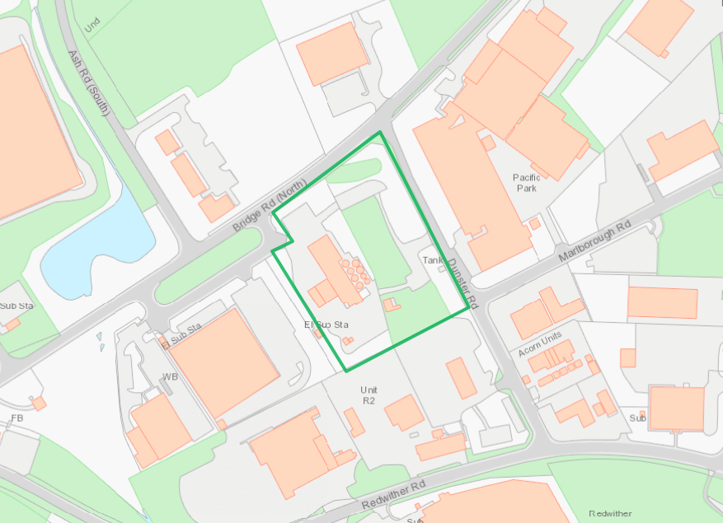

© Crown Copyright and database right 2017. Ordnance Survey licence number 100019741.

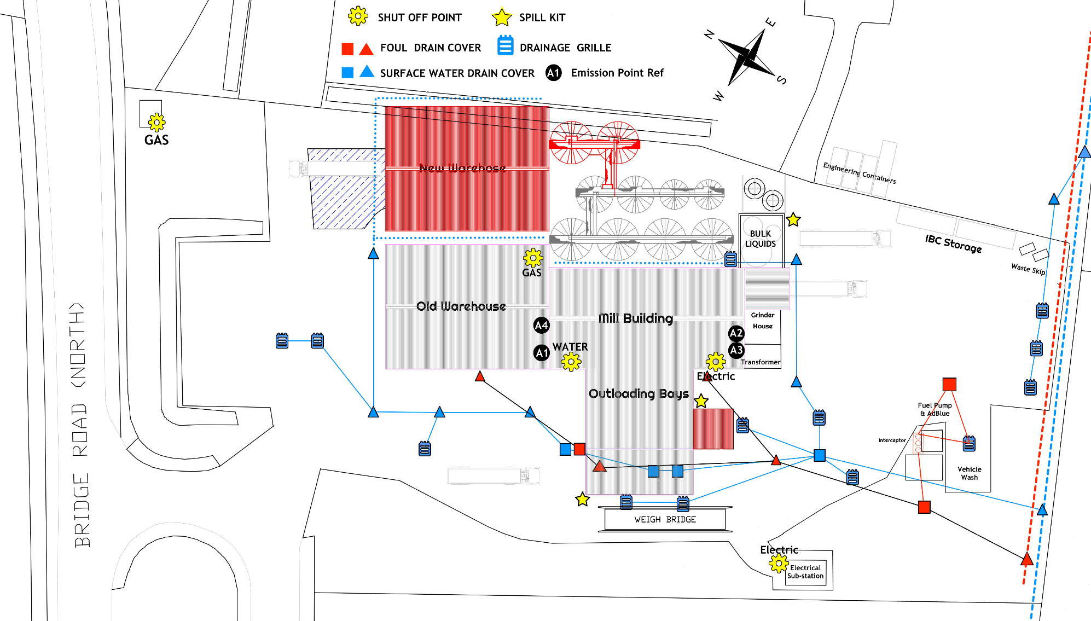
Site Layout Plan – new warehouse, silos and new outload bins shaded in red

END OF PERMIT

