PAN-016375 – MyMap Screening Report
- Plas Llanfinhangel – Surface watercourses –
- River running alongside fields 8, 10 and 11.
- watercourse located in field 1, 6, 9
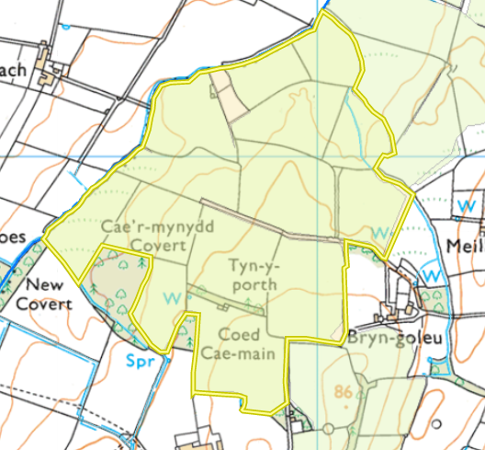
- Any well, spring (or issue) or borehole used for the supply of water for human consumption including from a private water supply or supplies (within 50m) – Marked with orange circle. South of the map – Location of a spring and an issue (lowest point) and a well (above). East of the map – location of a well.

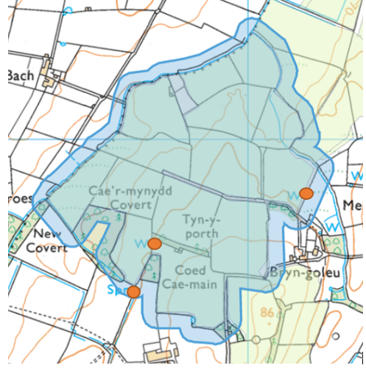

- Any spring (or issue), well or borehole used to supply water for domestic or food production purposes within 250m. Marked with orange circle. South of the map – Location of a spring and an issue (lowest point). East – shows location of 3 wells

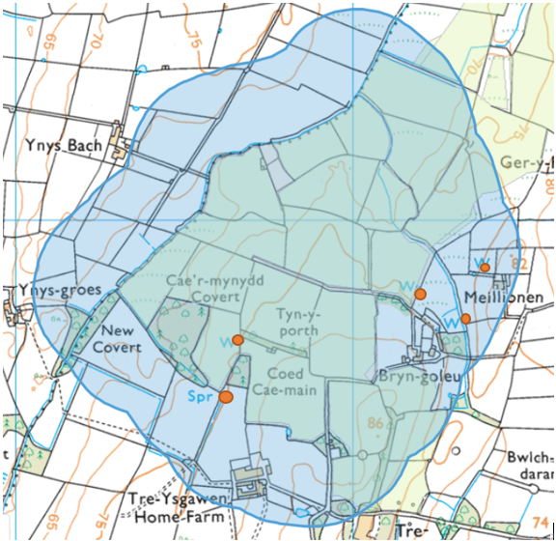

- Any European designated sites- Natura 2000 (SPA, pSPA, SAC or cSAC) or Ramsar- or SSSI within 500m – None within 500m – shown below

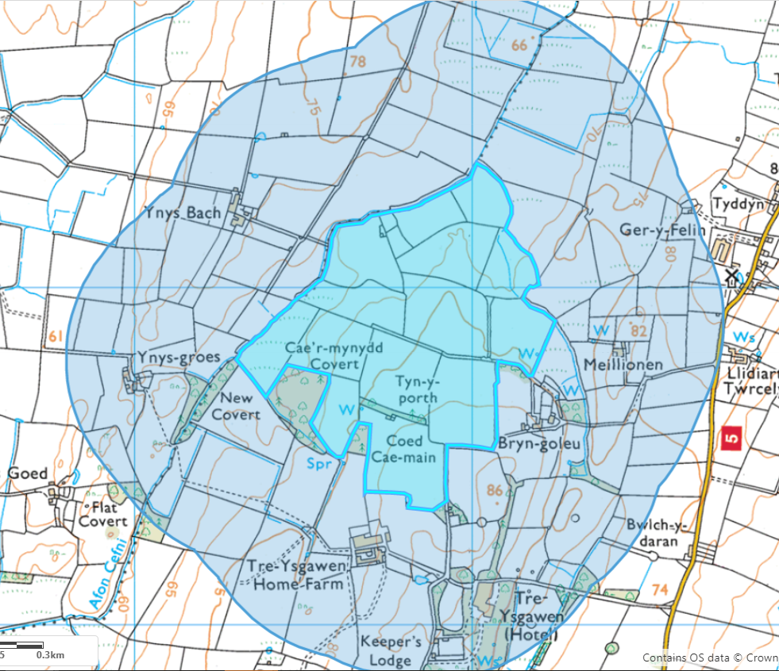

- Any buildings or houses within 250m.

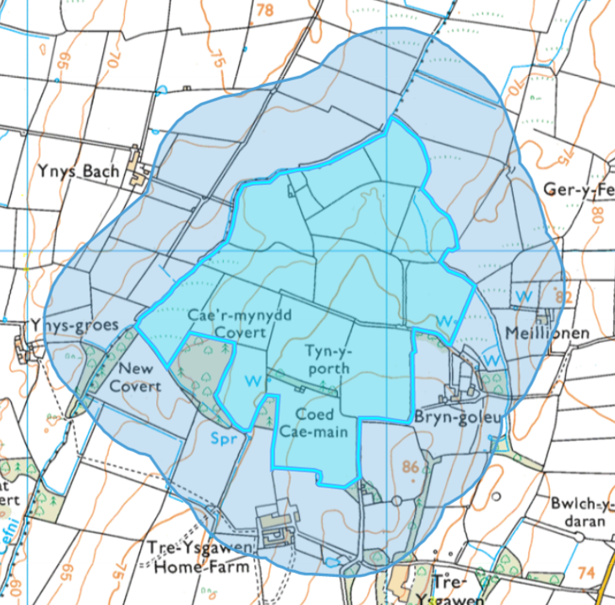

- The location of any other designated environmentally sensitive sites within 500m.

6a. Protected Habitats – Purple moor grass and rush pastures, Lowland dry acid grassland and Lowland calcareous grassland

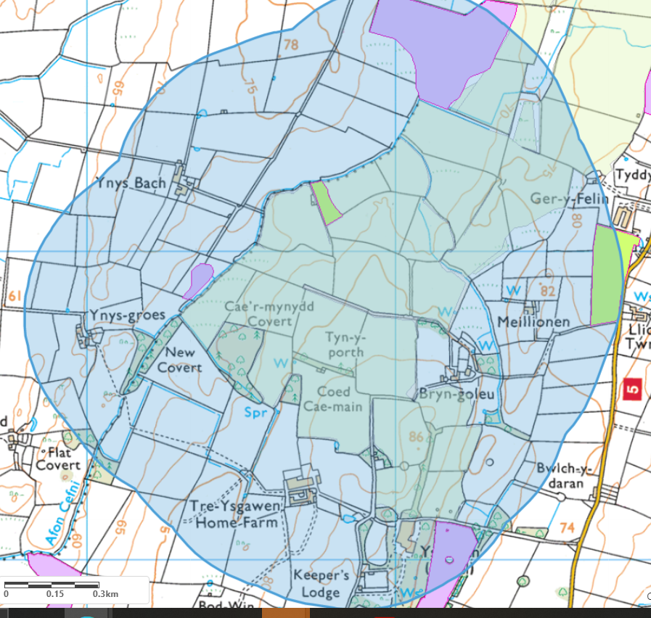
6b. Ancient woodland – Restored ancient woodland (Orange) and Ancient semi natural woodland (Green)

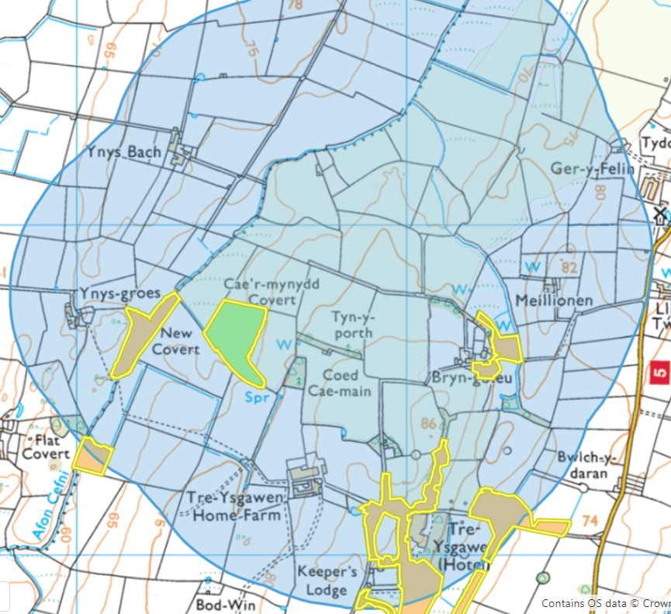

- Slope profile – None of the fields are steeply sloping (all fall between 0-7 degrees)


