CRoW Appendix 4 (140_10_SD02)

CRoW Act 2000: Natural Resources Wales application for permission - Formal Notice

Natural Resources Wales Formal Notice.
Requirements of Section 28I of the Wildlife & Countryside Act 1981 as amended by the Countryside and Rights of Way Act (CRoW) 2000.
Duty in relation to granting any consent, licence or permit for activities likely to damage Sites of Special Scientific Interest (SSSI).
- Natural Resources Wales area/region/NPS hub: | South Central
- Name of SSSI: | Cwm Taf Fechan Woodlands SSSI  Nant Glais Caves SSSI
- Type of permission: | Landspreading deployment under SR2010 No4
- Date for Natural Resources Wales permit determination: | 04/01/2022
- Predicted 28 day date for response from NRW conservation/ecology (under S28 I(4)): | N/A
- Natural Resources Wales reference no: | PAN-016060 under EPR/GP3792SK
- National grid reference: | 1 304842,210751, 2 304793,210838, 3 304680,210861, 4  4 304764,210913, 5 304854,210972, 6 304943,211036,  7 304840,211071, 8 304756,211049, 9 304674,211013  10 304581,210988, 11 304560,211146, 12 304674,211148  13 304765,211156, 14 304670,211265, 15 304770,211285  16 304884,211311, 17 304985,211445, 18 304836,211495  19 304698,211555, 20 304644,211436, 21 304523,211428  22 304385,211392, 23 304537,211267, 24 304408,211188  26 304425,210977, 27 304500,210965  Storage:  A. 304969 211232, B. 304927 211283, C. 305064 211383
- Description of proposal: | Spreading waste from Potable water treatment sludge and Whole anaerobic digestate (EWC codes: 19 09 02 and 19 09 06) produced by DCWW Pontsticill and Andigestion ltd respectively.  Application to spread a maximum of 11,425 tonnes. The waste will be spread over 45.7 hectares of land within the listed fields at Pengelli Fawr. The waste will be stored in stockpile / nurse tanks and then spread onto the fields.  Spreading will only take place subject to ground conditions  and following the Code of Good Agricultural Practice (Defra, 2011), NVZ regulations and the permit holder’s Environmental Management System (EMS).  Targeted periods of spreading to grass fields include spring 2022 (late Feb – Apr), and after cutting of silage through summer and autumn 2022 (May-August). Due to the post-spreading lay-off period, this could correspond to spreading up to every three weeks throughout the growing period.  No more than 50t/ha of liquid sludge will be spread on a field in any 3-week period in accordance with CoGAP, and no more than 250t/ha will be spread within any 12-month period.  The cake will be spread using conventional rear discharge spreaders as this equipment is readily available to the farmer/contractor and the most appropriate for the material and application rates used. Liquid sludges will be surface spread by tractor and tanker using a low-trajectory splash plate.  The wastes may be applied separately or in combination. If the wastes are applied in combination the total combined amount applied will not exceed 250t/ha, the total nitrogen loading will be less than 250kg/ha, and the amount of available nitrogen and total or available phosphate and potash (whichever is appropriate) will not exceed the fertiliser recommendation or the amount removed in crop offtake, whichever is the greater.  All fields are pH 6 or above so alum-based sludge (DCWW Pontsticill) can be spread across all fields.  The limiting factors for the different wastes are as follows;  • Pontsticill cake: total N or total P on fields with P index ≥2  • Pontsticill liquid: max rate of 250t/ha  • Andigestion: readily available N
- Is the proposed activity within (wholly or partially) the SSSI boundary? | NO - Cwm Taf Fechan Woodlands SSSI is 380m to the south of field 1  Nant Glais Caves SSSI is 380m to the southwest of field 26.  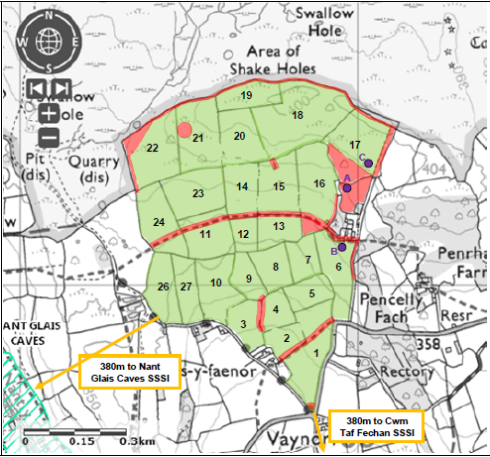
- Has there been any pre-application discussion or correspondence with NRW conservation/ecology | No
- What aspect(s) of the proposed permission may damage the features which are of special interest for the SSSI?

The following ‘Operations Requiring Consent’ (or other activities associated with the permission) that may cause damage) are relevant to the proposed permission.

Cwm Taf Fechan Woodlands SSSI
Dumping, spreading or discharging of any waste materials.

Nant Glais Caves SSSI
Dumping, spreading or discharging of any waste materials.

The following SSSI features and mechanisms of impact have been considered to assess the likelihood of damage:

Cwm Taf Fechan Woodlands SSSI
The Semi-natural Broadleaved Woodland at Cwm Taf Fechan is special for its wide variety of plants, including several rare species. The dominant tree species are oak, ash and downy birch, with an understorey of shrubs such as hazel and hawthorn. In places, springs occur, and where the water has previously seeped through limestone they can create porous or spongy deposits of calcium carbonate known as tufa. The humid conditions in the wooded ravine allow a particularly rich moss and liverwort flora to grow, with over a hundred species recorded.

Nant Glais Caves SSSI
The limestone gorge of Nant Glais and two cave systems, which lie parallel to it and under each bank of the stream are of geological interest. The cave systems are of interest because they are developed at the contact of two different forms of limestone within the Carboniferous Limestone and the way in which they dissolve which has spectacularly influenced the pattern of cave passages. As well as the cave feature listed above, Nant Glais Caves has habitats and species that may contribute to the interest. These include woodland along the gorge and species, such as invertebrates and fish, which live in the caves and river. Except where it is specified below, management of this site should also aim to look after these habitats and species as well as the feature mentioned above.
- Decision
i) The proposed permission is not likely to damage any of the flora, fauna or geological or physiological features which are of special interest because of the mitigation strategies set out below:

- Cwm Taf Fechan Woodlands SSSI is 380m to the south of field 1
- Nant Glais Caves SSSI is 380m to the southwest of field 26
- Waste streams have low potential to produce airborne dust and particulate matter
- Delivery to storage area is >1km away from designated area

Natural Resources Wales is minded to: Issue the permission
- Name and job title of Natural Resources Wales officer: | Gianluca Broadley  Permitting Officer
- Date form sent to NRW conservation/ecology | n/a saved for information noly

