PAN-016060 – MyMap Screening report
- Surface water courses
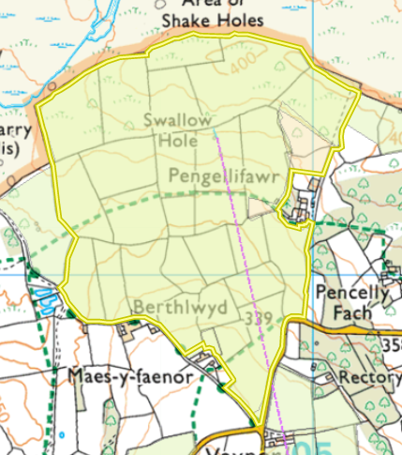
- Any European designated sites- Natura 2000 (SPA, pSPA, SAC or cSAC) or Ramsar- or SSSI within 500m
- Cwm Taf Fechan Woodlands – N on Map (below) - SSSI
- Nant Glais Caves – SW on Map (below) - SSSI

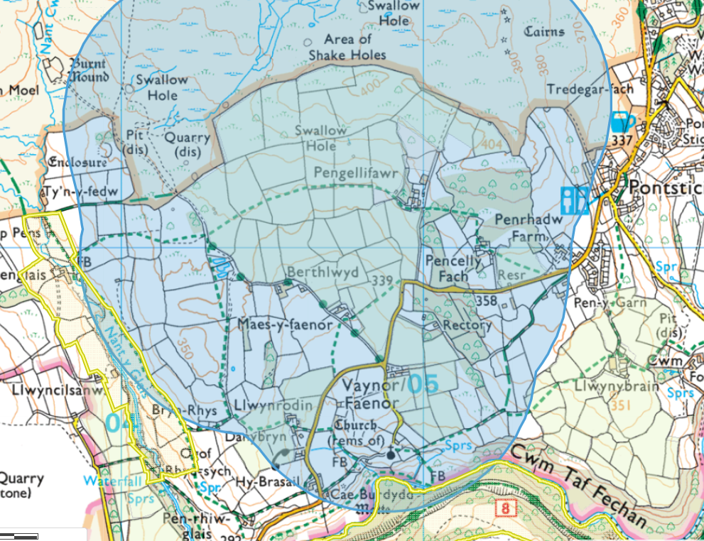

- Public rights of way

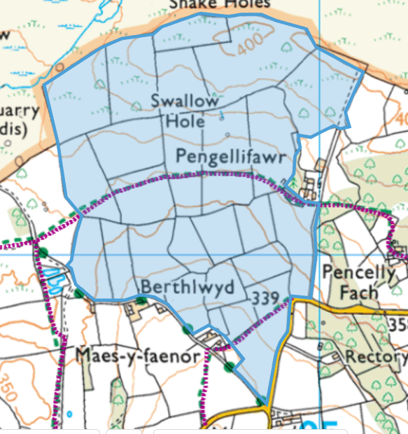

- Houses and building within 250m

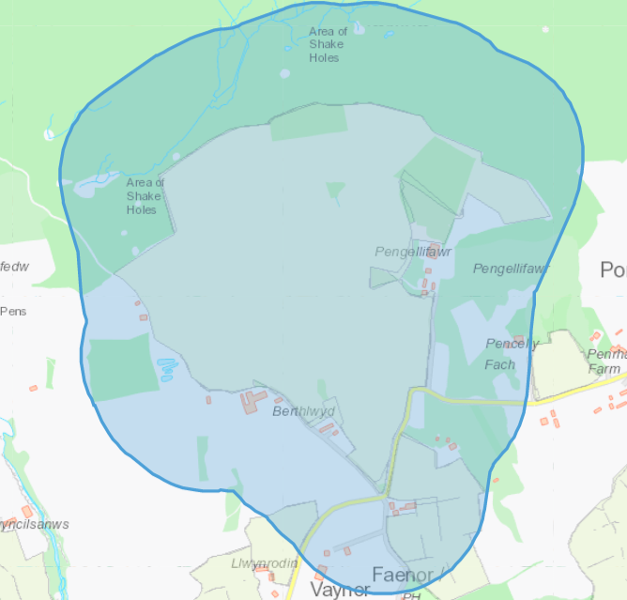

- Protected Habitats
- Lowland dry acid grassland and Lowland calcareous grassland
- Purple moor grass and rush pastures

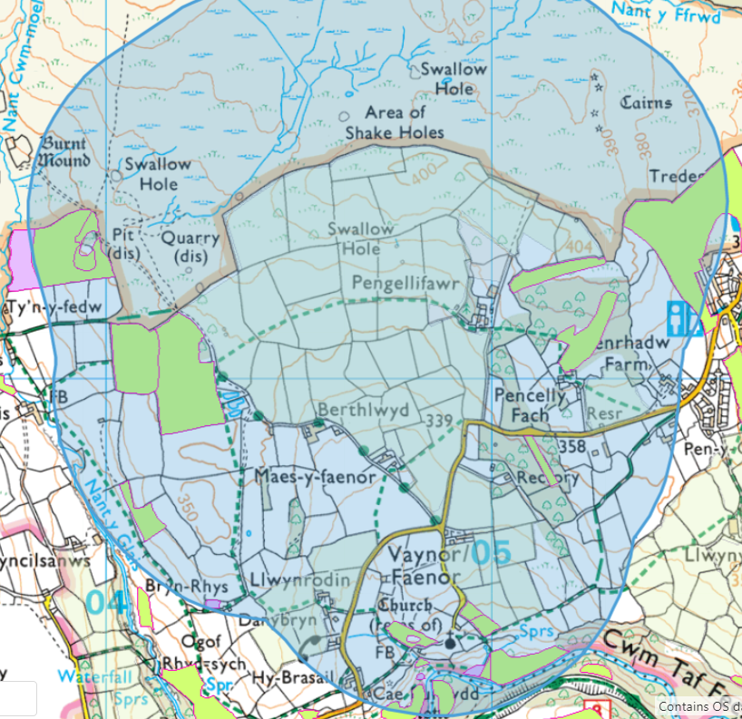

- Protected species
- Eel, silver eel, yellow eel, grisle, springer, Miller’s thumb, Brown trout, ferox, trout, sea trout, peal, Salmon trout, sewen, whitetrout, Threatened Bryophyte (moss).

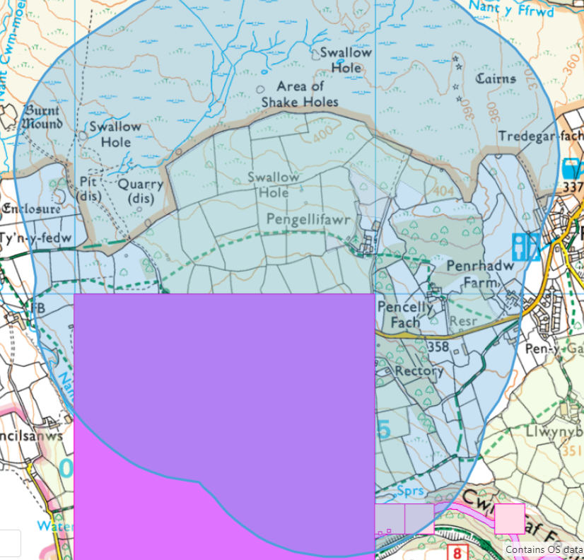

- Scheduled Ancient Monuments
- Enclosure East of Nant Cwn Moel
- Garn Pontsticill ring cairn
- Cae Burdydd Castle

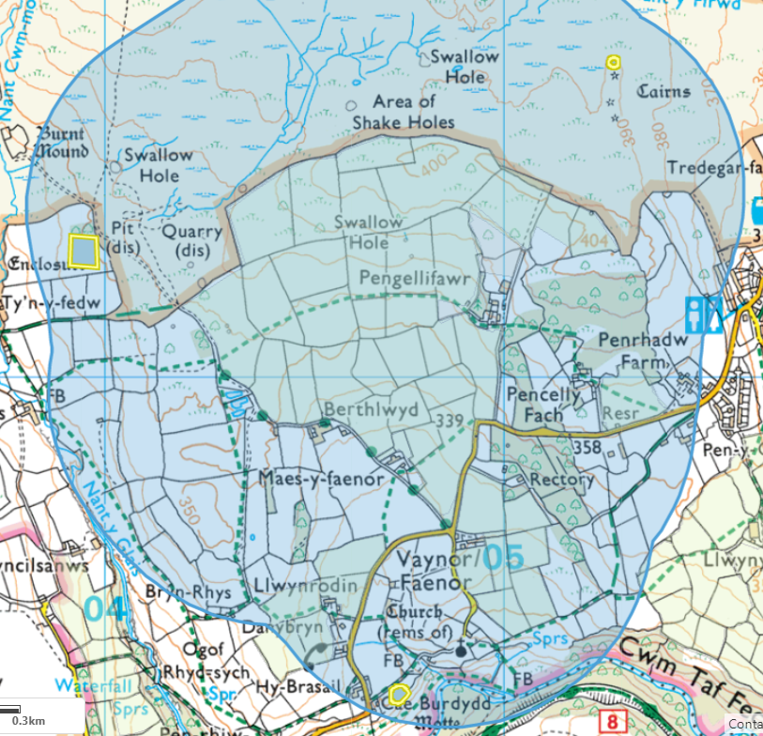

- Local Wildlife Sites (SINCs)
- Cwn Taf Fechan

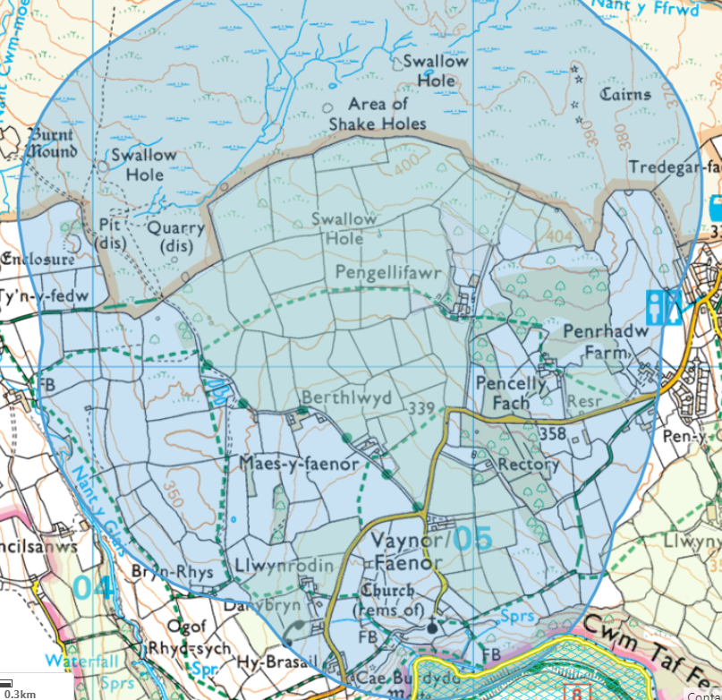

- Ancient Woodlands
- Ancient semi natural woodland
- Ancient Woodland site of unknown category

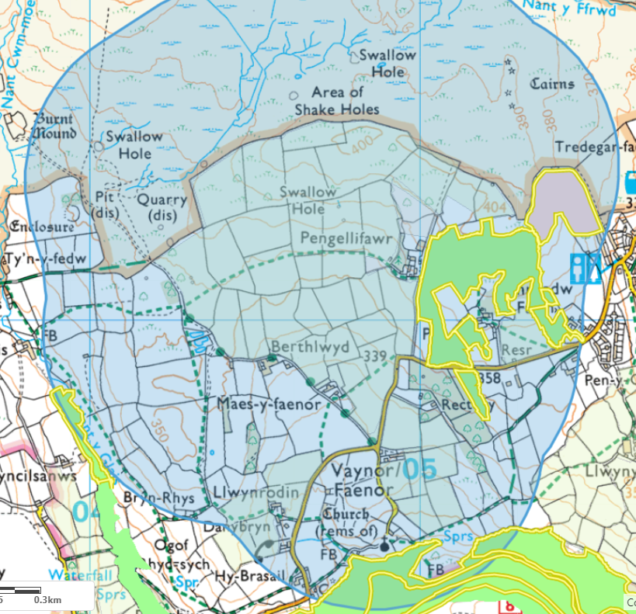

- National Parks
- Brecon Beacons

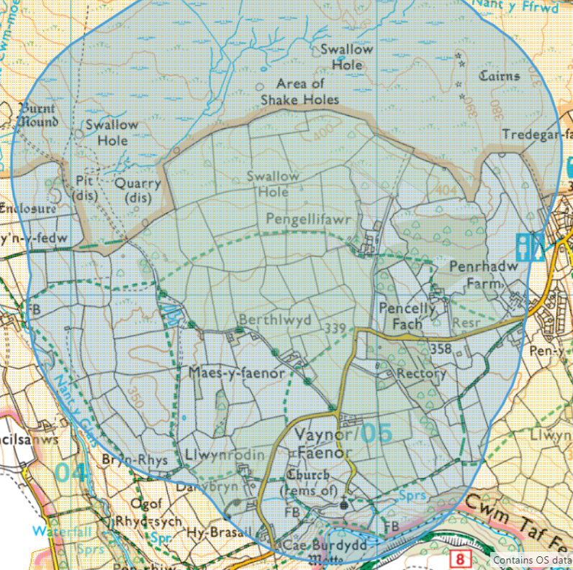

11 – Slope map



