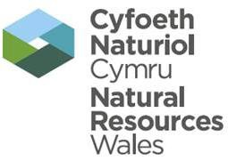


Compliance Assessment Report Report ID:TBC
This form will report compliance with your permit as determined by an NRW officer
Site | Metech Recycling | Permit Ref | EPR/DP3598FP
Operator/Permit holder | Metech Recycling (UK) Ltd
Regime | Waste Operation
Date of assessment | 26/05/2016 | Time in | 11:15 |  | Out | 12:30
Assessment type | Inspection
Parts of the permit assessed | Site operations
Lead officer’s name | Cathy Lloyd | Accompanied by |  | Gareth Davies
Recipient’s name/position | Mike Killett / director Metech Recycling (UK) Ltd | Date issued | 28/06/2016

Section 1 – Compliance Assessment Summary
This is based on the requirements of the permit under the Environmental Permitting Regulations. A detailed explanation is captured in “Compliance Assessment Report Detail” (Section 2) and any actions you may need to take are given in the “Action(s)” (Section 4). This summary details where we believe any non-compliance with the permit has occurred, the relevant condition and how the non-compliance has been categorised using our Compliance Classification Scheme (CCS). CCS Scores can be consolidated or suspended where appropriate, to reflect the impact of some non-compliances more accurately. For more details of our CCS scheme, contact your local office.
Permit conditions and compliance summary |  |  | CCS Category | Condition(s) breached
A1 - Specified by permit |  |  | A
B1 - Infrastructure - Engineering for prevention and control of emissions |  |  | 2 | 1.1.1, WEEE1
B2 - Infrastructure - Closure and decommissioning |  |  | N
B3 - Infrastructure - Site drainage engineering (clean and foul) |  |  | 2 | 2.1.2
B4 - Infrastructure - Containment of stored materials |  |  | 2 | 2.1.2
B4 - Infrastructure – Plant and equipment |  |  | N
C1 - General Management - Staff competency/training |  |  | 2 | 1.4.1
C2 - General Management - Management system and operating procedures |  |  | N
C3 - General Management - Materials acceptance |  |  | N
C4 - General Management - Storage, handling labelling, labelling and Segregation |  |  | 2
D1 - Incident Management - Site security |  |  | 2 | 3.2.1
D2 - Incident Management - accidents, emergency and incident planning |  |  | N
E1 - Emissions - Air |  |  | N
E2 - Emissions - Land and groundwater |  |  | N
E3 - Emissions - Surface water |  |  | N
E4 - Emissions - Sewer |  |  | N
E5 - Emissions - Waste |  |  | N
F1 - Amenity - Odour |  |  | N
F2 - Amenity - Noise |  |  | N
F3 - Amenity - Dust/ fibres/ particulates/ litter |  |  | N
F4 - Amenity - Pests/birds/scavengers |  |  | N
F5 - Amenity - Deposits on road |  |  | N
G1 - Monitoring and Records, Maintenance and Reporting - Monitoring of emissions and environment |  |  | N
G2 - Monitoring and Records, Maintenance and Reporting - Records of activity, site diary/journal/events |  |  | N
G3 - Monitoring and Records, Maintenance and Reporting - Maintenance records |  |  | N
G4 - Monitoring and Records, Maintenance and Reporting - Reporting and notification to Natural Resources Wales |  |  | 4 | 6.2.2
H1 - Resource Efficiency - Efficient use of raw materials |  |  | N
H2 - Resource Efficiency - Energy efficiency |  |  | N
KEY: See Section 4 for breach categories, suspended scores will be indicated as such.
A = Assessed or assessed in part (no evidence of non-compliance), N = Not Assessed, X= Action only
Number of breaches recorded | 8 | Total compliance score  (see section 5 for scoring scheme) |  |  | 190.1
If the number of breaches recorded is greater than zero, please see Section 3 for our proposed enforcement response

Section 2 – Compliance Assessment Report Detail
This section contains a report of our findings and will usually include information on:

The part(s) of the permit that were assessed (e.g. maintenance, training, combustion plant, etc.)  Where the type of assessment was ‘Data Review ’details of the report/results triggering the assessment  Any non-compliances identified  Any non-compliances with directly applicable legislation  Details of any multiple non-compliances | - Information on the compliance score accrued including:  - details of advice given;  - any other areas of concern;  - any actions requested;  - any examples of good practice;  - a reference to photos taken.

Present
Graham Bateman – Metech Recycling (UK) Ltd
Cathy Lloyd – Natural Resources Wales, Environment Officer
Gareth Davies – Natural Resources Wales, Snr Environment Officer

The purpose of the compliance visit was to carry out the first inspection following handover from SE Waste Regulation Team to SW Waste Regulation Team following restructuring within Natural Resources Wales. Operations carried out by Metech Recycling will now be regulated by the South West Waste Regulation Team.

Please note the Report ID will be confirmed in the near future.

WEEE1 – Operations
All WEEE permitted to be accepted under the permit shall be stored in areas provided with a weatherproof covering. WEEE waste was noted being stored within the damaged building and outside the building within the site boundary.

B1 Infrastructure – Specified Waste Management Operations Condition 1.1.1 category 2 breech
No waste management operation shall be authorised by this permit unless specified in and undertaken in accordance with the limitations in Table 1.1. Treatment and storage of waste are permitted on areas of impermeable pavement with sealed drainage system and within the building which is maintained to prevent the ingress of water.
Following the fire damage that occurred on the 28 February 2016 the building has been left in a state of disrepair which allows the ingress of rain water.

B3 Site drainage engineering Condition 2.1.2 category 2 breech
The permit allows storage on areas of impermeable pavement and within the building. A large quantity of waste including fire damaged WEEE and fridge freezers were being stored outside on concrete ground that drains to the surface water drainage system. You are not authorised to store waste outside unless it is waste specified in your working plan.

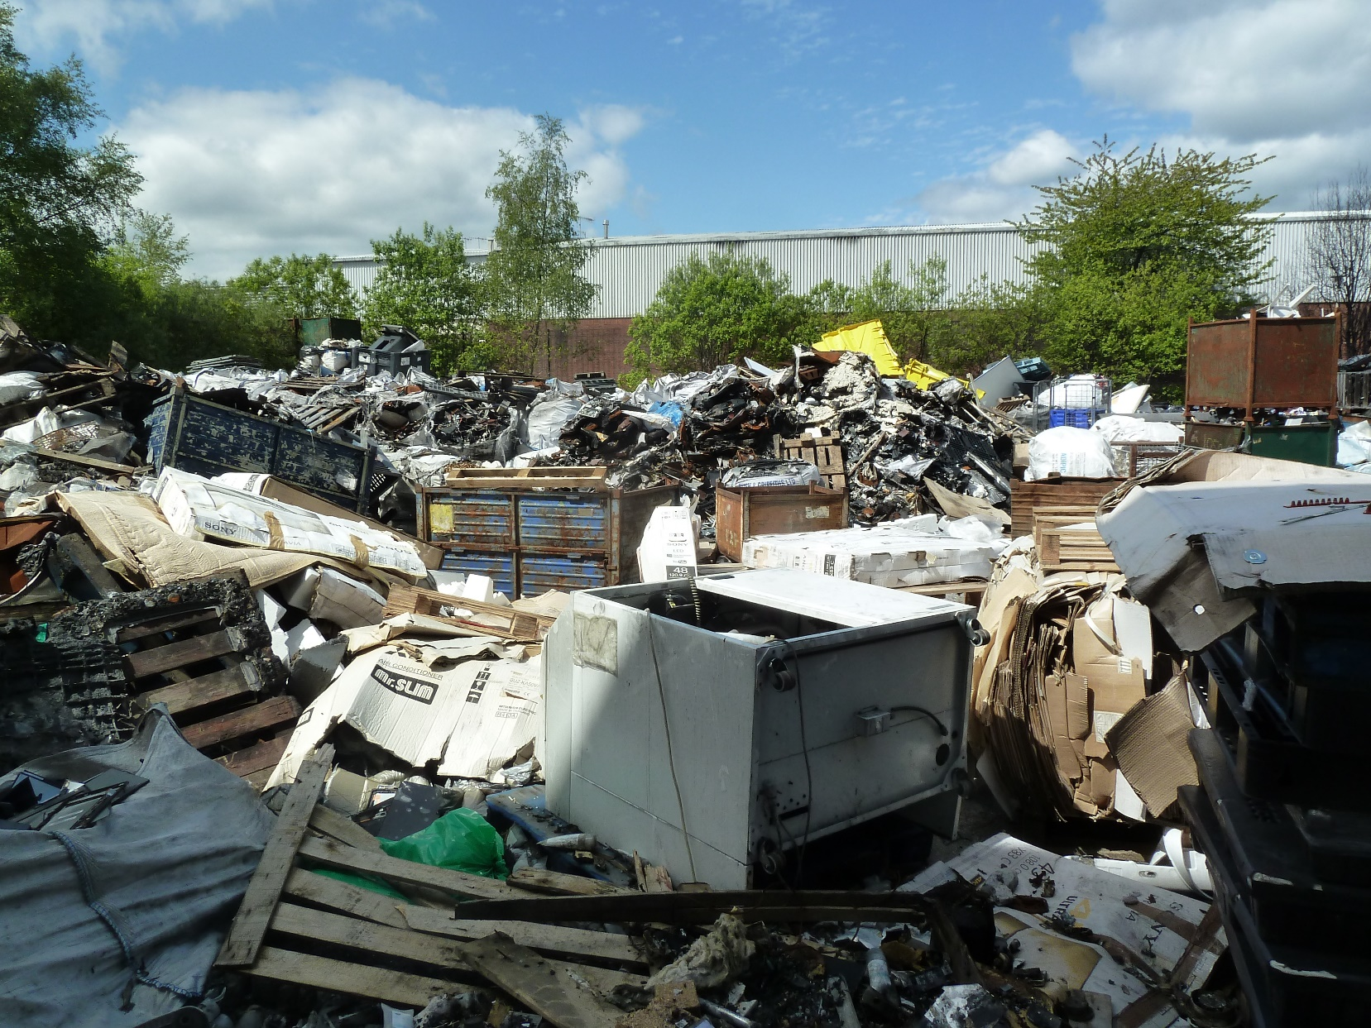
Photograph showing fire damaged WEEE, wood and cardboard being stored outside, an area where you are not authorised to store waste as it is not on a sealed drainage system. (Photo ref. 1020342)

B4 Infrastructure – Containment of stored materials Condition 2.1.2 category 2 breech
In the event of any damage occurring which breaches the integrity of the engineered containment so that it no longer meets the specified standards, the license holder shall cease importing waste into or treating waste in the affected area and shall not recommence importing or treating waste in the affected area until it has been repaired to a standard at least as good as the original specification. The building was damaged on the 28 February 2016. No waste is to be accepted at the site until the repairs have be carried out.

C1General Management – Changes to technically competent person 1.4.1 category 2 breech
Any changes to the technically competent management of the site and the name of any incoming person shall be submitted to the NRW in writing within 5 working days of the change of management. The employee who was technically competent has left and has not been replaced. This has resulted in poor management

D1 Incident Management - Site Security 3.2.1 category 2 breech
Under Condition 3.2.1 of your permit, site security systems shall be maintained to meet the requirement in Table 3.2. The site shall be kept closed and secure when unattended. The security shall be inspected every day and made secure by temporary repair by the end of working day and shall be repaired within seven working days of the damage being detected. There have been a number of unauthorised access to the unmanned site causing vandalism and theft from site. During our inspection it was noted that the fence was damaged and the site insecure.

C4 General Management – Storage, handling labelling and segregation. Condition 1.2.1. category 2 breech
Non – conforming waste has been accepted including polystyrene, cardboard, fridges, freezers, office equipment including chairs and furniture. Table 1.3 in the permit modification issued in 3/4/2012 that was issued to ensure it complies with the WEEE Directive, clearly states that the permitted waste types authorised by the modification applies to the waste listed under condition 1.2.1

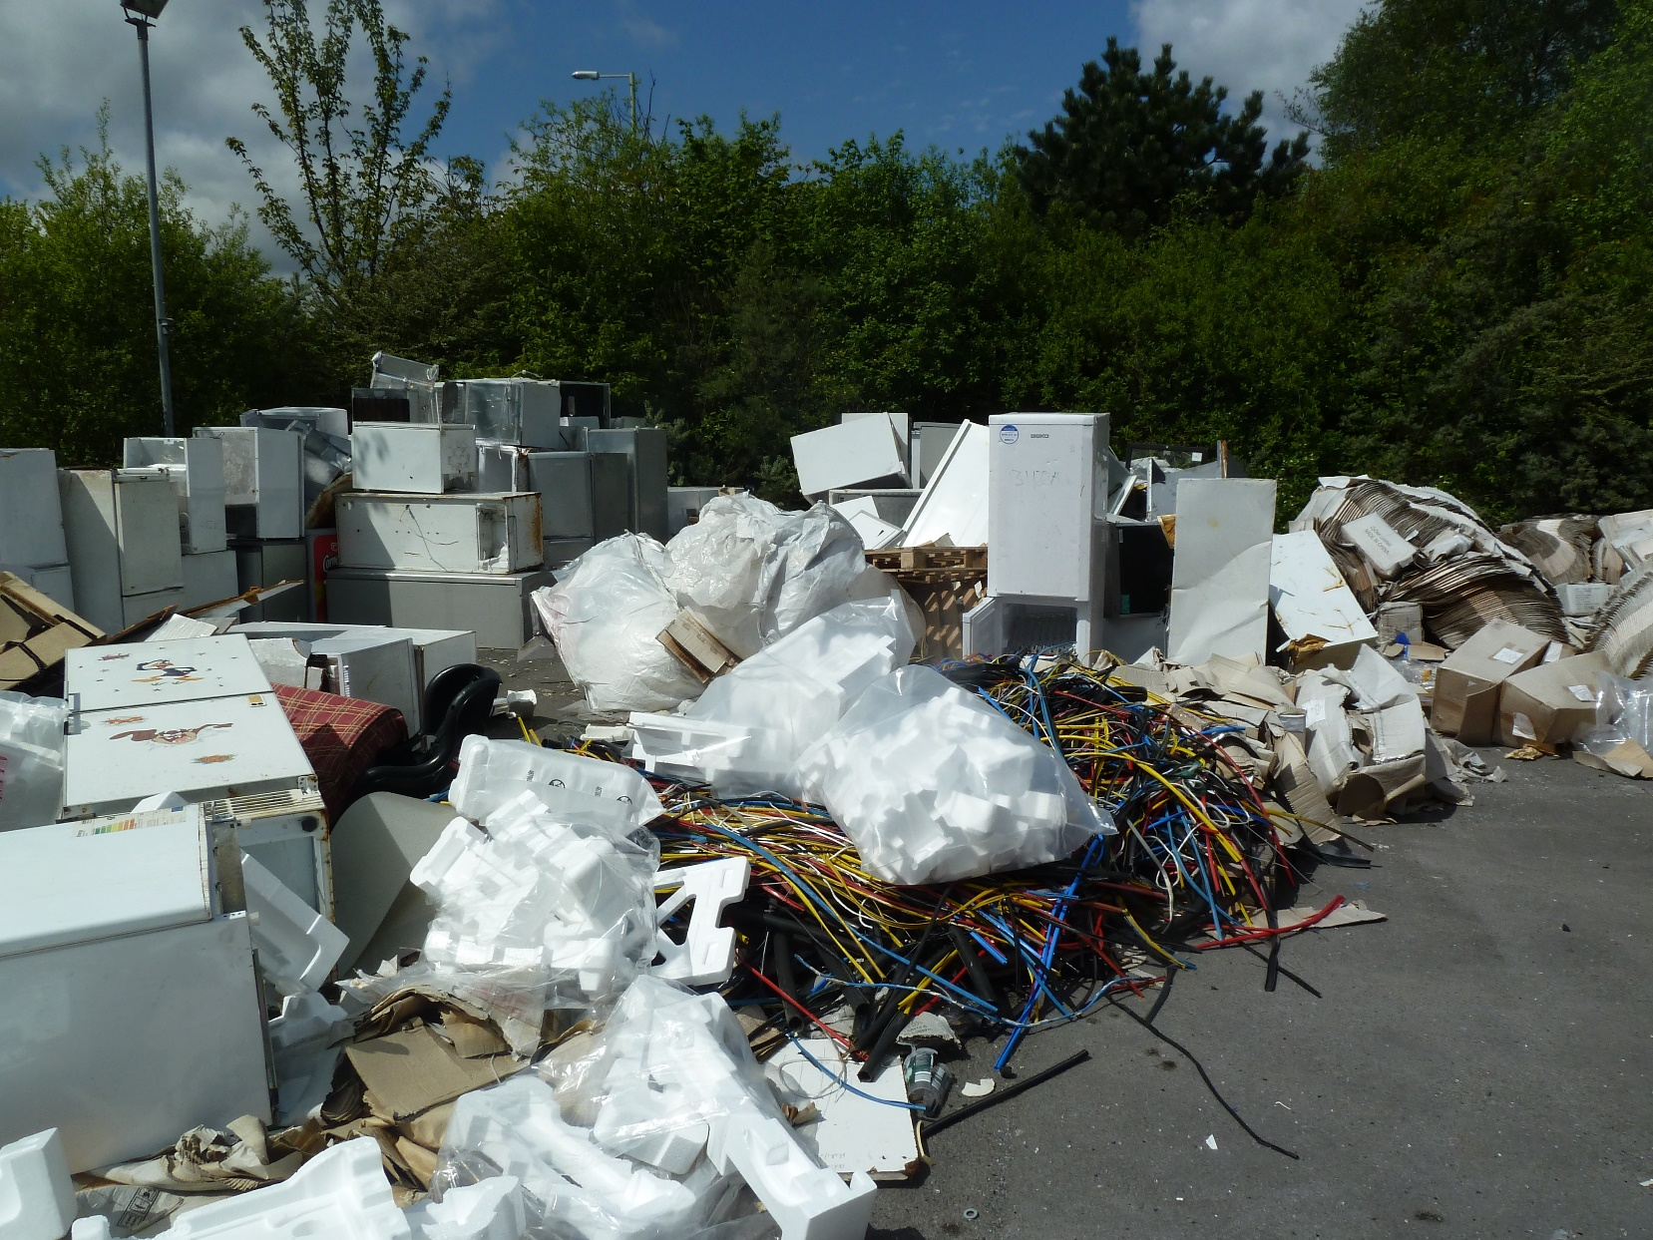
Photograph showing non-conforming waste including polystyrene, cardboard, fridges, freezers, office furniture. (Photo ref P1020336)

G4 Monitoring and Records, Maintenance and Reporting – Reporting to Natural Resources Wales, condition 6.2.2 catagory 4 breech
A summary of the waste types and quantities accepted and removed from the site shall be made each quarter of the financial year. The last submission made to NRW was for the period October to December 2015. Please report the waste imported and removed from the site during the period January to March 2016.

Due to the poor performance we have served a regulation 36 notice to comply with your permit. It is an offence not to comply with this notice. We are assessing what enforcement action to take following this inspection, which may include prosecution. I note that enforcement action has not been carried out for the previous three category 2 breaches following inspections carried out on the 1 March 2016, 15 April 2016 and the 21 April 2016.

 | Compliance Assessment Report |  |  | Report ID: TBC
This form will report compliance with your permit as determined by an NRW officer
Site |  | Metech Recycling | Permit Ref |  | DP3598FP
Operator/Permit holder |  | Metech Recycling (UK) Ltd | Date |  | 26/05/2016

Section 3 – Enforcement Response | Only one box should be ticked
You must take immediate action to rectify any non-compliance and prevent repetition.
Non-compliance with your permit conditions constitutes an offence and can result in criminal prosecutions and/or suspension or revocation of a permit. Please read the detailed assessment in Section 2 and the steps you need to take in Section 4 below.

Other than the provision of advice and guidance, at present we do not intend to take further enforcement action in respect of the non-compliance identified above. This does not preclude us from taking enforcement action if further relevant information comes to light or advice isn’t followed.

In respect of the above non-compliance you have been issued with a warning. At present we do not intend to take further enforcement action. This does not preclude us from taking additional enforcement action if further relevant information comes to light or offences continue.

We will now consider what enforcement action is appropriate and notify you, referencing this form. |  | X

Section 4 – Action(s)
This section summarises the actions identified during the assessment along with the timescales for when they will need to be completed.
Criteria Ref. | CCS  Category | Action required/ advised | Due Date
See Section 1 above |  | Action required/ advised | Due Date
A1 | C2 | A regulation 36 Notice has been issued requiring Metech Recycling to comply with the conditions of the permit. | 31 August 2016
B1 | C2 | If you intend to recommence waste treatment at the site please contact me before importing waste as I would need to inspect the building to ensure repairs have been carried out.
B3 | C3 | A regulation 36 Notice has been issued requiring Metech Recycling to comply with the conditions of the permit | 31 August 2016
B4 | C2 | Storage and treatment of waste is not authorised until the building has been repaired.
C1 | C2 | The services of a Technically Competent Manager must be obtained to ensure the removal of waste is carried out correctly. Please supply details of the technically competent manager of the site and include their relevant qualifications. | 20 June 2016
C4 | C2 | A regulation 36 Notice has been issued requiring Metech Recycling to comply with the conditions of the permit | 31 August 2016
D1 | C2 | A regulation 36 Notice has been issued requiring Metech Recycling to comply with the conditions of the permit | 31 August 2016
G4 | C4 | Waste returns have not been made to NRW and are overdue. Please report the quantities of waste imported and removed from the site for the period January to March 2016 | 20 June 2016

Section 5 – Compliance notes for the Operator
To ensure you correct actual or potential non-compliance we may
- Advise on corrective actions verbally or in writing
- Require you to take specific actions verbally or in writing
- Issue a notice
- Require you to review your procedures or management system
- Change some of the conditions of your permit
- Decide to undertake a full review of your permit
Any breach of a permit condition is an offence and we may take legal action against you

- We will normally provide advice and guidance to assist you to come back into compliance either after an offence is committed or where we consider that an offence is likely to be committed. This is without prejudice to any other enforcement response that we consider may be required.
- Enforcement action can include the issue of a formal caution, prosecution, the service of a notice and/or suspension or revocation of the permit.

See our Enforcement and Civil Sanctions guidance for further information
This report does not relieve the site operator of the responsibility to

- Ensure you comply with the conditions of the permit at all times and prevent pollution of the environment
- Ensure you comply with other legislative provisions which may apply
Non-compliance scores and categories
CCS  category | Description | Score
C1 | A non-compliance that could have a major environmental effect | 60
C2 | A non-compliance which could have a significant environmental effect | 31
C3 | A non-compliance which could have a minor environmental effect | 4
C4 | A non-compliance which has no potential environmental effect | 0.1
Operational Risk Appraisal (Opra) - Compliance assessment findings may affect your Opra score and/or your charges. This score influences the resource we use to assess permit compliance.
Section 6 – General information
Data protection notice

The information on this form will be processed by the Natural Resources Wales (NRW) to fulfil its regulatory and monitoring functions and to maintain the relevant public register(s). The NRW may also use and/or disclose it in connection with:

- Offering/providing you with its literature/services relating to environmental matters
- Consulting with the public, public bodies and other organisations (e.g. Health and Safety Executive, local authorities) on environmental issues
- Carrying out statistical analysis, research and development on environmental issues
- Providing public register information to enquirers
- Investigating possible breaches of environmental law
- Assessing customer service satisfaction and improving its service
- Freedom of Information Act/Environmental Regulations request

The NRW may pass it on to its agents/representatives to do these things on its behalf. You should ensure that any persons named on this form are informed of the contents of this data protection notice.
Disclosure of information

The NRW will provide a copy of this report to the public register(s). However, if you consider that any information contained in this reports should not be released to the public register(s) on the grounds of commercial confidentiality, you must write to your local area office within twenty working days of receipt of this form indicating which information it concerns and why it should not be released, giving your reasons in full.
Customer charter

What can I do if I disagree with this compliance assessment report?

If you are unable to resolve the issue with your site officer, you should firstly discuss the matter with officer’s line managers using the informal appeals procedure. If you wish to raise your dispute further through our official Complaints and Commendations procedure, phone our general enquiry number 0300 065 3000 (Mon to Fri 08.00 – 18.00) and ask for the Customer Contact team or send an email to enquiries@naturalresourceswales.gov.uk. If you are still dissatisfied you can make a complaint to the Public Services Ombudsman for Wales. For advice on how to complain to the Ombudsman phone their helpline on 0845 607 0987.

Welsh Language
If you would like this form in Welsh please contact your Regulatory Officer.

