CRoW Appendix 4 (140_10_SD02)  CRoW Act 2000: Natural Resources Wales application for permission - Formal Notice |  | 
Natural Resources Wales Formal Notice.
Requirements of Section 28I of the Wildlife & Countryside Act 1981 as amended by the Countryside and Rights of Way Act (CRoW) 2000.
Duty in relation to granting any consent, licence or permit for activities likely to damage Sites of Special Scientific Interest (SSSI).
- Natural Resources Wales area/region/NPS hub: | South East
- Name of SSSI: | Gwent Levels - Nash and Goldcliff SSSI  Gwent Levels – Whitson SSSI
- Type of permission: | Bespoke Environmental Permit under EPR 2016 (as amended) for the treatment of contaminated ground and surface water by Physico-chemical means.
- Date for Natural Resources Wales permit determination: | 24/05/2022 (at time of writing)
- Predicted 28 day date for response from NRW conservation/ecology (under S28 I(4)): | n/a saved for information only
- Natural Resources Wales reference no: | PAN-015549
- National grid reference: | 336338,186394
- Description of proposal: | The applicant has been commissioned by St Modwen to undertake water treatment works within the former Llanwern steelworks, which is currently undergoing development works. The area which the treatment system occupies is set within an area of largely vacant land near the southern boundary of the development site (as shown on drawing D1815/5129/A1). Residential properties are located approximately 850 m to the west, whereas an Amazon distribution warehouse lies 450m to the east. The Gwent Levels SSSI is located approximately 250 m to the south of the site and the Severn Estuary is located approximately 4 km to the south of the site. A railway line is located to the north of the site.  The development site is drained by a network of surface water ditches which discharge to the adjacent Tata Steel site via the Main East West Ditch (MEWD). An agreement has been reached between St Modwen and Tata Steel to allow this discharge to continue during the Glan Llyn site development works, on the basis that the water is treated to standard acceptable to Tata Steel. Groundwater which arises from remediation of land undertaken by other third parties within the wider St. Modwen development is at times pumped in to the network of surface water ditches. The liquid that is therefore treated by the Celtic Technologies Limited activities is a mixture of groundwater and surface water. No external / off-site waste will be imported or treated at the plant.  The applicant has been commissioned to install, commission, and operate a water treatment system to treat surface water exiting the site via Drain 4, which ultimately discharges to the Tata Steel effluent treatment plant. The surface water is pumped from a pre-treatment lagoon, through the treatment system, prior to discharge to the Drain 4 outfall. The treatment works carried out by the applicant will therefore result in improvement in the quality of water exiting the site.  The pre-treatment lagoon has been constructed to provide holding capacity for drainage waters prior to treatment through Celtic’s wastewater system. This pre-treatment lagoon has a capacity of approximately 2,000 m3. The pre-treatment lagoon forms part of the site’s surface water network and is the point from which the influent pump conveys water to the treatment system. Water is actively pumped from the pre-treatment lagoon into the wastewater treatment plant. This is part of the St Modwen site area and is not under the applicant control; furthermore, our only interaction is to pump from it and observe water quality. The permit operating area includes the winch and pump area which is under the applicants control.  This water is subsequently discharged to the Severn Estuary under an Environmental Permit held by Tata Steel UK Limited under EPR/BS3905IP with their express agreement.
- Is the proposed activity within (wholly or partially) the SSSI boundary? | No- See attached maps at the end of this document.
- Has there been any pre-application discussion or correspondence with NRW conservation/ecology | No
- What aspect(s) of the proposed permission may damage the features which are of special interest for the SSSI?
The following ‘Operations Requiring Consent’ (or other activities associated with the permission) that may cause damage) are relevant to the proposed permission.
- none. proposed activity is to treat contaminated ground and surface water only.

The following SSSI features and mechanisms of impact have been considered to assess the likelihood of damage:

Both Gwent Levels: Nash and Goldcliff and The Gwent Levels: Whitson SSSI
- Reen and Ditch Habitat
- Insects and other Invertebrates
- Shrill carder bee

Main pathway for harm is for unintentional runoff and leeching of contaminated material. As the contaminated ground and surface water is already in place at the development site i.e., no external waste material is being brought onto the site, this risk is minimised.

The source of the ground and surface to be treated is a secure lagoon. All hazardous and non-hazardous waste is required be stored and treated on an impermeable surface with sealed drainage.

Hazardous waste shall not be mixed, either with a different category of hazardous waste or with other waste, substances, or materials, unless it is authorised by schedule 1 table S1.1 and appropriate measures are taken.

All liquids in containers, whose emission to water or land could cause pollution, shall be provided with secondary containment, unless the operator has used other appropriate measures to prevent or where that is not practicable, to minimise, leakage and spillage from the primary container.

The maximum quantity of hazardous waste that can be stored at the site in total for recovery or disposal, shall not exceed 50 tonnes at any one time.

The maximum quantity of hazardous waste that can be treated for disposal or recovery by Physico-chemical treatment in total at the site shall not exceed 10 tonnes per day.

Discharge will be further treated prior to discharge to surface water under Tata Steel UK Limited EPR/BS3905IP.

The water treatment systems will be contained within bunds of capacity of 110% volume or more of the total system components capacity. High level float switches will ensure that the system is automatically switched off should any leakage occur within the system. Regular inspections of the treatment system and pipework will also be carried out by a competent engineer. Any impacted waters will undergo treatment prior to discharge. Weekly sampling of effluent will ensure only water acceptable to the discharge consent is discharged.

All chemicals present on site will be appropriately stored within their proper containers and within a water treatment system bund of 110% capacity of all system items. Maximum of 1m3 of each reagent will be stored on site within the bund.

Weekly inspection of all containers, dosing equipment and pipework will be carried out by a systems engineer to ensure they are in good condition with no obvious signs of leakage or loss of integrity. Any defects will be reported and addressed appropriately.

All wastes generated through the treatment process will accumulate within water treatment system components (tanks & pressure vessels) and within a water treatment system bund of 110% capacity of all system items. IBCs, stored within the water treatment system bund, will be used to store any separated NAPL prior to off-site disposal or reuse.

Water treatment system components, IBCs and their associated bunds will be subject to regular maintenance and inspection to ensure that they are in good condition with no obvious signs of leakage or loss of integrity.
- Decision
The permission is not likely to damage any of the flora, fauna or geological or physiological features which are of special interest because of conditions.
See conditions set in the permit, and application documents incorporated into the permit.

Natural Resources Wales is minded to: Issue the permission with conditions to ensure no damage to SSSI

- Name and job title of Natural Resources Wales officer: | Louise Bailey  Permitting Officer
- Date form sent to NRW conservation/ecology | Document completed 11/02/2022  Saved for information only

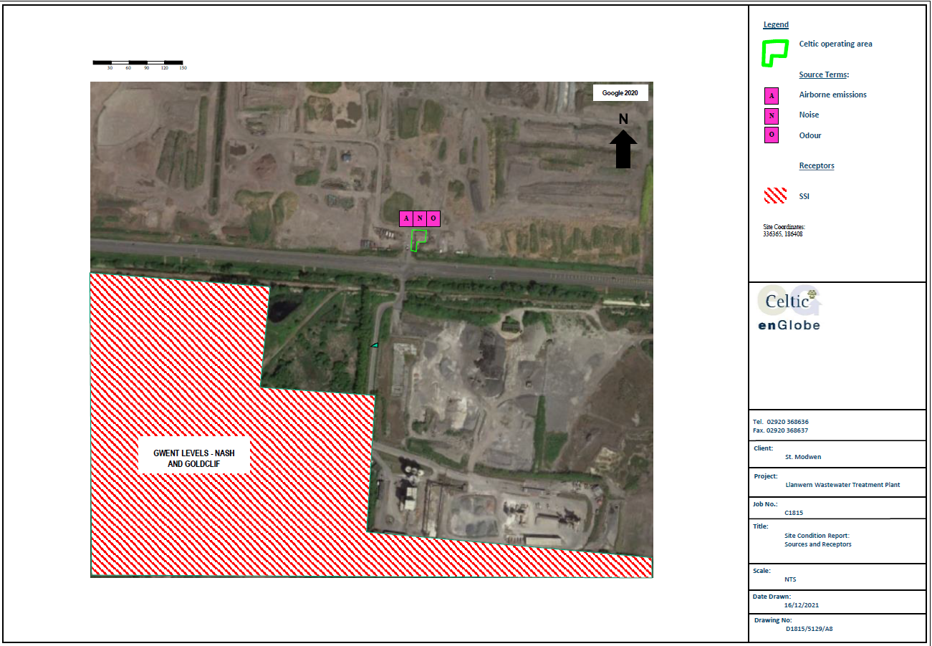
SSSI within 2km
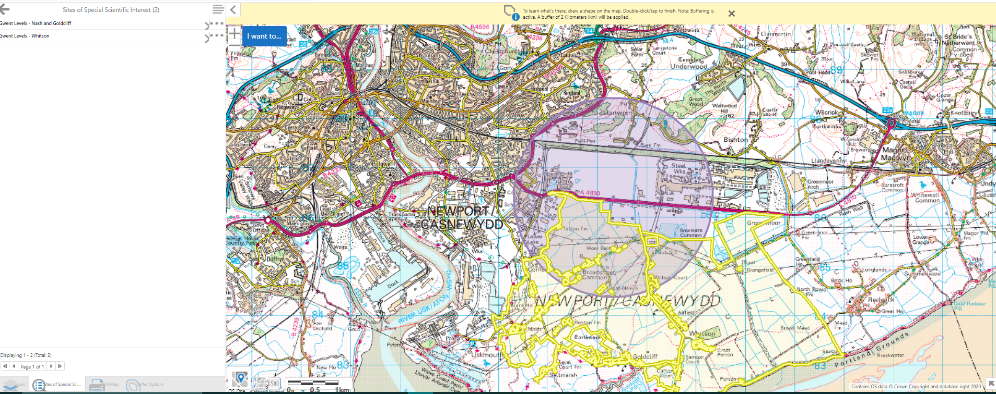

Gwent Levels - Nash and Goldcliff SSSI:
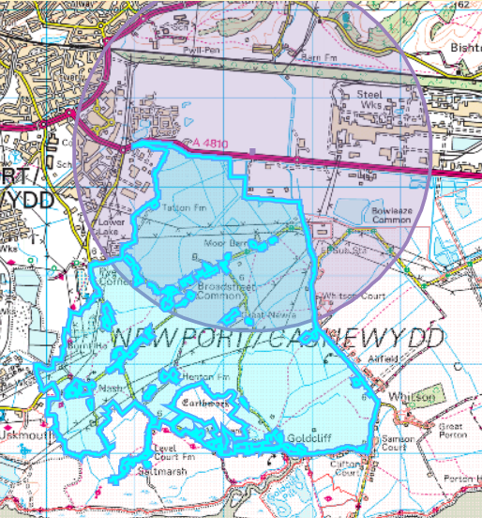

Gwent Levels – Whitson SSSI:


