

Permit
The Environmental Permitting (England & Wales) Regulations 2010

Mr Paul Andrew Gareth Cox

Cox Skip and Waste Management
Plot 80 Village Farm Road
Village Farm Industrial Estate
Pyle
Bridgend
CF33 6BN

Permit number

EPR/EB3893HR

Permit
The Environmental Permitting (England and Wales) Regulations 2010

Permit number

EPR/ EB3893HR

The Natural Resources Body for Wales (“Natural Resources Wales”) authorises, under regulation 13 of the Environmental Permitting (England and Wales) Regulations 2010

Mr Paul Andrew Gareth Cox (“the operator”),

Of

58 Pwll y Waun

Porthcawl

CF36 5HH

to operate waste operations at

Cox Skip and Waste Management

Plot 80 Village Farm Road

Village Farm Industrial Estate

Pyle

Bridgend

CF33 6BN

to the extent authorised by and subject to the conditions of this permit.

Under regulation 27(2) of the Regulations, standard rules SR2008 No1 are conditions of this permit.

Name | Date

Authorised on behalf of Natural Resources Wales

Schedule 1 - Site plan
This is the plan referred to in the standard rules SR2008 No1

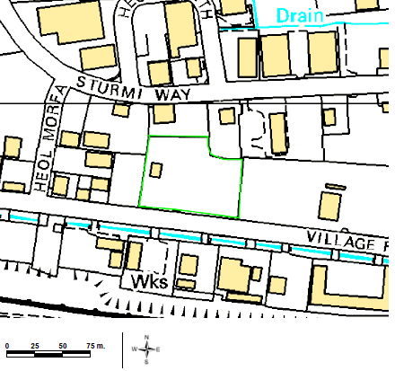

Reproduced by permission of Ordnance Survey on behalf of HMSO. © Crown Copyright and database right 2014. Ordnance Survey licence number 100019741.

END OF PERMIT

