Anglesey Energy Limited
Mona industrial Estate
Anglesey
LL65 4RJ

Permit reference EPR/AP3033HY

Improvement Program Requirements
Introduction
Following the NRW instigated BAT permit review, the operator (AEL) is required to submit further information in accordance with the improvement program requirements.
Table S1.4 of the permit identifies 7 improvement conditions of which IC1 to IC4 have been assessed as completed. This report provides the information needed to address the remaining improvement conditions.
IC5
The operator shall submit to NRW written procedures detailing how they intend to meet the following BAT requirements in accordance with requirements specified within BAT Conclusion of the Waste Treatment BREF Document (EU 2018):
BAT 1 Environmental Management System
BAT 2(b) and BAT 2(c) Improving Environmental Performance
BAT 3 (i)(a) and BAT 3(i)(b) – Establish and maintain a waste water and waste gas inventory as part of the EMS
BAT 4(b) – Adequate storage capacity
BAT 8 – Monitoring Emissions to air
BAT 19 (c) - Impermeable surface
BAT 21 – Emissions from accidents and incidents
BAT 24 – Reuse of packaging
BAT 34 Reduce emission to air of dust, organic compounds and odorous compounds (including H2S and NH3)
BAT 36 – Biological treatment of waste aerobic methods
BAT 37 – Biological treatment of waste – aerobic methods
IC6 Monitoring of the digestion process
IC7 Bioaerosol monitoring
BAT 1 – Environmental Management Systems
An EMS was submitted with the permit application. This has been reviewed and simplified with an updated version attached. The major variation in the document is to remove the phase 2 works which will not be commenced at this time. This removes the composting, drying, evaporation.

BAT 2(b) Set up and implement waste acceptance procedures
These are detailed in the EMS and define the process as:

WASTE AND MATERIAL ACCEPTANCE AND PROCEDURES

The acceptance procedures ensure that systems and procedures are in place to prevent acceptance of unsuitable wastes which may lead to adverse reactions or uncontrolled emissions. The proposed activities are covered by Schedule 1 Section 5.4 Part A(1)b) (i) Anaerobic Digestion (>100t/day) and the associated DAA activities including treatment of digestate, and the associated R codes
R3: Recycling or reclamation of organic substances.
R5: Recycling/reclamation of other inorganic materials
R13: Storage of waste pending recovery
D9: Physico-chemical treatment of waste which results in the compounds or mixtures which are discarded by means of any operations In D1 to D12

WASTE STORAGE PERIODS
It is the intention to transfer the waste feedstock into the process as soon as possible after delivery . All treated wastes and materials (solid and liquid digestate) will be processed or removed off site as soon as practicably possible.

The system for determining the suitability of the waste will consist of two stages:
- Stage 1: Pre-acceptance and initial screening procedure
This involves the operator getting information on the waste characteristics and process that produces the waste. This will enable the operator to determine the suitability of the waste for processing and will provide comparison information for wastes received at site
- Stage 2 – Acceptance procedures at site
When wastes are received at site there will need to be measures to confirm the characteristics of the waste, without time pressure and the potential hazard of checking a waste at the facility gate.

Stage 1
Pre-acceptance procedures will be carried out to determine information on new waste types. This will consist of the following key points:
- Nature of the process producing the waste, including the variability of the process
- Specific details of the process producing the wastes including any storage and preservatives used
- The chemical composition of the waste (the operator may need to take samples if the producer does not have this information)
- The physical composition of the waste e.g. solid/liquid/sludge
- Description of waste type including a visual and odour assessment
- Waste handling requirements
- Hazards associated with the wastes
- The waste EWC codes
The information listed above it will enable the operator to establish some key points regarding the waste, these include
- Screening out unsuitable wastes
- Confirming verification parameters that can be used to test waste batches arriving at site
- Identify any substances used in the producers processing that may impact the operators anaerobic digestion process (including contraries that may affect waste preparation)
- Identify any substances within the waste that may effect the treatment process (for example chemicals that are toxic to anaerobic bacteria)
- Identify any substances within the waste that may react with other wastes in the process
- Accurately define the range of hazards exhibited by the waste

Any information gathered on the different waste types will be kept on record within the facility. This will allow the operator to cross-reference future analysis and verification when the waste is accepted on site. Records should be updated on a regular basis if there are any changes to the process producing the waste or to the waste characteristics.

Wastes will not be accepted on site if the pre-acceptance information has not been collected, if the waste may have adverse effects on the process or if there is not a clearly defined route for the waste type. Feedstocks proposed are detailed in Section 5 below.

Stage 2
Acceptance procedures when the waste arrives at site will be put in place to confirm the characteristics of the wastes being delivered to the site. The main characterisation of the wastes will have been carried out in the waste pre-acceptance stage.
Procedures will be quick tests to minimise time delivery vehicles are kept waiting. There are several key issues that the operator must address during the arrival of wastes at the site, to determine if the waste can be accepted. The details at each stage must be recorded and copies kept at the site. The procedure for the acceptance of wastes at the site will be as follows
- The operator will record the details of the incoming batch of material. This will include details of the type of material, the amount of material, the waste producer, the waste haulier, the driver and vehicle details, the time and date of delivery
- The operator must then check if they have the pre-acceptance data for the particular waste.
- The operator must check the delivery has the correct paper work and has been assigned the correct EWC code.
- Once satisfied that the paper work is in order and that the facility is permitted to take the waste the operator can direct the driver to the appropriate discharge point
- Solid feedstock delivery vehicles will be directed into the appropriate storage area. If sheeted, the load will be unsheeted and the contents checked before tipping. Staff members will ensure that the driver tips the solid waste into the correct reception area. Waste and biomass discharge areas will be clearly defined so that there is no cross contamination between the feedstocks.
- At this point a suitably trained member of staff can make a visual and odour assessment of the waste
- If the waste material delivered does not conform to the paper work and EWC code associated with the delivery then the batch will be rejected. The material will be loaded back into the container/vehicle and sent back to the producer.
- Liquid feedstock deliveries will be directed to the reception unloading area at the side of the chicken litter storage shed. The tanker can be connected to the pipe work, open the correct valves under the supervision of a trained operator who will transfer the material to the appropriate tank. The valves and pipe work will be coded and labelled clearly to ensure that correct valves are opened and the correct tank is used.
- Samples of wastes will be taken regularly, at least every 6 months for analysis. This will confirm if the materials being received and processed on site are in accordance with the acceptance criteria in general and within the acceptance parameters for that particular waste.

NON-CONFORMING WASTE
Each incoming delivery of waste will be checked to confirm that it complies with the categories of wastes permitted for acceptance under the Environmental Permit and is consistent with the description of the waste provided. Any waste that, upon arrival at the site, is found to be unacceptable under the conditions of the permit and site acceptance procedures described above, will be rejected. If non-conforming waste is discovered after deposit it will either be immediately reloaded and returned to the waste producer or stored in a designated quarantine area.

Records of rejected waste and details of their removal from the site will be kept and maintained within the site log and will be available for inspection by NRW.

Wastes that are rejected and that exhibit any hazardous properties will be stored in containers that are appropriate to the hazardous properties that they possess. Should any hazardous wastes be identified that may present a serious and immediate risk of harm to the environment and/or human health then NRW will be notified immediately and asked for advice on appropriate actions. These wastes will be dealt with in a manner agreed with NRW and arrangements made as soon as possible for their removal off site to a suitably permitted facility.

Procedures dealing with unauthorised wastes: Any wastes that are rejected from the site due to insufficient/incorrect paper work will be sent back to the waste producer for them to arrange disposal.
BAT 2(c) Set up and implement a waste tracking and inventory
All deliveries are weighed in at the weighbridge with records maintained at the site. Chicken muck is taken to the reception hall. Visual checks on remaining capacity are undertaken throughout the working day and projections of future deliveries established a week in advance to ensure that adequate storage space remains on site.
Cow slurry is discharged into feed tank 1 or feed tank 2 which has constant level measurement which allows a precise calculation of the quantity of slurry and remaining buffer capacity.
The digesters and post digesters have level measurement as detailed in the EMS, and at any time the quantity of digestate in each tank can be established.
No other wastes are currently taken at the site, full details of tracking and inventory will be prepared in advance of wastes which will not be either received in the chicken muck hall or pumped into the feed tanks.

BAT 3 (i)(a) and BAT 3(i)(b) – Establish and maintain a waste water and waste gas inventory as part of the EMS
The SCADA system maintains a record of all liquid and gas levels at the plant. These are saved using a data management system called ACRON. Reports can be run at any time, for any period, to give a full inventory of liquids and gas on site at any time. The EMS contains a detailed description of the processes and the range of their performance.
A screen shot from the SCADA control system is as follows:
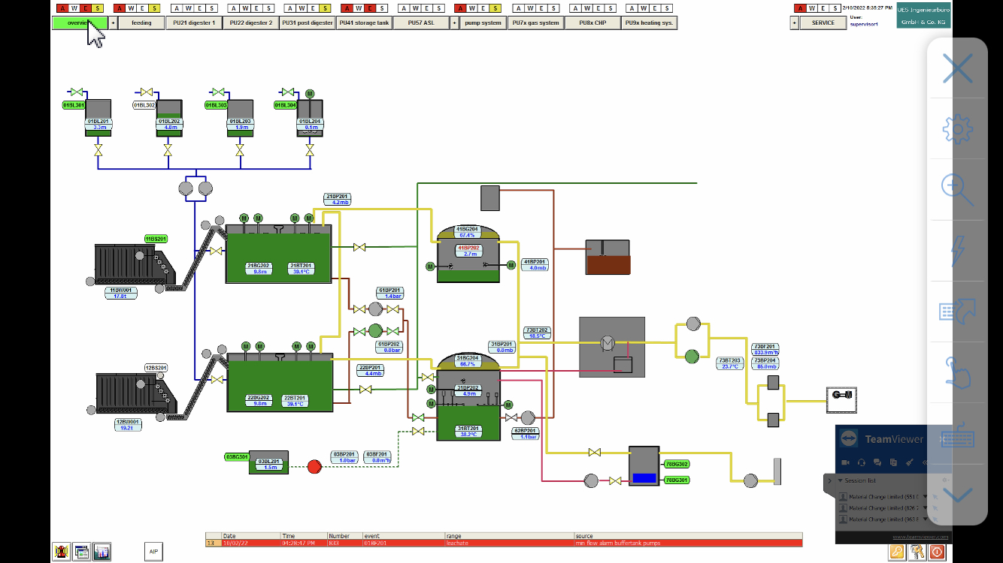

BAT3 (ii) requires information on the waste water flows at the site. There are no waste water flows since all grey or dirty water is retained on site and used in the process, and all clean surface water passes to the balancing lagoon and then offsite.

BAT 4(b) – Adequate storage capacity
Adequate storage capacity for the digestate on site is carefully monitored using the scada system. The level of digestate in the digesters is kept continuous while the post digester is lowered at certain times of the year. The storage tank provides winter storage and is the point of removal for all digestates.
The post digester has a minimum operating level of 1m and a maximum of 6.5m and has an available storage capacity of 3000m³; the Storage tank has a similar min and max range and a holding capacity of 3000m³.
The quantity of digestate is monitored daily, and with an alarm system every few seconds. The levels are recorded on the ACRON system and the historic details can be viewed. Manual records of the levels are taken and recorded in the daily log.
A screen shot from the SCADA system is shown below:
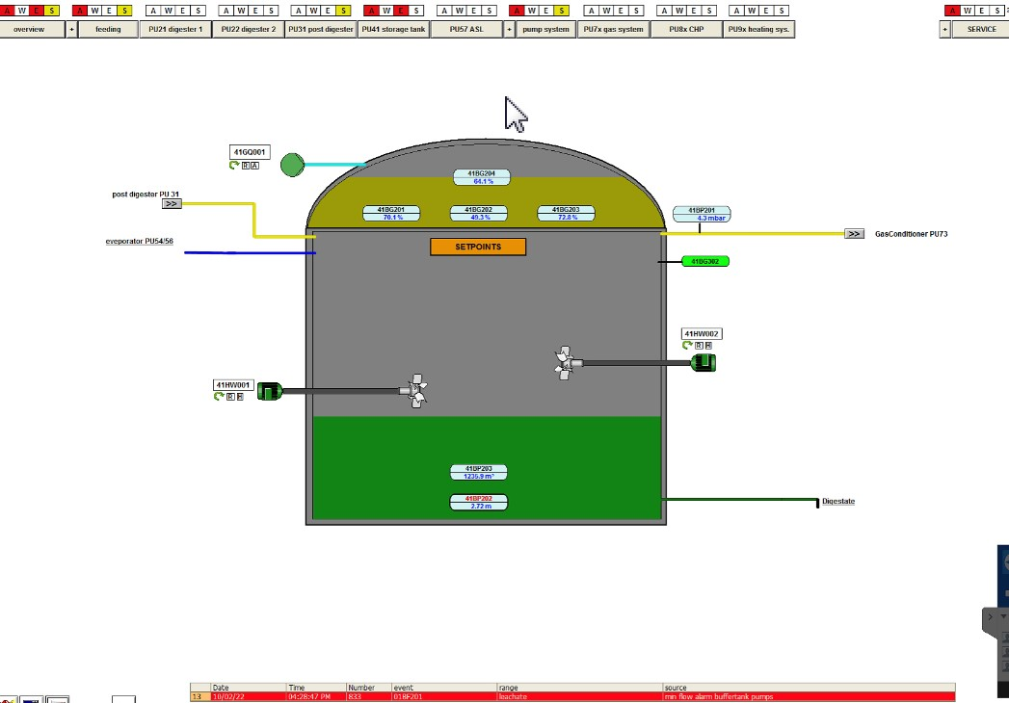

The retention time is calculated daily and recoded on the site log.

BAT 8 – Monitoring Emissions to air
The biological treatment of waste requires monitoring as follows:

Substance | Method | Frequency
H2S | No standard specified. H2S monitoring is carried on at the plant at both digesters, pre gas clean up on a 10 minute rolling cycle and recorded through the SCADA system. In addition hand held records are taken weekly to verify the SCADA results and recorded on the site data log. | Every 6 months
NH3 | No standard specified. The permit requires annual monitoring of the point source of NH3 – the vent to the Chicken muck reception hall. | Every 6 months
Odour concentration | BS EN13725. The permit requires annual monitoring of the point source of odour – the vent to the Chicken muck reception hall. | Every 6 months

The Permit requires an annual odour survey will be undertaken by an approved consultant to the requirements of BS EN13725. The survey will assess the odour air treatment system which has an access point at ground level and will be tested during normal operating conditions.
The consultant undertaking the odour assessment will also be engaged to undertake NH3 monitoring at the point source of the chicken muck reception hall.

BAT 19 (c) - Impermeable surface
The impermeable surface at Mona AD comprises a tarmac surface for the silage clamps (non waste storage area), a concrete apron, a tarmac surface for the bunded area under the tanks, and a concrete retaining structure which provides the catchment capacity in the event of tank failure. The tanks comprise post stressed reinforced concrete and are the primary containment system.
All surfaces are inspected weekly by the Site Manager, as detailed in the EMS. Defects are repaired within 7 days.

BAT 21 – Emissions from accidents and incidents
The site employs various techniques to limit the potential of accidents and incidents and the potential harm they could cause. These are as follows:
Protection measures
Secure fencing and a robust access gate reduce the probability for access to the site on foot or in vehicle. A CCTV system provides additional security
Fire suppression is installed in the higher risk areas of fire – the CHP has an automated suppression system which automatically stops the CHP in the event of fire. Hard wire testing of all the circuits is carried out every 3 years in accordance with the insurers requirements.
Access and operability of the systems is provided by multiple control systems – the computer control system can be logged onto remotely and so can be operated if parts of the site cannot be accessed. In addition, the plant is designed with manual controls which can override key components such as gas lines or the digestate pumping system.
Management of accidental emissions
The major risk from an AD site is failure of tanks which contain digestate. The Mona AD site has a secondary containment system comprising a tarmac floor and concrete walls which is designed to store 110% of the largest tank. A flood door is kept closed when vehicles are not accessing the containment area. Drains from the containment area are kept closed unless there is a positive intention to release any collected water from the containment area. The drain passes through an oil interceptor before release into the balancing lagoon. The balancing lagoon has a penstock which is kept closed unless the balancing pond has been tested and confirmed for intended release.
Incident/accident log
The site diary records all accidents, incidents, changes to procedures and the findings of inspections. The log is reviewed regularly by the Site Manager and the TCM.
BAT 24 – Reuse of packaging
Goods supplied in packaging at the site are oils, chemicals and additives, All deliveries of feedstock or delivered in loose loads.
Where possible containers used for the delivery of oils and chemicals are bulked up and sent to Safetykleen UK for re-use. Containers which have contained oils and chemicals which could be harmful are generally disposed of due to the risk of contamination.

BAT 34 Reduce emission to air of dust, organic compounds and odorous compounds (including H2S and NH3)
The channeled emissions to air on site are from the odour control unit of the chicken muck reception hall. The odour control unit uses a combination of fabric filter and UV to control odours from the hall.

BAT 36 – Biologiocal treatment of waste aerobic methods
This refers to the aerobic treatment of waste which is not undertaken at the site.
BAT 37 – Biological treatment of waste – aerobic methods
This revers to the aerobic treatment of waste which is not undertaken at the site.
IC6 Monitoring of the digestion process in accordance with Table 3.3
Tables 3.3 from the permit is as follows:
The Mona site has monitoring systems and processes sensors which are managed and displayed by the SCADA system and recorded for subsequent analysis by the ACRON system.
Parameter | Monitoring in place
Biogas flow | Monitored and logged by SCADA in real time
Biogas methane content | Recorded at 4 points in the gas management system in 10 minute intervals
Biogas H2S | Recorded at 4 points in the gas management system in 10 minute intervals
Biogas CO2 | Not recorded but calculated as the remaining element of the biogas once the other monitored gases are totalled
Digester, tanks, drying hall, compost storage | All operational areas are monitored daily by the Site Manager
Sulphuric acid usage | None used – part of phase 2 which is not developed
Biogas usage by CHP | Gas volume is recorded in real time and can be converted into a tonnage assuming a density of 1.2kg/m3

IC7 Bioaerosol monitoring
As previously detailed extensive bioaerosol monitoring was undertaken when the site was first operational. The results were not reliable due to the local topography, and the major generators of bioaerosols (the composting and the digestate drying) have not been installed. The operator will review the need for further monitoring if the situation changes but has suspended monitoring in agreement with NRW.

