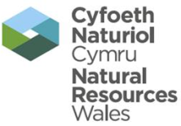 | EPR Compliance Assessment Report |  |  |  |  |  | Report ID: 101553/0213668
This form will report compliance with your permit as determined by an NRW officer
Site | Pencefnarda Quarry |  |  |  |  | Permit Ref |  |  | 101553
Operator/ Permit holder | J H Jenkins & Sons
Date | 30/06/2014 |  |  |  |  | Time in |  |  | 09:00 |  |  | Out | 10:00
What parts of the permit were assessed | A, C, D
Assessment | Site Inspection | EPR Activity: | Installation |  |  |  | Waste Op | X |  | Water Discharge
Recipient’s name/position | Richard Jenkins - Director
Officer’s name | David T Morgan |  |  |  | Date issued |  |  |  |  |  | 02/07/2014

Section 1 - Compliance Assessment Summary
This is based on the requirements of the permit under the Environmental Permitting Regulations. A detailed explanation and any action you may need to take are given in the “Detailed Assessment of Compliance” (section 3). This summary details where we believe any non-compliance with the permit has occurred, the relevant condition and how the non-compliance has been categorised using our Compliance Classification Scheme (CCS). CCS scores can be consolidated or suspended, where appropriate, to reflect the impact of some non-compliances more accurately. For more details of our CCS scheme, contact your local office.
Permit Conditions and Compliance Summary |  |  |  |  |  | Condition(s) breached
a) Permitted activities | 1. Specified by permit |  | A
b) Infrastructure | 1. Engineering for prevention & control of pollution |  | N
b) Infrastructure | 2. Closure & decommissioning |  | N
b) Infrastructure | 3. Site drainage engineering (clean & foul) |  | N
b) Infrastructure | 4. Containment of stored materials |  | N
b) Infrastructure | 5. Plant and equipment |  | N
c) General management | 1. Staff competency/ training |  | N
c) General management | 2. Management system & operating procedures |  | A
c) General management | 3. Materials acceptance |  | A
c) General management | 4. Storage handling, labelling, segregation |  | N
d) Incident management | 1. Site security |  | *C3 |  |  | 1.1.1;
d) Incident management | 2. Accident, emergency & incident planning |  | N
e) Emissions | 1. Air |  | N
e) Emissions | 2. Land & Groundwater |  | N
e) Emissions | 3. Surface water |  | N
e) Emissions | 4. Sewer |  | N
e) Emissions | 5. Waste |  | N
f) Amenity | 1. Odour |  | A
f) Amenity | 2. Noise |  | A
f) Amenity | 3. Dust/fibres/particulates |  | A
f) Amenity | 4. Pests, birds & scavengers |  | A
f) Amenity | 5. Deposits on road |  | A
g) Monitoring and records, maintenance and reporting | 1. Monitoring of emissions & environment |  | N
g) Monitoring and records, maintenance and reporting | 2. Records of activity, site diary, journal & events |  | N
g) Monitoring and records, maintenance and reporting | 3. Maintenance records |  | N
g) Monitoring and records, maintenance and reporting | 4. Reporting & notification |  | N
h) Resource efficiency | 1. Efficient use of raw materials |  | N
h) Resource efficiency | 2. Energy |  | N
KEY: C1, C2, C3, C4 = CCS breach category ( * suspended scores are marked with an asterisk),
A = Assessed (no evidence of non-compliance), N = Not assessed, NA = Not Applicable, O = Ongoing non-compliance – not scored
Number of breaches recorded |  | 1 |  | Total compliance score  (see section 5 for scoring scheme) |  |  | 0

If the Total No Breaches is greater than zero, then please see Section 3 for details of our proposed enforcement response

Section 2 – Compliance Assessment Report Detail
This section contains a report of our findings and will usually include information on:
- the part(s) of the permit that were assessed (e.g. maintenance, training, combustion plant, etc)  - where the type of assessment was ‘Data Review’ details of the report/results triggering the assessment  - any non-compliances identified  - any non-compliances with directly applicable legislation  - details of any multiple non-compliances | - information on the compliance score accrued inc. details of suspended or consolidated scores.  - details of advice given  - any other areas of concern  - all actions requested  - any examples of good practice.  - a reference to photos taken
This report should be clear, comprehensive, unambiguous and normally completed within 14 days of an assessment.

A routine site inspection was undertaken on Monday 30th June 2014.

At the time of the visit there was no activity ongoing at the site. It was noted that the rolling planning permission is due to be re-issued by the City and County of Swansea planning department.

All wastes viewed on site were compliant with those listed in the permit. One area of the quarry (lower area) could not be accessed due to overgrown hedges. Although this area of the site can be viewed from the adjacent field please ensure all areas of the site are accessible in the future.

It has been noted that there is a large scale drainage project in development at the site. The new drainage channel is on the side of the site which borders a public footpath.

Condition 1.1.1 of the permit was breached (Category 3 - Minor) (Ref:D1)
This condition was breached as the Environment Management System (EMS or Working Plan) states that security for the site will be put in place. Although the gate at the top of the track is kept locked to prevent vehicle access, provisions should also be made to stop pedestrian access from the footpath. It was agreed that temporary fencing be put in place to restrict access to site. Following the completion of the drainage channel permanent fencing must be erected.

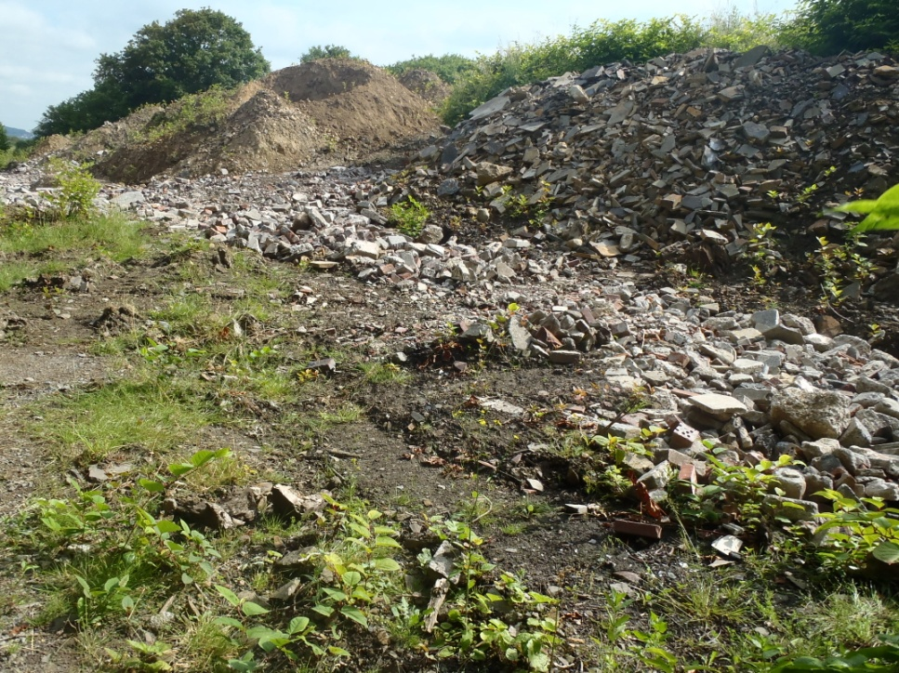

The compliance score for this breach has been suspended until 30th July 2014. If a temporary fence is erected in this time the non-compliance score will be rescinded.

No other non-compliances were recorded during the visit.

 | EPR Compliance Assessment Report |  | Report ID: 101553/0213668
This form will report compliance with your permit as determined by an NRW officer
Site | Pencefnarda Quarry | Permit |  | 101553
Operator/ Permit | J H Jenkins & Sons | Date |  | 30/06/2014

Section 3- Enforcement Response | Only one of the boxes below should be ticked
You must take immediate action to rectify any non-compliance and prevent repetition.
Non-compliance with your permit conditions constitutes an offence and can result in criminal prosecutions and/or suspension or revocation of a permit. Please read the detailed assessment in Section 2 and the steps you need to take in Section 4 below.
Other than the provision of advice and guidance, at present we do not intend to take further enforcement action in respect of the non-compliance identified above. This does not preclude us from taking enforcement action if further relevant information comes to light or advice isn’t followed.
In respect of the above non-compliance you have been issued with a warning. At present we do not intend to take further enforcement action. This does not preclude us from taking additional enforcement action if further relevant information comes to light or offences continue.
We will now consider what enforcement action is appropriate and notify you, referencing this form.

Section 4- Action(s)
Where non-compliance has been detected and an enforcement response has been selected above, this section summarises the steps you need to take to return to compliance and also provides timescales for this to be done.
Criteria Ref. | CCS Category | Action Required/Advised | Due Date
See Section 1 above
D1 | C3 | A temporary fence must be installed to restrict access to the site. If this is completed by the due date the score will be rescinded. | 30/07/2014

Section 5 - Compliance notes for the Operator |  |  |  | Section 6 – General Information
To ensure you correct actual or potential non-compliance we may  advise on corrective actions verbally or in writing  require you to take specific actions in writing  issue a notice  require you to review your procedures or management system  change some of the conditions of your permit  decide to undertake a full review of your permit |  |  |  | Data protection notice  The information on this form will be processed by the Natural Resources Wales (NRW) to fulfill its regulatory and monitoring functions and to maintain the relevant public register(s). The NRW may also use and/or disclose it in connection with:  offering/providing you with its literature/services relating to environmental matters  consulting with the public, public bodies and other organisations (e.g. Health and Safety Executive, local authorities) on environmental issues  carrying out statistical analysis, research and development on environmental issues  providing public register information to enquirers  investigating possible breaches of environmental law and taking any resulting action  preventing breaches of environmental law  assessing customer service satisfaction and improving its service  Freedom of Information Act/Environmental Information Regulations request.  The NRW may pass it on to its agents/representatives to do these things on its behalf. You should ensure that any persons named on this form are informed of the contents of this data protection notice.
Any breach of a permit condition is an offence and we may take legal action against you.

We will normally provide advice and guidance to assist you to come back into compliance either after an offence is committed or where we consider that an offence is likely to be committed. This is without prejudice to any other enforcement response that we consider may be required.
Enforcement action can include the issue of a formal caution, prosecution, the service of a notice and or suspension or revocation of the permit.
See our Enforcement and Civil Sanctions guidance for further information
This report does not relieve the site operator of the responsibility to
ensure you comply with the conditions of the permit at all times and prevent pollution of the environment
ensure you comply with other legislative provisions which may apply.
Non-compliance scores and categories |  |  |  | Disclosure of information  The NRW will provide a copy of this report to the public register(s). However, if you consider that any information contained in this report should not be released to the public register(s) on the grounds of commercial confidentiality, you must write to your local area office within twenty working days of receipt of this form indicating which information it concerns and why it should not be released, giving your reasons in full.
CCS category | Description | Score
C1 | A non-compliance which could have a major environmental effect | 60
C2 | A non-compliance which could have a significant environmental effect | 31
C3 | A non-compliance which could have a minor environmental effect | 4 |  | Customer charter  What can I do if I disagree with this compliance assessment report?  If you are unable to resolve the issue with your site officer, you should firstly discuss the matter with the officer’s line managers. If you wish to raise your dispute further through our official Complaints and Commendations procedure, phone our general enquiry number 0300 065 3000 (Mon to Fri 08.00–18.00) and ask for the Customer Contact team or send an email to enquiries@naturalresourceswales.gov.uk. If you are still dissatisfied you can make a complaint to the Public Services Ombudsman for Wales. For advice on how to complain to the Ombudsman phone their helpline on 0845 607 0987.
C4 | A non-compliance which has no potential environmental effect | 0.1
Operational Risk Appraisal (Opra) - Compliance assessment findings may affect your Opra score and/or your charges. This score influences the resource we use to assess permit compliance.

