Environmental Protection Act 1990
Section 59(1)(a)

NOTICE TO REMOVE CONTROLLED WASTE

To: AllWaste Services Limited Company No: 04359925. C/O Bevan and Buckland, Langdon House, Langdon Road, Swansea. SA18QY.

Under Section 59 of the Environmental Protection Act 1990, as amended, Natural Resources Wales can require removal of controlled waste or extractive waste.

Being satisfied that the controlled waste namely deposited waste wood and woodchip as pictured in photograph DE01, DE02 and DE03. Has been deposited on land at the Woodyard, Station Road, Llangadog, Carmarthenshire. SA19 9LS as shown edged red on the attached plan DE/Plan01. In contravention of [Section 33(1) of the Environmental Protection Act 1990, as amended. Natural Resources Wales requires you to remove the above mentioned waste by Tuesday 31 October 2017.

Date: .................................. Signed: ....................................................
Jonathan Willington
Team Leader, South West Waste Regulation

Natural Resources Wales
Llys Afon (Hawthorn Rise),
Haverfordwest
Pembrokeshire
SA61 2BQ

Please see over for notes.
Environmental Protection Act 1990
Section 59(1)(a)

Notes:

General
- You may wish to seek independent legal advice.

- If you fail to comply with this notice, Natural Resources Wales may take the steps and recover from you any expenses reasonably incurred in so doing.

- Failure to comply with this notice is an offence under Section 59 (5) of the Environmental Protection Act 1990, as amended, and may result in legal action being taken against you.

Appeal provisions
You are entitled to appeal against this notice under Section 59(2) of the Environmental Protection Act 1990, as amended. Notice of appeal must be made within a period of 21 days beginning with the service of this notice to a Magistrate’s Court by way of a complaint. The requirements of this Notice shall have no effect pending the determination of the appeal.

Legislation note
In this document “Natural Resources Wales” means the Natural Resources Body for Wales established by Article 3 of the Natural Resources Body for Wales (Establishment) Order 2012. On 01 April 2013 the Natural Resources Body for Wales (Functions) Order 2013 transferred the relevant functions of the Countryside Council for Wales, and functions of the Environment Agency and the Forestry Commission in Wales to the Natural Resources Body for Wales.

DE01
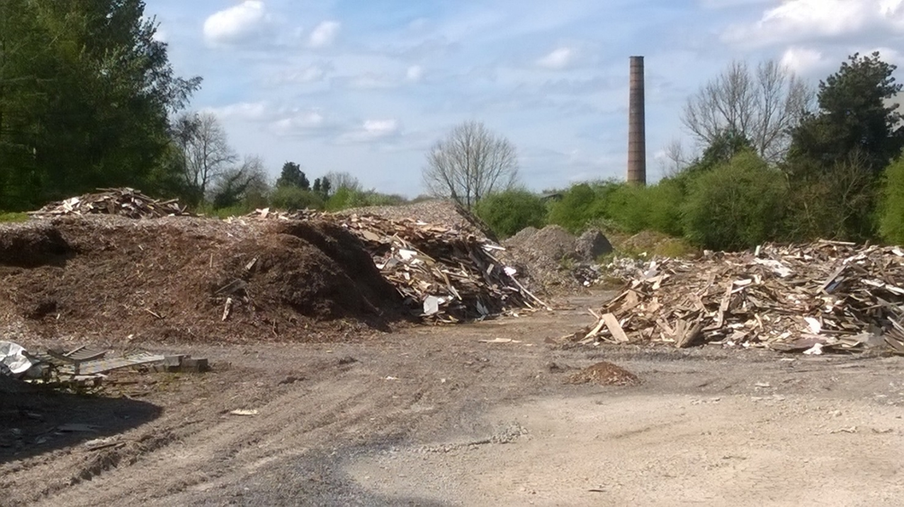

DE 02
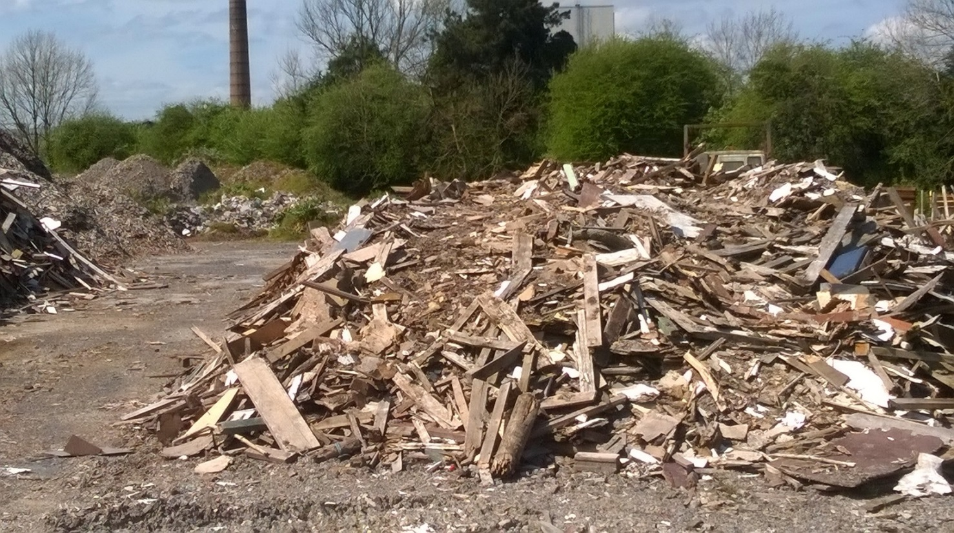

DE03


