Mr. Phillip Thomas &  Mr. Stephen Thomas  TBS Recycling  Victoria Depository  Waterston Industrial Estate  Waterston  Milford Haven  Pembrokeshire  SA73 1DP | Our ref: EPR/VP3598FA  Date: 15th September 2015

Dear Sirs

RE: Sample of a substance collected from waste container at TBS Recycling Transfer Station, Waterston Industrial Estate on 14th May 2014.

Further to our meeting on 9th September and our discussion regarding a sample of a substance collected from waste container at TBS Recycling Transfer Station, Waterston Industrial Estate on 14th May 2014.

I appreciate this matter has taken some time to resolve and that this delay has caused you concern. I would like to draw this matter to a close and confirm that Natural Resources Wales will not be pursuing the matter and no further action will be taken in this regard.

During our meeting you requested a copy of the laboratory analysis. I can confirm that having checked our records the only report present is that enclosed with this letter, that is the report from our MIDAS system. I believe you have previously received a copy of this report.

You were kind enough to provide me with a copy of the laboratory analysis report for the sample of the same substance collected on your behalf on 14th May 2015, stating the substance contained approximately 70% sugar parameters.

Our laboratory report states that Phenol was present at 543 mg/kg or parts per million (ppm) and there was also the presence of an aldehyde and polyol. The report does not identify the substance or confirm whether the substance is hazardous or non-hazardous.

The presence in the substance of Phenol at 543ppm equates to 0.054%. Therefore whilst the original bonding substance was hazardous, the analysis available indicates that the substance sampled did not have hazardous properties as would be defined under current guidance (Technical Guidance WM3).

I trust this satisfactorily brings this matter to a close. If you wish to discuss further please contact Dave Ellar on 0300 065 4016 or david.ellar@cyfoethnaturiolcymru.gov.uk

Yours sincerely,

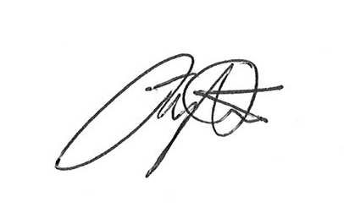

Jonathan Willington
Arweinydd Tîm/Team Leader
Tîm Rheoleiddio Gwastraff (DG Cymru) / Waste Regulation Team (Southwest)

Ffôn/Tel: 0300 065 4070
Ffôn synmudol/Mobile: 07468 742628
Ebost/Email: jonathan.willington@cyfoethnaturiolcymru.gov.uk

Enclosed: Copy of MIDAS report in respect of sample of substance collected from waste container at TBS Recycling Transfer Station, Waterston Industrial Estate on 14th May 2014.

