Wrexham PFI
Operations Report
- Weather data
1.1 Site Op Data (using Kestrel 5500)
Location (see plan for locations) | Weather conditions | Time | Wind direction | Wind speed (MPH) | Temperature (˚C)
SP1–Downwind IVC | Cloudy/sunny | 10:36 | ESE | 1 | 19.2
SP2- Upwind IVC | Cloudy/sunny | 10:51 | S | 1 | 19
SP3-Downwind MBT | Cloudy/sunny | 11:27 | E | 1.5 | 18.3
SP4-Upwind MBT | Cloudy/sunny | 11:36 | SE | 2 | 17.5
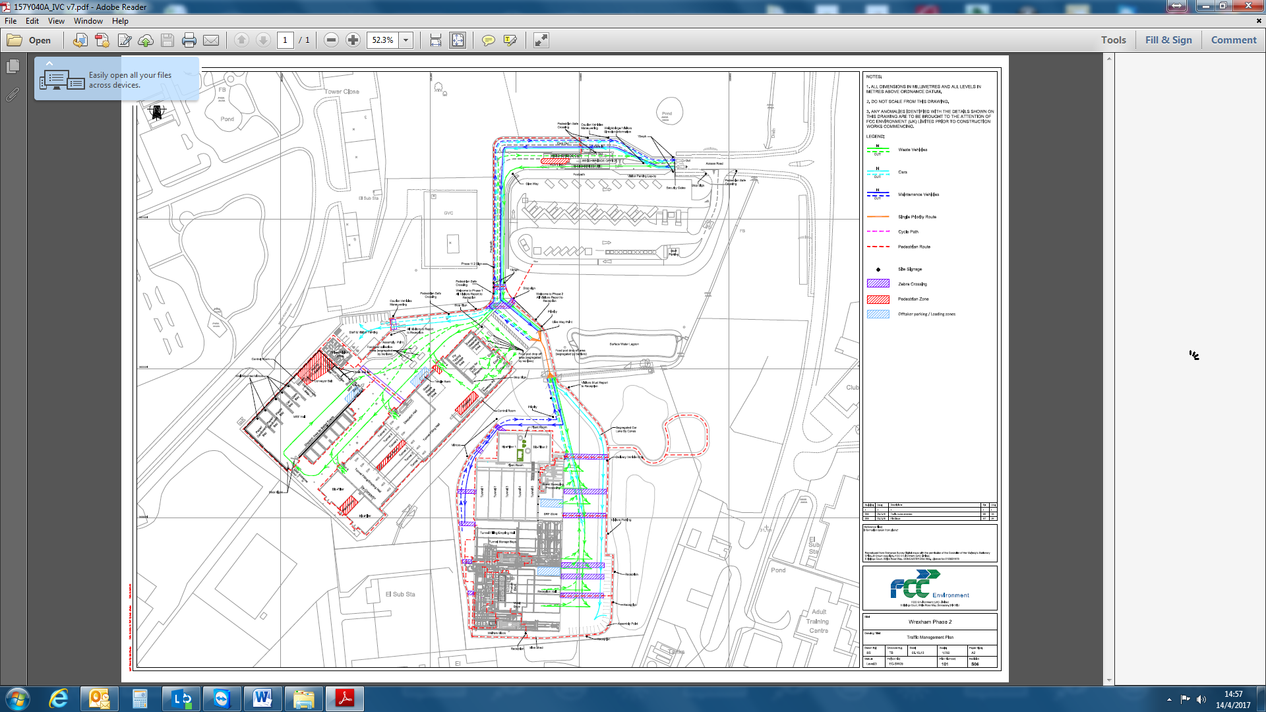
SP1
SP2
SP3
SP4

1.2 Weather station data

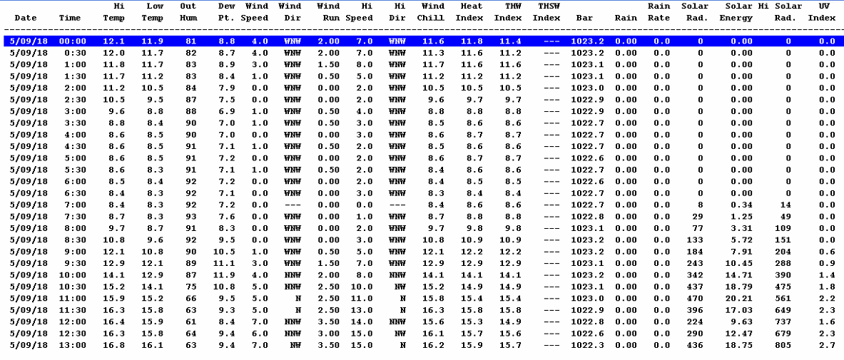
- Site activities

Site  (IVC/TS/MRF/MBT) | Activity | Waste stream | Tonnages
MBT | Pre-treatment shredding | MSW | 91.3
MBT | Bio-drying Tunnel 1 – phase 6 | RDF | 392.15
MBT | Bio-drying Tunnel 2 – phase 6 | RDF | 400
MBT | Bio-drying Tunnel 3 – phase 3 | RDF | 375.62
MBT | Bio-drying Tunnel 4 – phase 9 | RDF | 390.13
MBT | Bio-drying Tunnel 5 – phase 6 | RDF | 427.47
MBT | RDF dispatch | RDF | 120
MRF | Baling | Ali Cans | 0.5
MRF | Baling | Steel cans | 1
MRF | Baling | Card | 6
IVC | Tunnel’s 1,2,3,4,5,6 Hygenise | Green | 1200
IVC | Mulch dispatch | Mulch | 20

- Bio filter data

  - Phase 1

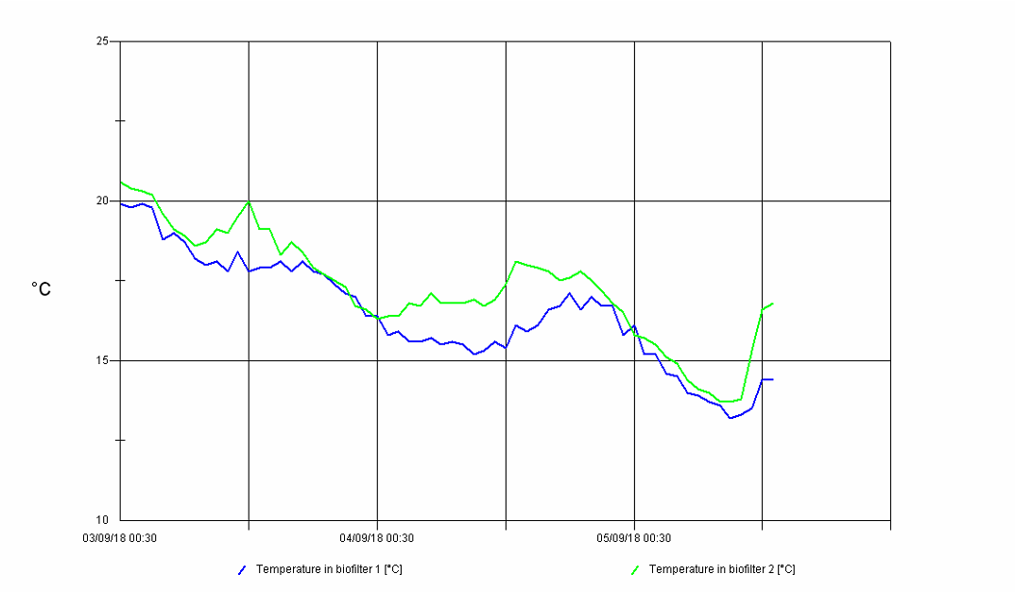
  - Phase 2

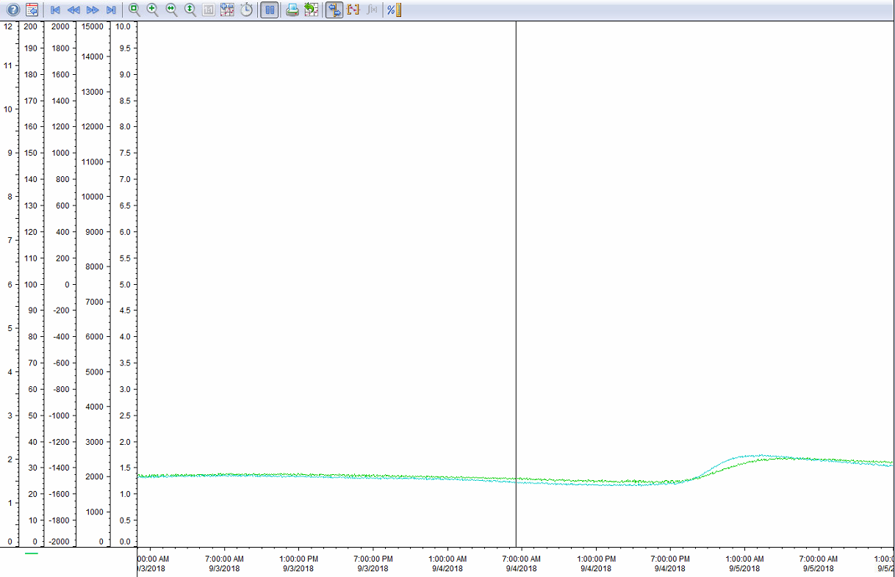

  - Moisture data

Phase1
Filter 1 = 67%
Filter 2 = 77%
Phase 2
Filter 1 = 76%
Filter 2 = 79%
- Site Observations
Phase1
Odours from food manufacturing at sample point 1 during the monitoring.
Door 4 opened at 10:40 (IVC reception hall) for vehicles tipping. Council vehicle travelled past monitors at 11:05, 11:06 and at 11:08
Phase 2
Road sweeper driving past monitors at 11:46 followed by council vehicles at 11:49 and 11:54. Reception door C opened for vehicles tipping at 11:50.

