Ein cyf/Our ref: DB3332RH
Eich cyf/Your ref:

Natural Resources Wales
Ffordd Penlan
Parc Menai
Bangor
Gwynedd
LL57 4DE

Ebost/Email: Mefty.haider@cyfoethnaturiolcymru.gov.uk
Ffôn/Phone: 03000653696

Mr Carl Thompson
30 Hallfield Close
Flint
Flintshire
CH6 5HL

Date: 22 August 2016

Dear Mr Thompson,

RE: Compliance Assessment Report (CAR) for DB3332RH

Please find attached a copy of the Compliance Assessment Report (CAR) following the compliance visit/audit undertaken by Haider, Mefty on 02/08/2016.
Please review the report and provide comments back as appropriate within 15 working days of receipt. If we do not receive any comment within 15 working days we will assume that you are satisfied with our findings and the document will be published to the public register.

If you have any questions regarding the attached report please do not hesitate to contact me.

Yours sincerely,

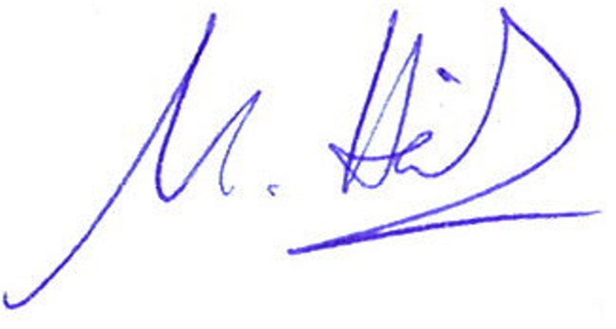

Mefty Haider
Environment Officer

