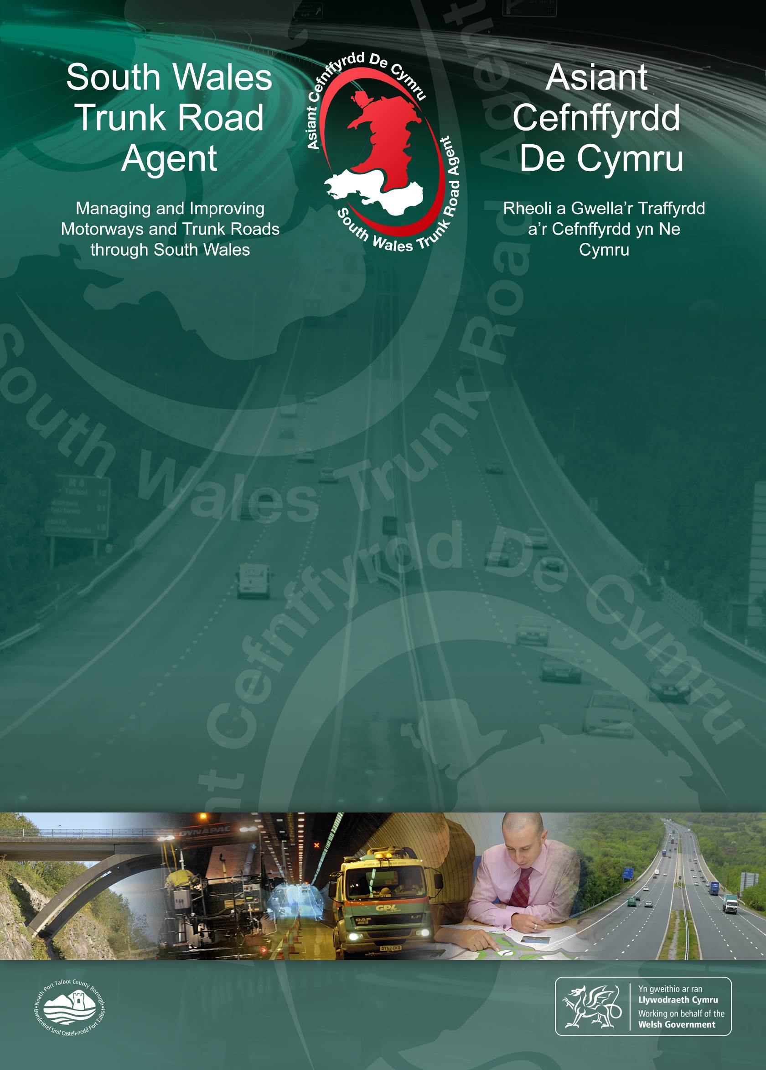
A40 Llanegwad Afon Tywi Erosion Scheme

Screening for Environmental Impact Assessment

January 2021

A40 Llanegwad Afon Tywi Erosion Scheme
Screening for Environmental Impact Assessment
January 2021

Service Provider/Consultant Name: |  | Atkins Limited
Service Provider/Consultant Project Number: 5198351.101

IRIS Number: 18/SW/CHS/004 |  | File Number:
 | Name | Signature | Date
Author: | J Lorraine |  | 09-12-2020
Checked: | B Noutch |  | 11-12-2020
Reviewed: | M Huband |  | 18-12-2020
South Wales Trunk Road Agent

 | Name | Signature | Date
Reviewed by:

Revision History
Revision | Revision date | Details | Authorized | Name | Position
1 | 11/01/2021 | For Review
2 | 29/01/2020 | For Issue

Table of Contents
1. Introduction 4
1.1 Context 4
1.2 Screening for Environmental Impact Assessment 4
1.3 Well-Being of Future Generations Act (Wales) 2015 5
2. Scheme Description 5
2.1 Site location 5
2.2 Scheme description 6
2.3 Construction phase 9
3. EIA Screening 10
3.1 Method 10
3.2 Assessment 11
3.2.1 Archaeology 11
3.2.2 Ecology 12
3.2.3 Flood risk and water quality 16
3.2.4 Contamination and soils 17
3.2.5 Population and human health (agricultural land holdings) 20
3.2.6 Traffic and transport 21
3.2.7 Waste 21
3.3 Summary 22
4. Mitigation Measures 22
4.1 Operational Mitigation 22
4.2 Construction Mitigation 23
4.2.1 General 23
4.2.2 Pollution prevention 23
4.2.3 Archaeology 24
4.2.4 Ecology 25
4.2.5 Flood risk 26
4.2.6 Land contamination and soils 26
4.2.7 Waste 27
5. Summary and Conclusion 28
Appendix A – Annex III EIA Screening form 30

Introduction

Context
Between Llandeilo and Carmarthen the A40 runs along the northern edge of the floodplain to the Afon Tywi. East of Llanegwad at National Grid Reference SN 525 213. Rapid lateral progression of the Afon Tywi towards to edge of the floodplain threatens to undercut the A40 and render it unsafe for traffic.

As the agent responsible for maintaining the strategic road network in South Wales, the South Wales Trunk Road Agent (SWTRA) is developing a design for a scheme to protect the road from undercutting of the Afon Tywi (hereafter ‘the Scheme’).

Screening for Environmental Impact Assessment
The purpose of this Environmental Impact Assessment (EIA) screening is to determine whether a statutory EIA is needed in accordance with the requirements of the EIA Directive (85/337/EEC as amended by 97/11/EC) and under the Highways (Environmental Impact Assessment (Miscellaneous Amendments relating to Harbours, Highways, and Transport) Regulations 2017. Guidance is provided in the Design Manual for Roads and Bridges (DMRB) Standard LA 102 “Screening projects for Environmental Impact Assessment” (formerly HD47/08), and has been used in this assessment in the form of a simple process referred to as the Annex III form, as shown in Appendix A.

The Scheme, which is described in section 2 of this report, constitutes an improvement scheme, as defined in DMRB Standard LA 102. The site area, including land required to complete the works is anticipated to be approximately 1 hectare in size and will be located adjacent to the Afon Tywi Special Area of Conservation (SAC) and Site of Special Scientific Interest (SSSI). As such the Scheme is considered a ‘relevant project’ falling within Annex II of the EIA Directive and EIA screening has been undertaken due to the nature of the works and the proximity to the SAC and SSSI. Welsh Government will publish a Notice of Determination on the need for EIA screening.

In addition to the Annex III screening form provided in Appendix A, an appraisal of the likely construction and operation impacts of the Scheme on relevant environmental topics has been undertaken. The appraisals consider the likelihood of impacts being significant and recommend actions or measures considered necessary to mitigate the effects.

The report concludes that no significant environmental effects are likely and that the Scheme is not considered EIA development.

Well-Being of Future Generations Act (Wales) 2015
The Well-being of Future Generations Act (Wales) 2015, Section 5, requires SWTRA, as a public body, to act in a manner which seeks to ensure that the needs of the present are met without compromising the ability of future generations to meet their own needs. In order to achieve this, Section 5 establishes a number of requirements for public bodies to take account of.

The first aspect of this is to take account of the importance of balancing short-term needs while safeguarding the ability to meet long term needs. The Scheme will protect the existing carriageway in situ, avoiding the need to realign the road and use valuable natural resources. Once operational, the Scheme will support the continued safe use of the A40 by the public. The A40 is a critical part of the strategic road network in South Wales, connecting Carmarthenshire, Pembrokeshire and the docks with southeast Wales and England. The Scheme is proposed to have a design life of 120 years and will allow the A40 to continue supporting the economic and social prosperity of the region into the future.

Scheme Description

Site location
The Scheme is located on the A40, 500m east of Llanegwad, Carmarthenshire (National Grid Reference SN 525 213).

The area of works (hereafter ‘the site’) comprises agricultural land immediately adjacent to the westbound carriageway of the A40. The site stretches for approximately 250m along the highway boundary.

The Tywi meanders through the field to the south of the site. At its narrowest, the distance from the bank of the outside bend of the Tywi to the base of the embankment supporting the A40 is 25m. The site will be located within the intervening land and set back from the top of the riverbank by at least 8m. The top of the riverbank forms the boundary of the Afon Tywi Special Area of Conservation (SAC) and Site of Special Scientific Interest (SSSI).

The extent of the Scheme is illustrated in Figure 1.

The channel of the Afon Tywi is a designated SSSI and SAC. It is designated primarily for supporting European Otter and Twaite Shad as well as Lamprey, Sandmartin and shingle invertebrates.

The site is not located in the SSSI or SAC nor in proximity to any landscape or heritage designations, tree preservation orders or public rights of way.

Figure 1 – Scheme location
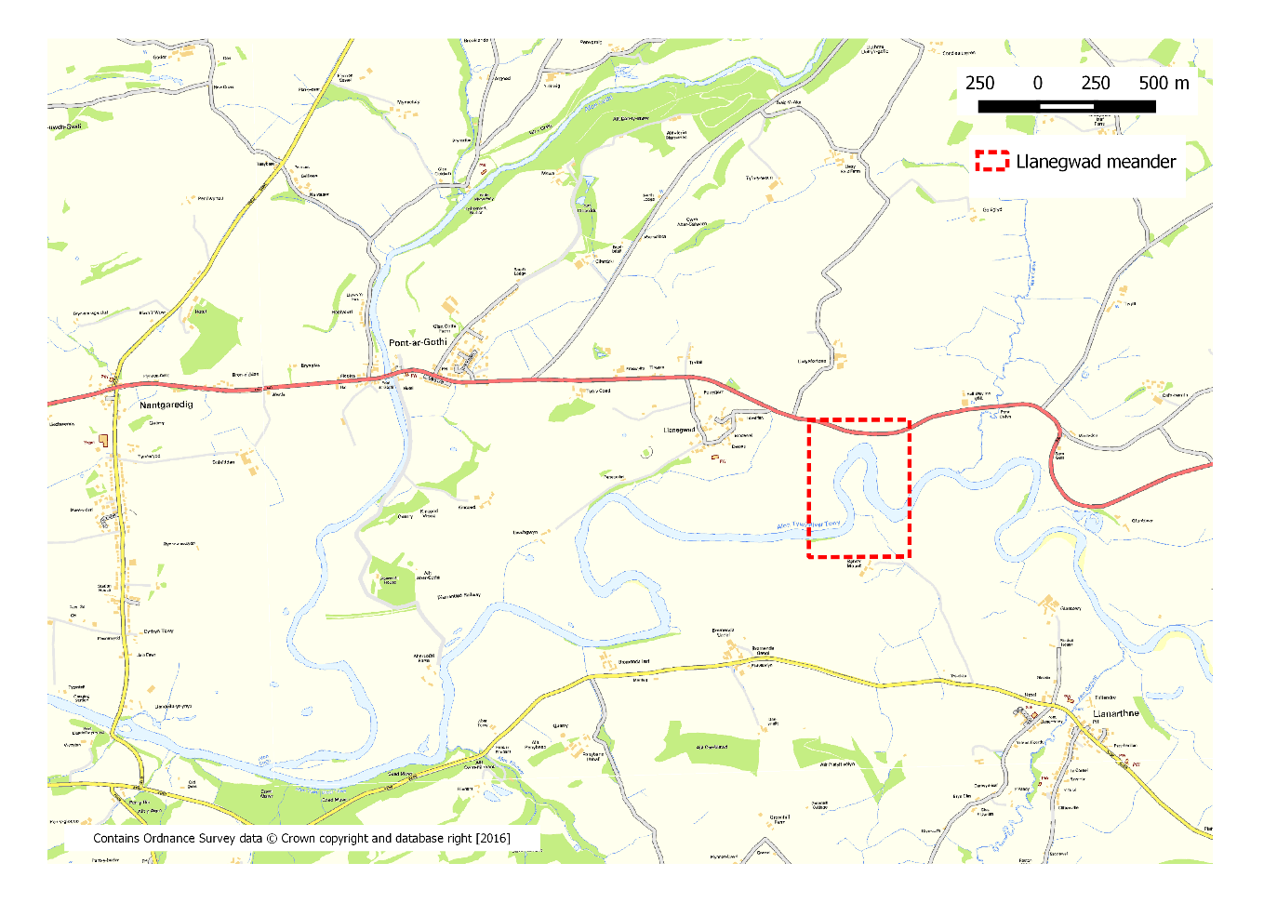

Scheme description
The scheme comprises five design options which would hold the existing line of the A40. Each option would involve a buried hard engineering defence extending up and downstream of the meander for a maximum length of 250m. Each option would maintain a minimum 8m ‘river exclusion zone’ between the top of the riverbank to the edge of the construction area.

All works will be undertaken in accordance with the DMRB design standards.

Figure 2 – Scheme cross section
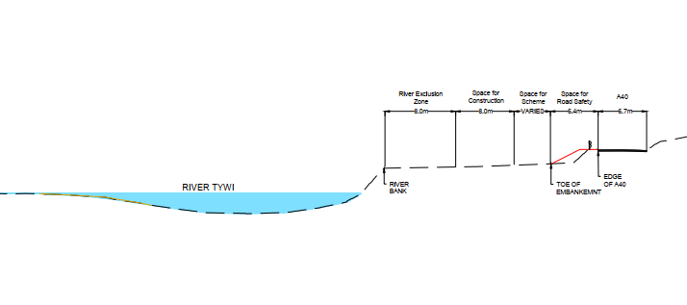

Anchored sheet pile wall
This option comprises an embedded retaining wall (likely to be steel sheet piles) with an inclined ground anchor to provide restraint at the top of the wall. The wall would be embedded close to the toe of the widened embankment and provide retention for the full depth of estimated scour. The anchor will key into the mudstone beneath the existing carriageway. The maximum depth of the piled wall is expected to be 18m.

Figure 3 – Anchored sheet pile wall

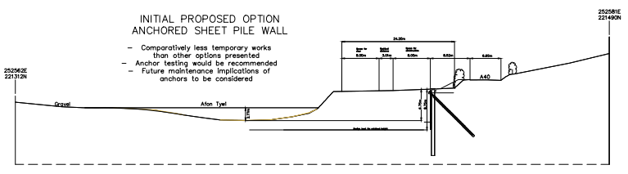

Soil nailed slope with shotcrete/hard facing and pile wall
This option uses soil nails to construct a steepened reinforced slope, at the base of which a pile wall (likely concrete bored) will be installed to retain the remaining estimated scour depth. A hard facing e.g. shotcrete will be implemented on the steeped slope face. Significant temporary excavation will be required which will be backfilled upon completion of the reinforced slope and pile wall. The maximum depth of the piled wall is expected to be 18m.

Figure 4 – Soil nailed slope with shotcrete/hard facing and pile wall

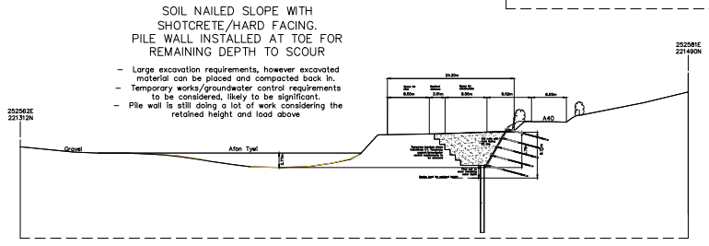

Piled reinforced concrete retaining wall, with two rows of supporting piles
This option comprises a conventional reinforced concrete retaining wall, with the addition of supporting piles at the toe and heel. At the toe, the piles will be continuous to provide retention for the remainder of the estimated scour depth. Discrete concrete piles may be used at the heel. The temporary excavation required to construct the works will be backfilled upon completion of the piled retaining wall. The maximum depth of the piled walls is expected to be 18m.

Figure 5 - Piled reinforced concrete retaining wall

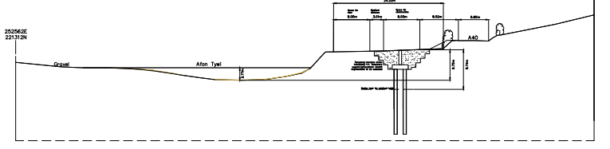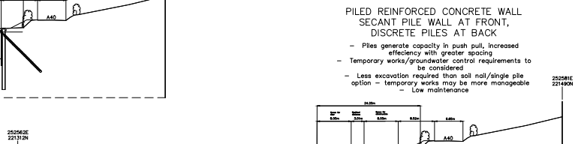

Box trench excavation with rock revetment infill
This involves the implementation of an ‘excavate and replace’ detail, where a trench will be excavated to the full depth of estimated scour and re-filled with rock revetment material. It is anticipated that this material will form a natural slope revetment once breached by erosion. Propping/shoring will be installed in the temporary case to construct the solution. The maximum depth of the box trench is expected to be 9m.

Figure 6 - Box trench excavation with rock revetment infill

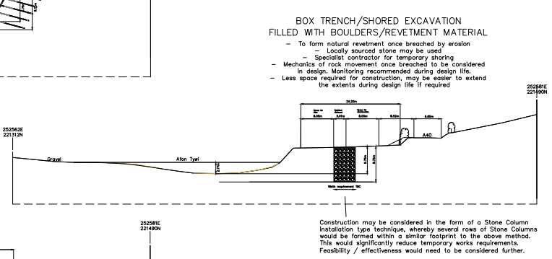

Box trench excavation with gabion basket/precast block infill
This involves the implementation of an ‘excavate and replace’ detail, where a trench will be excavated to the full depth of estimated scour and re-filled with gabion baskets, precast concrete blocks, or a combination of the two. It is anticipated that this material will form a controlled slope revetment once breached by erosion. Propping/shoring will be installed in the temporary case to construct the solution. The maximum depth of the box trench is expected to be 9m.

Figure 7 – Box trench excavation with gabion basket/precast block infill

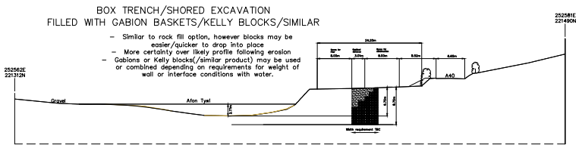

Construction phase
All five options would require an excavator during construction for excavating and backfilling soil. The most significant excavations would be required for the buried revetment option. Deep excavations will be supported by a shoring solution such as a hydraulic bracing system. Depending on the chosen option, piling, anchor or soil nail rigs will be required during construction.

The materials to be used in construction will depend on the final design option chosen. The piled options would involve the reuse of excavated materials.

Anchors and soil nails would be constructed of steel. Piles would be steel or concrete. Grout would be required. The two box trench options would require gabion baskets or stone. These options would require the removal of excavated material from site.

The length of the construction phase will depend on the final design option. It is anticipated that the construction phase will commence in Autumn 2021, and have a maximum duration of 8 months. Although, it is anticipated that excavations will take two to three months to complete depending on the number of excavator rigs used and the final design option chosen..

No construction activities, except vehicle tracking and temporary storage of materials will take place within 8m of the riverbank. The ‘river exclusion zone’ will be maintained throughout the construction phase to ensure works avoid the SSSI and SAC designation.

A Construction Environmental Management Plan will be prepared and adhered to by contractors throughout the construction phase. The Management Plan will establish the sensitive receptors affected by the works and detail the measures and working practices to be adhered to during construction to avoid and minimise potential impacts. Mitigation measures will include those measures identified in this screening report and additional measures developed by specialists and agreed with SWTRA.

EIA Screening

Method
The EIA screening for the Scheme is based on the five preliminary design options, as described in Section 2. In each instance, commentary on the likelihood of significant impacts is based on the worst performing of the five options.

A preferred option has not been selected at this stage and the details of the construction method are unconfirmed. As such, should the details described in Section 2 change during the development of the detailed design, advice should be sought on the potential need to rescreen the project for EIA.

Annex III of the EIA Directive sets out EIA screening criteria. This criteria has been considered in the form attached at Appendix A. This form supplements the environmental screening of relevant topics in Section 3.2 and is the basis of the screening decision.

The Scheme is considered to have potential for impacts to arise relating to the following topics:
- Archaeology;
- Ecology;
- Flood risk and water quality;
- Geology and soils (Contamination and soils);
- Population and human health (agricultural land holdings);
- Traffic and transport; and
- Waste;

The types and characteristics of the potential impacts and the likely significance of the effects on these topics are considered in section 3.2 of this report.

A review of the preliminary scheme information and an initial review of the environmental constraints of the site and its surroundings has led to the following topics being screened out of the EIA Screening:
- Air quality;
- Built heritage;
- Climate;
- Geology and soils (Geology);
- Landscape and visual impacts;
- Noise and vibration; and
- Population and human health (all other sub-topics).

Annex III of the EIA Directive requires that screening considers likely significant effects which could arise in combination with other projects. It is not considered appropriate or proportionate to consider the in-combination effects from the Scheme and other projects due to the nature of the works involved. The Scheme would have very limited potential for operational effects and will effectively mitigate potential impacts during construction through the use of the scheme-wide mitigation measures set out in Section 4.

Screening for Habitats Regulations Assessment is being undertaken concurrently and will be reported separately.

Assessment

Archaeology
The archaeological potential for the Scheme is high based on the geology and the high number of archaeological assets within the surrounding area although archaeological survival may be low due to previous disturbance related to the construction of the A40. A study area of 500m was deemed appropriate to identify the heritage assets.

There is a high potential for paleoenvironmental remains due to the presence of alluvium and peat. Archaeological remains within a 500m area surrounding the site is dominated by the prehistoric and Roman period. The site lies within alluvial deposits, which suggests that the course of the Tywi had been fairly stable since an early period, perhaps as far back as the Bronze Age as three round barrows are situated near White Mill. Nationally significant monuments are located just outside the study area, Bronze Age structures, Llech Ciste Standing Stone and Maes y Crug round barrow, signify a strong probability of the presence of intact burial or ritual deposits, together with environmental and structural evidence.

There is potential for further medieval presence within the study area, with excavations in 2007 revealing industrial activity within the village of Llangewad including tanning, possibly temporary in nature. Pottery from some of these deposits suggests a medieval date to this activity, sometime between the 12th and 16th centuries. To the north a possible kiln and other features containing large amounts of ferric slag indicate more extensive industrial activity, undated but presumably broadly contemporary

Analysis of the historic maps show the historical development for this site is in the movement of the Afon Twyi. There is likely to be buried archaeological remains associated with the settlement movements. There have been few archaeological investigations in the area, which could relate to the lack of the development within the study area and wider environs. A watching brief at Roman Road at Llwynfortune Farm was carried out in 2004, however the report is not available online.

Construction
The works will not impact any known historic assets; however, all the options include ground intrusive works within the footprint of the Site. Due to the archaeological and paleoenvironmental potential of the area there is potential for unknown archaeological remains to be truncated by the works. There are no anticipated impacts on the setting of any heritage assets from the options under consideration.

Due to the identification of a number of heritage constraints, both in the Site and within the 500m study area, regard should be given to the sensitivity and potential impacts from the Scheme.

Further archaeological assessment, to be agreed in consultation with Dyfed Archaeological Trust and the Local Planning Authority, may be required. This could include watching briefs on further ground investigations and during the construction work. If the monitoring exercise reveals sequences different from those observed to date, it may be necessary to obtain additional samples for paleoenvironmental assessment/analysis.

Further archaeological assessment, to be agreed in consultation with Dyfed Archaeological Trust and the Local Planning Authority, may be required.

Operation
There will be no operational impacts to the historic environment. The number of archaeological features at risk of damage or loss from erosion and regularity of flooding would increase over time. It is likely that the options under consideration would benefit the historic assets within the study area by protecting them from erosion and flooding. Due to the Site location on this stretch of the A40 it is unlikely to have impacts on the visual connectivity and setting of heritage assets. Likewise, negative visual impacts in relation to the existing historic characters of the area are not anticipated.

Residual Effects
The potential impact of the proposed works on the historic environment and heritage assets within the study area is on hitherto unknown archaeological features. The proposed works may have a negative impact on undisturbed areas of ground, where there is the potential for below ground archaeological remains. Pre-development archaeological testing and subsequent monitoring of intrusive works will ensure recording of any buried finds or features. Therefore, taking into account mitigation, it is anticipated there will be no residual impacts on the archaeological understanding of the area.

Ecology
The principal consideration in terms of potential impacts on ecology, relate to the River Tywi SAC and SSSI. Screening for Habitat Regulations Assessment (following DMRB LA 115) is being undertaken for the five design options. The screening process will determine whether significant impacts on ecology are likely.

Designating features of the SAC include European Otter, Twaite Shad, Allis Shad, Sandmartin, Sea Lamprey, Brook Lamprey, River Lamprey and Bullhead.

The Site itself also has the potential to support a range of protected/ notable species, including birds, badger, foraging and commuting bats, dormice, common species of reptile and amphibian, invertebrates, hedgehog, polecat and hare.

Construction
The hedgerows and tree within and adjacent to the Site have potential to support nesting birds. In addition, the riverbanks of the Afon Tywi have potential to support nesting kingfisher and sand martin. The Site also has potential to support over wintering birds, and approximately 20 green sandpiper were recorded adjacent to the Site along the banks of the river during the Phase 1 survey. It is anticipated that vegetation clearance will be undertaken outside of the bird breeding season, thereby avoiding any adverse impacts on nesting birds as a result of disturbance or injury during construction. Due to the localised nature of the Site, no significant impacts are anticipated on wintering birds during construction.

No habitat suitable for roosting bats is present within the Site or immediately adjacent to the Site, and there will be no impact on roosting bats during construction. Hedgerows within the Site and the river adjacent to the Site are considered suitable to support foraging and commuting bats, although the improved grassland is of low-quality foraging habitat. The Scheme requires the permanent removal of a short section (approximately 20m) of hedgerow to facilitate the works, and the translocation of a length (approximately 200m – 300m) of hedgerow parallel to the A40. Permanent removal of 20m of hedgerow is not considered to be detrimental to the commuting/foraging bat population owing to the amount of similar habitat in the surrounding landscape and the fact that removal of the hedgerow will not result in severance of this habitat type. The translocation of 200m – 300m of roadside hedgerow will be temporary in nature and the hedgerow will be replanted parallel to its existing location. Although there will be a regrowth period, reducing the suitability of the hedgerow for foraging bats temporarily, bats are known to use ditches and other low-height features for navigation and therefore the translocated coppiced hedgerow will maintain connectivity for commuting bats. Due to the localised nature of the proposed works and the limited and temporary nature of vegetation removal, there will be no significant impact on foraging ang commuting bats as a result of habitat removal during construction. No night-time working will be required (defined as 30 minutes before sunset to 30 minutes after sunrise) and therefore no artificial lighting will be required to facilitate construction. Any security lighting which may be required will avoid illuminating retained habitats of value to bats, namely retained trees and hedgerows, and the river. Therefore, there will be no significant impacts on foraging and commuting bats during the construction phase.

No badger setts or evidence of badger was recorded within the Site during the Phase 1 survey. The hedgerows provide opportunity for sett building, although this is limited owing to the banks being relatively shallow. A pre-works check for badger setts within the Site will be carried out no longer than 24 hours prior to works commencing. If any active badger setts are identified, a licence will be obtained from Natural Resources Wales in order to close the sett. Construction of the proposed Scheme has potential to harm individual badger which may traverse the Site. Measures to ensure the Site remains free of hazards for wildlife, including badger, will be implemented throughout construction, thereby avoiding any significant impacts on badgers during construction.

Hedgerows within the Site are considered suitable for dormice. The Scheme requires the permanent removal of a short section (approximately 20 m) of hedgerow to facilitate the works, and the translocation of a length (approximately 200 m – 300 m) of hedgerow parallel to the A40. Dormouse presence/ absence surveys are required to identify whether the scheme will result in the loss of a small amount of dormouse habitat and temporary habitat severance, and whether the Scheme has potential to directly impact individual dormouse which may be present during vegetation clearance.

Otter are a primary reason for designation of the Afon Tywi SAC. No evidence of otter was recorded during the Phase 1 Survey, nor were any potential holts identified along the stretch of the Afon Tywi within 50 m of the Site. Habitats to be impacted during construction include improved grassland and managed hedgerows which do not provide suitable terrestrial habitat for otter. As no night-time working will be required (defined as 30 minutes before sunset to 30 minutes after sunrise), the works are not anticipated to result in significant disturbance impacts to otter which may be present within the Afon Tywi or commuting through the Site. There is potential for otter to be impacted as a result of pollution of the River Tywi. Pollution prevention measures are to be implemented on Site for the duration of the construction works. The Site will also be maintained free of hazards for wildlife, including otter. Checks for evidence of otter will be carried out alongside the dormouse presence/absence survey. In addition, pre-works checks for otter holts and layups will be carried out along the stretch of the Afon Tywi adhacent to the Site bu an ecologist immediately prior to works commencing. On this basis, it is anticipated that there will be no significant impacts on otter during construction.

The section of the Afon Tywi located adjacent to the Site is not considered suitable to support water vole owing to the fast-flowing water and lack of any substantial bankside vegetation. Therefore, the proposed construction works are not anticipated to have any impacts on water vole.

Hedgerows within the Site are considered suitable to support common reptile and amphibian species. There is potential for individual reptiles and amphibians to be injured or killed during construction. A precautionary method of working (PMW) will be implemented on Site during construction and therefore, there will be no significant impacts on these species.

The hedgerows within the Site also provide suitable habitat for a range of invertebrates, including Priority species. Given the localised nature of the scheme, the relatively small amount of habitat to be impacted and the amount of similar habitat in the wider area, invertebrate species will not be significantly impacted during construction.

There is potential for the construction of the Scheme to adversely impact fish species, including species which are designated features of the SAC, through disturbance as a result of noise and vibrations, with potential for exposure to pollutants. It is anticipated that works will be undertaken outside of the main spawning/ migratory season for Twaite shad (primary reason for designation) and Allis shad (typically May – June inclusive). Works would then also be outside of the main spawning season for the other fish interest features, except Bullhead. If works are timed to avoid the main spawning and migratory season, and measures are implemented to prevent pollution of the River Tywi, no significant impacts are anticipated on fish owing to the temporary nature of the works.

Permanent removal of 20m of hedgerow is not considered to be detrimental to priority species (i.e. hedgerow) owing to the amount of similar habitat in the surrounding landscape and as removal of this section of hedgerow will not result in severance of this habitat due to its lack of connectivity to the south. The translocation of 200m – 300m of roadside hedgerow will be temporary in nature, and the hedgerow will be replanted parallel to its existing location. The translocated edgerow will maintain connectivity in the long-term, and therefore impacts on priority species using it for communiting will be temporary. Due to the localised nature of the Scheme and the small amount of habitat to be permanently lost, there are not anticipated to be any significant impacts on any other Priority Species (including hedgehog, pole cat or hare) as a result of the construction of the proposed Scheme. The PMW implemented on site for reptiles will ensure no individuals of these species are harmed during the construction works.

Operation
Permanent habitat loss is limited to a small area of improved grassland of low ecological value, and a short section of hedgerow measuring approximately 20 m in length. Owing to the small area of habitat to be permanently lost, no significant long-term impacts to any protected species are anticipated as a result of habitat loss due to the proposed Scheme. The proposed Scheme will not result in increased levels of disturbance for example from increased traffic, footfall, pollution, noise or lighting. Therefore, no impacts to protected species, the SAC or the features of the designation are anticipated as a result of the operational phase of the Scheme.

Residual Effects
The construction of the scheme will be carried out in accordance with the mitigation measures set out in Section 4 of this report and will be timed to minimise impacts on species. In addition, a construction environmental management plan will be prepared which will set out additional mitigation measures based on the findings of the recommended additional ecology surveys.

Taking into consideration the use of mitigation measures and the short-term and localised nature of potential ecology impacts arising during construction, significant impacts are not anticipated.

Flood risk and water quality
Construction
The scheme is located in flood zone C2 adjacent to the Afon Tywi, as illustrated on the NRW online flood mapping. The works will occur in the active floodplain in an area identified as having a high potential for flooding.

There is potential for flood risk implications during construction, associated with construction activities and the storage of stockpiled soil, materials and construction plant in the floodplain.

Water pollution could arise from contaminated ground or surface water runoff or windblown contaminants from stockpiled material or other debris associated with construction activities. An 8m river exclusion zone will be maintained at all times during construction, no materials, equipment or vehicles will be stored within the exclusion zone. Where essential, construction vehicles will be permitted in the exclusion zone. . Best practice construction methods, including dust suppression, covering of stockpiles and tracking vehicles across fields will be adhered to at all times.

Any silty or contaminated water will be treated using silt socks or settling tanks before being allowed to runoff.

An emergency plan for flood events will be included in the Construction Environment Management Plan and adhered to throughout construction. It will include details of the procedures for monitoring weather forecasts for flood events, and set out the evacuation procedure and muster points in the event of flooding.

Considering the materials that will be used during construction and the best practice mitigation measures which will be implemented to reduce pollution, it is considered unlikely that significant impacts on the water environment would result from the works.

Operation
The scheme is designed to defend the existing A40 carriageway from undercutting by the Afon Tywi. It will introduce a below ground structure in the floodplain which will prevent the future lateral progression of the river. At present the scheme is predicted to have a design life of 120 years. It is predicted that within 78 years the natural progression of the river will cut off the Llanegwad meander, at which point the alignment and future progression of the Afon Tywi will shift radically away from the road.

The development will not increase impermeable surfaces within the floodplain and surface water runoff will not increase.

Depending on the preferred design option taken forward, there is potential for groundwater flows to be impeded by the scheme or for the scheme to generate preferential pathways. A risk assessment will be undertaken for the preferred scheme to identify possible risks and develop appropriate design mitigation.

In its operational phase, neither the passive presence nor the occasional maintenance of the defence is considered likely to give rise to significant impacts on flood risk or water quality.

A Water Framework Directive Assessment and Flood Consequences Assessment will be prepared for the preferred option and appropriate mitigation measures will be developed and included in the CEMP. Both assessments will be prepared on the basis that during the operational phase there would be no change to floodplain topography or the river channel.

Residual Effects
The Scheme will be operated in accordance with the relevant regulations and best practice guidance. The final design will respond to the recommendations of the WFD assessment, FCA and appropriate mitigation measures will be established in the CEMP. It is considered unlikely that any of the options will cause residual significant impacts on the water environment.

Contamination and soils
Construction
There may be potential on-site sources of contamination including Made Ground associated with the construction of the existing A40 carriageway as well as spillages/leaks of fuels from vehicles associated with the operation of the road and potentially contaminated groundwater. There may also be potential off-site sources of contamination associated with agricultural land.
Construction works have the potential to cause physical effects associated with vegetation clearance, stripping of topsoil in highway verges, temporary stockpiling of excavated materials, earthworks and construction of new infrastructure required to mitigate the river bank erosion. A list of the proposed scheme options, their potential operational impacts and mitigation measures are provided below in Table 1. Mitigation measures and best practice will be incorporated into the construction process through the Construction Environmental Management Plan (CEMP).

Table 1 Construction impacts

Proposed Option | Construction Impacts | Mitigation
Anchored sheet pile wall | Minimal excavated material generated with driven sheet piles.  Installation of piles may create preferential contamination pathway.  Sheet pile wall may cause impediment to groundwater flow.  Degradation of soils due to backfilling of top and subsoils. | Undertake a piling risk assessment to identify possible risks of preferential pathway generation and groundwater flow impediment and select appropriate mitigation.  Adoption of safe working methods and construction practices to manage groundwater.  Implementation of appropriate pollution incident control and safe storage of fuels, oils and equipment.  Implementation of a soil management plan for appropriate storage and backfilling of soils.
Soil nailed slope with shotcrete/hard facing and pile wall | Installation of the piles may generate preferential contamination pathway.  Excavation requirements would generate larger volumes of excavated soil arisings than other options. This has the potential to mobilise soil contamination and expose arisings at the surface during materials movement and stockpiling.  Soil erosion from plant movements and stockpiled materials may increase sediment load to the Afon Tywi through surface run-off.  Dewatering likely to be required in close proximity to the Afon Tywi. Shallow geology is designated a secondary A aquifer.  Degradation of soils due to backfilling of top and subsoils. | Undertake a piling risk assessment to identify possible risks of preferential pathway generation and groundwater flow impediment and select appropriate mitigation.  Management of stockpiles through adoption of site wide materials management plan (MMP) to be included within the CEMP.  Implementation of appropriate pollution incident control and safe storage of fuels, oils and equipment.  Reinstate vegetation cover to minimise soil erosion from run-off.  Undertake risk assessment of possible impact to local water resources as a result of dewatering. Apply appropriate mitigation as required.  Implementation of a soil management plan for appropriate storage and backfilling of soils. The plan will be included in the CEMP.
Piled reinforced concrete retaining wall, with two rows of supporting piles | Excavation required which will generate soil arisings and potentially mobilise soil contamination.  Soil erosion from plant movements and stockpiled materials may increase sediment load to the Afon Tywi through surface run-off.  Installation of the piles may generate preferential contamination pathway.  Degradation of soils due to backfilling of top and subsoils. | Management of stockpiles through adoption of site wide materials management plan (MMP) to be included within the CEMP.  Implementation of appropriate pollution incident control and safe storage of fuels, oils and equipment.  Reinstate vegetation cover to minimise soil erosion from run-off.  Undertake a piling risk assessment to identify possibly risks of preferential pathway creation and select appropriate mitigation.  Implementation of a soil management plan for appropriate storage and backfilling of soils. The plan will be included in the CEMP.
Boxed trench excavation with rock revetment infill | Large excavation requirements which may mobilise soil contamination. Excavated materials generate exposed arisings during temporary stockpiling at the surface.  Increased soil erosion which may increase sediment load to the Afon Tywi through surface run-off  Gabion baskets/rock infill may create a preferential contamination pathway.  Degradation of soils due to backfilling of top and subsoils. | Management of stockpiles through adoption of site wide materials management plan (MMP) to be included within the CEMP.  Implementation of appropriate pollution incident control and safe storage of fuels, oils and equipment.  Reinstate vegetation cover to minimise soil erosion from run-off  Implementation of a soil management plan for appropriate storage and backfilling of soils. The plan will be included in the CEMP.
Boxed trench excavation with gabion baskets/ precast block infill | As above. | As above.

Construction phase impacts can be mitigated through use of a materials management plan (MMP), ensuring appropriate chemical testing and suitability of use of proposed backfill materials. Options that include the installation of permanent piling structure such as sheet pile walls may create preferential pathways for contamination migration and/or cause an impact to groundwater flow and should be assessed through a Piling Risk Assessment (PRA).

The Scheme will be operated in accordance with the relevant regulations, best practice guidance and pollution prevention, to protect the water resources at the site. By undertaking a PRA, possible risks from piling works can be identified and the appropriate mitigation can be implemented.

Construction mitigation measures to be set out in the Construction Environment Management Plan will include:
- The adoption of working methods to manage groundwater appropriately such employing appropriate piling techniques (for example, limit under-rotation during pile augering and monitoring of arisings for contamination);
- Materials management plan;
- Management of stockpiles to reduce soil erosion and degradation; and
- Implementation of both appropriate pollution incident control and safe storage of fuel, oils and equipment.

It is considered that the proposed scheme options are unlikely to have significant effects in relation to land contamination and groundwater resource, with the implementation of appropriate mitigation.

Operation
During operation, impacts will be limited through reinstatement of the site and continued operational highway maintenance. No specific mitigation measures are required beyond prevailing road management pollution prevention measures or any additional measures defined by the design requirements.

Residual Effects
The Scheme will be operated in accordance with the relevant regulations, best practice guidance and pollution prevention, to protect the water resources at the site. Through the implementation of appropriate mitigation measures and adherence to the process detailed in the CEMP, it is considered unlikely that any of the options will cause residual impacts of contamination or degradation of the water resources.

Population and human health (agricultural land holdings)
Construction
The site comprises approximately one hectare of agricultural land which falls within two agricultural land holding. The fields are pasture. The holding is accessed by several gates off the A40.

During construction of the scheme there will be temporary loss of pasture land as a result of the area of works. Due to the short-duration of the temporary loss and the small proportion of the overall agricultural holding that would be affected, significant impacts are not anticipated on the holding.

Operation
There will be a permanent loss of some land from two agricultural land holdings. Only the land in which the flood wall is located will be acquired by Welsh Government. This represents a small and insignificant proportion of the overall holdings and will not have a significant impact on the viability of either holding.
Severance impacts are not considered likely to arise owing to the availability of field access off of the A40 both to the east and west of the meander. No significant impacts on agricultural land holdings is anticipated during operation.

Residual Effect
No significant impacts are anticipated on agricultural land holdings.

Traffic and transport
Construction
The location and arrangements for accessing the site during construction is to be determined, and depending on the final arrangements traffic management may be required. It is not anticipated that lane or road closures will be required during construction and no significant impacts are anticipated.

Traffic management measures will be developed and included within the CEMP.

Operation
Once operational the scheme will give rise to beneficial effects for the strategic road network by providing long-term protection to the A40 from undercutting by the Afon Tywi.

Residual effects
No significant traffic or transport impacts are anticipated.

Waste
Construction
The piled options would involve limited excavations and the majority of excavated material would be backfilled. Limited quantities of excavated material would be removed from site.

The revetment and gabion basket options would involve a greater quantity of excavated material being removed from site due to the import of rock.

The quantity and type of waste material resulting from the Scheme is not considered likely to result in significant effects. Arrangements for the handling of waste disposal off-site are described in Section 4 and will be set out in site-specific CEMPs.

A Site Waste Management Plan (SWMP) will be prepared and implemented during construction. The SWMP will contain details of the roles and responsibilities of those involved with the project. It will include estimates of waste types and volumes, and will provide the details of licenced waste transfer facilities and sub-contractors used. Measures for handling waste will also be set out in the CEMP.

Operation
Once operational, the scheme would create no waste.

Residual Effects
Standard waste management procedures to be set out in a Site Waste Management Plan for the scheme will limit the potential for impacts arising from waste generated by the construction of the scheme. No significant impacts are anticipated.

Summary
The EIA screening has considered the potential for significant impacts arising from five design options.

The primary cause of impacts from the scheme is considered to relate to potential pollution events during the construction of the scheme; however, good practice construction methods and the provision of a river buffer zone will minimise the likelihood of significant impacts.

Once operational, the Scheme will be a dormant below-ground feature and it is considered unlikely to give rise to any significant effects. Ongoing maintenance will be infrequent and will follow SWTRA’s standard procedures for maintaining the strategic highway network. As such the EIA screening primarily considers the construction of the scheme.

It is considered unlikely that the design option which is advanced to detailed design will give rise to significant environmental impacts.

Detailed assessments, including a Water Framework Directive Assessment and Flood Consequences Assessment will be undertaken for the preferred option. Mitigation measures will be developed alongside the design to minimise potential environmental impacts. These measures will be set out in a CEMP (including measures for managing traffic, materials and soils), a Flood Response Plan and Site Waste Management Plan; the details of which will be adhered to throughout construction to minimise residual impacts.

In addition, Appendix A considers the EIA screening criteria as per Annex III of the EIA Directive. Appendix A concludes that the Scheme is not EIA development.

Mitigation Measures

Operational Mitigation
The primary mitigation measure on which the Scheme is based is the provision of a minimum 8m exclusion zone adjacent to the Afon Tywi. No structures will be constructed within 8m of the bank of the river.

Construction Mitigation

General
The primary mitigation measure on which the Scheme is based is the provision of a minimum 8m exclusion zone adjacent to the Afon Tywi. No works or activities other than temporary construction vehicle movements will occur within 8m of the bank of the river.

Construction mitigation measures detailed in the CIRIA C715 ‘Environmental good practice on site handbook’ (2012) are recommended during construction. As are measures set out within the Pollution Prevention Guidelines (PPGs), and the emerging Guidelines for Pollution Prevention (GPPs). PPGs are out of date and a review process is currently underway to replace them with GPPs. The PPGs and GPPs considered of relevance to the LFFN scheme include:
- PPG1 – Pollution Prevention Guidelines (2013);
- GPP5 – Works and maintenance in or near water (2018);
- PPG6 – Working at construction and demolition sites (2012); and
- PPG20 – Dewatering of Underground Ducts and Chambers.

All mitigation measures set out below, and additional mitigation measures identified through ongoing design development and environmental input to the scheme will be set out in a Construction Environmental Management Plan which will be maintained and adhered to throughout construction by all contractors.

Pollution prevention
The following measures are recommended to minimise pollution impacts on air and water quality. These measures should be included in a Construction Environmental Management Plan and then adhered to throughout construction.

- Materials and equipment shall not be stored in flood zones C1 and C2.
- The Contractor shall employ works methodologies that do not require water discharges directly to watercourses (i.e. which would otherwise require an Environmental Permit).
- The Contractor shall implement working methods to protect surface water and groundwater from pollution and other adverse impacts, including changes to flow, flood storage volume, water levels and water quality.
- Adequate drainage systems will be installed prior to construction works where necessary with appropriate treatment prior to discharge. This will include sediment treatment and the inclusion of oil separators where necessary. Any installed drainage system will be appropriately maintained throughout the Scheme works such that it remains efficient.
- Measures will be taken to prevent the deposition of silt or other material arising from work operations in existing watercourses or catchment areas.
- Ground protection measures shall be employed where the ground is at risk of rutting caused by vehicle/equipment and any damage that is caused shall be reinstated, as necessary, to make it good.
- Construction material stockpiles will be dampened down during dry periods;
- Use non-potable water for dust suppression where available. Water shall always be made available for dust suppression should it be required;
- Ensure skips and materials stockpiles (containing friable/easily crumbled materials) are covered by an impermeable surface;
- Avoid the use of diesel or petrol-powered generators and use mains electricity or battery-powered equipment where practicable;
- All refuelling, oiling and greasing will take place over a plant nappy including on impermeable surfaces adequate to provide protection to underground strata and watercourses, and away from drains as far as is reasonably practicable.
- Vehicles and plant will not be left unattended during refuelling and appropriate spill kits will be easily accessible during these activities.
- Plant nappies will be placed below static mechanical plant.
- No fuel, oil or chemical substances will be stored within 15m of a watercourse. Where practicable, only biodegradable hydraulic oils will be used in equipment working in or over watercourses.
- Where there is a risk of dust nuisance, use cutting, grinding or sawing equipment fitted with (or in conjunction with) suitable dust suppression techniques; and
- No washing-down of vehicles (including wheel washing) and equipment will take place unless in designated areas and wash water is prevented from passing untreated into watercourses and groundwater and subject to Environmental Permit requirements if discharged to controlled water;

Should an incident occur, the pollution would first be stopped at its source, then, once safe (wearing appropriate personal protection equipment), clear up would be carried out with appropriate materials and clean-up materials would be disposed of in the correct and appropriate manner (ensuring waste is classified correctly). The incident would be reported through the appropriate recording systems. A review of how the incident occurred would be carried out and corrective actions implemented.

Archaeology
Further archaeological assessment, to be agreed in consultation with Dyfed Archaeological Trust and the Local Planning Authority, may be required. This could include watching briefs on further ground investigations and during the construction work. If the monitoring exercise reveals sequences different from those observed to date, it may be necessary to obtain additional samples for palaeoenvironmental assessment/analysis.

If unknown archaeological remains are discovered, the Contractor shall stop work and contact the appointed Environmental Manager. If it is determined by the archaeological consultant, in liaison with the County Archaeologist, that the planned works may affect those remains, the works shall not re-commence until an assessment is undertaken and appropriate mitigation measures are agreed.

Ecology
It is anticipated vegetation clearance will be undertaken outside of bird breeding season. Where this is not the case a qualified ecologist will undertake a pre-works check up to 24 hours before vegetation clearance or translocation takes place.

It is recommended that a presence/ absence survey for hazel dormouse is undertaken. It is proposed that a footprint tunnel survey will be undertaken between May and July 2021, in accordance with the recommended survey methodology. This survey ethod has been chosen due to the comparatively quick timeframe in which results can be obtained, with 95% chance of detecting dormice across a three month period, even at low densities. If dormice are discovered on site during the surveys, there will be sufficient time to apply for and obtain a licence fron NRW to enable the works to proceed. Should evidence of dormouse be recorded during the survey, an EPS mitigation licence from NRW will be required in order to undertake the vegetation clearance and hedgerow translocation works. Vegetation clearance should be carried out during September and October to avoid dormouse breeding and hibernation seasons. Alternatively, fingertip searches of hedgerows should be carried out by a suitably qualified ecologist immediately prior to clearance during these seasons.

It is recommended that the proposed works are carried out following a PMW with regard to nesting birds, hazel dormouse and reptiles. This will require an ecologist to provide a toolbox talk to the site contractors before the commencement of the works to outline the signs and identification of the above listed species. An ecologist will also carry out a pre-works check of the works area for the presence of these species immediately prior to the works commencing. If one of these species is found during the checks, the ecologist will provide further advice on how to proceed.

It is recommended that works are undertaken outside of the main spawning/ migratory season for Twaite shad (primary reason for designation) and Allis shad (typically May – June inclusive). Works would then also be outside of the main spawning season for the other fish interest features, except Bullhead. Bullhead are a commonly occurring species in south-west Wales, any disturbance is unlikely to affect their conservation status in the watercourse.

Protection measures for otter and badger should also be implemented on Site during construction, to avoid harm to any individuals which may traverse the Site, as detailed below.

Excavations will not be left uncovered overnight to prevent trapping or injury to wildlife. If this is not possible a ramp will be provided at the end of a trench to allow a means of escape. In some instances, it may be appropriate to erect temporary fencing along open excavations to deter wildlife, this will be detailed in CEMPs as appropriate. All excavations should be checked for animals at the beginning of each shift before proceeding with works.

It is anticipated that the works will be completed during day-time hours. If any night-time working or artificial lighting is required (for example around the site compound), an ecologist should be contacted to provide further advice. It is recommended that artificial lighting should be directed away from habitat features such as hedgerows and the river that may be used by commuting and foraging otters, badger, bats and dormice.

The site compound and any storage areas should be adequately screened to prevent access by otter and badger.

Protected and priority species-specific mitigation measures may be required following surveys and should be incorporated into the CEMP.

Flood risk
An Emergency Flood Response Plan will be prepared and adhered to during construction. The Plan will establish the flood risk monitoring procedures and set out the measures to secure the safety of the workforce, prevent flood risk to 3rd parties and avoid pollution of the SSSI / SAC in a flood event.

Land contamination and soils
Mitigation measures to reduce impacts of possible contamination may include:
- The adoption of working methods to manage groundwater appropriately such employing appropriate piling techniques (for example, limit under-rotation during pile augering and monitoring of arisings for contamination);
- Implementation of a Soil Management Plan Management to manage stockpiles to reduce soil erosion and degradation; and
- Implementation of both appropriate pollution incident control and safe storage of fuel, oils and equipment.
If any unknown contamination is discovered during the works, the contractor shall ensure works stop immediately, isolate the affected area or segregate the affected material (if already excavated) if it is safe to do so.

The Contractor shall ensure a methodology for managing the area of discovered unexpected contamination is produced (which shall then be reviewed and approved by a Contaminated Land Specialist, in agreement with the Environmental Health Officer (EHO) where appropriate, via the appointed Environmental Manager).

Following any remedial works undertaken, the Contractor shall ensure a verification report detailing works completed is obtained and filed. Appropriate ground investigation and assessment will be carried out and where necessary remediation will be carried out to deal with any risks from land contamination that are identified. Where remediation is required a remediation management plan will be produced and submitted to the Client, and the EHO where appropriate. The remediation management plan will detail the methodology for the design, preparation, implementation, verification and monitoring and maintenance of land affected by contamination. Following remediation, verification reports shall be produced.

Guidance from the Environment Agency Land Contamination: Risk Management procedures (LCRM) shall be adopted as appropriate.
Mitigation against the potential creation of a barrier to groundwater flow can include:
- Review of ground investigation data to determine the likelihood of the piled structure encountering the bedrock (and subsequently preventing groundwater flow beneath the structure)
- Where required, utilisation of dummy piles where sheet pile walls may be employed, which involves the inclusion of shorter piles within the sheet pile sequence
- Employment of secant piles where appropriate to allow groundwater movement, where the piling structure may encounter bedrock.

Waste
Opportunities to minimise the amount of waste produced during the works shall be identified and implemented where appropriate.

The Contractor shall ensure that waste is segregated and stored in accordance with waste Duty of Care. Non-hazardous wastes shall be stored in labelled bins or skips in designated areas. Hazardous wastes shall be stored in designated area(s), in appropriately labelled enclosed skips or receptacles in accordance with legislative requirements. If the designated areas are external, they will be enclosed to prevent rainwater accumulating and material degradation. Inert waste shall be stored in inert skips or in designated storage area(s).

The Contractor shall ensure that waste is sent to an appropriately licenced facility and all waste duty of care paperwork, written information, transfer notes and hazardous waste consignment notes contain accurate information and are compliant with the waste Duty of Care.

Where possible, if invasive non-native species are present on site, waste containing INNS will be kept on-site. Where such waste must be disposed of off-site, it is classified as controlled waste and procedures for the disposal of hazardous waste will be followed, including:
- Consultation with an experienced ecologist is recommended if INNS waste needs to be removed from Site;
- Controlled waste must be disposed of at an appropriately permitted landfill site or incineration facility with appropriate documentation; and
- All controlled waste material being removed from Site must be transported by a suitably licensed carrier.

Summary and Conclusion
The A40 Llanegwad Afon Tywi Erosion Scheme will be delivered by South Wales Trunk Road Agent (SWTRA) working on behalf of the Welsh Government as the agent for the trunk road network in South Wales. The scheme will protect the A40 carriageway from undercutting by the Afon Tywi. The Scheme is considered to constitute a highways improvement scheme.

The site area, including all works areas required to deliver the scheme is expected to be approximately 1 hectare in size. It will largely comprise agricultural land adjacent to the highway and the Afon Tywi. Much of the site is located in the active floodplain (flood zone C2) and immediately adjacent to the Afon Tywi ‘sensitive area’; designated as a Site of Special Scientific Interest and Special Protection Area.

Following the guidance for screening projects for EIA set out in DMRB Standard LA 102, the scheme will exceed the screening threshold for improvement schemes and is considered a ‘relevant project’ requiring EIA screening under the Highways Act 1980.

The EIA screening has been undertaken following the simple process comprised in Appendix A of this report, which combined with Sections 2, 3 and 4 of this report, fulfil the requirements set out in Annex III of the EIA Directive. The EIA screening takes account of the Annex III questions within the context of the geographical extent and nature of the scheme, including:
- The Scheme’s size and location adjacent to the existing highway;
- The nature of the construction works; and
- The dormant nature of the Scheme once operational.

Appendix A concludes that the scheme would be unlikely to give rise to significant impacts. As such the scheme is not considered EIA development.

Nonetheless, it is recognised that during construction minor impacts are likely to arise and that and that these impacts can be avoided, reduced and mitigated by adhering to mitigation measures. The mitigation measures established in Section 4 will be set out as part of a Construction Environmental Management Plan. The CEMP will be adhered to throughout the construction of the scheme.

In summary, the Scheme is not considered EIA Development, and a Notice of Determination is to be published to this effect in accordance with the Highways Act 1980.

Appendix A – Annex III EIA Screening form
Step 1: Is the Project Annex I or Annex II?

The first stage is to identify if the project falls within Annex I or Annex II of the EIA Directive descriptions, as provided in Table 1 below.

Table 1: Projects that fall within Annex I or Annex II of the EIA Directive

EIA Directive | Type of project | EIA requirement
Annex I | Construction of motorways and express roads. Construction of a new road of four or more lanes, or realignment and /or widening of an existing road of two or more lanes, where such new road, or realigned and/ or widened section of road  would be 10 km or more in a continuous length. | EIA mandatory; an ES must be published.
Annex II | All other road projects (excluding strictly maintenance projects) not listed in Annex I. | A determination must be followed that meets the requirements of the EIA Directive and the EIA Regulations. EIA need is determined by significance of effect.

The Scheme constitutes an improvement scheme. The site area is expected to exceed 1 hectare in size and will be located immediately adjacent to Afon Tywi SAC and SSSI; both are classified as ‘sensitive areas’ as defined by Schedule 2 of the Environmental Impact Assessment (Miscellaneous Amendments Relating to Harbours, Highways and Transport) Regulations 2017. Therefore, the scheme is a ‘Relevant Project’ and a Notice of Determination on the need for a statutory EIA is required.

The Scheme has been screened under Annex III, as set out in Table 2.

Table 2: Screening Process Decision Table

Is the project a Maintenance or Improvement project? |  |  | Improvement
Does the project fall under an Annex I or Annex II  project? |  |  | Annex II
Is the project over 1 ha incorporating all of the storage area for materials and equipment? |  |  | Yes
Is the project likely to have a significant effect on the environment? |  |  | Not anticipated
Considering Annex III of the EIA Regulations – is the project going to have a significant effect on the environment? | What is the existing land use? |  | Approximately 1ha of agricultural land.
 | What is the relative abundance, quality and regenerative capacity of natural resources in the area? |  | The Scheme will take place on a small area of semi-improved grassland agricultural land.  The Afon Tywi SAC and SSSI is situated adjacent to the site. Its primary and secondary designating features are European otter, twaite shad and other fish species.  HRA screening indicates that the scheme is unlikely to impact habitats or species during operation.
 | What is the absorption capacity of the natural environment with regards to the following:
 | Wetlands riparian areas, river mouths; | See “Areas classified or protected under member states’ legislation; special protection areas”
 | Coastal zones and the marine environment | Not applicable
 | Mountain and forest areas | Not applicable
 | Nature reserves and parks | See “Areas classified or protected under member states’ legislation; special protection areas”
 | Areas classified or protected under member states’ legislation; special protection areas designated by member states pursuant to Directive 79/409/EEC and 92/43/EEC | The scheme will be adjacent to part of the Afon Tywi SAC and SSSI. Both designations extend upstream and downstream of the scheme for a total length of 80km. Potential impacts from the scheme would be limited to the construction phase and would be localised and temporary in nature.  Taking into account the potential for minor temporary impacts during construction, the passive nature of the operational scheme and following the implementation of mitigation measures such as those set out in Section 4, it is considered unlikely that the scheme will give rise to impacts that these designations would not have capacity to absorb.
 | Areas in which there has already been a failure to meet the environmental quality standards, laid down in legislation and relevant to the project, or in which it is considered that there is such a failure; | Not applicable.
 | Densely populated areas | Not applicable
 | Landscapes of historical, cultural or archaeological significance | There are no local historic landscape designations, no listed buildings, scheduled monuments or registered parks and gardens in proximity of the scheme.  The area has high potential for paleoenvironmental remains due to the presence of alluvium and peat. Archaeological remains in the area are primarily prehistoric and Roman period. There is potential for medieval presence within the study area.
What is the overall outcome of the screening process |  | The scheme is unlikely to give rise to significant impacts on the environment. The scheme is not considered to be Environmental Impact Assessment development.



Design Manual for Roads and Bridges. Aug 2019. Volume 11. Section 2 Part 2: LA 102 Screening projects for Environmental Impact Assessment http://www.standardsforhighways.co.uk/ha/standards/dmrb/vol11/section2/la102.pdf (accessed August 2019)
Design Manual for Roads and Bridges, Volume 10 Environmental Design, Section 1 The Good Roads Guide – New Roads
https://www.thenbs.com/PublicationIndex/Documents/Details?DocId=301385
Pollution Prevention Guidelines (PPGs) are out of date and a review process is currently underway to replace them with Guidance for Pollution Prevention (GPPs). These documents are available at http://www.netregs.org.uk/environmental-topics/pollution-prevention-guidelines-ppgs-and-replacement-series/guidance-for-pollution-prevention-gpps-full-list/. GPPs provide environmental good practice guidance for the whole UK, and environmental regulatory guidance directly to Northern Ireland, Scotland and Wales only.
Bullion, S. & Looser, A. (2019). Guidance for using Hazel Dormouse Footprint Tunnels. Suffolk Wildlife Trust. Available at: https://ptes.org/wp-content/uploads/2020/10/Footprint-Tunnel-Guidance-4.pdf
Environment Agency, Land Contamination: Risk Management (LRCM) Guidance, https://www.gov.uk/guidance/land-contamination-how-to-manage-the-risks, June 2019.
Source: Design Manual for Roads and Bridges, August 2019, Volume 11, Section 2, Part 2, LA 102.

