Permit
The Environmental Permitting (England & Wales) Regulations 2016

Mr John Richard Llewellyn Jenkins and Mrs Rosemarie Celia Jenkins

Westfield Industrial Estate Soil and Aggregate Treatment Facility
Westfield Industrial Park
Waunarlwydd
Swansea
SA5 4SF

Permit number

EPR/AB3395FG

Permit
The Environmental Permitting (England and Wales) Regulations 2016
Permit number

EPR/AB3395FG

The Natural Resources Body for Wales (“Natural Resources Wales”) authorises, under regulation 13 of the Environmental Permitting (England and Wales) Regulations 2016

Mr John Richard Llewellyn Jenkins and Mrs Rosemarie Celia Jenkins

(“the operator”),

whose principal office is

Pencefnarda Farm

37 Pencefnarda Road

Gorseinon

Swansea

SA4 4FY

to operate waste operations at

Westfield Industrial Estate Soil and Aggregate Treatment Facility

Westfield Industrial Park

Waunarlwydd

Swansea

SA5 4SF

to the extent authorised by and subject to the conditions of this permit.

Under regulation 27(2) of the Regulations, standard rules SR2010 No12 are conditions of this permit.

Name | Date
Holly Noble | 09/02/2017

Authorised on behalf of Natural Resources Wales

Schedule 1 - Site plan
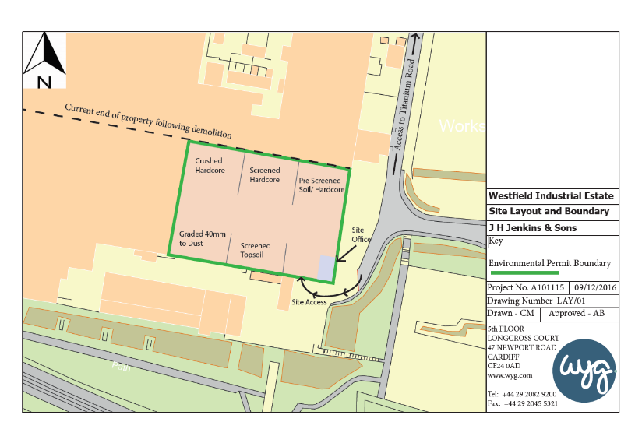
This is the plan referred to in the standard rules SR2010 No12
© Crown Copyright and database right 2017. Ordnance Survey licence number 100019741.

END OF PERMIT

