Permit
The Environmental Permitting (England & Wales) Regulations 2016
South West Wood Products Limited

Kings Dock
Swansea
SA1 8QT

Permit number

EPR/CB3495FF

Permit
The Environmental Permitting (England and Wales) Regulations 2016
Permit number

EPR/CB3495FF

The Natural Resources Body for Wales (“Natural Resources Wales”) authorises, under regulation 13 of the Environmental Permitting (England and Wales) Regulations 2016

South West Wood Products Limited (“the operator”),

whose registered office is

Clifton Moor

Clifton

Penrith

Cumbria

CA10 2EY

company registration number 06880439

to operate waste operations at

Kings Dock

Swansea

SA1 8QT

to the extent authorised by and subject to the conditions of this permit.

Under regulation 27(2) of the Regulations, standard rules SR2011 No4 are conditions of this permit.

Name | Date
Huw Davies | 28/03/2022

Authorised on behalf of Natural Resources Wales

Schedule 1 - Site plan

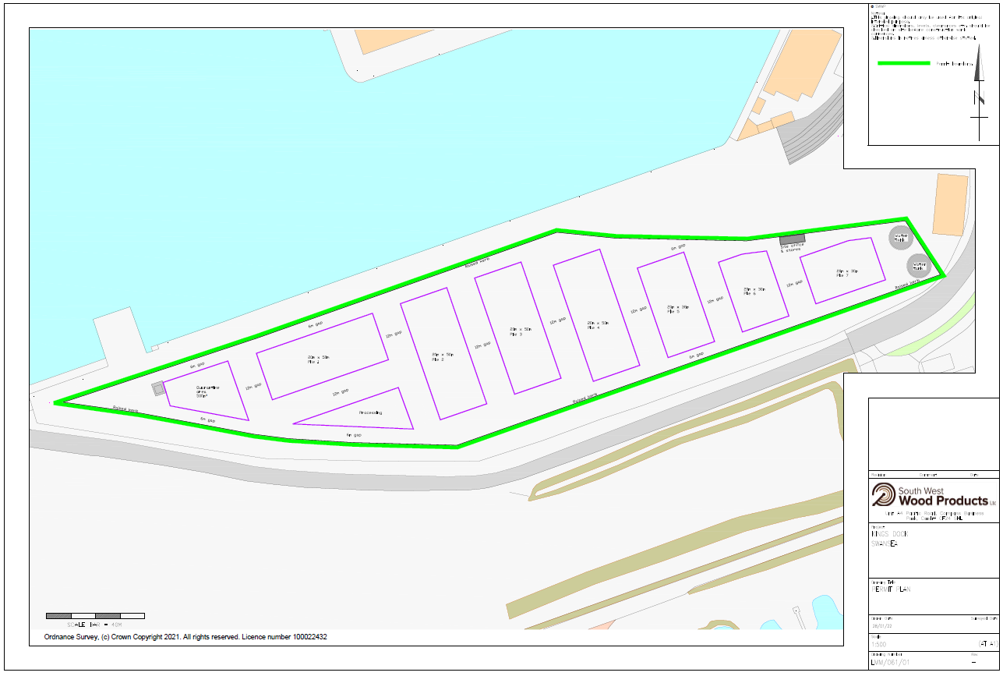
This is the plan referred to in the standard rules SR2011 No4.

END OF PERMIT

